 

CSIT314 - Software Development Methodologies

Report

**Team <IWantToGraduate>**

| **Name** | **UOW ID** | **Contribution** | **Signature** |
| --- | --- | --- | --- |
| Chai You Xiang Roydenn | 8081244 | 100 |  |
| Lim Wootaek | 7898848 | 100 |  |
| Jerry Brooklyn Ma | 8065433 | 100 |  |
| Frentsen Seah Zhi Wei | 8082923 | 100 |  |
| Chew Wei Hong | 7911130 | 100 |  |
| Ngo Truong Vuong | 7560138 | 100 |  |

| **Name** | **Tasks** |
| --- | --- |
| Chai You Xiang Roydenn | Code, documentation, test cases, createDatabase, create a script to generate dummy data |
| Lim Wootaek | Code, documentation, test cases, CI/CD, DDD, TDD |
| Jerry Brooklyn Ma | Documentation, test cases |
| Frentsen Seah Zhi Wei | Documentation, ethical consideration |
| Chew Wei Hong | Code, wireframe, documentation, test cases, GUI, demo video |
| Ngo Truong Vuong | Code, documentation, test cases, demo video |

Contents

**List of User stories 5**

System Admin 5

Seller 7

Real Estate Agent 8

Buyer 10

**Sprint Zero 12**

Sprint Planning, Review and Retrospective 12

**Sprint One 14**

Sprint Planning, Review and Retrospective 14

Taiga - Start 18

Taiga - End 28

ER Diagram 38

Class Diagram 39

#1 System Admin - Login 40

#2 System Admin - Logout 43

#3 System Admin - View User Account 46

#4 System Admin - Search User Account 49

#5 System Admin - Update User Account 52

#6 System Admin - Suspend User Account 57

#12 Seller - Login 61

#13 Seller - Logout 64

#14 Seller - Create User Account 67

#19 Seller - View Own Account 72

#16 Real Estate Agent - Login 75

#17 Real Estate Agent - Logout 78

#18 Real Estate Agent - Create User Account 81

#20 Real Estate Agent - View Own Account 85

#35 Buyer - Login 88

#36 Buyer - Logout 92

#37 Buyer - Create User Account 95

#38 Buyer - View Own Account 99

#616 System Admin - View Own Account 102

**Sprint Two 105**

Sprint Planning, Review and Retrospective 105

Taiga - Start 107

Taiga - End 112

ER Diagram 117

Class Diagram 118

#7 System admin - Create user account 119

#8 System admin - View user profile 123

#9 System admin - Search user profile 126

#10 System admin - Update user profile 129

#11 System admin - Suspend user profile 134

#15 System admin - Create user profile 138

#617 System Admin - Update own account details 143

#21 REA - Update own account details 147

#24 Seller - Update own account details 152

#39 Buyer - Update own account details 157

**Sprint Three 162**

Sprint Planning, Review and Retrospective 162

Taiga - Start 165

Taiga - End 170

ER Diagram 175

Class Diagram (Original Diagram attached) 176

#22 REA - Create properties 177

#23 REA - View own properties 182

#25 REA - Update properties 185

#27 REA - Delete properties 190

#30 REA - View ratings 194

#32 REA - View reviews 197

#28 Seller - View number of times my property has been viewed 200

#31 Seller - View number of times my property has been shortlisted 203

#597 Seller - View agents 206

**Sprint Four 209**

Sprint Planning, Review and Retrospective 209

Taiga - Start 212

Taiga - End 219

ER Diagram 226

Class Diagram 227

#33 Seller - Rate real estate agents 228

#34 Seller - Review real estate agents 233

#40 Buyer - View agent account details 238

#41 Buyer - View Old properties 242

#43 Buyer - Add old properties to a shortlist 245

#44 Buyer - View New properties 249

#46 Buyer - Add New properties to a shortlist 252

#47 Buyer - Calculate mortgage estimates 256

#48 Buyer - Rate real estate agents 260

#607 Buyer - Search for properties based on address 265

#634 Buyer - Search for Old properties 268

#635 Buyer - Search for New properties 271

#49 Buyer - Review real estate agents 275

**Sprint Five 280**

Sprint Planning, Review and Retrospective 280

Gantt Chart 281

ER Diagram - Finalized 282

Class Diagram - Finalized 283

**CI/CD 284**

Commits 284

Root directory 285

Boundary directory 286

Controller directory 288

Entity directory 290

Utility directory (for db connection) 290

.yml file 291

Pipeline 292

**Test Driven Development 293**

**Data-Driven Development 300**

**Ethical Considerations 303**

# List of User stories

## System Admin

| **Taiga ID** | **User Stories** | **Sprint Number** |
| --- | --- | --- |
| #1 | As a System admin, I want to login, so that I can access the administrative dashboard and perform necessary tasks efficiently. | Sprint 1 |
| #2 | As a System admin, I want to logout, so that I can exit the administrative dashboard and protect sensitive information. | Sprint 1 |
| #3 | As a System admin, I want to View user accounts (sys- admin/seller/buyer/agent), so that I can access and review the details associated with different user accounts in the system. | Sprint 1 |
| #4 | As a System admin, I want to Search user accounts (sys- admin/seller/buyer/agent), so that I can efficiently locate specific user accounts based on their details or identifiers. | Sprint 1 |
| #5 | As a System admin, I want to Edit user accounts (sys-admin/seller/buyer/agent) so that I can edit account details. | Sprint 1 |
| #6 | As a System admin, I want to Suspend user accounts (sys-admin/seller/buyer/agent) so that I can remove suspicious and unused accounts and ensure the reliability and trustworthiness of the system. | Sprint 1 |
| #616 | As a System admin, I want to View my own account so that I can access and review my own details. | Sprint 1 |
| #617 | As a System admin I want to Update my account information, such as contact details or ensuring my information remains current. | Sprint 2 |
| #7 | As a System admin, I want to Create user accounts (sys-admin/seller/buyer/agent) so that I can add new users who would like to use the product to the system | Sprint 2 |
| #8 | As a System admin, I want to View user profiles, so that I can access and review the details of different user profiles in the system. | Sprint 2 |
| #9 | As a System admin, I want to Search user profiles, so that I can efficiently locate specific user profiles. | Sprint 2 |
| #10 | As a System admin, I want to Update user profiles so that I can edit profile details. | Sprint 2 |
| #11 | As a System admin, I want to Suspend user profiles so that I can remove unused profiles. | Sprint 2 |
| #15 | As a System admin, I want to Create user Profiles so that I can add new user profiles for the system. | Sprint 2 |

## Seller

| **Taiga ID** | **User Stories** | **Sprint Number** |
| --- | --- | --- |
| #12 | As a Seller, I want to Login, so that I can access my account and my property listings efficiently. | Sprint 1 |
| #13 | As a Seller, I want to Logout, so that I can securely exit my account and protect my personal information. | Sprint 1 |
| #14 | As a Seller, I want to Create a user account, so that I can register and start tracking my properties on the platform. | Sprint 1 |
| #19 | As a Seller, I want to View my user account details, so that I can review and ensure the accuracy of the information associated with my account. | Sprint 1 |
| #24 | As a Seller, I want to Update my user account, so that I can modify my contact information or other details as needed. | Sprint 2 |
| #28 | As a Seller, I want to view the number of times my property has been viewed, so that I can monitor the level of interest and engagement on my property listings. | Sprint 3 |
| #597 | As a Seller, I want to view details of an agent who is tied to my property so that I can check their contact number or experience. | Sprint 3 |
| #31 | As a Seller, I want to view the number of times my property has been shortlisted, so that I can monitor the level of interest and engagement on my property listings. | Sprint 3 |
| #33 | As a Seller, I want to rate real estate agents, so that I can share feedback and experiences with agents and help other users make informed decisions. | Sprint 4 |
| #34 | As a Seller, I want to review real estate agents, so that I can share feedback and experiences with agents and help other users make informed decisions. | Sprint 4 |

## Real Estate Agent

| **Taiga ID** | **User Stories** | **Sprint Number** |
| --- | --- | --- |
| #16 | As a Real Estate Agent, I want to Login to the platform using my credentials, so that I can access my account and perform tasks related to property management and interaction with buyers. | Sprint 1 |
| #17 | As a Real Estate Agent, I want to be able to Logout of my account securely, ensuring that my session is terminated and my account remains protected from unauthorized access. | Sprint 1 |
| #18 | As a Real Estate Agent, I want to be able to Create new accounts for myself, providing necessary details and information to grant myself access to the system and features. | Sprint 1 |
| #20 | As a Real Estate Agent, I want to be able to View the details of my own user account, including my profile information and contact details, to ensure they are accurate and up-to-date. | Sprint 1 |
| #21 | As a Real Estate Agent, I want to be able to Update my user account information such as my contact details so that my information remains current and accurate. | Sprint 2 |
| #22 | As a Real Estate Agent, I want to be able to Create new property listings, providing comprehensive details such as property type, location, amenities, and pricing, to attract potential buyers or renters. | Sprint 3 |
| #23 | As a Real Estate Agent, I want to View my property listings available on the platform, so that I can view the property in detail. | Sprint 3 |
| #25 | As a Real Estate Agent, I want to Update my existing property listings, such as modifying property details or adjusting pricing, to reflect any changes accurately. | Sprint 3 |
| #27 | As a Real Estate Agent, I want to be able to Delete a property listing from the platform, either because it has been sold or rented out, or because it is no longer available for other reasons. | Sprint 3 |
| #30 | As a Real Estate Agent, I want to be able to view the average rating I have been given by buyers and sellers so that I can review my own performance based on ratings given. | Sprint 3 |
| #32 | As a Real Estate Agent, I want to be able to view a review I have been given so that I can review my own performance based on the details of reviews. | Sprint 3 |

## Buyer

| **Taiga ID** | **User Stories** | **Sprint Number** |
| --- | --- | --- |
| #35 | As a buyer, I want to Login to the platform using my credentials, ensuring secure access to my account and its features. | Sprint 1 |
| #36 | As a buyer, I want to be able to Logout of my account securely, terminating my session and protecting my account from unauthorized access. | Sprint 1 |
| #37 | As a buyer, I want to Create an account on the platform, providing necessary details such as name, email, and password, to access its features and services. | Sprint 1 |
| #38 | As a buyer, I want to be able to View my own account information, including profile details and settings, to ensure they are accurate and up-to-date. | Sprint 1 |
| #39 | As a buyer, I want to Update my account information, such as contact details or ensuring my information remains current. | Sprint 2 |
| #40 | As a buyer, I want to be able to View the profile of a real estate agent, including their contact information, qualifications, and listings, to assess their suitability for my needs. | Sprint 4 |
| #41 | As a buyer, I want to View OLD property listings on the platform, including details such as property features, and pricing so that I can compare their details. | Sprint 4 |
| #634 | As a buyer, I want to Search for OLD property listings so that I can view details about the OLD property. | Sprint 4 |
| #43 | As a buyer, I want to be able to Add OLD property listings to a favorites or watchlist, so that I can easily access and track properties that interest me. | Sprint 4 |
| #44 | As a buyer, I want to View NEW property listings on the platform, including details such as property features, and pricing. | Sprint 4 |
| #635 | As a buyer, I want to Search for NEW property listings so that I can view details about the NEW property. | Sprint 4 |
| #46 | As a buyer, I want to be able to Add NEW property listings to a favorites or watchlist, so that I can easily access and track properties that interest me. | Sprint 4 |
| #47 | As a buyer, I want to Calculate mortgage estimates based on loan amount, interest rate, and loan term, to determine my budget and affordability. | Sprint 4 |
| #48 | As a buyer, I want to be able to rate real estate agents based on my experience with them, providing feedback to help other users make informed decisions. | Sprint 4 |
| #49 | As a buyer, I want to be able to review real estate agents based on my experience with them, providing feedback to help other users make informed decisions. | Sprint 4 |
| #607 | As a buyer, I want to Search for property listings based on their address so that I can find property in the location I want. | Sprint 4 |

# 

# Sprint Zero

**Duration: 3rd April - 8th April**

## Sprint Planning, Review and Retrospective

| **Meeting Date**: 03/04/2024 (Wednesday) | | |
| --- | --- | --- |
| **Duration:** 13:00 - 15:00 | | |
| **Sprint duration:** 03/04/2024 - 08/04/2024 | | |
| **Attendees:**  Wootaek, Vuong, Jerry,  Wei Hong, Frentsen, Roydenn | | **Agenda** |
| 1. Discuss about individual members’ capabilities, strengths and weaknesses. 2. Discuss about user stories. |
| **Absentees:**  N/A | |
|
| **What we have done during the meeting** | | **All members**   * Discussed about what we are going to do based on individual strengths and weaknesses. (e.g., how proficient we are in coding/programming) * Initial draft of 37 user stories and sent to tutor for feedback. |
| **What we are going to do for this sprint** | | **All members**   * Revise our user stories based on product owner’s feedback. * Create a Taiga account. * Create a shared Google Drive folder for this project.   **Roydenn**   * BCE & Sequence diagram * User Login * User Logout   **Wootaek**   * BCE & Sequence diagram * User Create Account   **Wei Hong**   * BCE & Sequence diagram * SA - Suspend account   **Jerry**   * BCE & Sequence diagram * User - View account   **Vuong**   * BCE & Sequence diagram * SA - Update account   **Frentsen**   * BCE & Sequence diagram * SA - Update account |

# Sprint One

**Duration: 8th April - 19th April**

## Sprint Planning, Review and Retrospective

| **Meeting Date**: 08/04/2024 (Monday) | | |
| --- | --- | --- |
| **Duration:** 12:00 - 13:45 | | |
| **Sprint duration:** 08/04/2024 - 22/04/2024 | | |
| **Attendees:**  Wootaek, Vuong, Wei Hong, Roydenn, Jerry, Frentsen | | **Agenda** |
| 1. Discuss class diagrams of our project. 2. Discuss about attributes of each data entity. |
| **Absentees:**  N/A | |
|
| **What we have done** | | **All members**   * Revised our user stories based on product owner’s feedback. * Completed making user stories. * Created a Taiga account. * Created a shared Google Drive folder for this project. * Drew sequence and BCE diagrams of a few user stories. |
| **Reflection** | | **What went well:**   * Everyone finished their assigned User Stories and tasks on time.   **What could be improved:**   * Knowledge on how to draw diagrams. * As this is our first time drawing diagrams, our diagrams had to undergo a few iterations. |
| **What we are going to do for this sprint** | | **All members**   * Schedule the next meeting with the product owner. * draw the class diagram. * Set up a local workspace for the project.   + Shared Google Drive   + Local phpMyAdmin server/database * Set up a Gitlab repository. * Improve BCE and Sequence Diagrams for the following user stories based on feedback from product owner:   + User Login (Roydenn)   + User Logout (Roydenn)   + User Create Account (Wootaek)   + SA - Suspend account (Wei Hong)   + User - View account (Jerry)   + SA - Update account (Vuong)   + SA - Search account (Frentsen)   **Wei Hong**   * Create wireframe and write functions for selected user stories in this sprint. |

| **Meeting Date**: 15/04/2024 (Monday) | | |
| --- | --- | --- |
| **Duration:** 10:30 - 11:30 | | |
| **Sprint duration:** 08/04/2024 - 22/04/2024 | | |
| **Attendees:**  Wootaek, Vuong, Wei Hong, Roydenn, Frentsen, Jerry | | **Agenda** |
| 1. Discuss about each group member’s role and contribution 2. Discuss about Taiga screenshotting 3. Discuss about documentation team scope 4. Start on documentation for report 5. Discuss about diagrams’ feedback 6. Check on progress |
| **Absentees:**  N/A | |
|
| **What we have done** | | **All members**   * Scheduled the next meeting with the product owner. * Completed a draft of the class diagram. * Set up a local workspace for the project. * Set up a Github repository. * Improved BCE and Sequence Diagrams for the following user stories based on product owner feedback:   + User Login (Roydenn)   + User Logout (Roydenn)   + User Create Account (Wootaek)   + SA - Suspend account (Wei Hong)   + User - View account (Jerry)   + SA - Update account (Vuong)   + SA - Search account (Frentsen)   **Wei Hong**   * Created wireframe and wrote functions for selected user stories in this sprint. |
| **Reflection** | | **What went well:**  **What could be improved:**   * Knowledge on how to draw diagrams. |
| **What we are going to do** | | **All members**   * Start writing the report for sprint 1. * Amend our diagrams based on our product owner’s feedback.   **Jerry & Frentsen**   * Screenshot Taiga   **Wootaek & Roydenn**   * Code for selected user stories. * System Admin View User.   **Wei Hong**   * Code for selected user stories. * GUI for the shared main page   **Vuong**   * Code for selected user stories. * “User update” user story |

## Taiga - Start

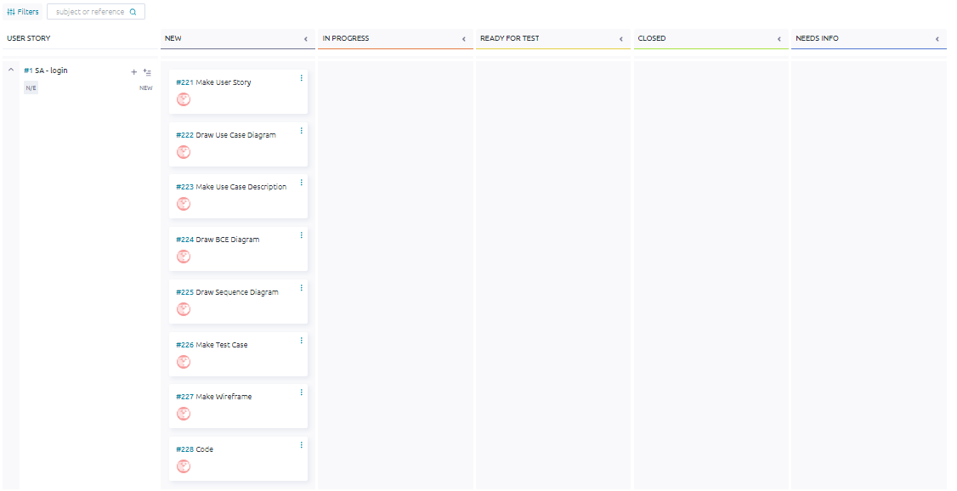

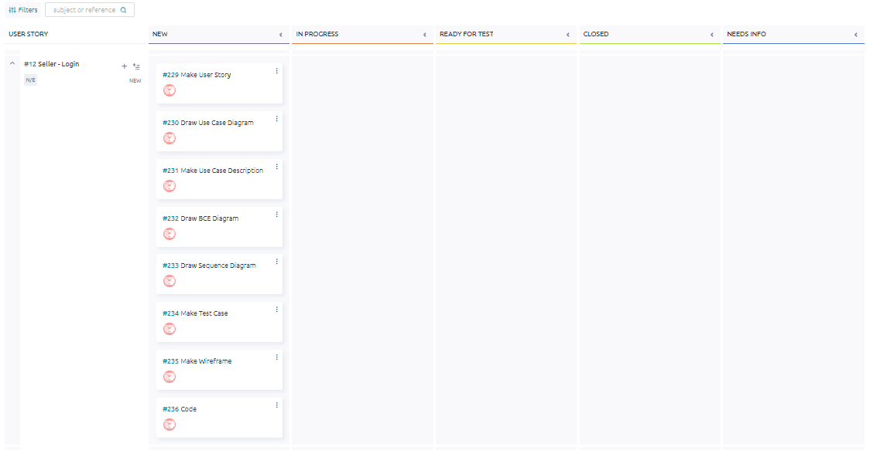

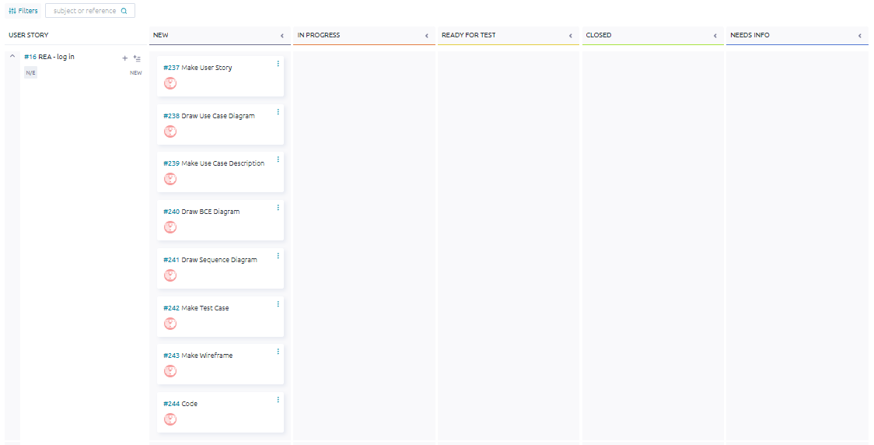

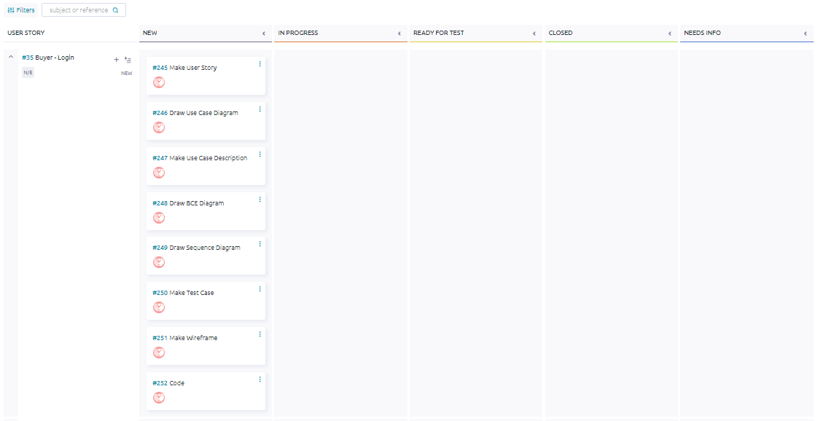

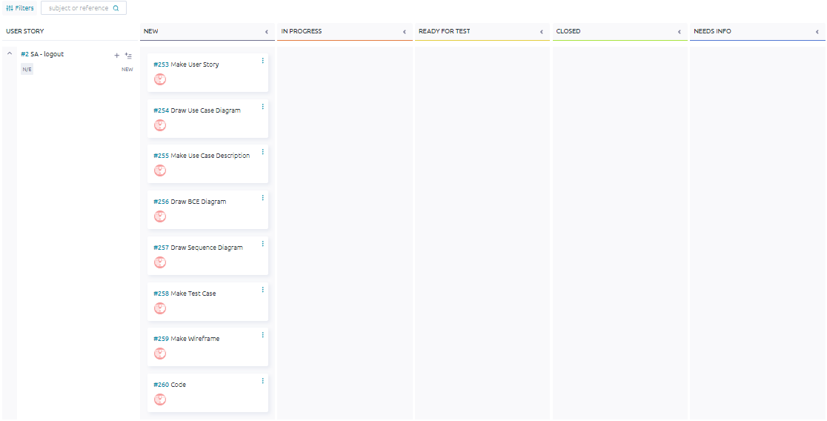

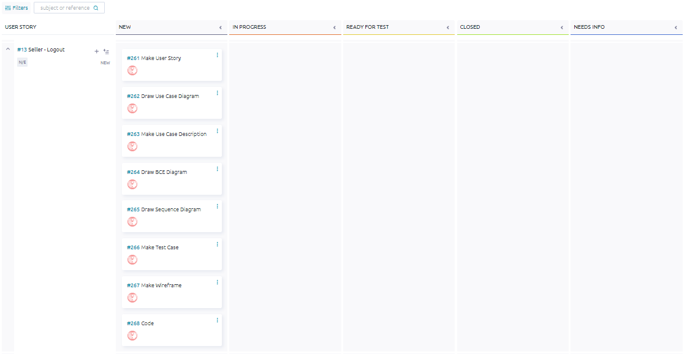

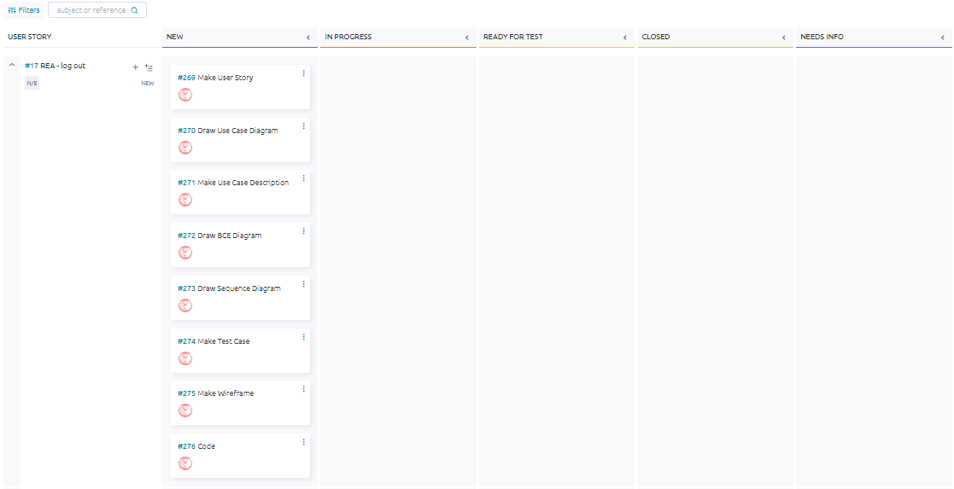

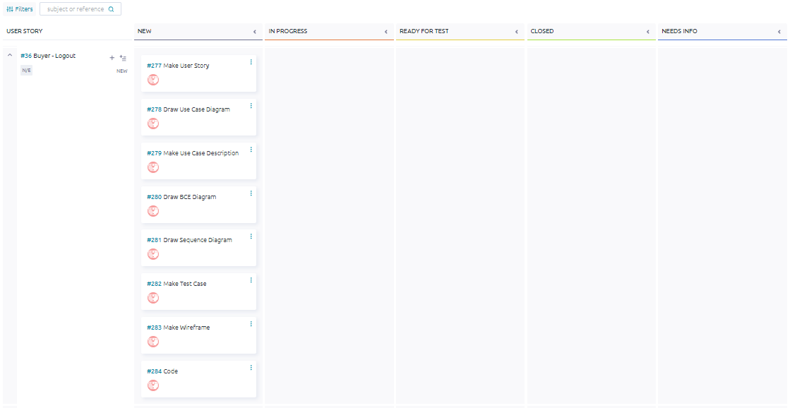

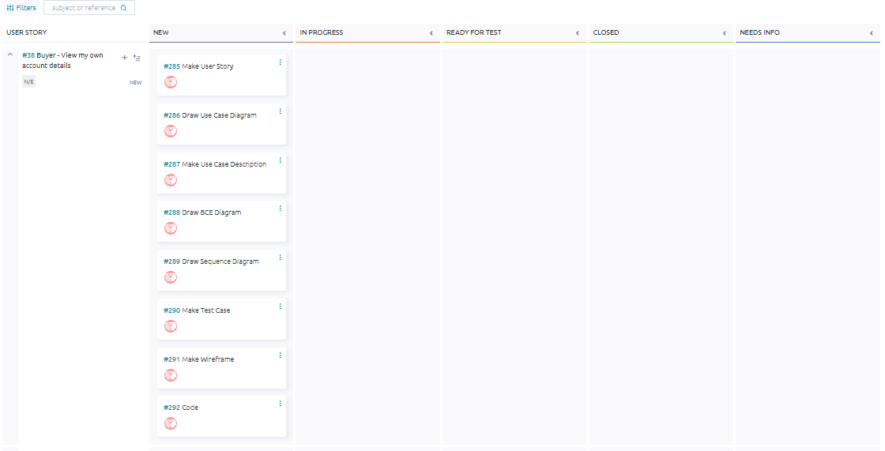

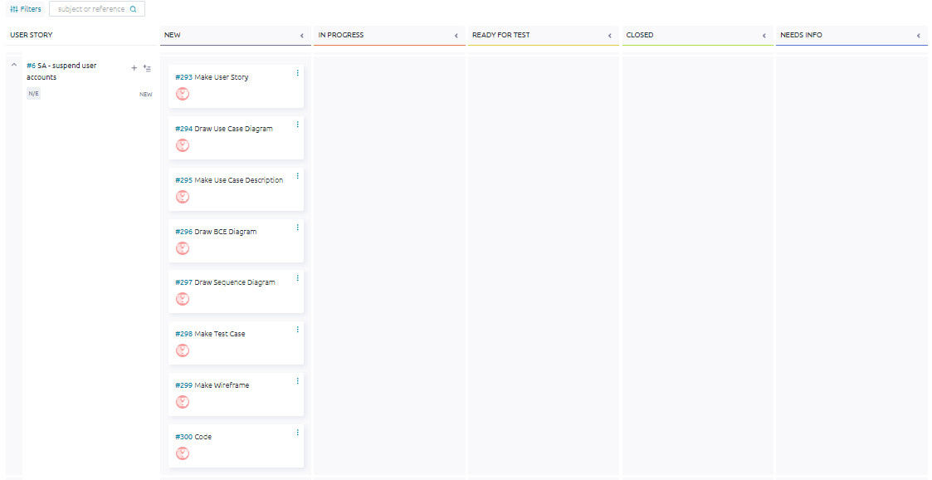

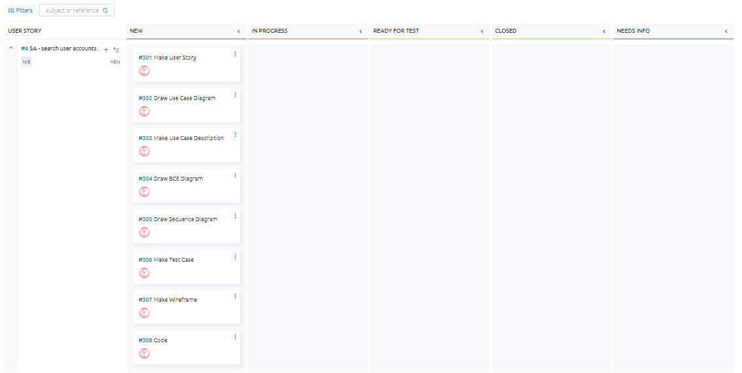

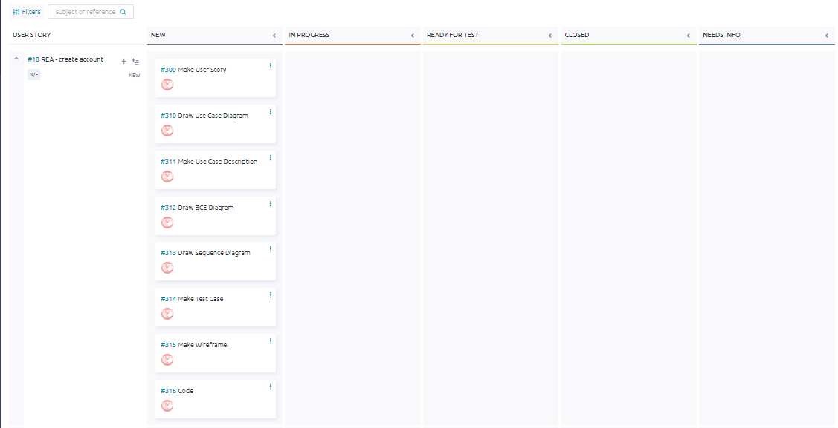

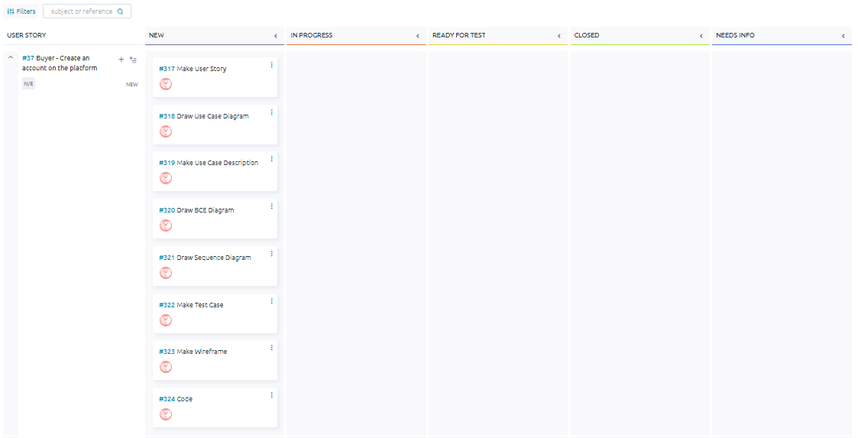

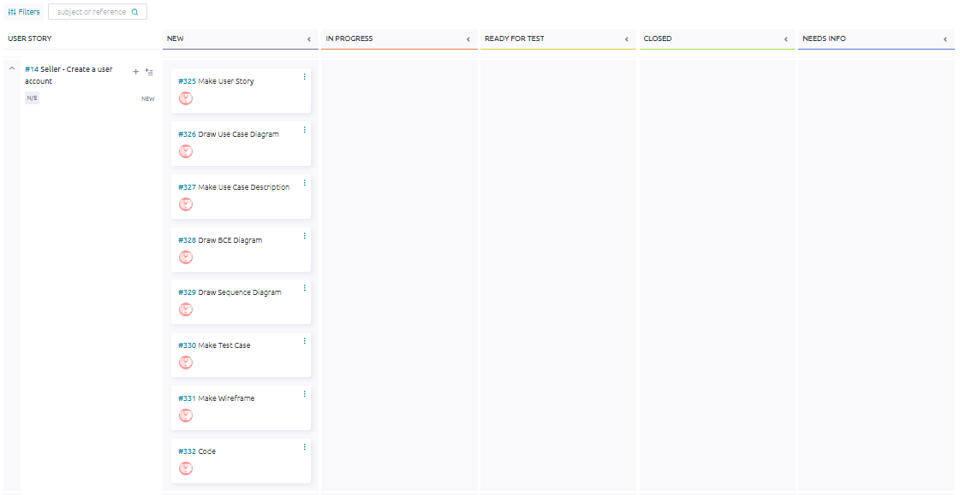

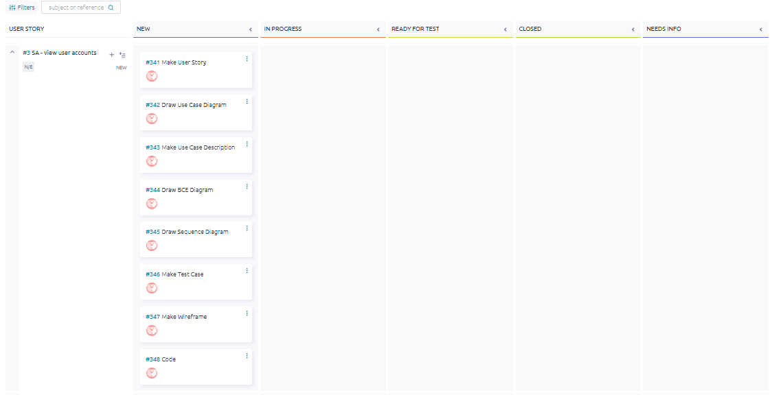

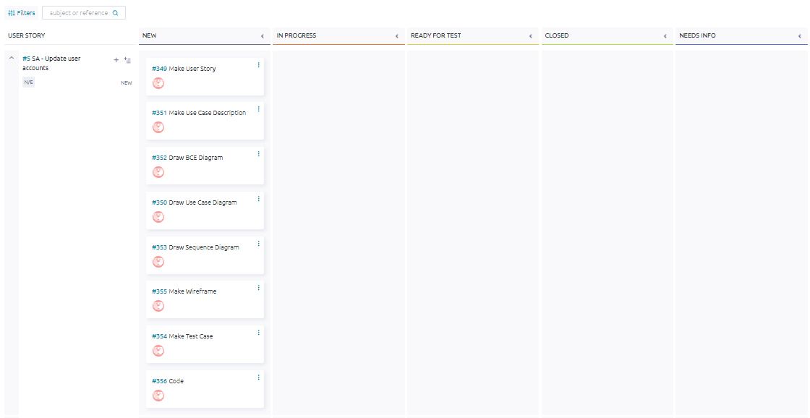

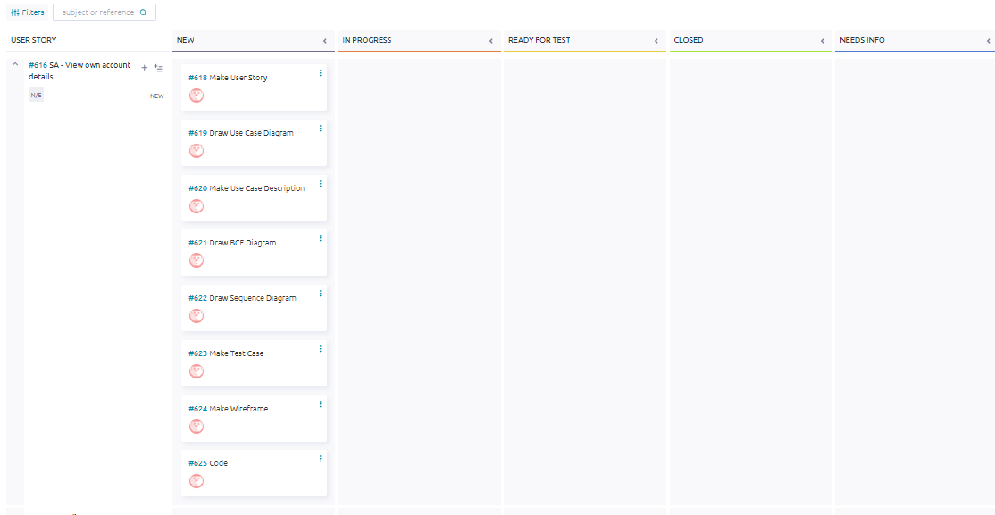

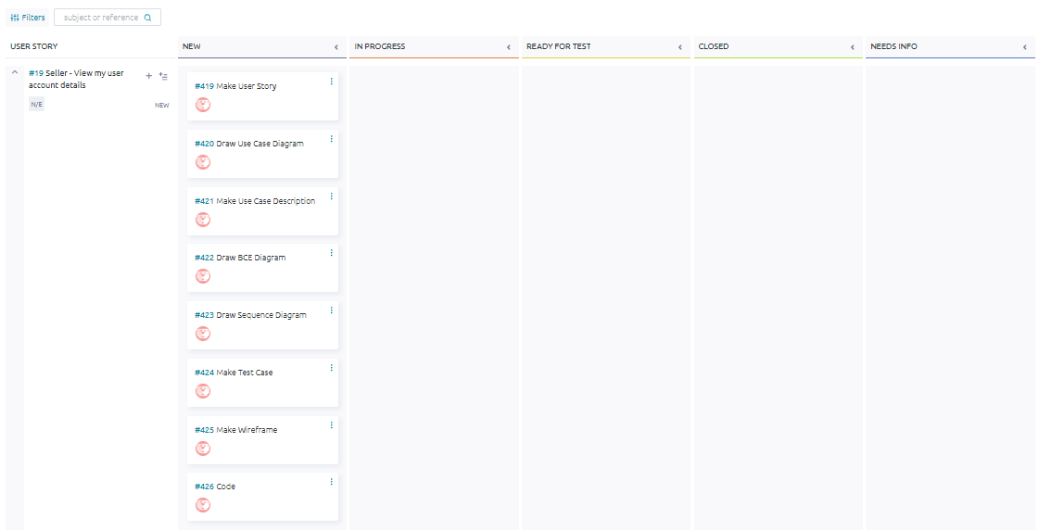

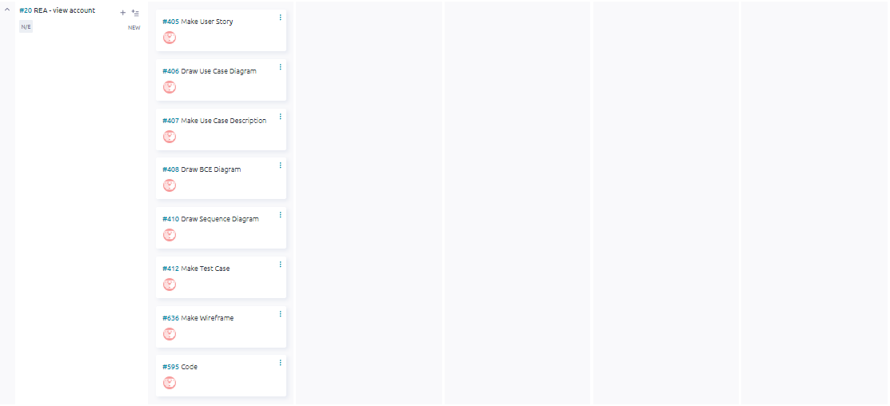

## Taiga - End

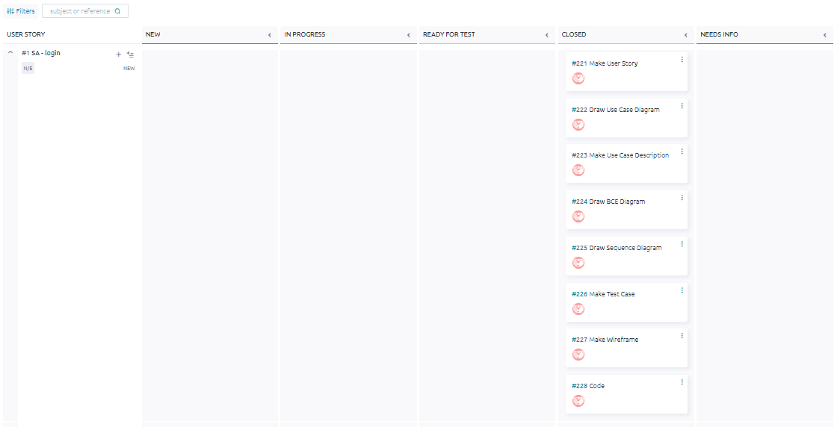

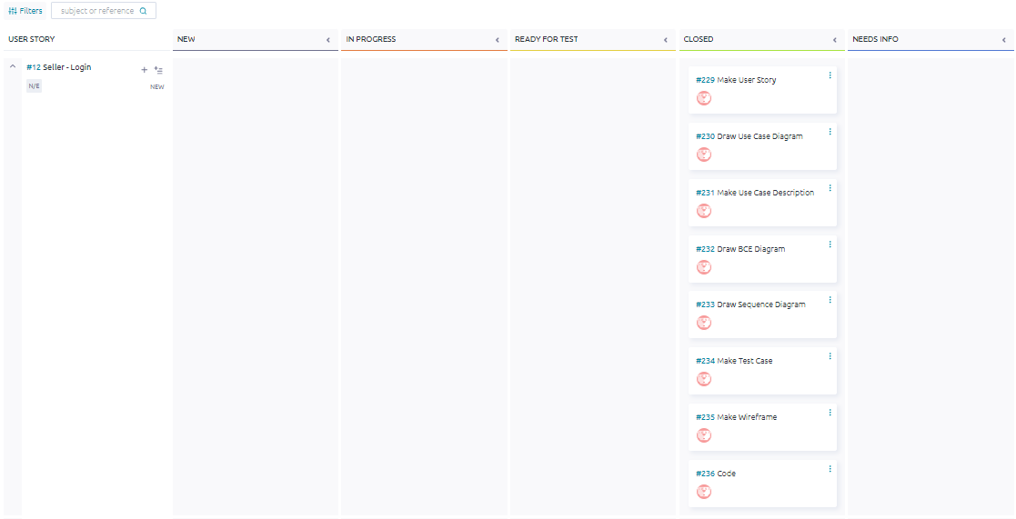

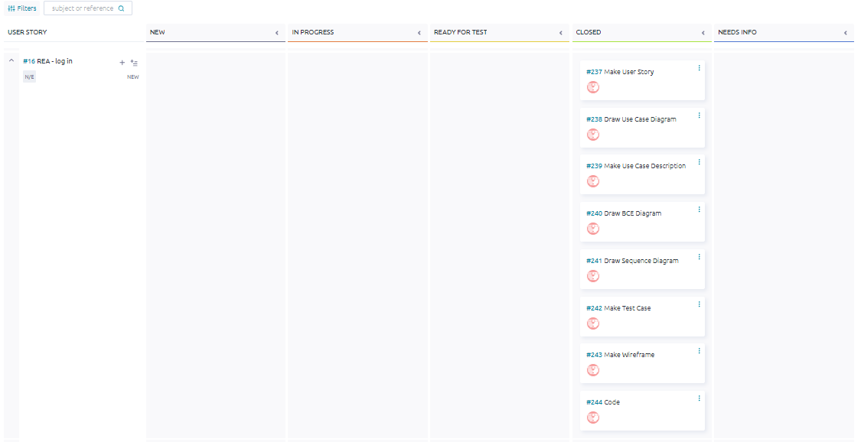

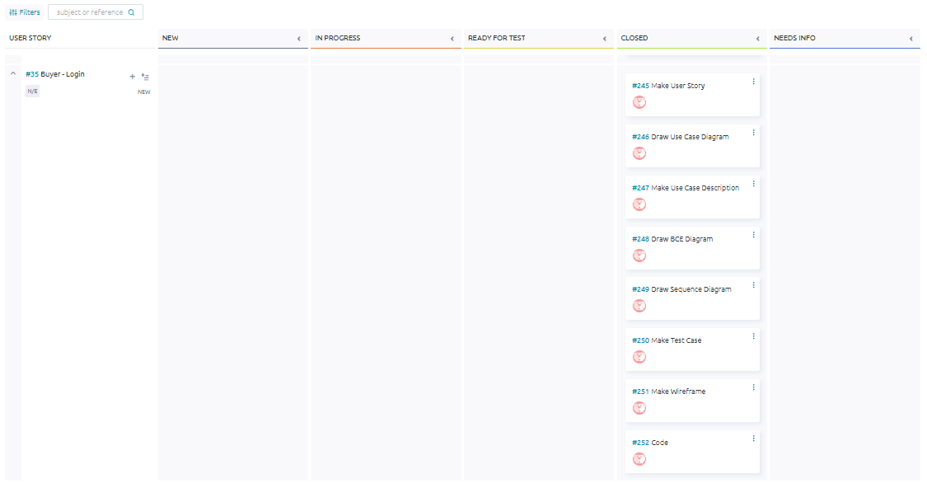

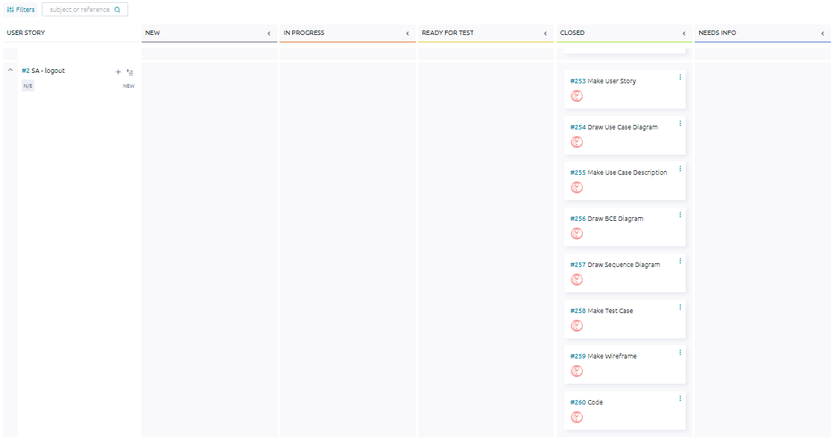

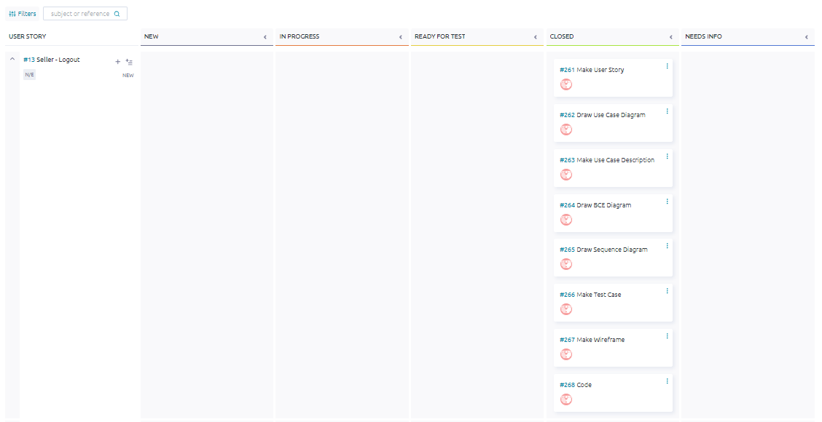

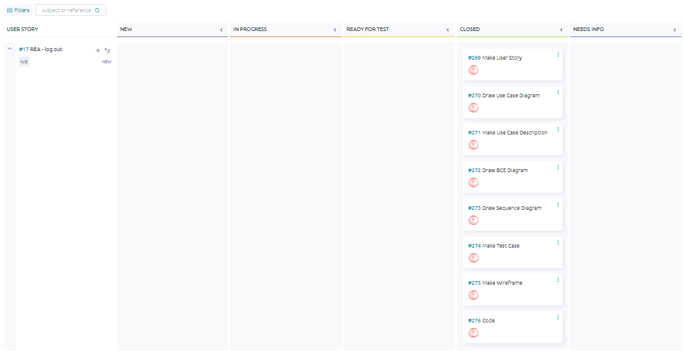

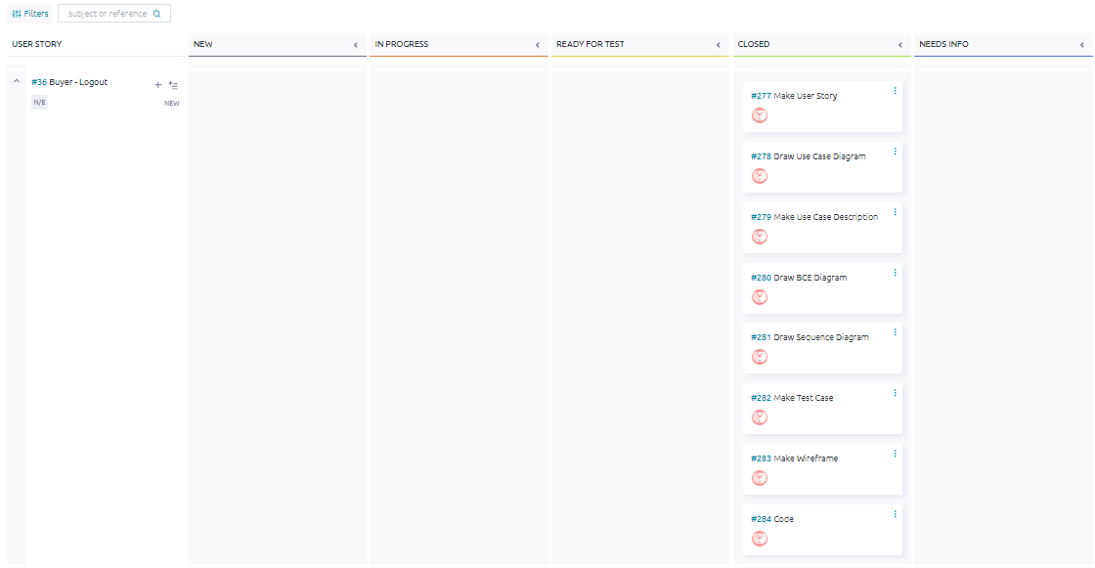

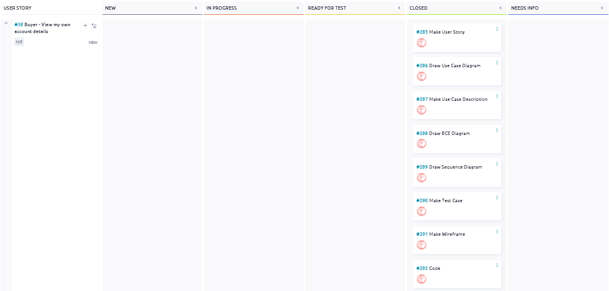

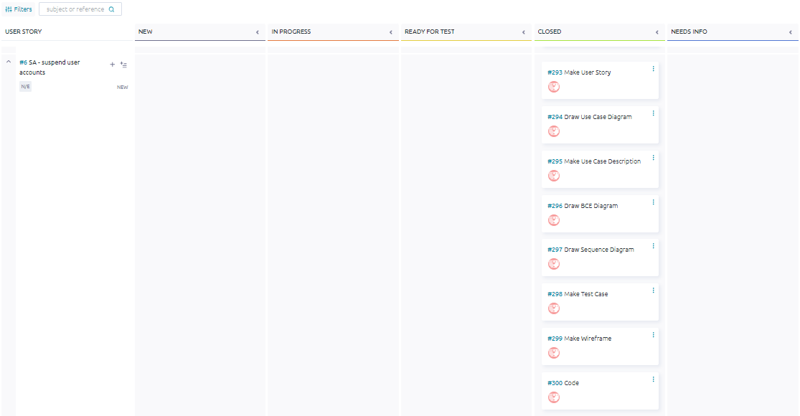

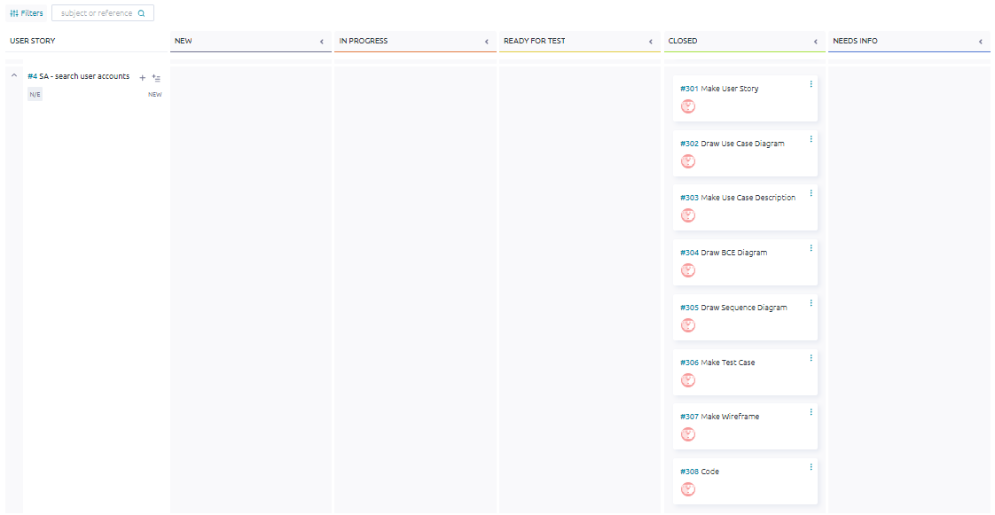

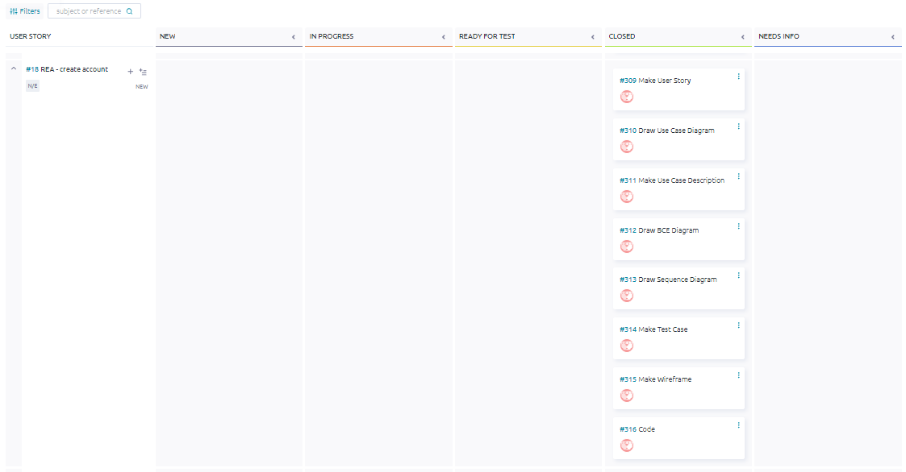

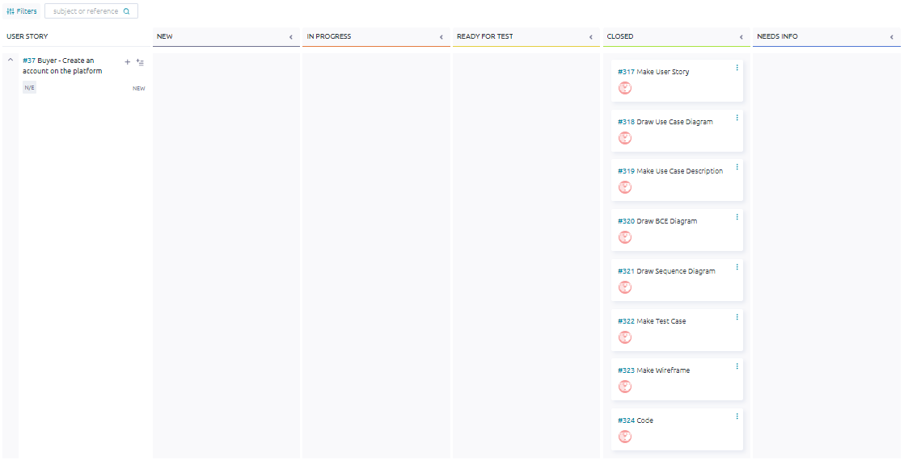

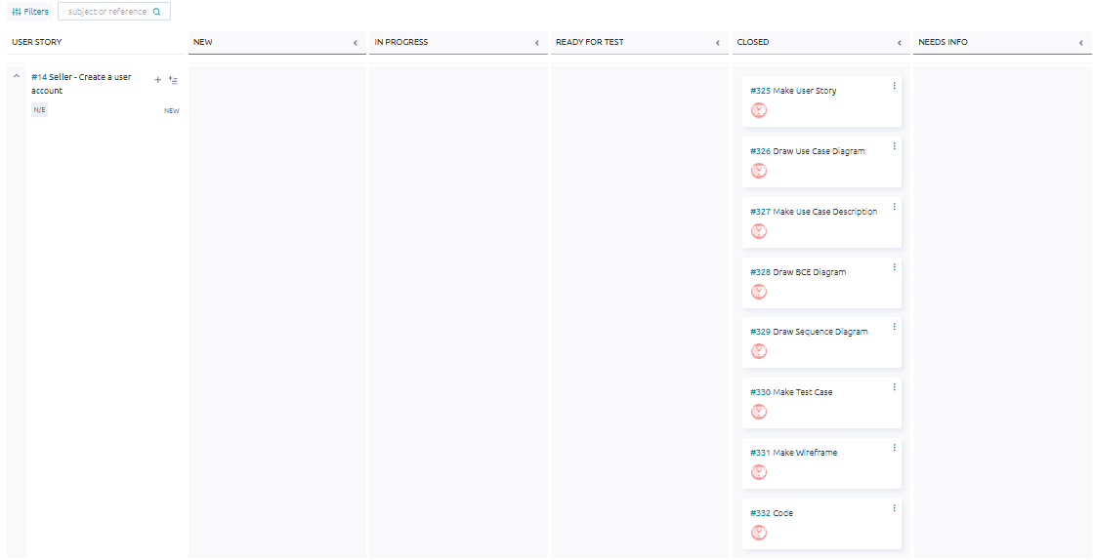

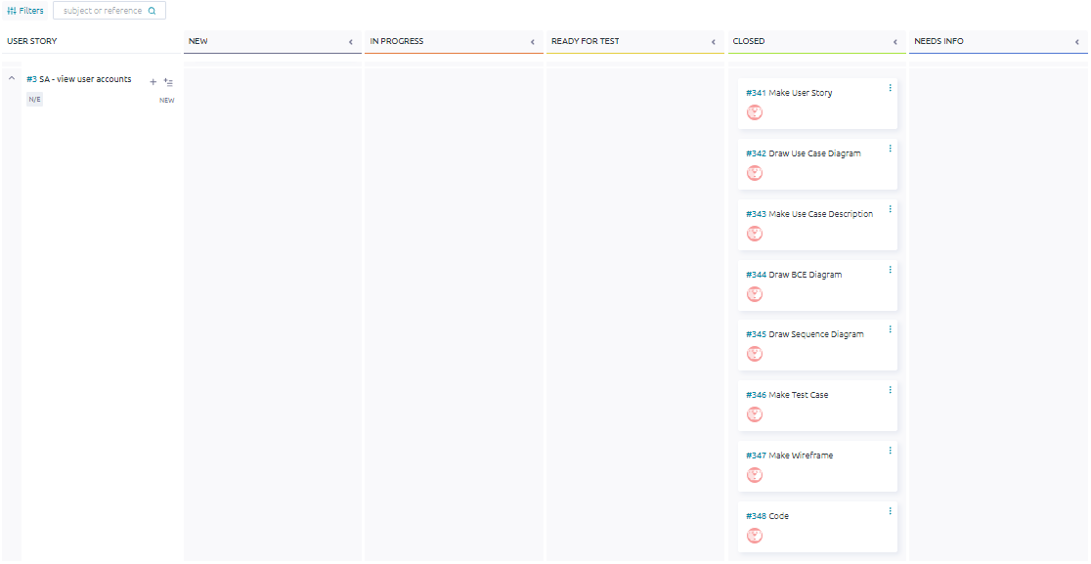

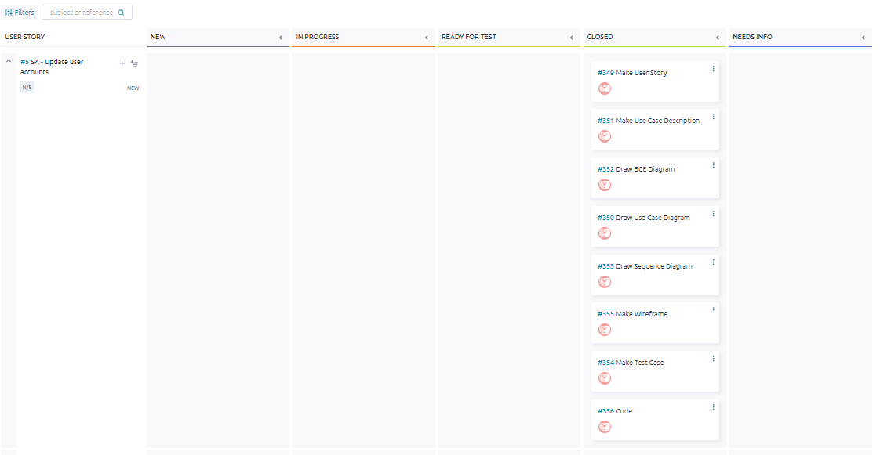

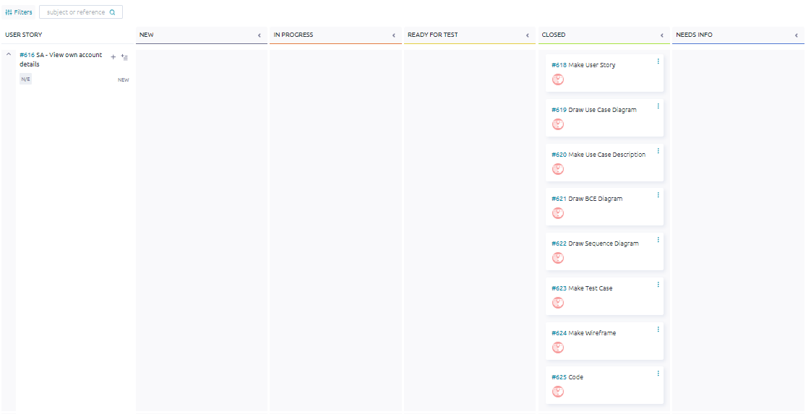

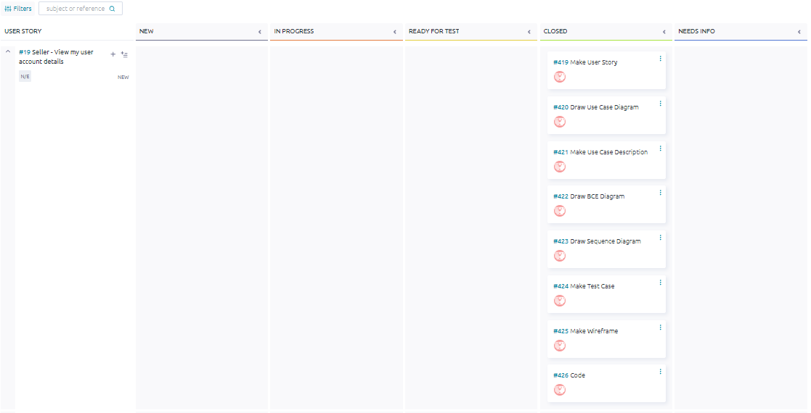

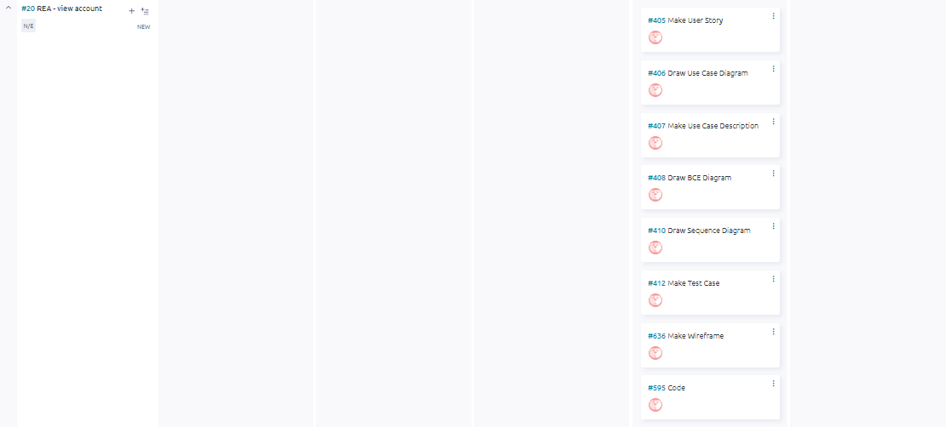

## ER Diagram

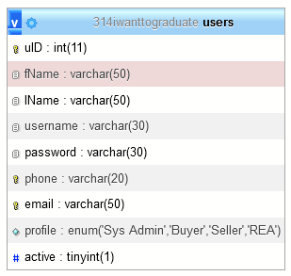

## 

## Class Diagram

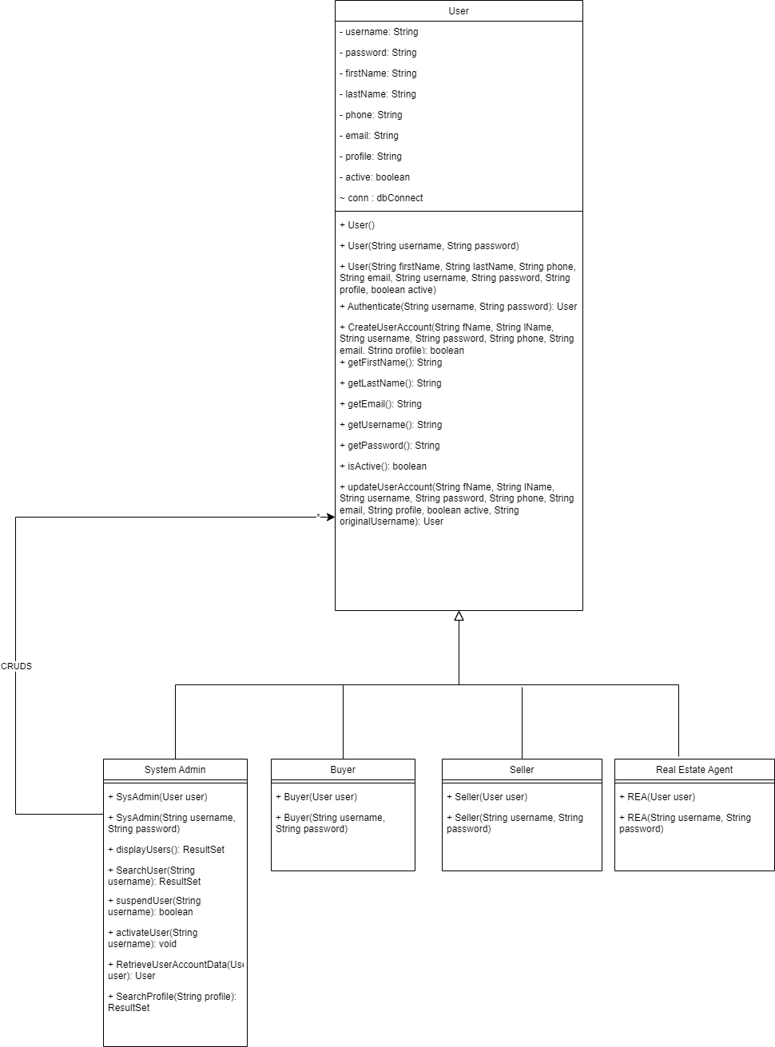

## 

## #1 System Admin - Login

*#221 User Story*

As a System admin, I want to login, so that I can access the administrative dashboard and perform necessary tasks efficiently.

*#222 Use Case Diagram*

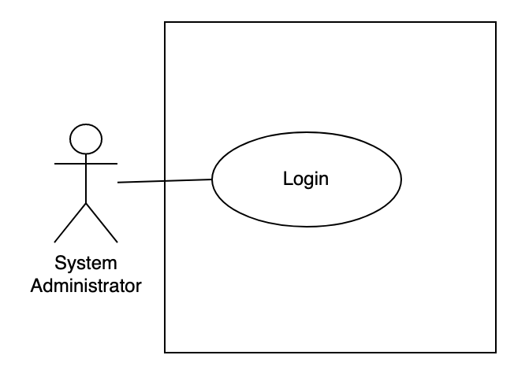

*#223 Use Case Description*

| **Name:** SA - login | **ID:** #1 |
| --- | --- |
| **Stakeholders and goals:** System Admin - To login to the system | |
| **Description:** System Admin inputs their credentials and clicks on the “Login” button to log in to the system. | |
| **Actors:** System Admin | |
| **Trigger:** When the System Admin enters login details and clicks on the login button. | |
| **Pre-condition:** System Admin has a valid user account | |
| **Main flow:**   1. System Admin launches the system. 2. System prompts System Admin for their username and password. 3. System Admin input their details. 4. System Admin clicks the “Login” button. 5. System Admin is redirected to the home page. 6. End. | |
| **Sub- flow:** None. | |
| **Alternative/Exceptional flow:**  4a. Invalid login: System display message “Invalid login. Please try again”  4b. User re-enters credentials and clicks on the “Login” button again. | |

*#224 BCE Diagram*

**

*#225 Sequence Diagram*

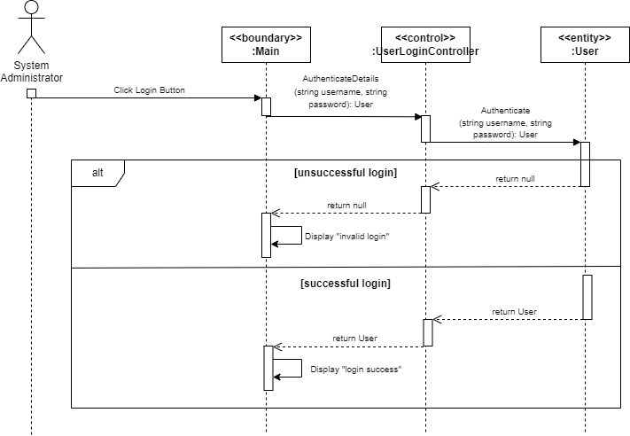

*#226 Test Case*

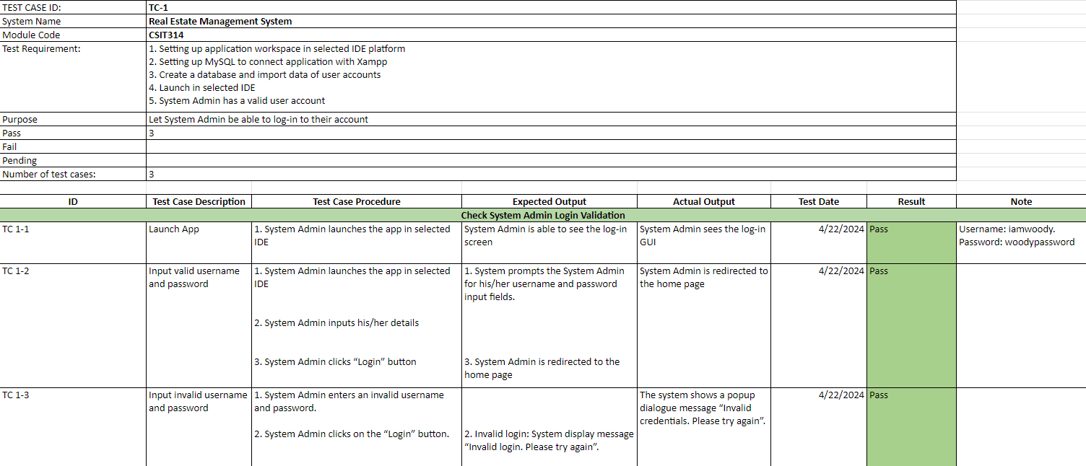

*#227 Wireframe*

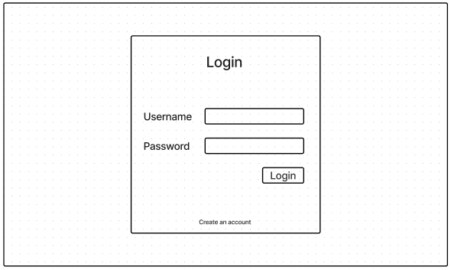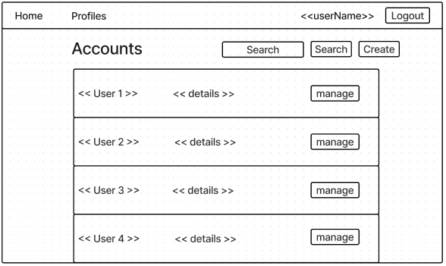

## #2 System Admin - Logout

*#253 User Story*

As a System admin, I want to logout, so that I can exit the administrative dashboard and protect sensitive information.

*#254 Use Case Diagram*

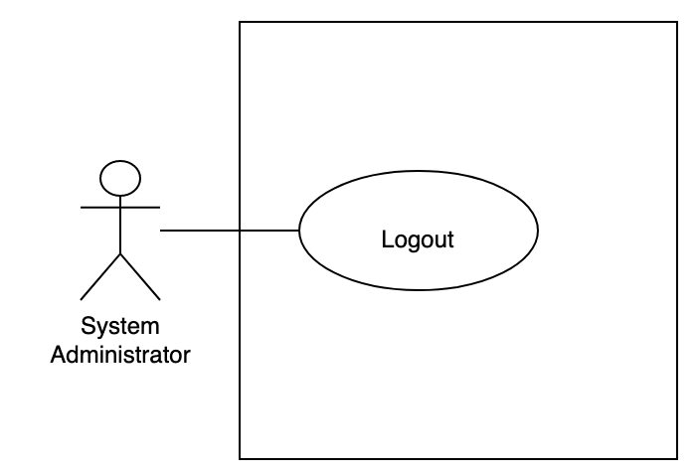

*#255 Use Case Description*

| **Name:** System Admin - logout | **ID:** #2 |
| --- | --- |
| **Stakeholders and goals:** System Admin - To logout from the system | |
| **Description:** System Admin clicks on the “Logout” button and logs out from the system. | |
| **Actors:** System Admin | |
| **Trigger:** When the System Admin clicks on the logout button. | |
| **Pre-condition:**  System Admin is logged in | |
| **Main flow:**   1. System Admin clicks on the “Logout” button. 2. System logs the System Admin out. 3. System Admin is directed to the login page. 4. End. | |
| **Sub-flow:** None. | |
| **Alternative/Exceptional flow:** | |

*#256 BCE Diagram*

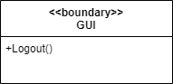

*#257 Sequence Diagram*

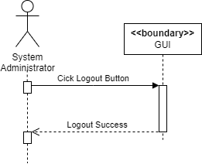

*#258 Test Case*

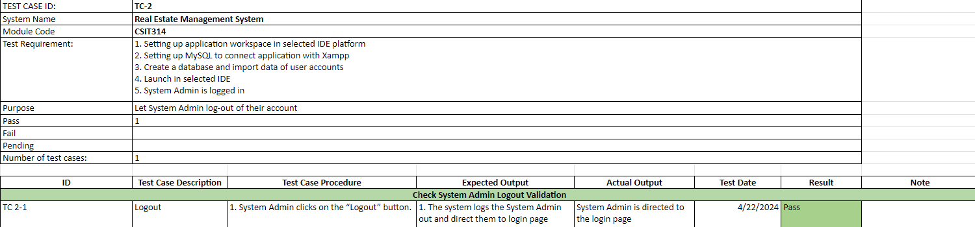

*#259 Wireframe*

**

**

## #3 System Admin - View User Account

*#341 User Story*

As a System admin, I want to View user accounts (sys admin/seller/buyer/agent), so that I can access and review the details and activities associated with different user accounts in the system.

*#342 Use Case Diagram*

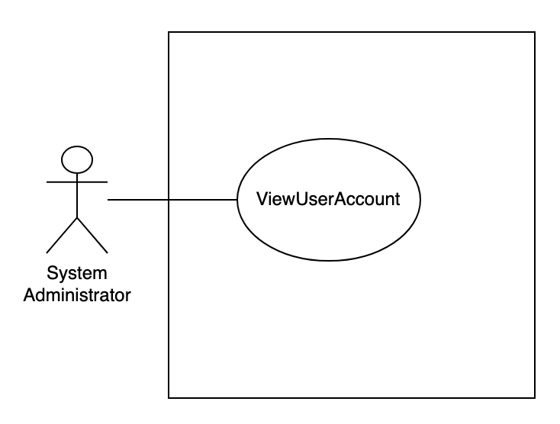

*#343 Use Case Description*

| **Name:** SA - view user accounts | **ID:** #3 |
| --- | --- |
| **Stakeholders and goals:** System Admin - To view user accounts | |
| **Description:** System Admin clicks on the “Manage” button tagged to a user account and views that user’s details. | |
| **Actors:** System Admin | |
| **Trigger:** When System Admin clicks on “Manage” button beside selected user account | |
| **Pre-condition:**  System Admin is logged in  System Admin is in their homepage | |
| **Main flow:** 1. System displays the list of the user account  2. System Admin clicks on “Manage” button beside selected user account 3. System shows the selected user’s data 4. End | |
| **Sub-flows:** None. | |
| **Alternative/Exceptional flows:** | |

*#344 BCE Diagram*

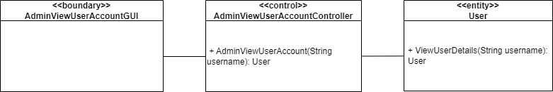

*#345 Sequence Diagram*

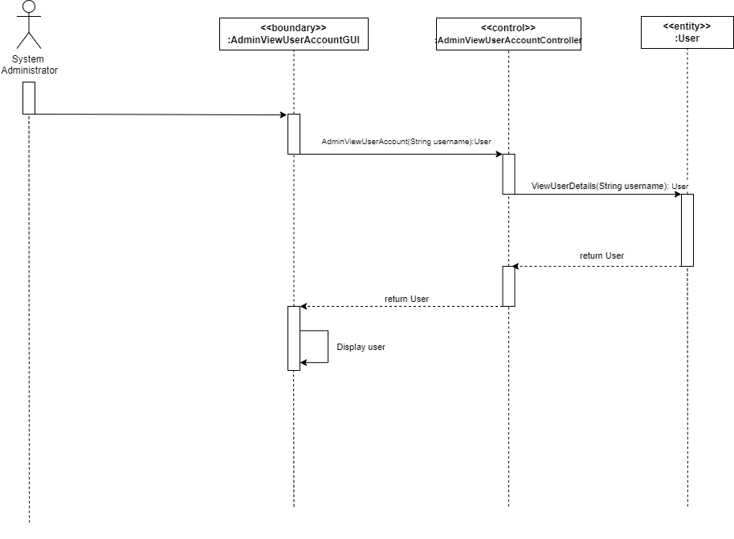

*#346 Test Case*

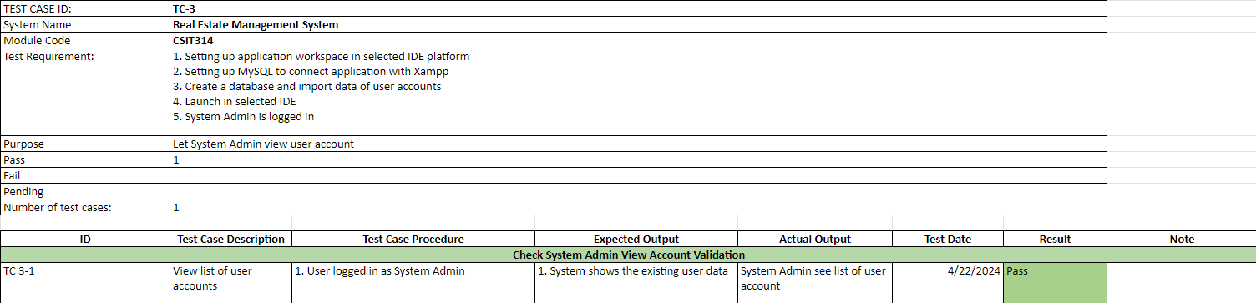

*#347 Wireframe*

**

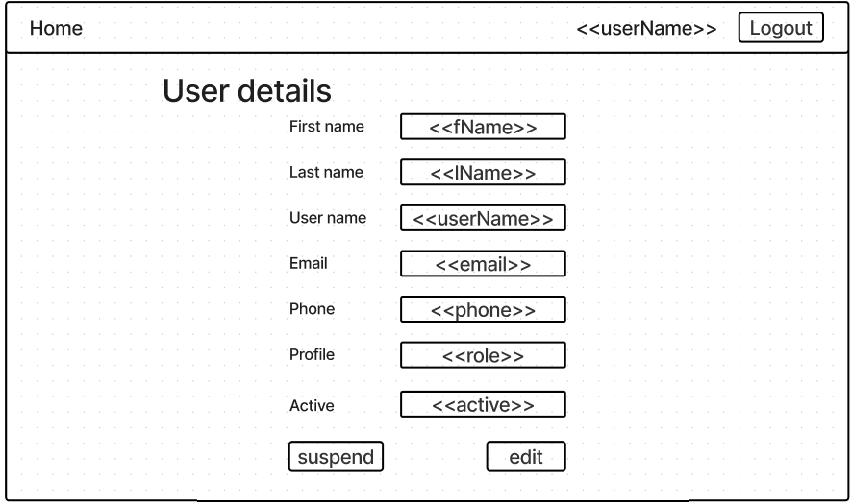

## 

## 

## #4 System Admin - Search User Account

*#301 User Story*

As a System admin, I want to Search user accounts (sysadmin/seller/buyer/agent), so that I can efficiently locate specific user accounts based on their username.

*#302 Use Case Diagram*

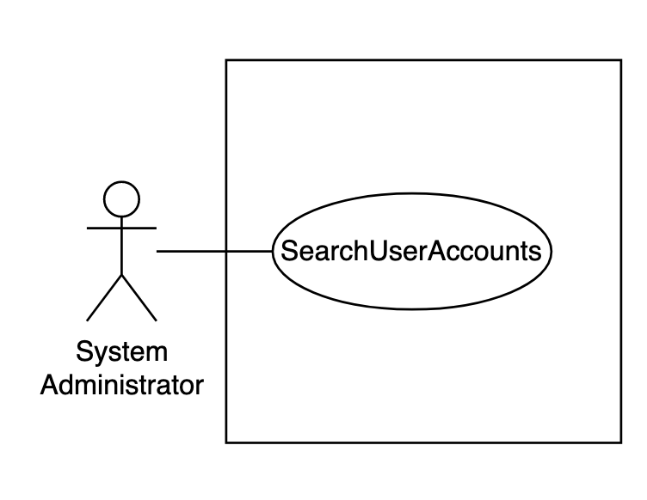

*#303 Use Case Description*

| **Name:** SA - search user account | **ID:** #4 |
| --- | --- |
| **Stakeholders and goals:** System Admin - To search for a user account | |
| **Description:** System Admin inputs a user’s username into the search bar and clicks on the “Search” button to search for a specific user. | |
| **Actors:** System Admin | |
| **Trigger:** The System Admin clicks on search button | |
| **Pre-condition:**  System Admin is logged in  System Admin is in their homepage | |
| **Main flow:** 1. System Admin input the username onto the search field. 2. System Admin clicks on the “Search” button.  3. System returns a list of user accounts that matches the search input.  4. End | |
| **Sub-flows:** None. | |
| **Alternative/Exceptional flows:**  3.a. No matching accounts found: System display empty scroll pane with no accounts  3.b. System Admin enters blank: All accounts displayed | |

*#304 BCE Diagram*

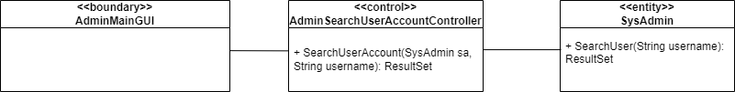

*#305 Sequence Diagram*

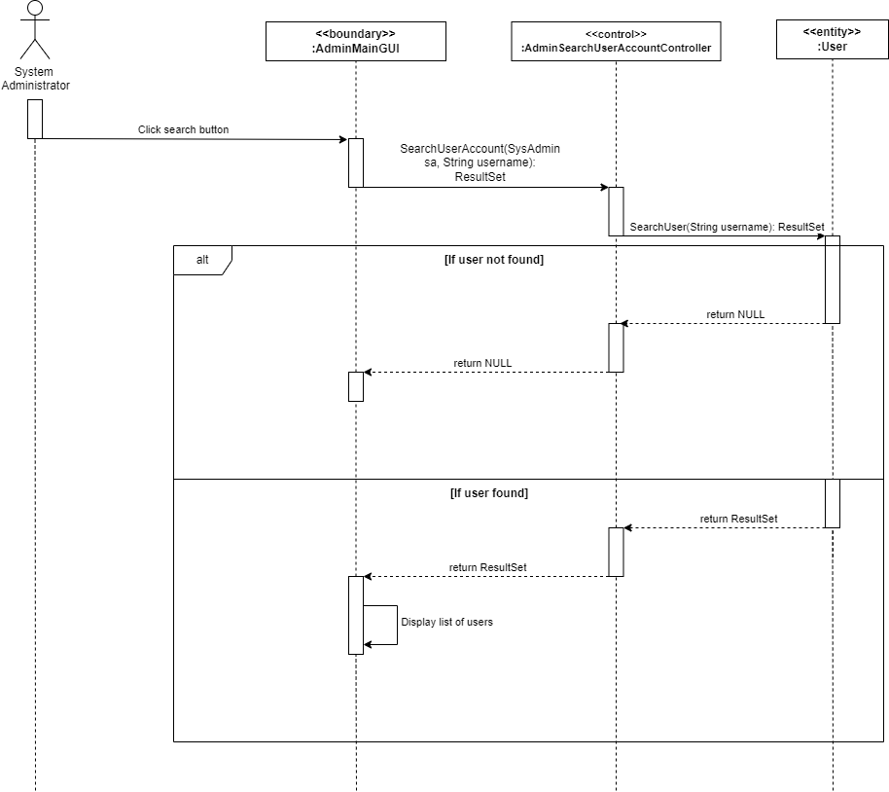

*#306 Test Case*

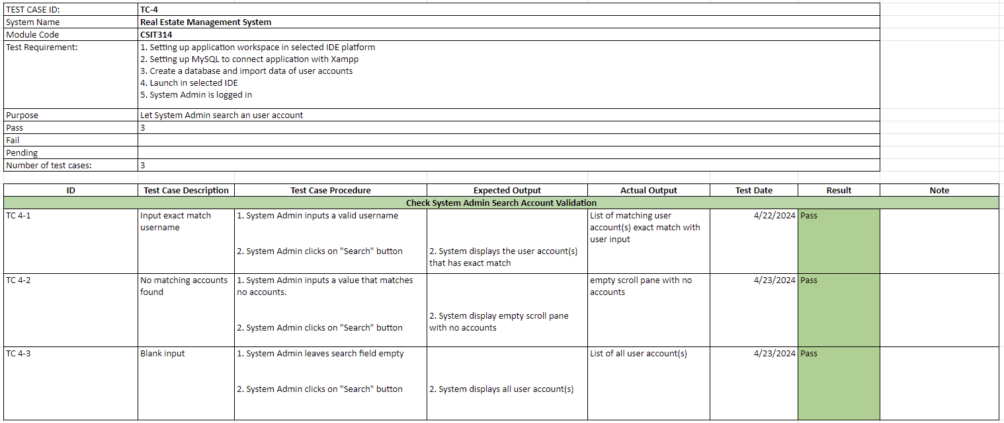

*#307 Wireframe*

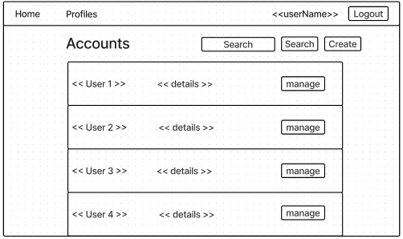

## #5 System Admin - Update User Account

*#349 User Story*

As a System admin, I want to Update user accounts (sysadmin/seller/buyer/agent) so that I can edit account details.

*#350 Use Case Diagram*

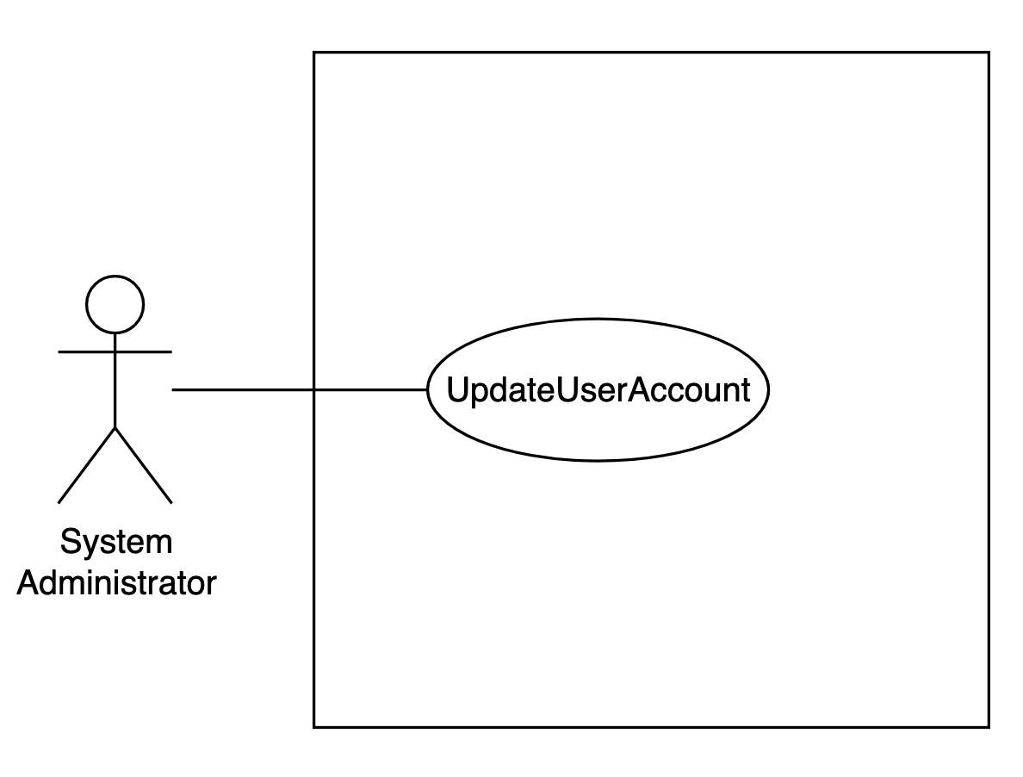

*#351 Use Case Description*

| **Name:** SA - edit user accounts | **ID:** #5 |
| --- | --- |
| **Stakeholders and goals:** System Admin - To edit any user account | |
| **Description:** System Admin clicks on “Edit” button and changes selected user’s details and clicks on “Update” button to save changes to system. | |
| **Actors:** System Admin | |
| **Trigger:** When System Admin clicks edit button | |
| **Pre-condition:**  System Admin is logged in  System Admin is currently viewing a user’s details | |
| **Normal flow:**  1. System Admin clicks on “Edit” button  2. System redirects system admin to account update page  3. System display submission form of user current details  4. System Admin input new details 5. System Admin clicks “Update” button  6. System updates the account  7. System shows message “User details updated successfully" and redirects System Admin back to the main page.  8. End | |
| **Sub-flows:** | |
| **Alternative/Exceptional flows:** 6.a. If Blank input: System displays popup message in popup "Field cannot be empty" 6.b. If SQL Error: System displays message "Failed to update user details" | |

*#352 BCE Diagram*

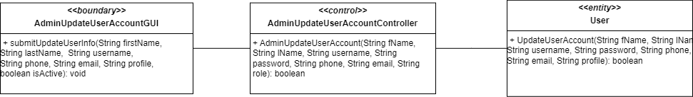

*#353 Sequence Diagram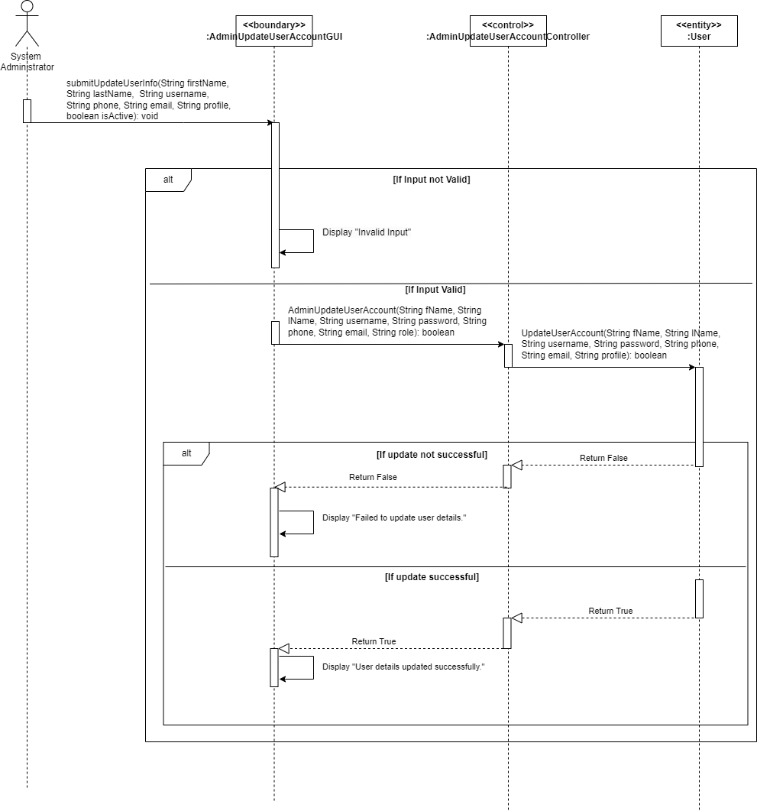*

*#354 Test Case*

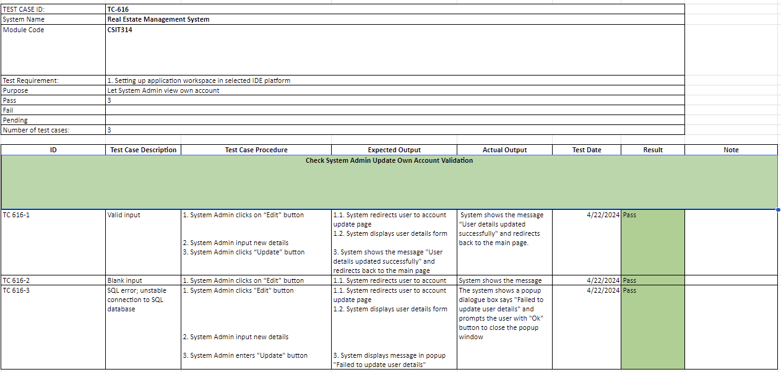

*#355 Wireframe*

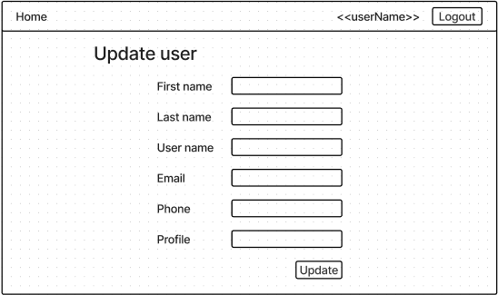

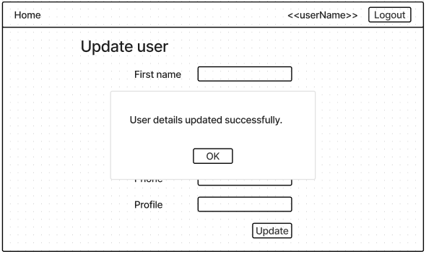

## #6 System Admin - Suspend User Account

*#293 User Story*

As a System admin, I want to Suspend user accounts (sys admin/seller/buyer/agent) so that I can remove suspicious and unused accounts and ensure the reliability and trustworthiness of the system.

*#294 Use Case Diagram*

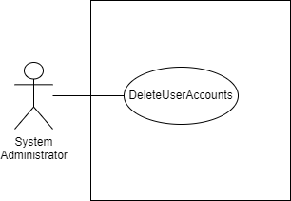

*#295 Use Case Description*

| **Name:** SA - suspend user accounts | **ID:** #6 |
| --- | --- |
| **Stakeholders and goals:** System Admin - To suspend a user account | |
| **Description:** System Admin clicks on the “Suspend” button to suspend the user account from the system. | |
| **Actors:** System Admin | |
| **Trigger:** When System Admin clicks suspend button when viewing a user account | |
| **Pre-condition:**  System Admin is logged in  System Admin is currently viewing a user’s details | |
| **Main flow:** 1. System Admin clicks “Suspend” button  2. System shows a confirmation window that displays “Are you sure you want to suspend <<username>>?”  3. System Admin clicks “Yes”  4. System suspends the account and says “User suspended successfully”  5. End | |
| **Sub-flows:** None. | |
| **Alternative/Exceptional flows:**  4.a. If user already suspended: System displays message "Suspension failed; User already suspended." | |

*#296 BCE Diagram*

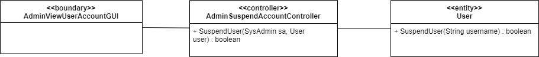

*#297 Sequence Diagram*

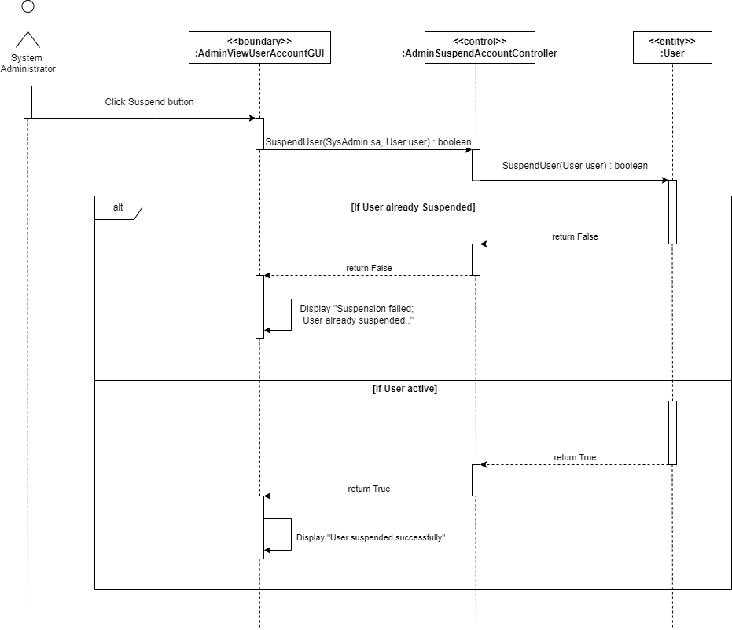

*#298 Test Case*

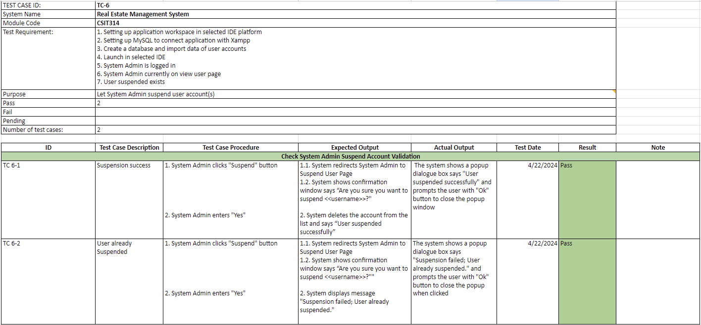

*#299 Wireframe*

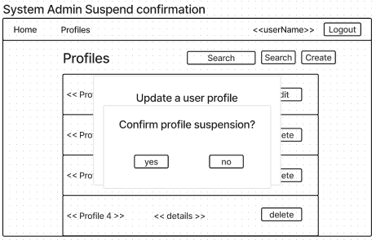

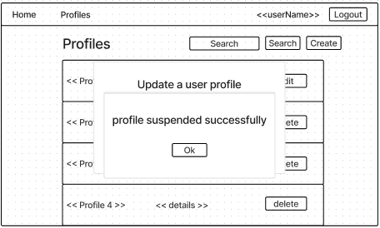

## #12 Seller - Login

*#229 User Story*

As a Seller, I want to Login, so that I can access my account and manage my property listings efficiently.

*#230 Use Case Diagram  
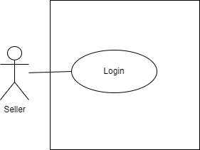*

*#231 Use Case Description*

| **Name:** Seller - login | **ID:** #12 |
| --- | --- |
| **Stakeholders and goals:** Seller - To login to the system | |
| **Description:** Seller inputs their credentials and clicks on the “Login” button to log in to the system. | |
| **Actors:** Seller | |
| **Trigger:** When Seller enters login details and clicks on the login button. | |
| **Pre-condition:** Seller has a valid user account | |
| **Main flow:**   1. Seller launches the system 2. System prompts Seller for their username and password 3. Seller input their details 4. Seller clicks “Login” button 5. Seller is redirected to the home page 6. End. | |
| **Sub- flow:** None. | |
| **Alternative/Exceptional flow:**  4a. Invalid login: System display message “Invalid login. Please try again”  4b. User re-enters credentials and clicks on the “Login” button again. | |

*#232 BCE Diagram*

**

*#233 Sequence Diagram*

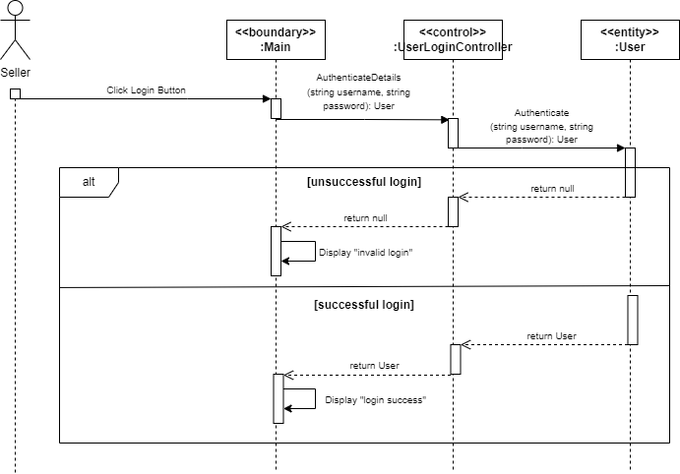

*#234 Test Case*

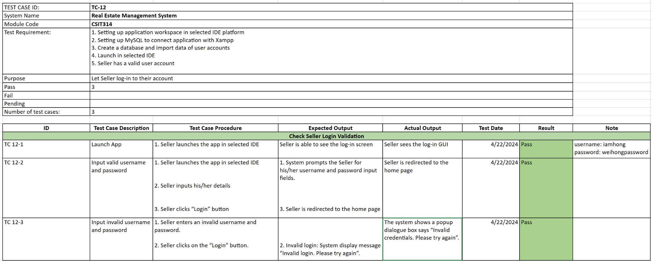

*#235 Wireframe*

**

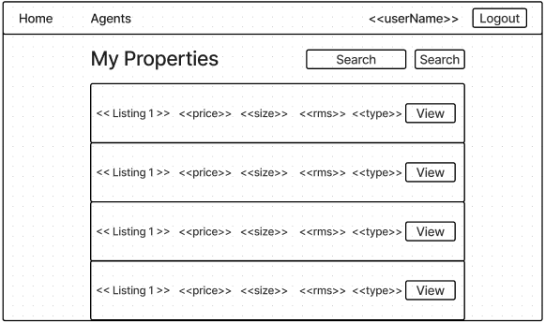

## #13 Seller - Logout

*#261 User Story*

As a Seller, I want to Logout, so that I can securely exit my account and protect my personal information.

*#262 Use Case Diagram  
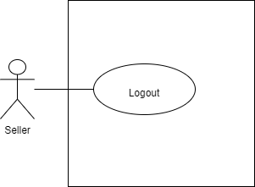*

*#263 Use Case Description*

| **Name:** Seller - logout | **ID:** #13 |
| --- | --- |
| **Stakeholders and goals:** Seller - To logout from the system | |
| **Description:** Seller clicks on the “Logout” button and logs out from the system. | |
| **Actors:** Seller | |
| **Trigger:** When Seller clicks on the logout button. | |
| **Pre-condition:**  Seller is logged in | |
| **Main flow:**   1. Seller clicks on the “Logout” button. 2. System logs the Seller out. 3. Seller is directed to the login page. 4. End. | |
| **Sub-flow:** None. | |
| **Alternative/Exceptional flow:** | |

*#264 BCE Diagram*

**

*#265 Sequence Diagram*

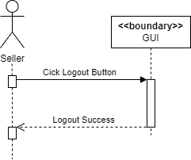

*#266 Test Case  
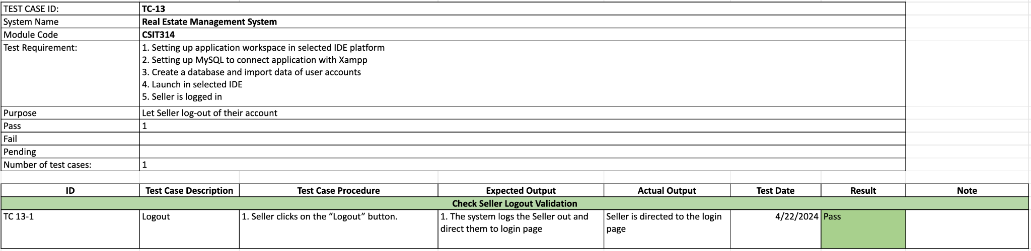*

*#267 Wireframe*

**

## #14 Seller - Create User Account

*#325 User Story*

As a Seller, I want to Create a user account, so that I can register and start listing my properties on the platform.

*#326 Use Case Diagram*

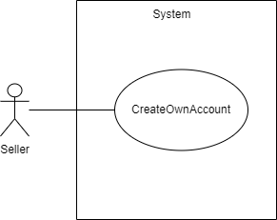

*#327 Use Case Description*

| **Name:** Seller - Create a user account | **ID:** #14 |
| --- | --- |
| **Stakeholders and goals:** Seller - To create my user account | |
| **Description:** Seller clicks on “Create an account”, inputs their details and clicks on the “Create” button to create an account. | |
| **Actors:** Seller | |
| **Trigger:** When Seller clicks create an account | |
| **Pre-condition:**  None | |
| **Main flow:**  1. Seller clicks on “Create an account”  2. System redirects user to account creation page  3. Seller enters user data information/credentials  4. Seller clicks “Create” button  5. System creates an account and displays message "Account created, you may now login."  6. System redirects user to login page  7. End | |
| **Sub-flows:** None. | |
| **Alternative/Exceptional flows:** 5.1a. Blank input: System displays message "Invalid input"  5.1b. Seller clicks on the “Ok” button and repeats steps 3 and 4.  5.2a. SQL Error: System displays message "Invalid credentials. Please try again."  5.2b. Seller clicks on the “Ok” button and repeats steps 3 and 4. | |

*#328 BCE Diagram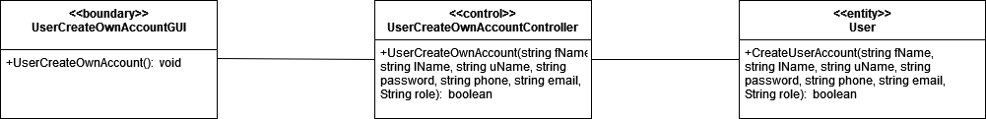*

*#329 Sequence Diagram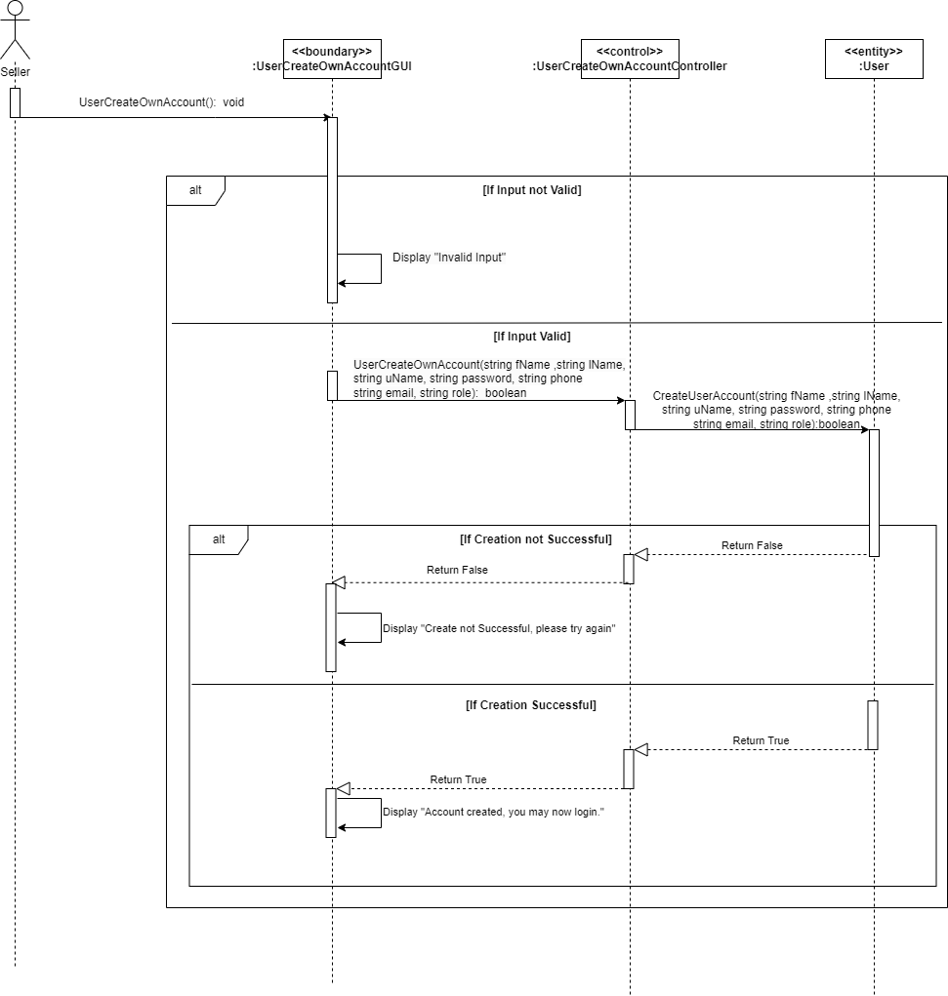*

*#330 Test Case  
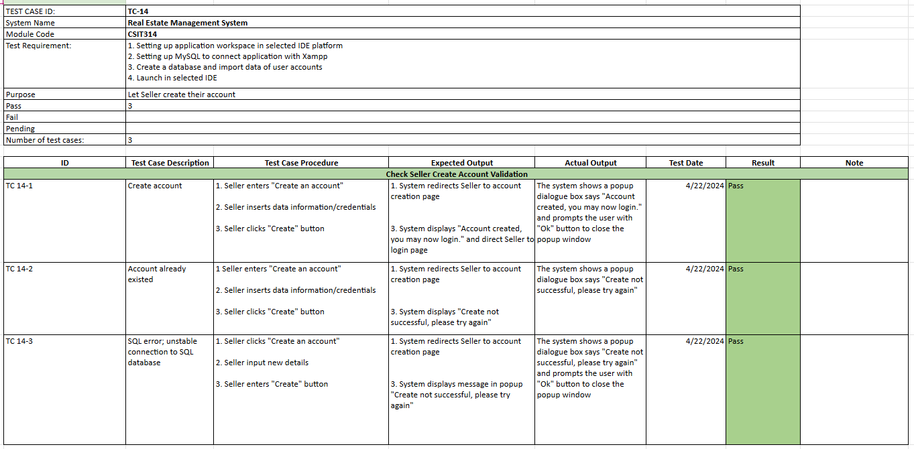*

*#331 Wireframe*

**

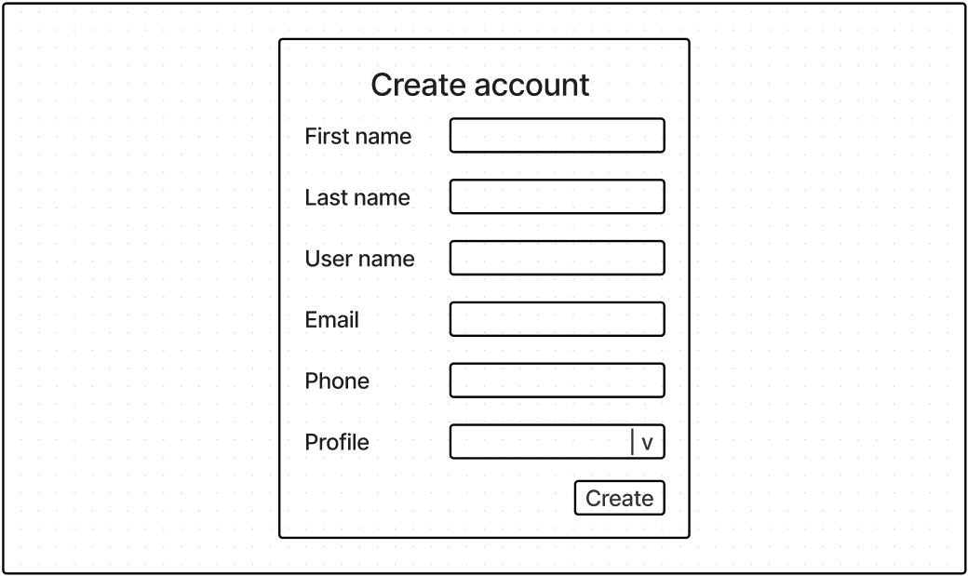

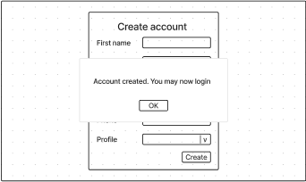

## 

## #19 Seller - View Own Account

*#419 User Story*

As a Seller, I want to View my user account details, so that I can review and ensure the accuracy of the information associated with my account.

*#420 Use Case Diagram  
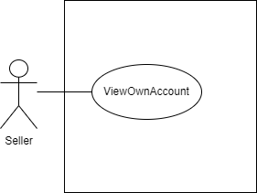*

*#421 Use Case Description*

| **Name:** Seller - view own account details | **ID:** #19 |
| --- | --- |
| **Stakeholders and goals:** Seller - To view own account | |
| **Description:** Seller clicks on their username and system redirects them to their account page where their details are shown and Seller is able to view their details. | |
| **Actors:** Seller | |
| **Trigger:** When Seller clicks their own username | |
| **Pre-condition:**  Seller is logged in | |
| **Main flow:**  1. Seller clicks on their username 2. System redirects user to their account page  3. System shows the user details 4. End | |
| **Sub-flows:** None. | |
| **Alternative/Exceptional flows:** | |

*#422 BCE Diagram*

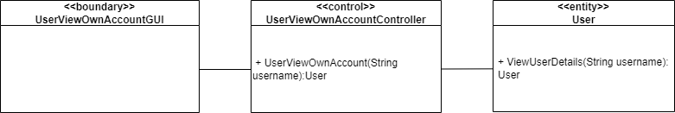

*#423 Sequence Diagram*

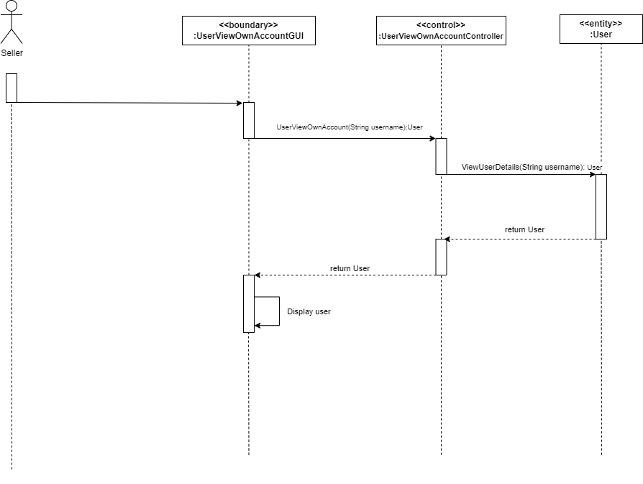

*#424 Test Case*

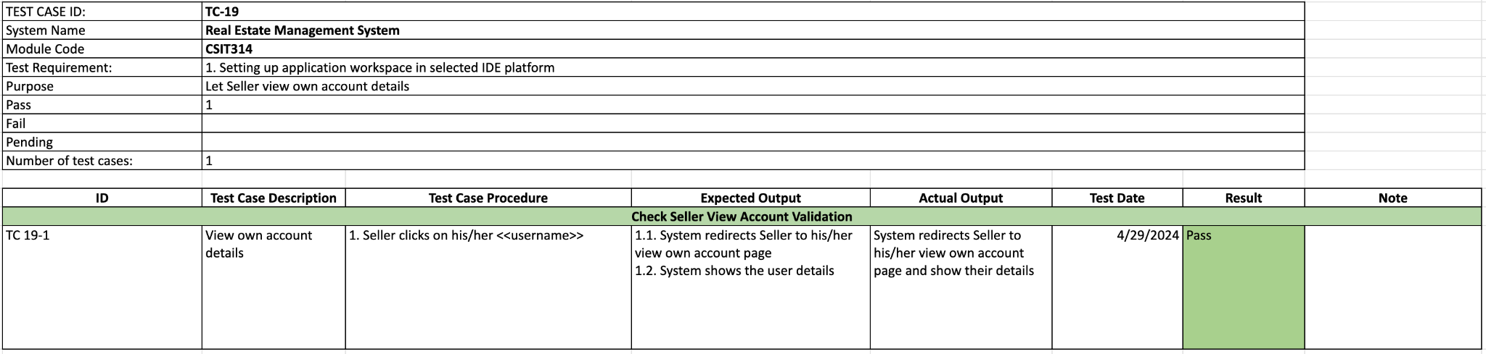

*#425 Wireframe*

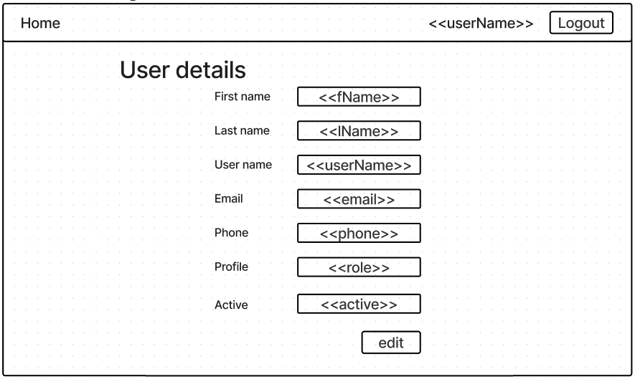

## 

## #16 Real Estate Agent - Login

*#237 User Story*

As a Real Estate Agent, I want to Login to the platform using my credentials, so that I can access my account and perform tasks related to property management and interaction with buyers.

*#238 Use Case Diagram*

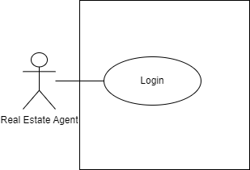

*#239 Use Case Description*

| **Name:** REA - login | **ID:** #16 |
| --- | --- |
| **Stakeholders and goals:** Real Estate Agent - To login to the system | |
| **Description:** Real Estate Agent inputs their credentials and clicks on the “Login” button to log in to the system. | |
| **Actors:** Real Estate Agent | |
| **Trigger:** When Real Estate Agent enters login details and clicks on the login button. | |
| **Pre-condition:** Real Estate Agent has a valid user account | |
| **Main flow:**   1. Real Estate Agent launches the system 2. System prompts Real Estate Agent for their username and password 3. Real Estate Agent input their details 4. Real Estate Agent clicks “Login” button 5. Real Estate Agent is redirected to the home page 6. End. | |
| **Sub- flow:** None. | |
| **Alternative/Exceptional flow:**  4a. Invalid login: System display message “Invalid login. Please try again”  4b. User re-enters credentials and clicks on “Login” button again. | |

*#240 BCE Diagram*

**

*#241 Sequence Diagram*

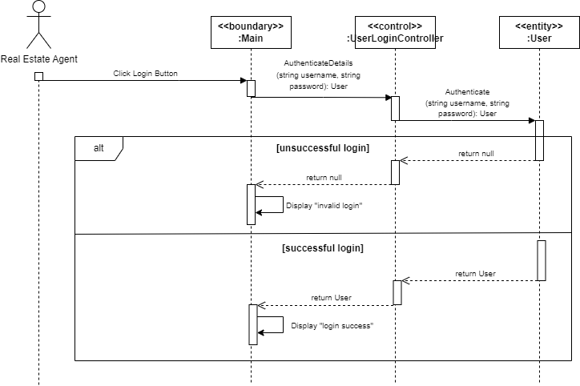

*#242 Test Case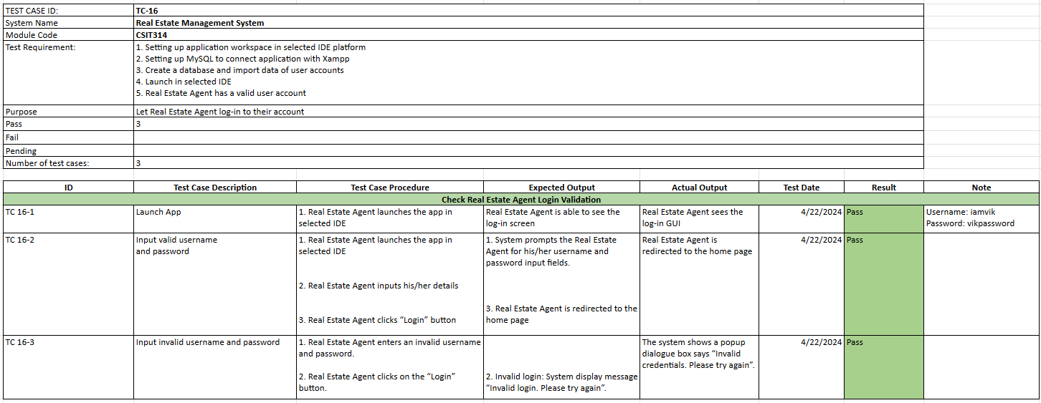*

*#243 Wireframe*

**

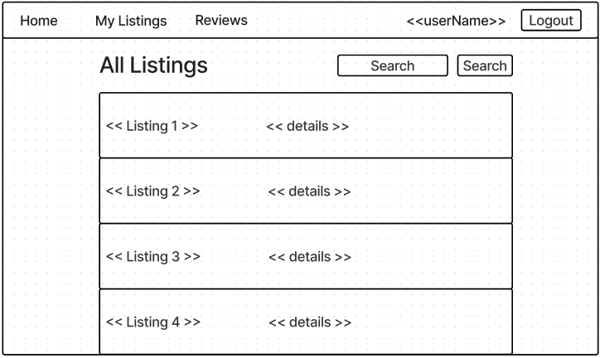

## #17 Real Estate Agent - Logout

*#269 User Story*

As a Real Estate Agent, I want to be able to Logout of my account securely, ensuring that my session is terminated and my account remains protected from unauthorized access.

*#270 Use Case Diagram*

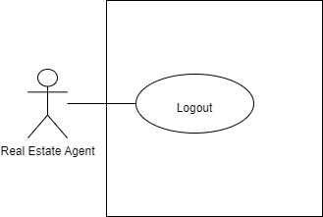

*#271 Use Case Description*

| **Name:** REA - logout | **ID:** #17 |
| --- | --- |
| **Stakeholders and goals:** Real Estate Agent - To logout from the system | |
| **Description:** Real Estate Agent clicks on the “Logout” button and logs out from the system. | |
| **Actors:** Real Estate Agent | |
| **Trigger:** When Real Estate Agent clicks on the logout button. | |
| **Pre-condition:**  Real Estate Agent is logged in | |
| **Main flow:**   1. Real Estate Agent clicks on the “Logout” button. 2. System logs the Real Estate Agent out. 3. Real Estate Agent is directed to the login page. 4. End. | |
| **Sub-flow:** None. | |
| **Alternative/Exceptional flow:** | |

*#272 BCE Diagram*

**

*#273 Sequence Diagram*

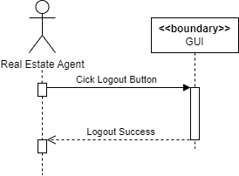

*#274 Test Case*

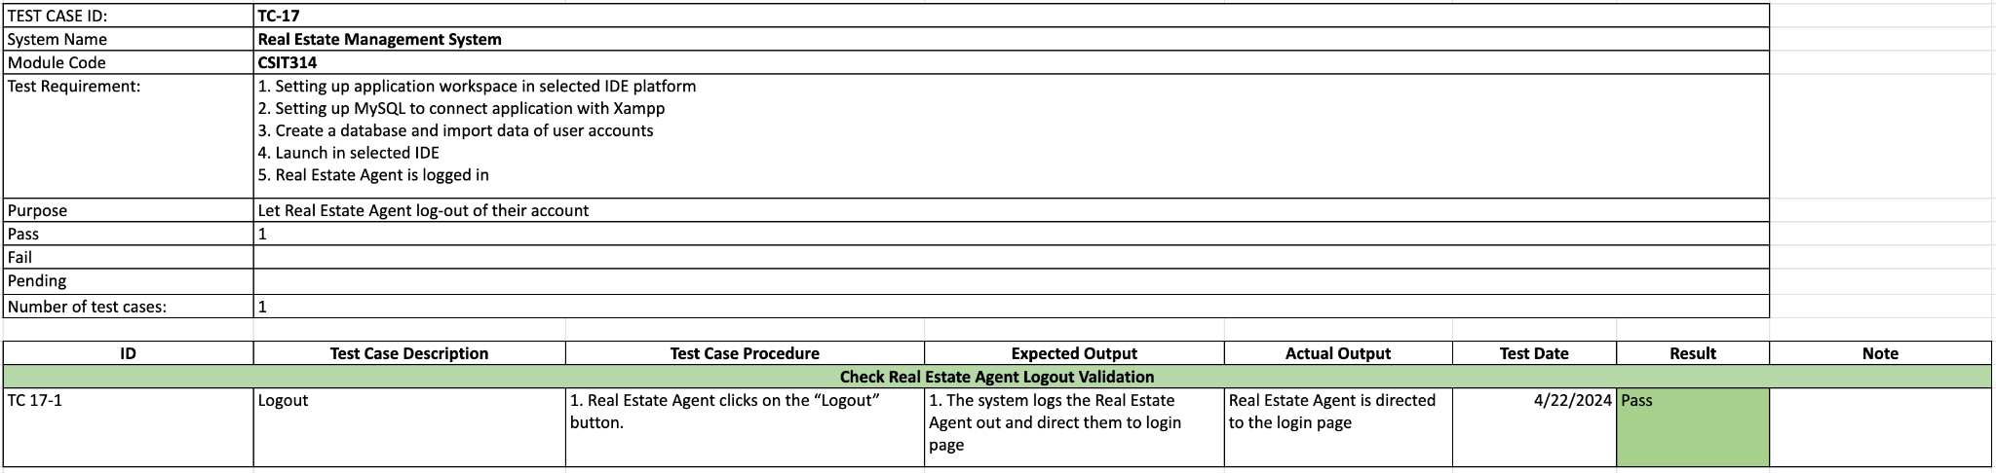

*#275 Wireframe*

**

**

## 

## 

## #18 Real Estate Agent - Create User Account

*#309 User Story*

As a Real Estate Agent, I want to be able to Create new accounts for myself, providing necessary details and information to grant myself access to the system and features.

*#310 Use Case Diagram  
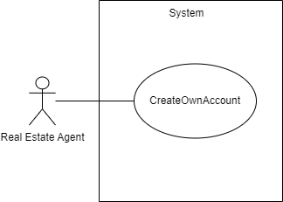*

*#311 Use Case Description*

| **Name:** REA - create account | **ID:** #18 |
| --- | --- |
| **Stakeholders and goals:** Real Estate Agent - To create my user account | |
| **Description:** Real Estate Agent clicks on “Create an account”, inputs their details and clicks on the “Create” button to create an account. | |
| **Actors:** Real Estate Agent | |
| **Trigger:** When Real Estate Agent clicks create an account | |
| **Pre-condition:**  None | |
| **Main flow:**  1. Real Estate Agent clicks on “Create an account”  2. System redirects user to account creation page  3. Real Estate Agent insert user data information/credentials  4. Real Estate Agent clicks “Create” button  5. System creates an account and displays message "Account created, you may now login."  6. System redirects user to login page  7. End | |
| **Sub-flows:** None. | |
| **Alternative/Exceptional flows:** 5.1a. Blank input: System displays message "Invalid input"  5.1b. Real Estate Agent clicks on “Ok” button and repeats steps 3 and 4.  5.2a. SQL Error: System displays message "Invalid credentials. Please try again."  5.2b. Real Estate Agent clicks on “Ok” button and repeats steps 3 and 4. | |

*#312 BCE Diagram*

**

*#313 Sequence Diagram*

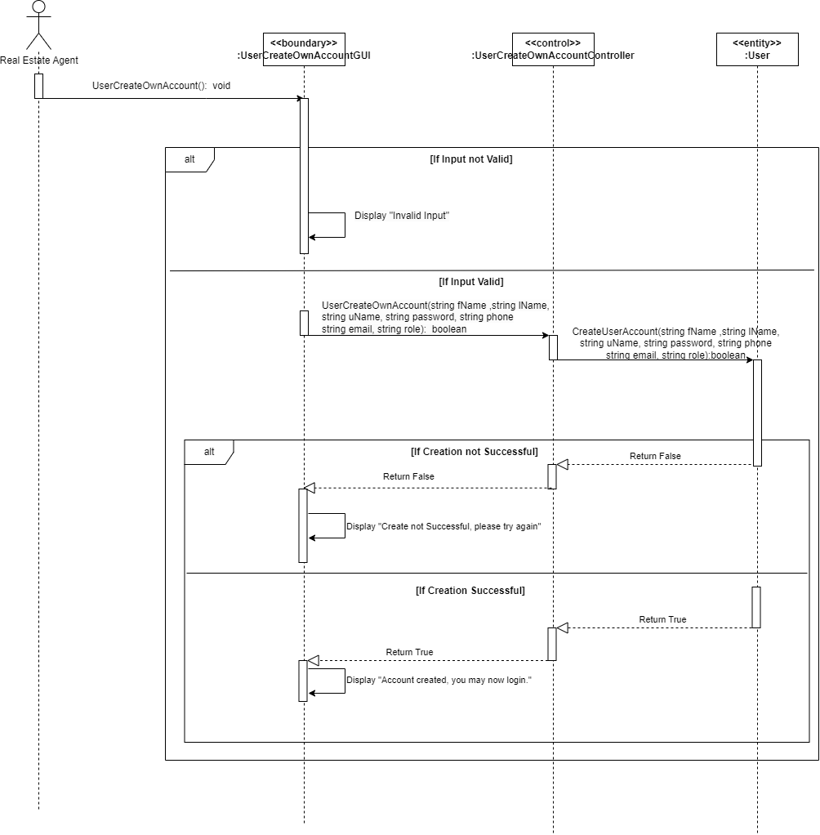

*#314 Test Case*

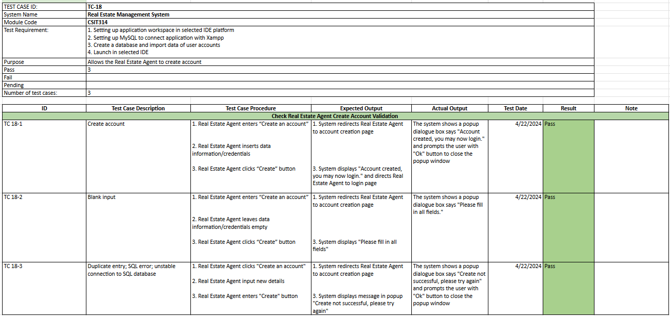

*#315 Wireframe*

**

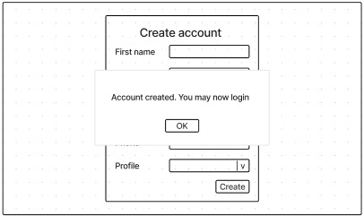

## #20 Real Estate Agent - View Own Account

*#405 User Story*

As a Real Estate Agent, I want to be able to View the details of my own user account, including my profile information and contact details, to ensure they are accurate and up-to-date.

*#406 Use Case Diagram*

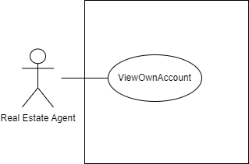

*#407 Use Case Description*

| **Name:** REA - view own account | **ID:** #20 |
| --- | --- |
| **Stakeholders and goals:** Real Estate Agent - To view own account | |
| **Description:** Real Estate Agent clicks on their username and system redirects them to their account page where their details are shown and Real Estate Agent is able to view their details. | |
| **Actors:** Real Estate Agent | |
| **Trigger:** When Real Estate Agent clicks on their username in GUI. | |
| **Pre-condition:**  Real Estate Agent is logged in | |
| **Main flow:**  1. Real Estate Agent clicks on their username. 2. System redirects user to their account page  3. System shows the user details 4. End | |
| **Sub-flows:** None. | |
| **Alternative/Exceptional flows:** | |

*#408 BCE Diagram*

**

*#410 Sequence Diagram*

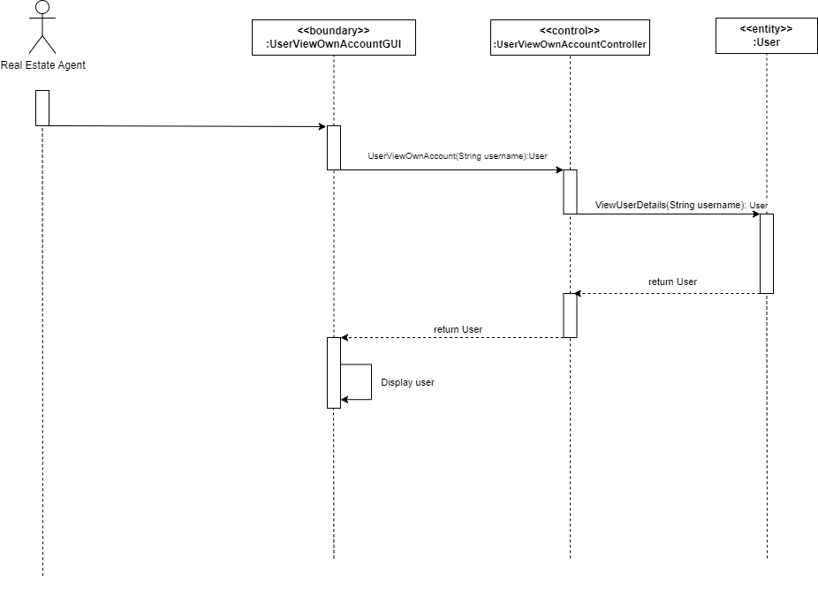

*#412 Test Case*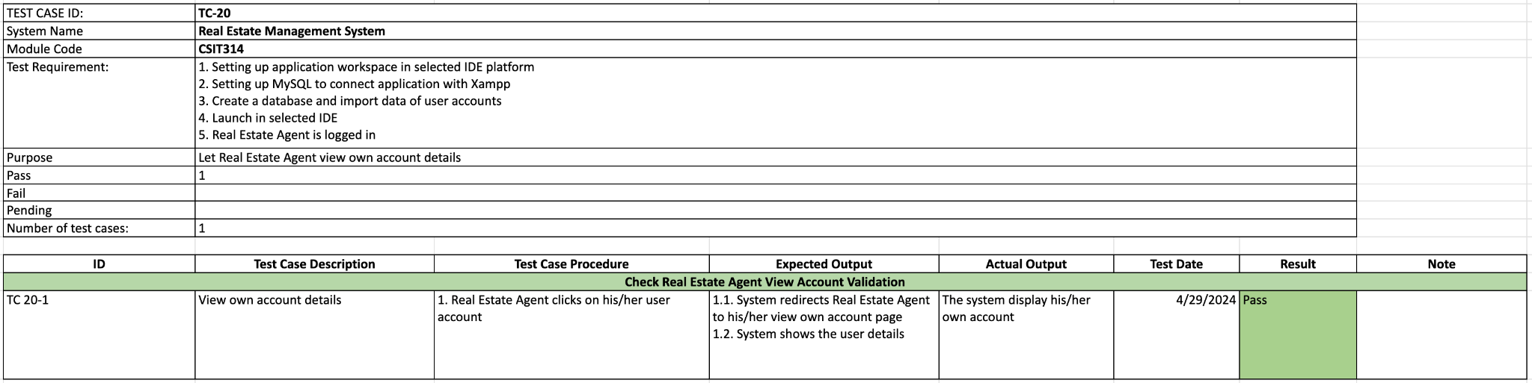

*#636 Wireframe*

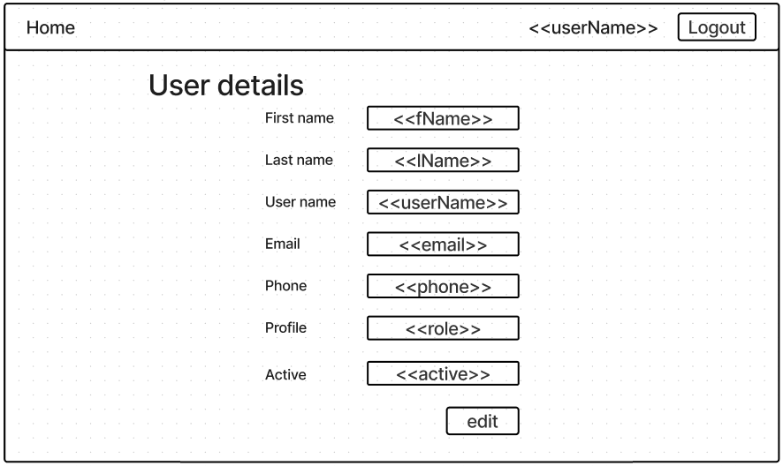

## #35 Buyer - Login

*#245 User Story*As a Buyer, I want to Login to the platform using my credentials, ensuring secure access to my account and its features.

*#246 Use Case Diagram*

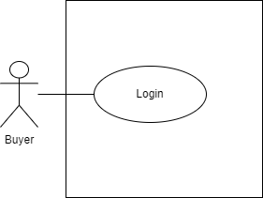

*#247 Use Case Description*

| **Name:** Buyer - login | **ID:** #35 |
| --- | --- |
| **Stakeholders and goals:** Buyer - To login to the system | |
| **Description:** Buyer inputs their credentials and clicks on the “Login” button to log in to the system. | |
| **Actors:** Buyer | |
| **Trigger:** When Buyer enters login details and clicks on the login button. | |
| **Pre-condition:** Buyer has a valid user account | |
| **Main flow:**   1. Buyer launches the system 2. System prompts Buyer for their username and password 3. Buyer input their details 4. Buyer clicks “Login” button 5. Buyer is redirected to the home page 6. End. | |
| **Sub- flow:** None. | |
| **Alternative/Exceptional flow:**  4a. Invalid login: System display message “Invalid login. Please try again”  4b. User re-enters credentials and clicks on “Login” button again. | |

*#248 BCE Diagram*

**

*#249 Sequence Diagram  
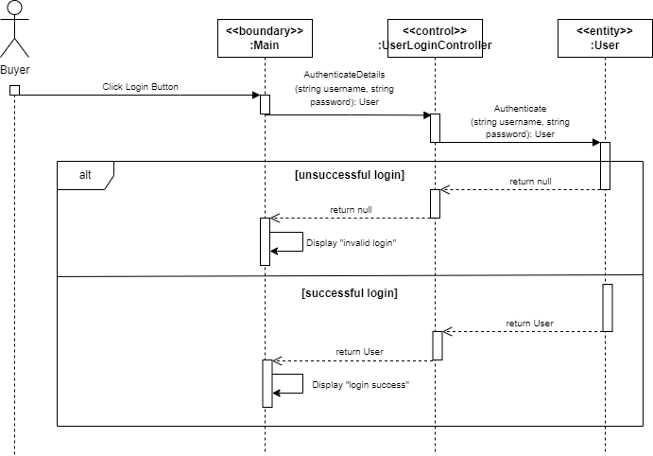*

*#250 Test Case  
  
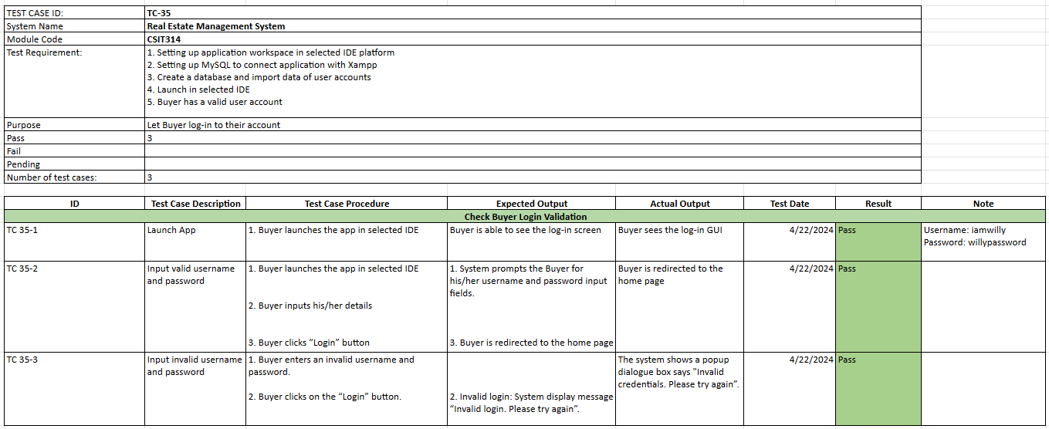*

*#251 Wireframe*

**

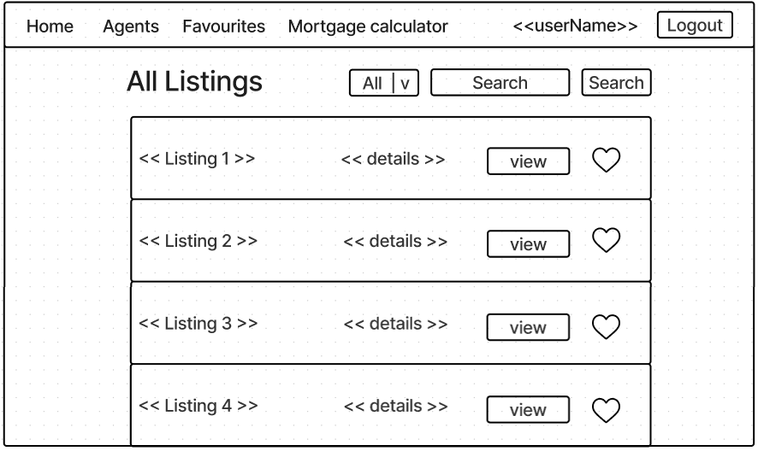

## 

## #36 Buyer - Logout

*#277 User Story*

As a Buyer, I want to be able to Logout of my account securely, terminating my session and protecting my account from unauthorized access.

*#278 Use Case Diagram*

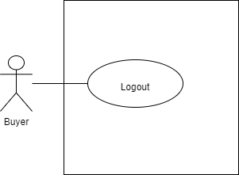

*#279 Use Case Description*

| **Name:** Buyer - logout | **ID:** #36 |
| --- | --- |
| **Stakeholders and goals:** Buyer clicks on the “Logout” button and logs out from the system. | |
| **Description:** As a Buyer, I want to be able to Logout of my account securely, terminating my session and protecting my account from unauthorized access. | |
| **Actors:** Buyer | |
| **Trigger:** When Buyer clicks on the logout button. | |
| **Pre-condition:**  Buyer is logged in | |
| **Main flow:**   1. Buyer clicks on the “Logout” button. 2. System logs the Buyer out. 3. Buyer is directed to the login page. 4. End. | |
| **Sub-flow:** None. | |
| **Alternative/Exceptional flow:** | |

*#280 BCE Diagram  
*

*#281 Sequence Diagram*

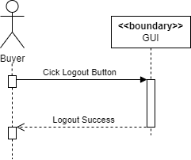

*#282 Test Case  
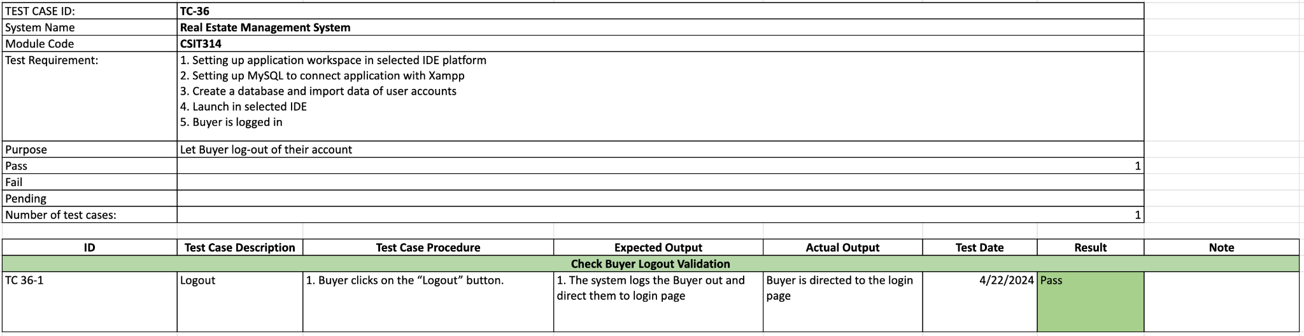*

*#283 Wireframe*

**

**

## 

## #37 Buyer - Create User Account

*#317 User Story*

As a buyer, I want to Create an account on the platform, providing necessary details such as name, email, and password, to access its features and services.

*#318 Use Case Diagram  
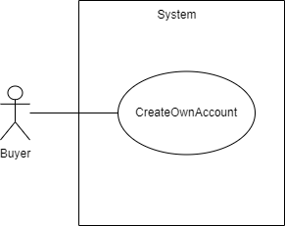*

*#319 Use Case Description*

| **Name:** Buyer - Create account | **ID:** #37 |
| --- | --- |
| **Stakeholders and goals:** Buyer - To create my user account | |
| **Description:** Buyer clicks on “Create an account”, inputs their details and clicks on the “Create” button to create an account. | |
| **Actors:** Buyer | |
| **Trigger:** When buyer clicks create an account | |
| **Pre-condition:**  None | |
| **Main flow:**  1. Buyer clicks on “Create an account”  2. System redirects user to account creation page  3. Buyer insert user data information/credentials  4. Buyer clicks “Create” button  5. System creates an account and displays message "Account created, you may now login."  6. System redirects user to login page  7. End | |
| **Sub-flows:** None. | |
| **Alternative/Exceptional flows:** 5.1a. Blank input: System displays message "Invalid input"  5.1b. Buyer clicks on “Ok” button and repeats steps 3 and 4.  5.2b. SQL Error: System displays message "Invalid credentials. Please try again."  5.2b. Buyer clicks on “Ok” button and repeats steps 3 and 4. | |

*#320 BCE Diagram*

**

*#321 Sequence Diagram*

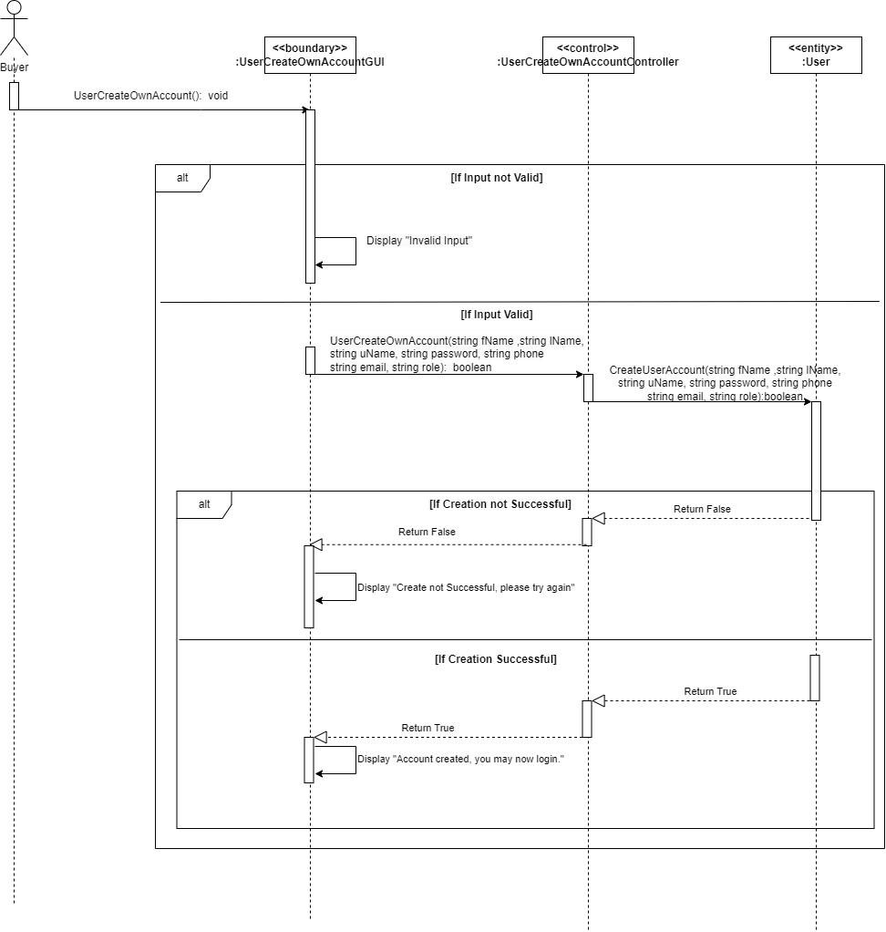

*#322 Test Case*

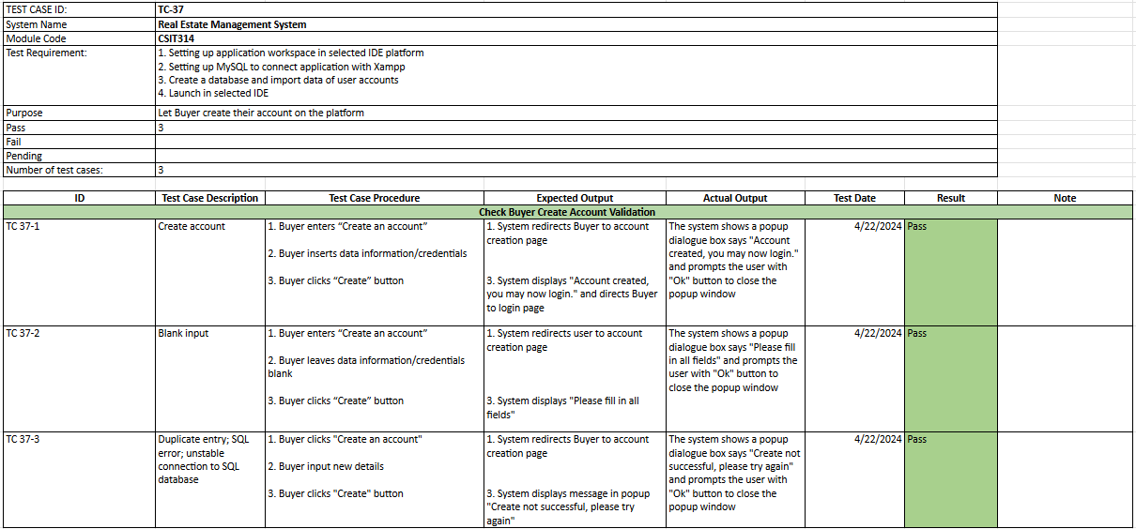

*#323 Wireframe*

**

**

## #38 Buyer - View Own Account

*#285 User Story*As a buyer, I want to be able to View my own account information, including profile details and settings, to ensure they are accurate and up-to-date.

*#286 Use Case Diagram  
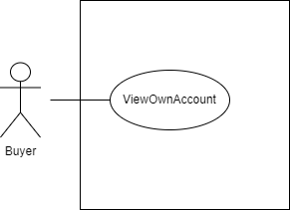*

*#287 Use Case Description*

| **Name:** Buyer - view own account details | **ID:** #38 |
| --- | --- |
| **Stakeholders and goals:** Buyer - To view own account | |
| **Description:** Buyer clicks on their username and system redirects them to their account page where their details are shown and Buyer is able to view their details. | |
| **Actors:** Buyer | |
| **Trigger:** When Buyer clicks on their username in GUI. | |
| **Pre-condition:**  Buyer is logged in | |
| **Main flow:**  1. Buyer clicks on their username 2. System redirects user to their account page  3. System shows the user details 4. End | |
| **Sub-flows:** None. | |
| **Alternative/Exceptional flows:** | |

*#288 BCE Diagram  
*

*#289 Sequence Diagram  
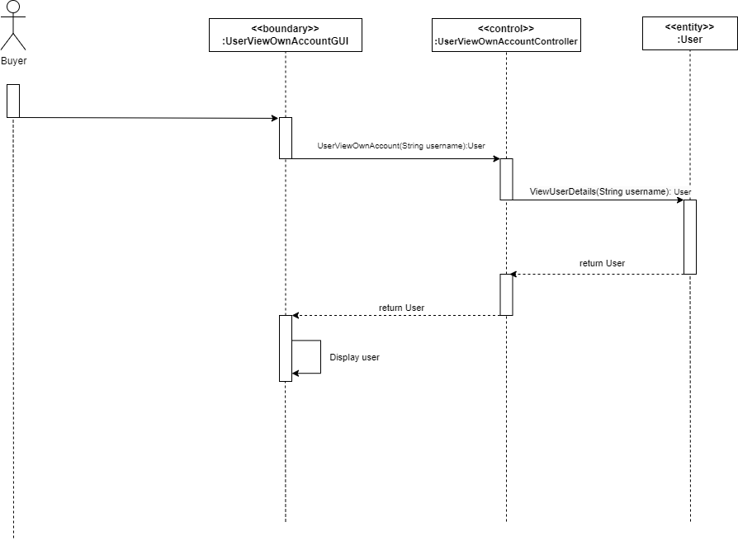*

*#290 Test Case*

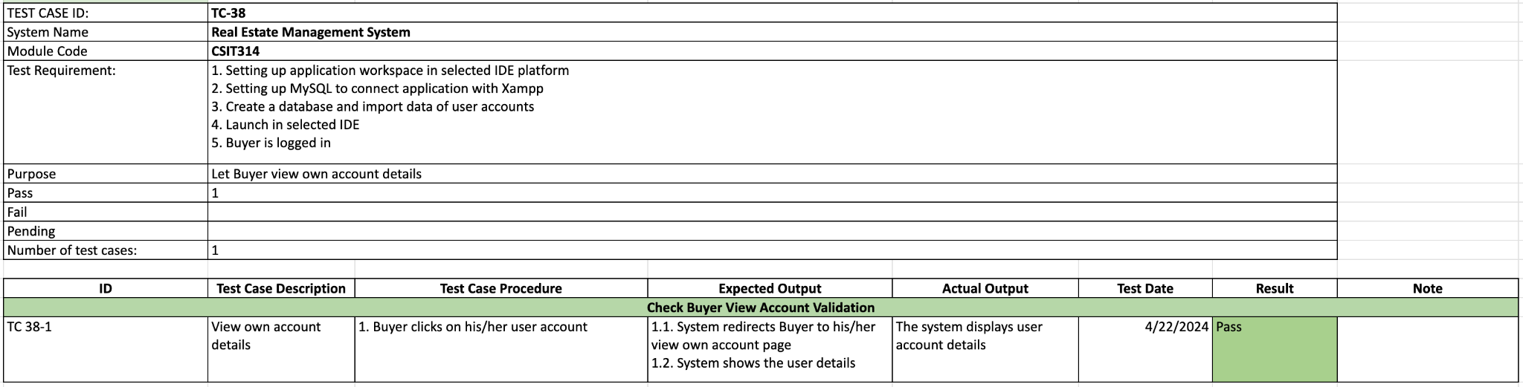

*#291 Wireframe*

**

## #616 System Admin - View Own Account

*#618 User Story*

As a System admin I want to Update my account information, such as contact details or ensuring my information remains current.

*#619 Use Case Diagram*

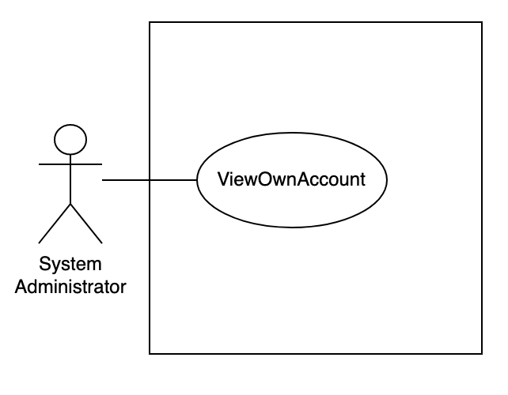

*#620 Use Case Description*

| **Name:** SA - view own account information | **ID:** #616 |
| --- | --- |
| **Stakeholders and goals:** System Admin - To view own account | |
| **Description:** System Admin clicks on their username and system redirects them to their account page where their details are shown and System Admin is able to view their details. | |
| **Actors:** System Admin | |
| **Trigger:** When System Admin clicks on their username in GUI. | |
| **Pre-condition:**  System Admin is logged in | |
| **Main flow:** 1. System Admin clicks on their username. 2. System redirects user to their account page  3. System shows the user details 4. End | |
| **Sub-flows:** None. | |
| **Alternative/Exceptional flows:** | |

## 

*#621 BCE Diagram*

**

*#622 Sequence Diagram*

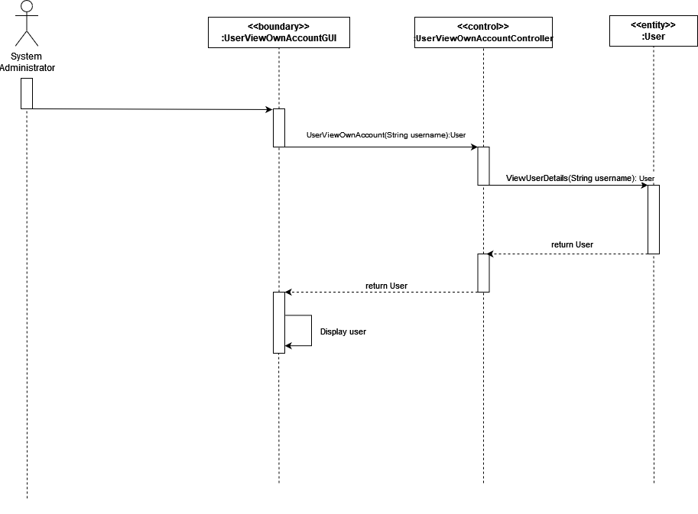

*#623 Test Case*

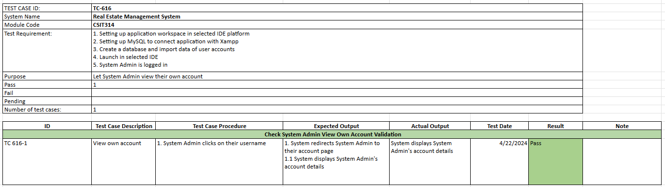

*#624 Wireframe*

**

# 

# Sprint Two

**Duration: 22th April - 29th April**

## Sprint Planning, Review and Retrospective

| **Meeting Date**:22/04/2024 (Monday) | | |
| --- | --- | --- |
| **Duration:** 12:00 - 13:30 | | |
| **Sprint duration:** 22/04/2024 - 29/04/2024 | | |
| **Attendees:**  Wootaek, Vuong, Wei Hong, Roydenn, Frentsen, Jerry | | **Agenda** |
| 1. Go through what has been done during sprint 1. 2. What we are going to do during sprint 2. |
| **Absentees:**  N/A | |
|
| **What we have done** | | **All members**   * Start writing the report for sprint 1. * Amend our diagrams based on our product owner’s feedback.   **Jerry & Frentsen**   * Screenshot Taiga   **Wootaek & Roydenn**   * Gantt chart * Code for selected user stories. * System Admin View User.   **Wei Hong**   * Code for selected user stories. * GUI for the shared main page   **Vuong**   * Code for selected user stories. * “User update” user story |
| **Reflection** | | **What went well:**   * The class diagram for the last sprint has been clarified and approved by the product owner.   **What could be improved:**   * Updating each other when our tasks are done so that team is updated on current progress |
| **What we are going to do for this sprint** | | **Roydenn**   * Coding & diagram * Update database to make users scalable * SA - Search user profiles * Buyer, Seller - Update account * Update Gantt Chart   **Wootaek**   * Update class diagram * Coding & diagram * SA - Create user accounts * SA - Create User profiles * SA - suspend User profiles * Amend Create account and User class   **Wei Hong**   * Create wireframe for this week’s user stories * Coding & diagram * GUI for REA, Seller, Buyer * SA - View user profiles   **Vuong**   * Coding & diagram * Fix Update function to return to main page * SA - Edit user profiles * SA, REA - Update account   **Jerry & Frentsen**   * Use case descriptions for all user stories in this sprint * Update existing diagrams * Update report * Draw BCE, Use case diagrams for all user stories in this sprint |

## Taiga - Start

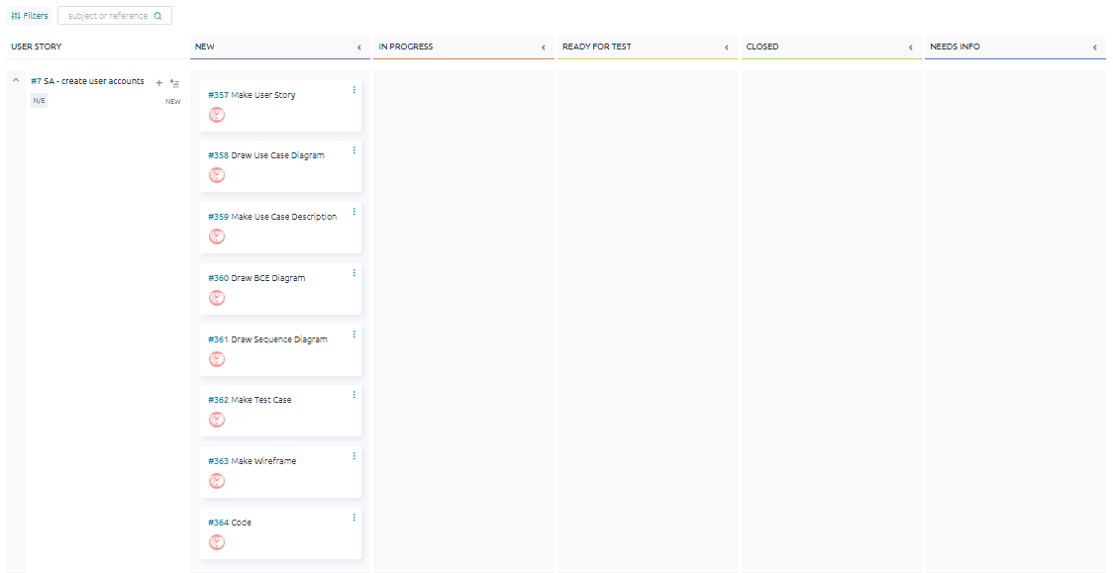

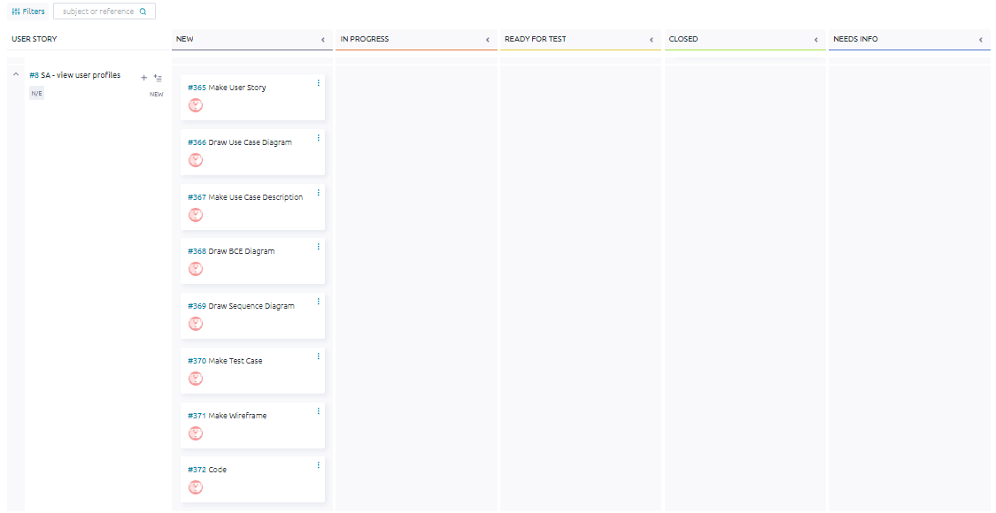

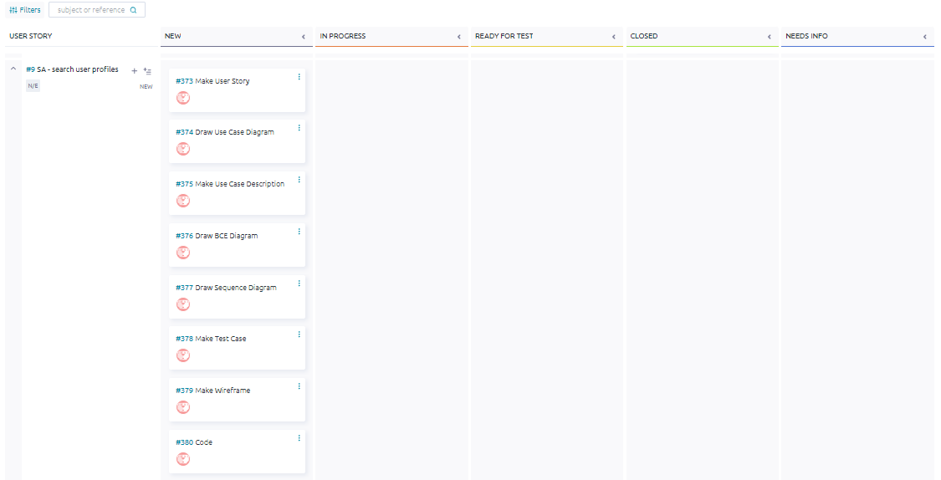

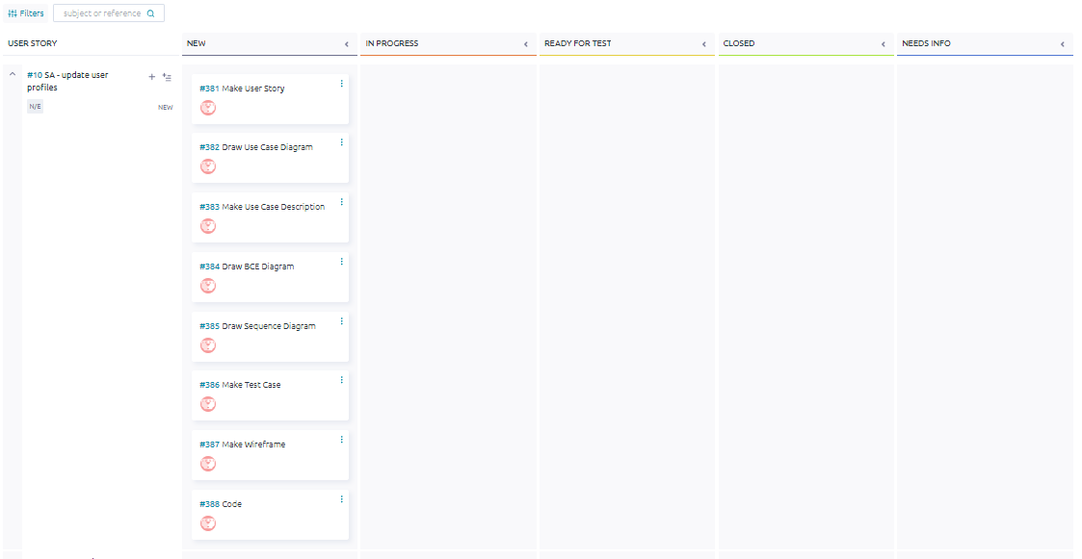

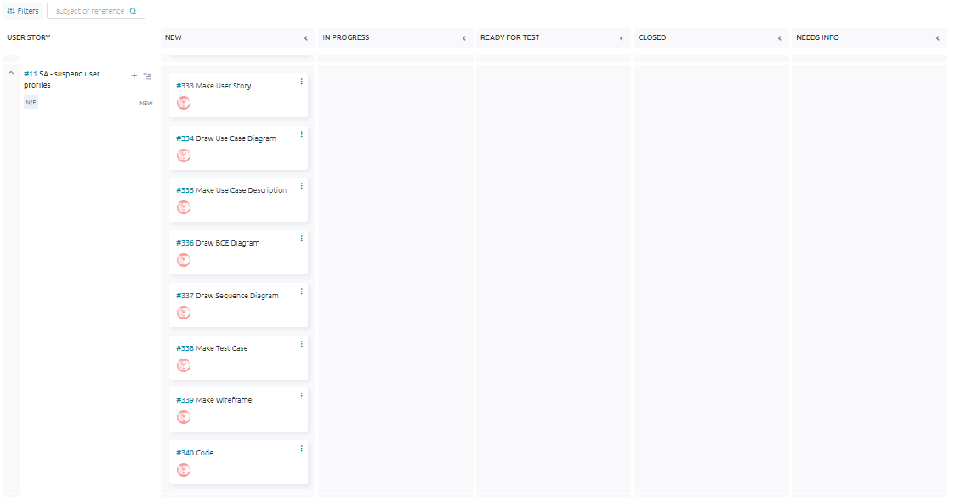

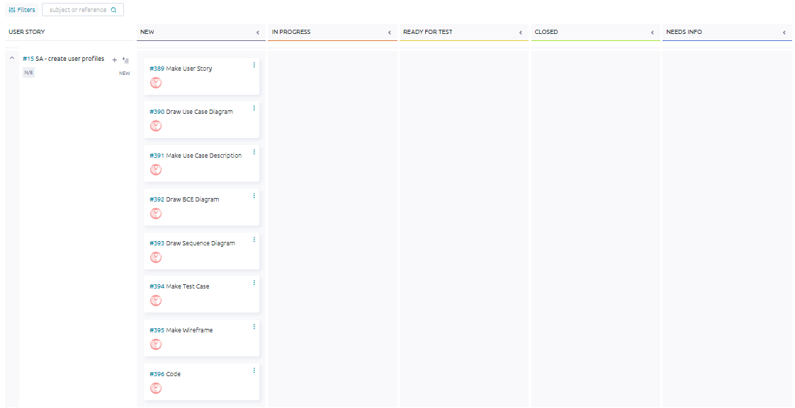

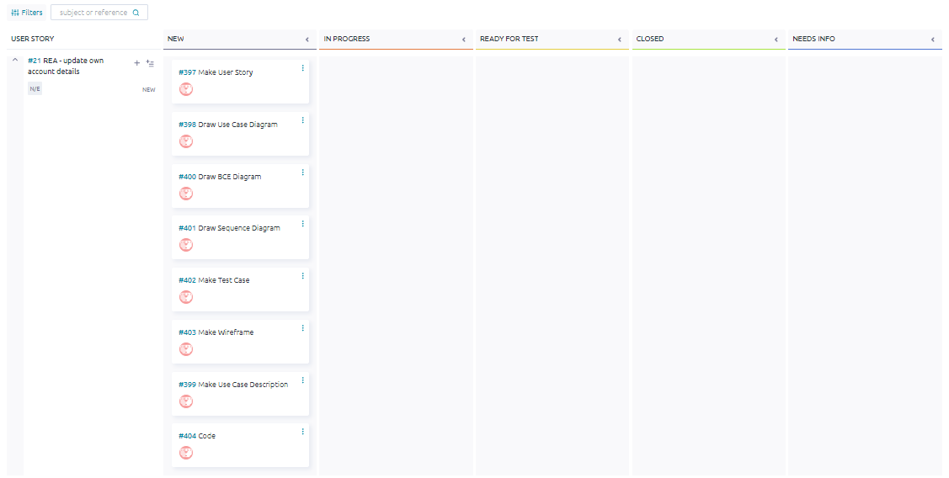

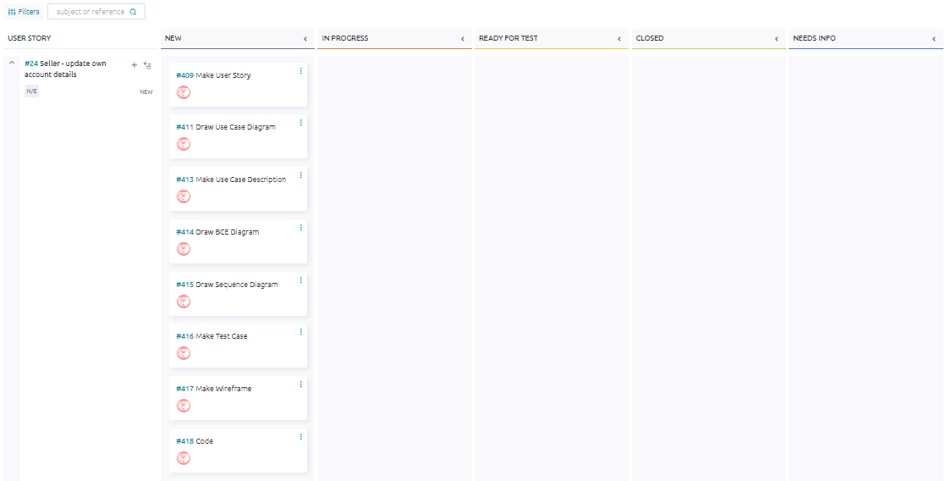

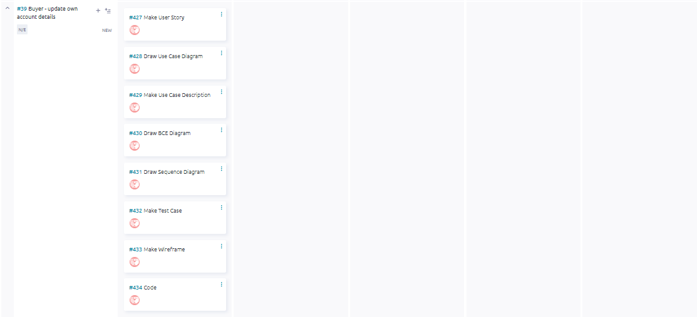

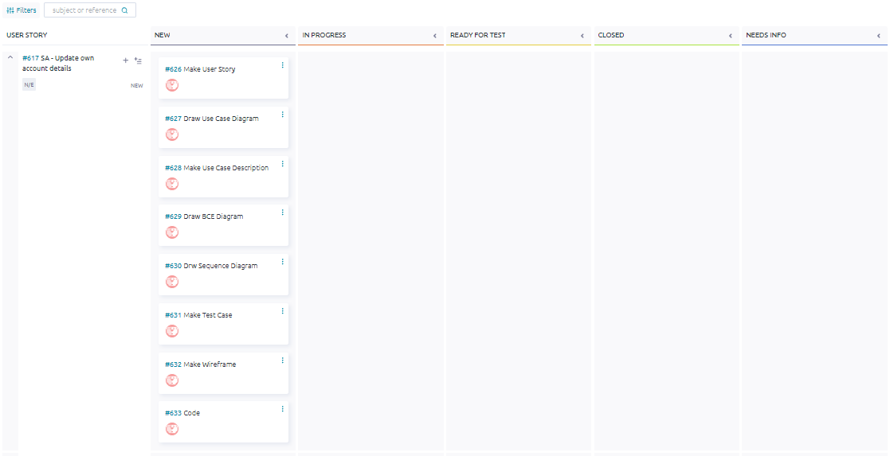

## Taiga - End

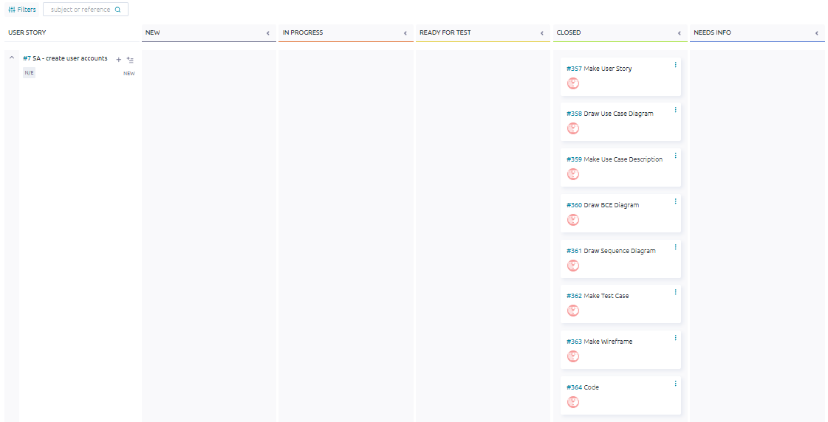

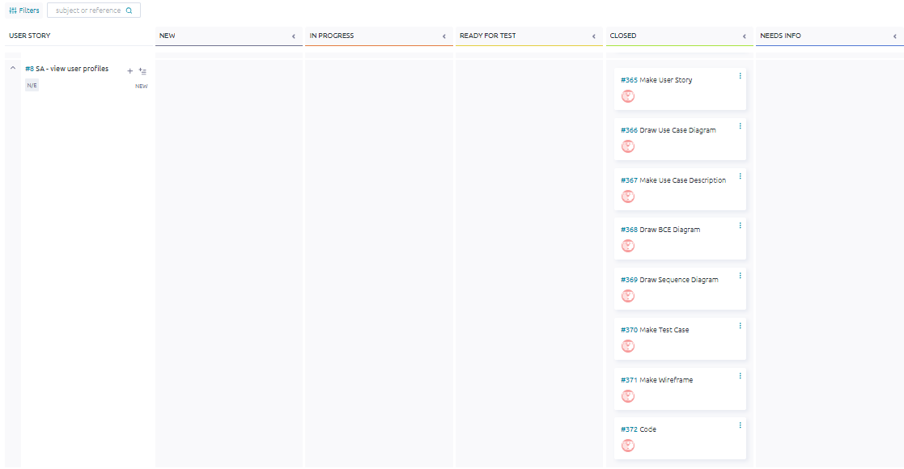

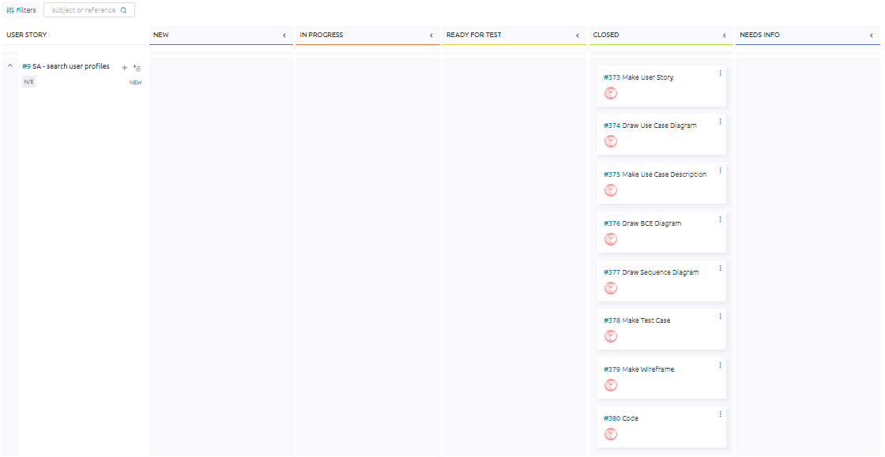

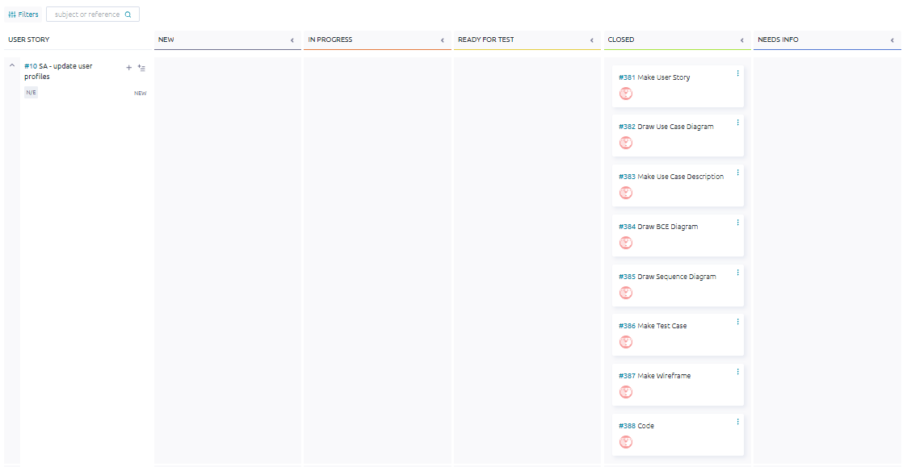

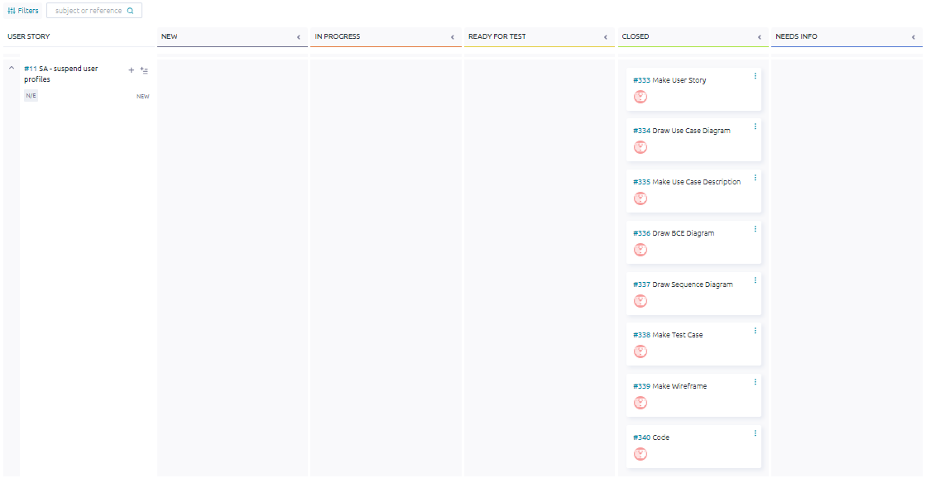

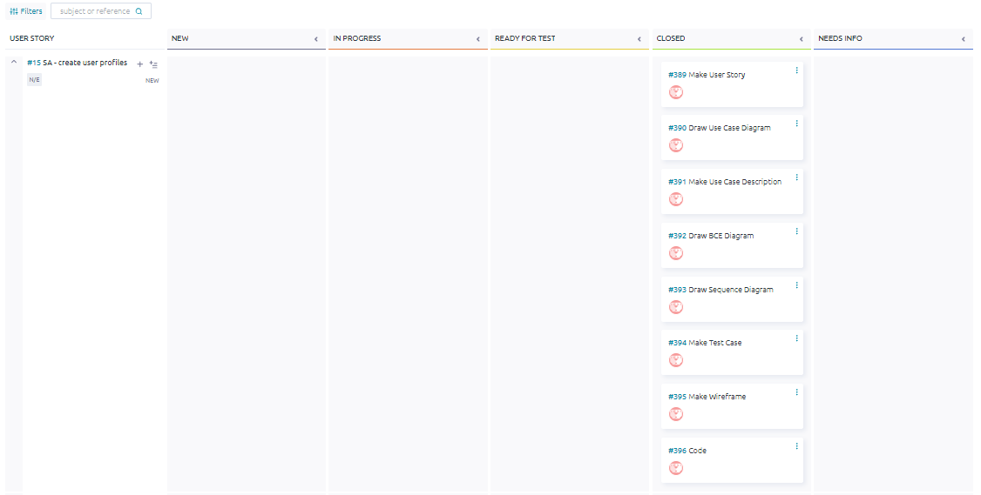

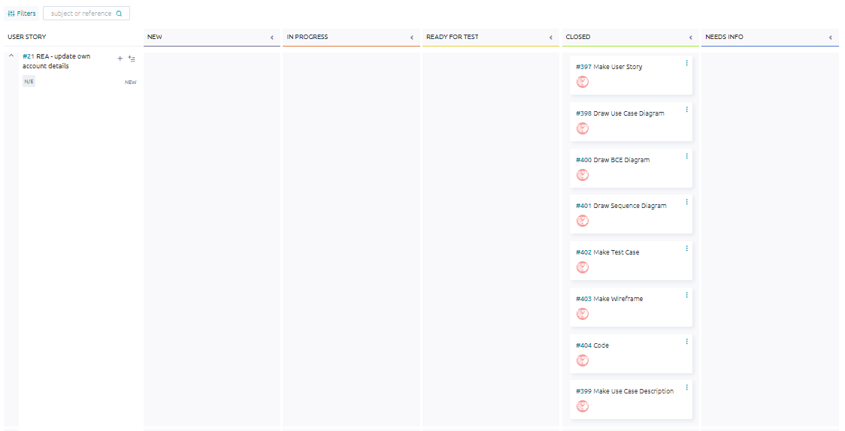

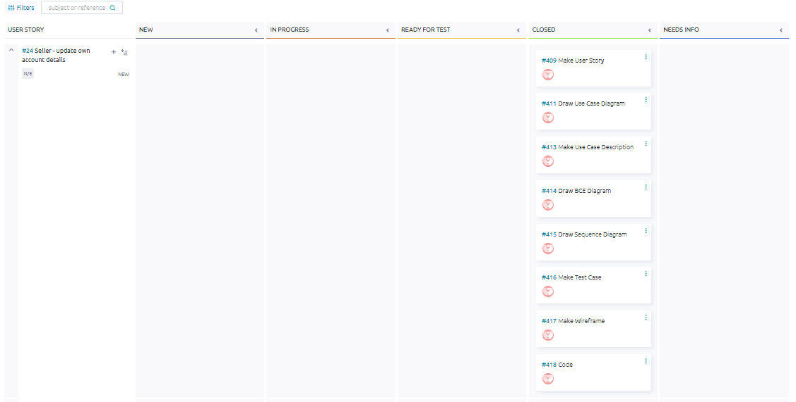

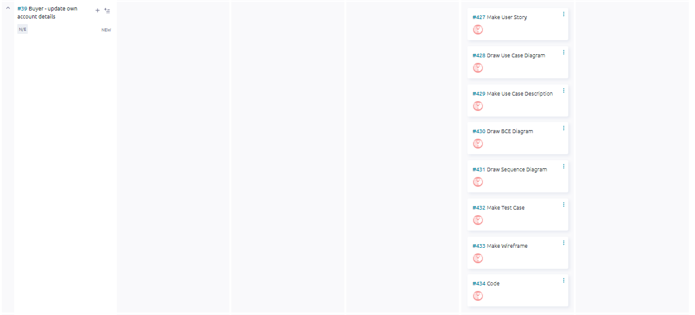

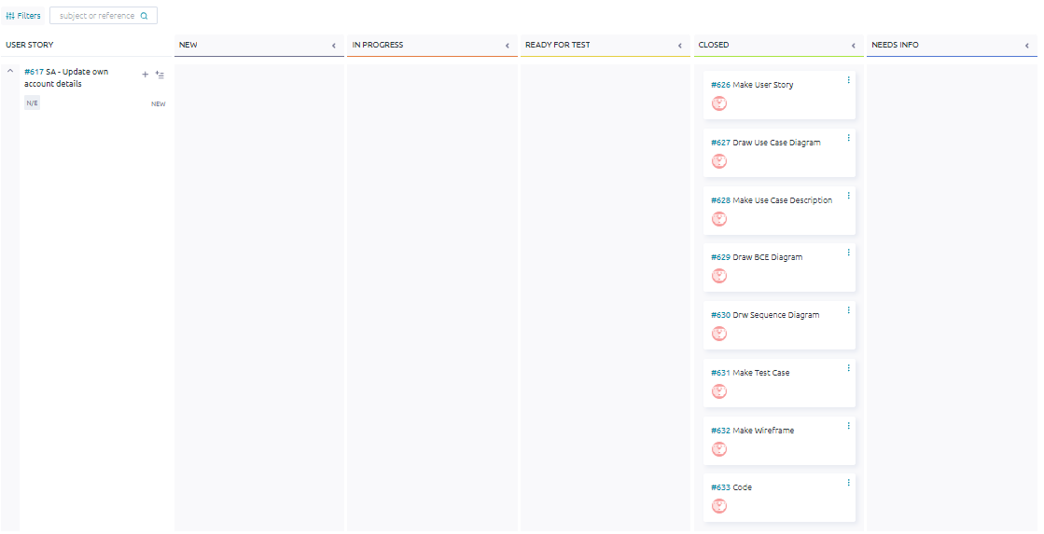

## ER Diagram

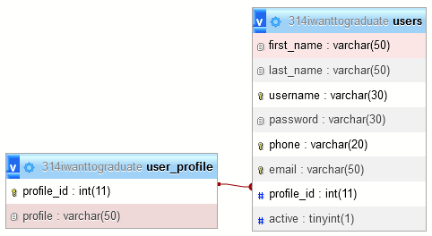

## Class Diagram

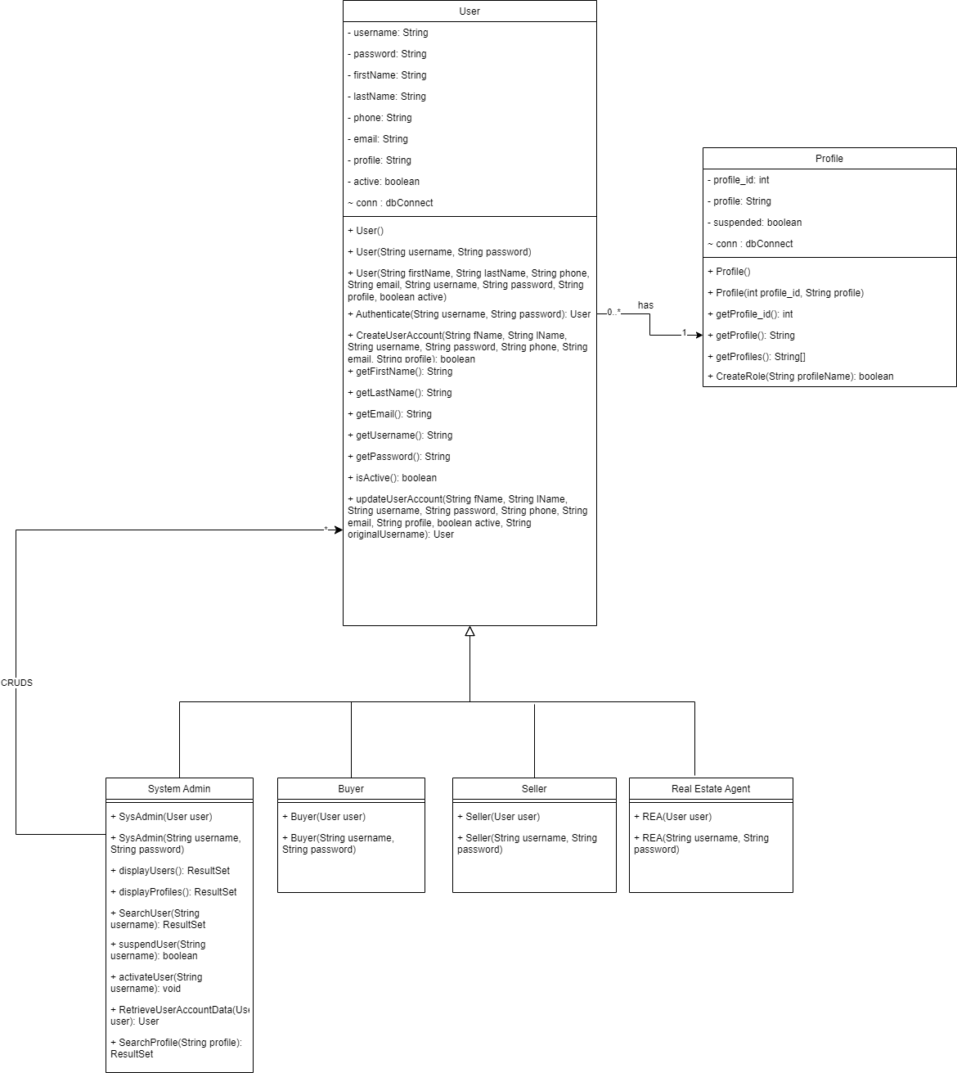

## 

## #7 System admin - Create user account

*#357 User Story*

As a System admin, I want to Create user accounts (sys-admin/seller/buyer/agent) so that I can add new users who would like to use the product to the system.

*#358 Use Case Diagram*

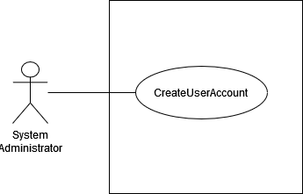

*#359 Use Case Description*

| **Name:** SA - create user account | **ID:** #7 |
| --- | --- |
| **Stakeholders and goals:** System Admin - To create a user account for other users | |
| **Description:** System Admin clicks on the “Create” button, inserts all required details, clicks on the “Create” button and the system creates a new entry in the database. | |
| **Actors:** System Admin | |
| **Trigger:** When System Admin clicks on “create” button | |
| **Pre-condition:**  System Admin is logged in  System Admin is currently on homepage | |
| **Main flow:**  1. System Admin clicks on the “Create” button.  2. System redirects the user to the account creation page.  3. System Admin inserts details for a new user account.  4. System Admin clicks the “Create” button.  5. System shows a popup message “Account created successfully”.  6. End. | |
| **Sub-flows:** None. | |
| **Alternative/Exceptional flows:**  5.1a. Blank input: System displays message “Invalid input”  5.1b. System Admin clicks on the “Ok” button and repeats steps 2, 3 and 4.  5.2a. SQL Error: System displays message “Creating account failed.”  5.2.b System Admin clicks on the “Ok” button and repeats steps 2, 3 and 4. | |

*#360 BCE Diagram*

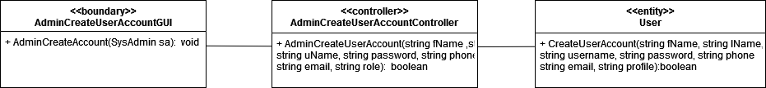

*#361 Sequence Diagram*

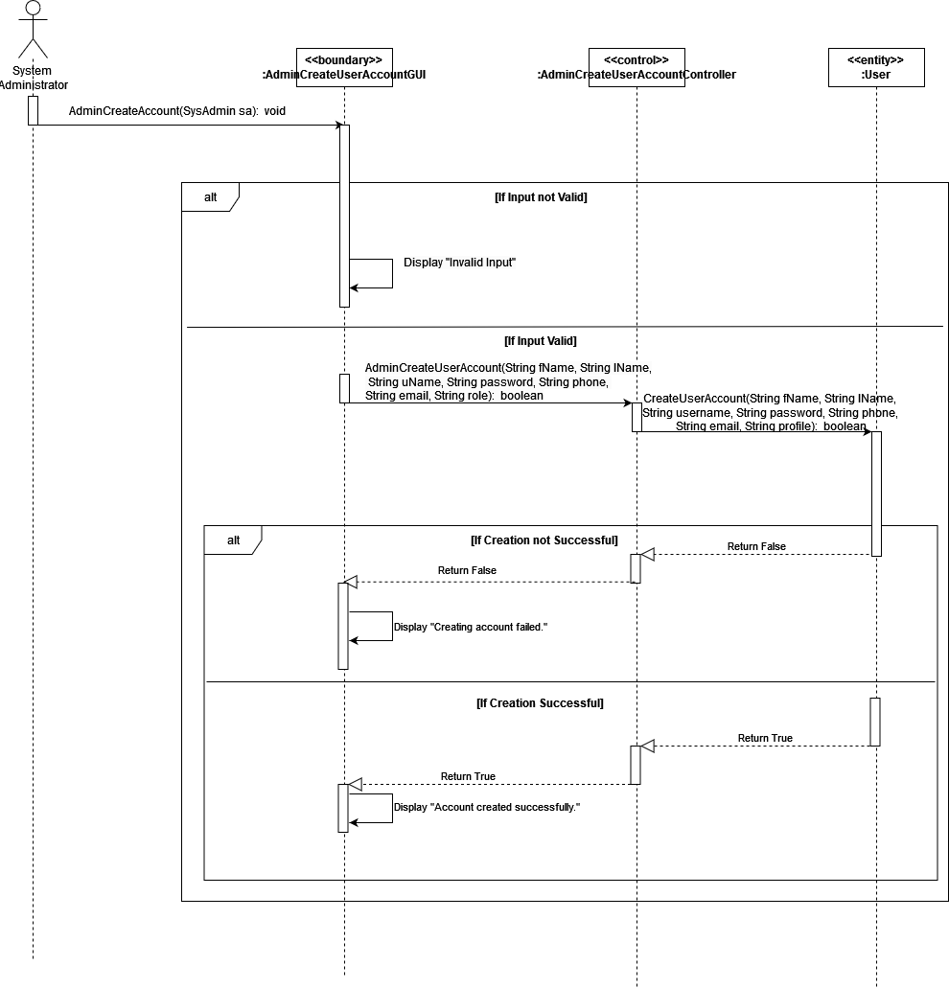

*#362 Test Case*

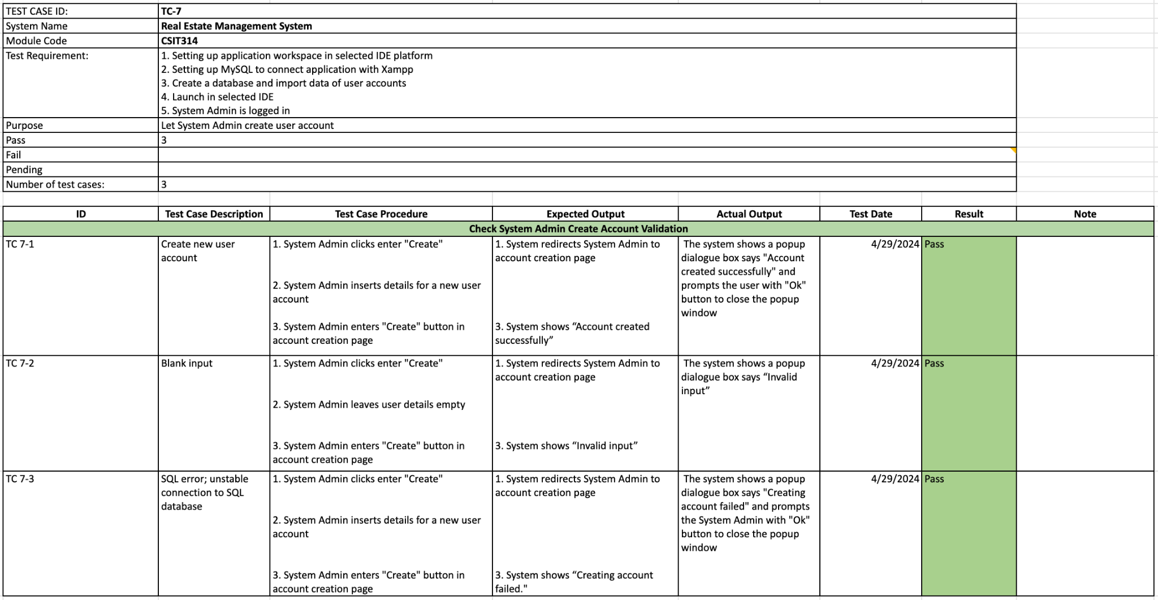

*#363 Wireframe*

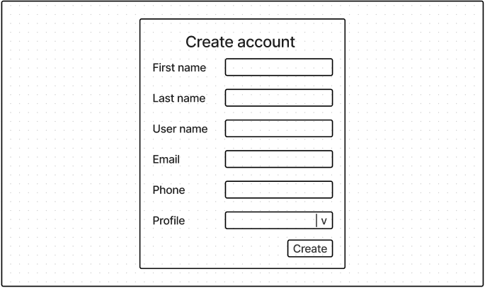

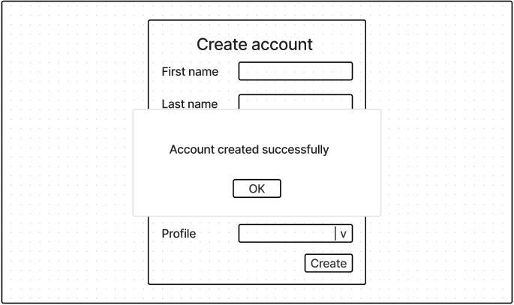

## 

## #8 System admin - View user profile

*#365 User Story*

As a System admin, I want to View user profiles, so that I can access and review the details of different user profiles in the system.

*#366 Use Case Diagram*

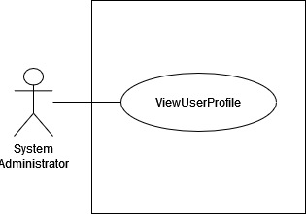

*#367 Use Case Description*

| **Name:** SA - view user profile | **ID:** #8 |
| --- | --- |
| **Stakeholders and goals:** System Admin - To be able to view a list of existing user profiles | |
| **Description:** System Admin clicks on “Profile” and system displays all existing user profiles details | |
| **Actors:** System Admin | |
| **Trigger:** When System Admin clicks on “Profile” label | |
| **Pre-condition:**  System Admin is logged in  System Admin is currently on home page | |
| **Main flow:** 1. System Admin clicks on “Profile” 2. System displays all the existing user profiles with details  3. End | |
| **Sub-flows:** None. | |
| **Alternative/Exceptional flows:** | |

*#368 BCE Diagram*

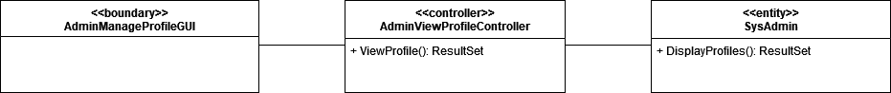

*#369 Sequence Diagram*

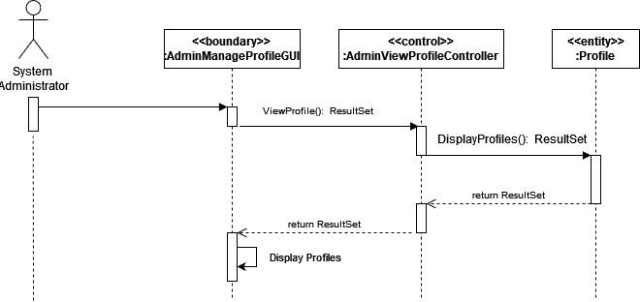

*#370 Test Case*

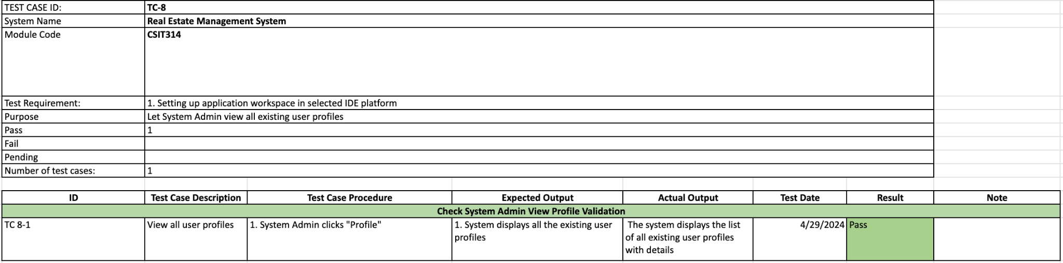

*#371 Wireframe*

## 

## #9 System admin - Search user profile

*#373 User Story*

As a System admin, I want to Search user profiles, so that I can efficiently locate specific user profiles.

*#374 Use Case Diagram*

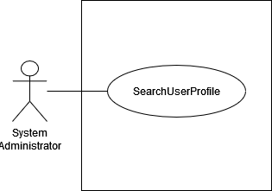

*#375 Use Case Description*

| **Name:** SA - search user profiles | **ID:** #9 |
| --- | --- |
| **Stakeholders and goals:** System Admin - To search any user profiles | |
| **Description:** System Admin inputs the user profile into the search bar and clicks on “Search” then system displays every similar matching user profile name | |
| **Actors:** System Admin | |
| **Trigger:** When System Admin clicks search button | |
| **Pre-condition:**  System Admin is logged in  System Admin is currently on user profile management page | |
| **Main flow:** 1. System Admin input the user profile name in the search bar. 2. System Admin clicks on “Search”.  3. System displays all similar existing user profile names that match the user input.  4. End. | |
| **Sub-flows:** None. | |
| **Alternative/Exceptional flows:**  3.a. No matching profiles found: System display empty scroll pane with no profiles  3.b. System Admin enters blank: All profiles displayed | |

*#376 BCE Diagram*

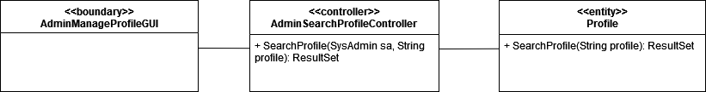

*#377 Sequence Diagram*

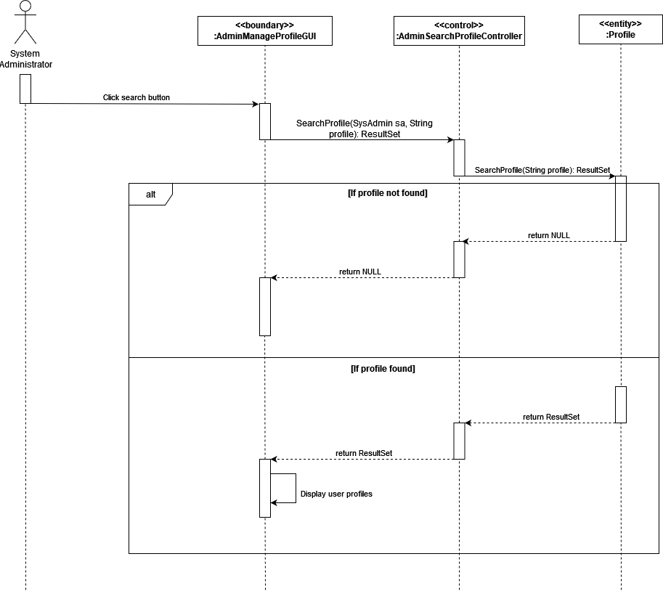

*#378 Test Case*

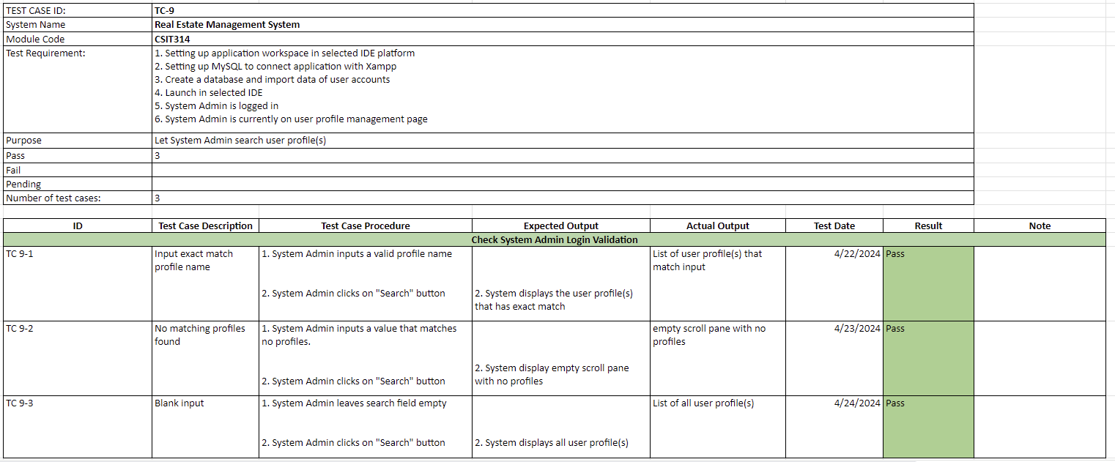

*#379 Wireframe*

## 

## #10 System admin - Update user profile

*#381 User Story*

As a System admin, I want to Update user profiles so that I can edit profile details.

*#382 Use Case Diagram*

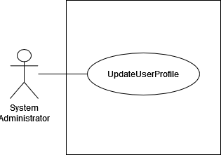

*#383 Use Case Description*

| **Name:** SA - Update user profile | **ID:** #10 |
| --- | --- |
| **Stakeholders and goals:** System Admin - To update any user profiles | |
| **Description:** System Admin clicks on the “Manage” button on the selected profile and the system displays a window to change the profile name. System Admin inserts new profile name and clicks “Update” | |
| **Actors:** System Admin | |
| **Trigger:** When System Admin clicks manage button | |
| **Pre-condition:**  System Admin is logged in  System Admin is currently on user profile management page | |
| **Normal flow:**  1. System Admin clicks on the “Manage” button on the selected profile.  2. System redirects user to system admin update user profile page. 3. System popups a window to change profile name. 4. System Admin inputs a new profile name. 5. System Admin clicks “Update”. 6. System displays "User profile updated successfully" and directs the user back to the user profile management page. 7. End. | |
| **Sub-flows:** None. | |
| **Alternative/Exceptional flows:**  6.1.a. Blank input: System displays message "Invalid input"  6.1.b System Admin clicks on the “Ok” button and repeats steps 3, 4 and 5.  6.2.a. SQL Error: System displays message "Failed to update user profile. Please try again."  6.2.b System Admin clicks on the “Ok” button and repeats steps 3, 4 and 5. | |

*#384 BCE Diagram*

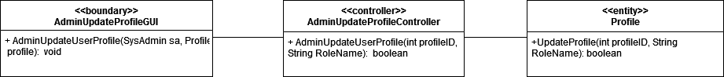

*#385 Sequence Diagram*

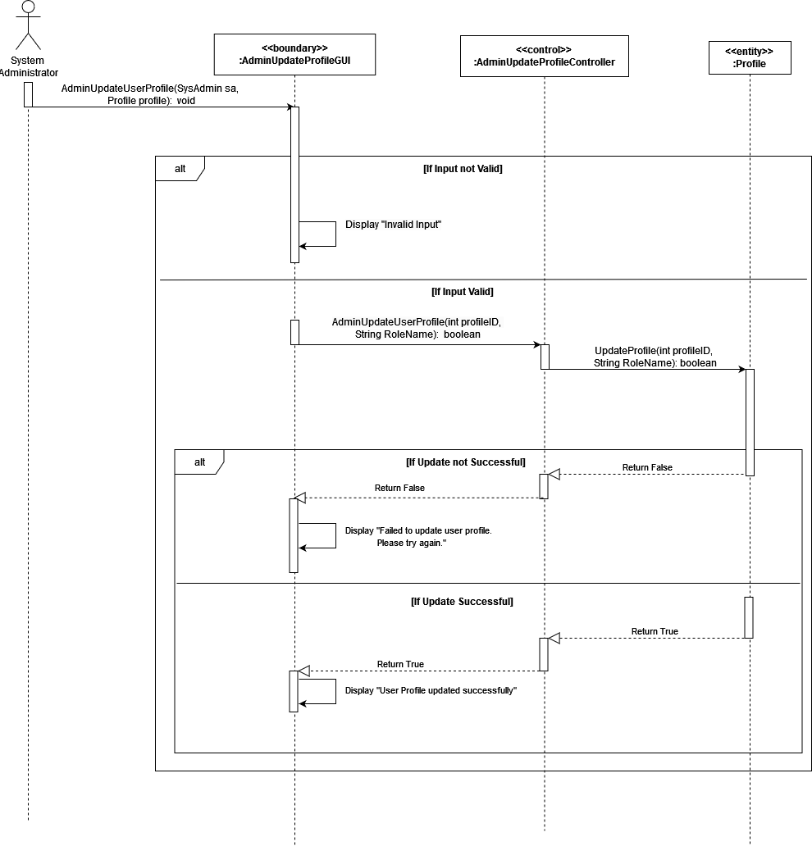

*#386 Test Case*

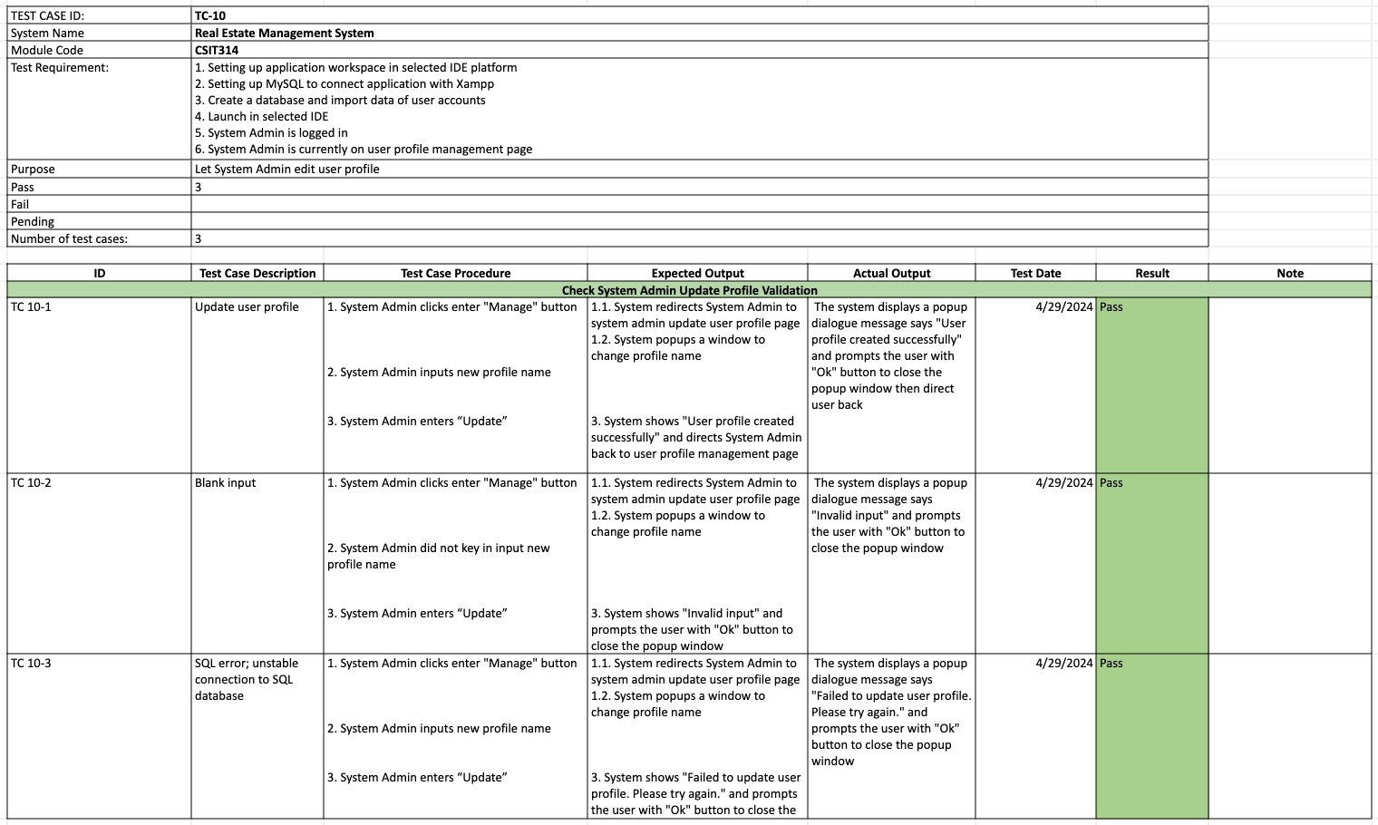

*#387 Wireframe*

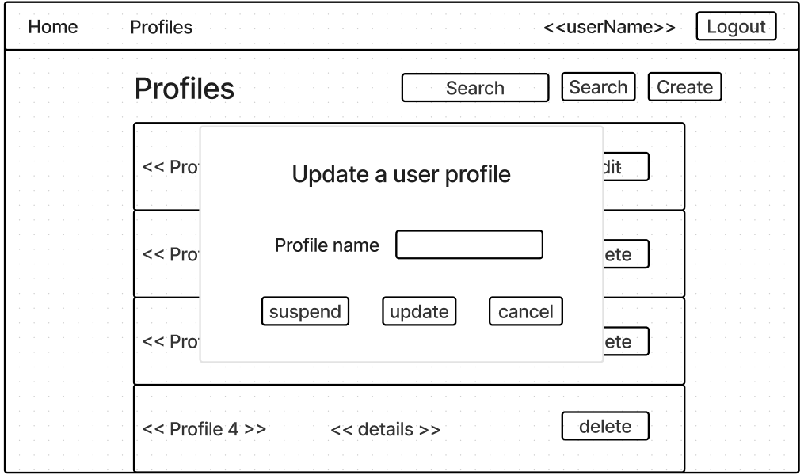

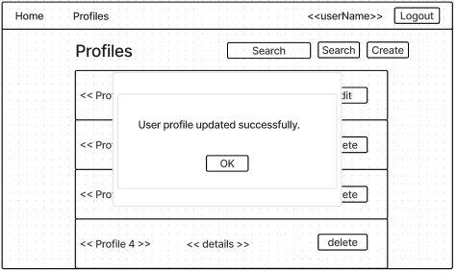

## 

## #11 System admin - Suspend user profile

*#33 User Story*

As a System admin, I want to Suspend user profiles so that I can remove unused profiles.

*#334 Use Case Diagram*

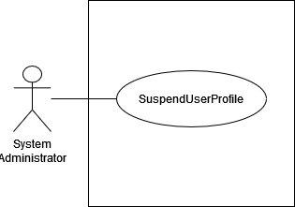

*#335 Use Case Description*

| **Name:** SA - suspend user profile | **ID:** #11 |
| --- | --- |
| **Stakeholders and goals:** System Admin - To be able to suspend user profiles | |
| **Description:** System Admin clicks on “Manage” and system directs user to system admin update user profile page. System Admin clicks “Suspend” and confirms the action to suspend user profile | |
| **Actors:** System Admin | |
| **Trigger:** When System Admin clicks on suspend button | |
| **Pre-condition:**  System Admin is logged in  System Admin is currently user profile management | |
| **Main flow:** 1. System Admin clicks on the “Manage” button.  2. System redirects user to system admin update user profile page.  3. System Admin clicks the “Suspend” button. 4. System displays a confirmation message, “Confirm profile suspension?” 5. System Admin clicks on the “Yes” button.  6. System suspends the selected profile and displays the message “Profile Suspended”. 7. End. | |
| **Sub-flows:** None. | |
| **Alternative/Exceptional flows:**  6.a. Profile is already suspended : System displays message “Profile already suspended” | |

*#336 BCE Diagram*

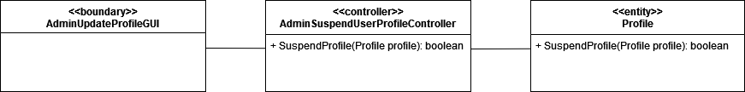

*#337 Sequence Diagram*

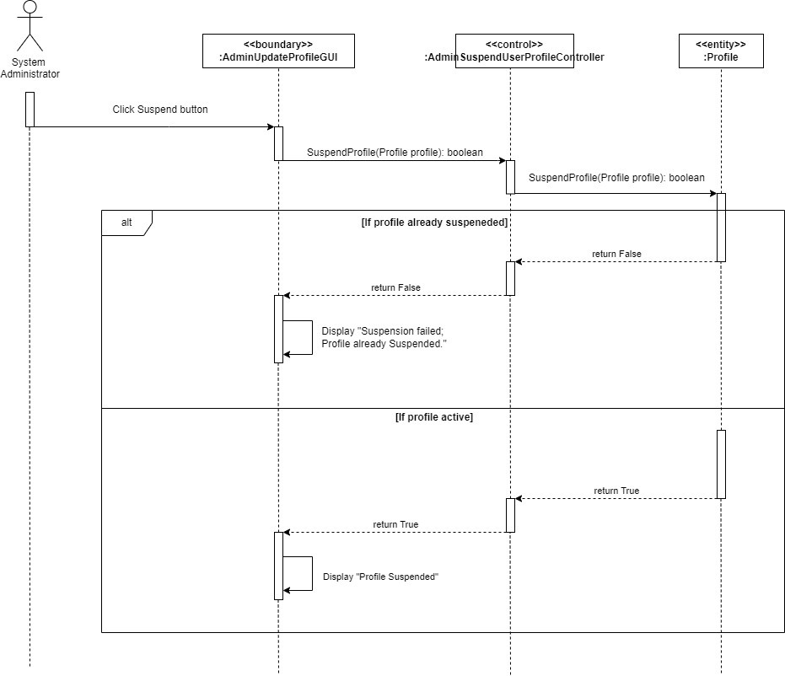

*#338 Test Case*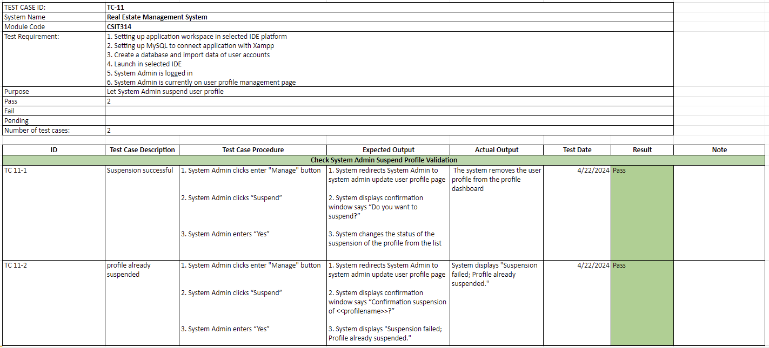

*#339 Wireframe*

**

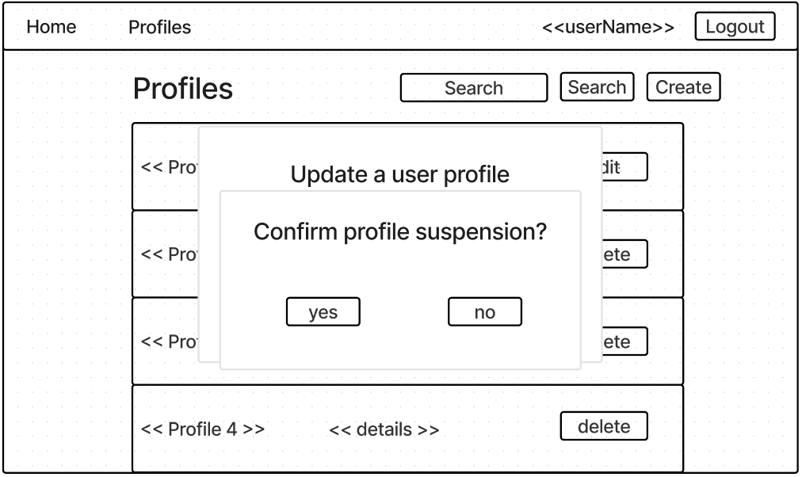

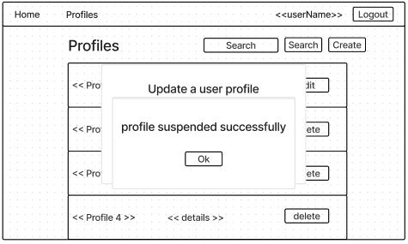

## 

## #15 System admin - Create user profile

*#389 User Story*

As a System admin, I want to Create user Profiles so that I can add new user profiles to the system.

*#390 Use Case Diagram*

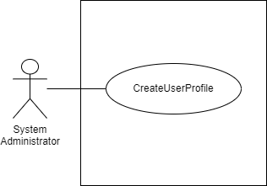

*#391 Use Case Description*

| **Name:** SA - create user profile | **ID:** #15 |
| --- | --- |
| **Stakeholders and goals:** System Admin - To create user profile | |
| **Description:** System Admin fills in the field to create a new profile and clicks on the “Create” button and system inserts a new entry into the database. | |
| **Actors:** System Admin | |
| **Trigger:** When System Admin clicks on create button | |
| **Pre-condition:**  System Admin is logged in  System Admin is currently on user profile management page | |
| **Main flow:** 1. System Admin clicks the “Create” button. 2. System redirects user to system admin create user profile page. 3. System pop-up a window to create profile name displaying empty field. 4. System Admin enters a profile name. 5. System Admin clicks on the “Create” button. 6. System adds a new entry into the profile dashboard and displays a popup "User Profile created successfully" message. 7. End. | |
| **Sub-flows:** None. | |
| **Alternative/Exceptional flows:**  6.1.a Blank Input: System fails to create the profile and displays message “Invalid input”.  6.1.b System Admin clicks on the “Ok” button and repeats steps 3, 4 and 5.  6.2.a. SQL error : System fails to create the profile and displays message “Failed to create a new user profile”.  6.2.b System Admin clicks on the “Ok” button and repeats steps 3, 4 and 5. | |

*#392 BCE Diagram*

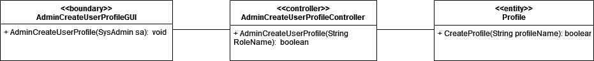

*#393 Sequence Diagram*

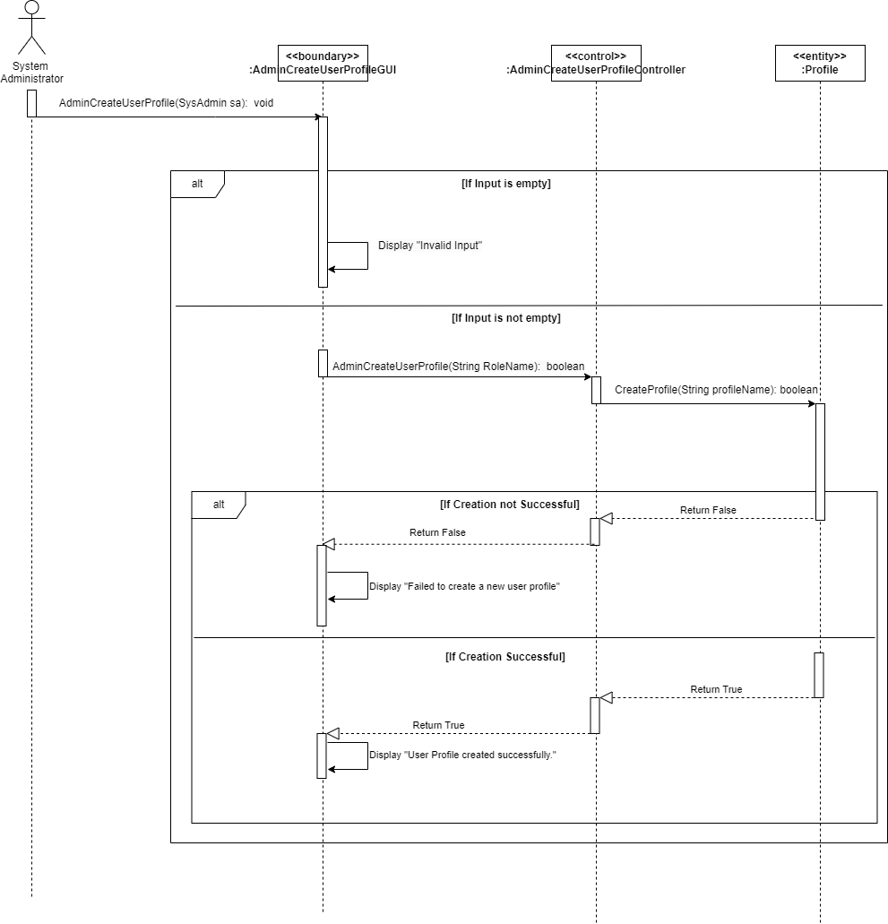

*#394 Test Case*

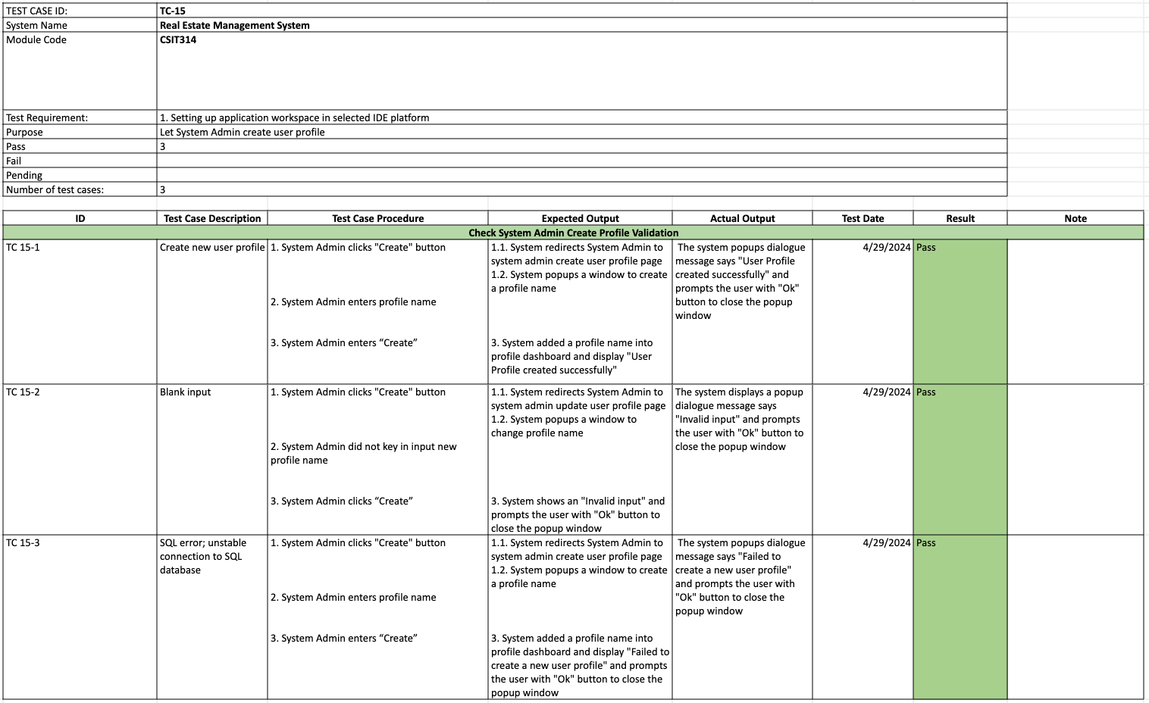

*#395 Wireframe*

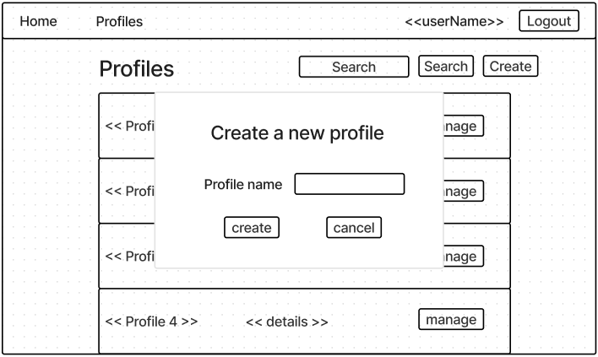

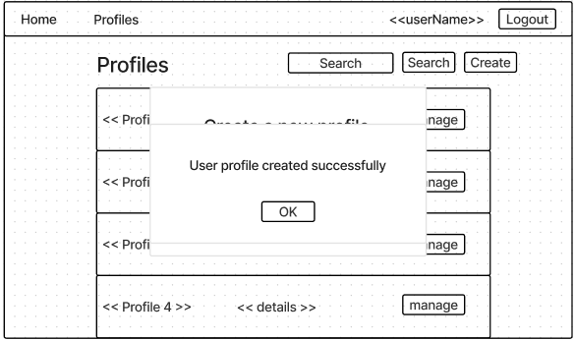

## 

## #617 System Admin - Update own account details

*#626 User Story*

As a System admin, I want to be able to Edit my user account information such as my name and contact details, so that my information remains current and accurate.

*#627 Use Case Diagram*

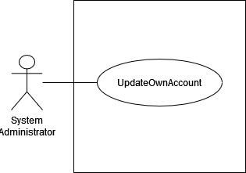

*#628 Use Case Description*

| **Name:** SA - edit own account details | **ID:** #617 |
| --- | --- |
| **Stakeholders and goals:** System Admin - To edit the details of my account | |
| **Description:** System Admin clicks on the “Edit” button and the system displays user details form. System Admin makes changes accordingly and clicks on “Update” button for the system to reflect that changes. | |
| **Actors:** System Admin | |
| **Trigger:** When System Admin clicks edit button | |
| **Pre-condition:**  System Admin is logged in  System Admin is currently on view own account page | |
| **Main flow:** 1. System Admin clicks on the “Edit” button. 2. System redirects user to account update page. 3. System displays the current user details form. 4. System Admin makes changes to their details. 5. System Admin clicks the “Update” button.  6. System updates the user and shows the message “User details updated successfully”  7. System redirects the user back to the main page.  8. End | |
| **Sub-flows:** None. | |
| **Alternative/Exceptional flows:**  6.1.a Blank input: System displays message in popup “Invalid Input”  6.1.b System Admin clicks on the “Ok” button and repeats steps 3, 4 and 5.  6.2.a SQL Error: System displays message “Failed to update user details”  6.2.b System Admin clicks on the “Ok” button and repeats steps 3, 4 and 5. | |

## 

*#629 BCE Diagram*

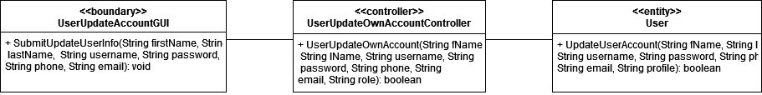

*#630 Sequence Diagram*

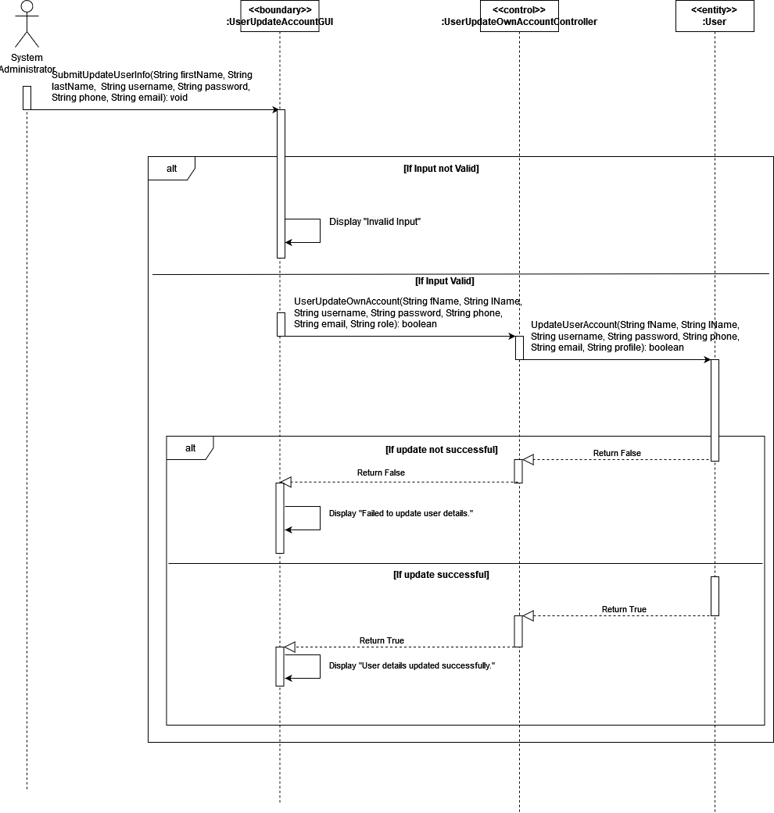

*#631 Test Case*

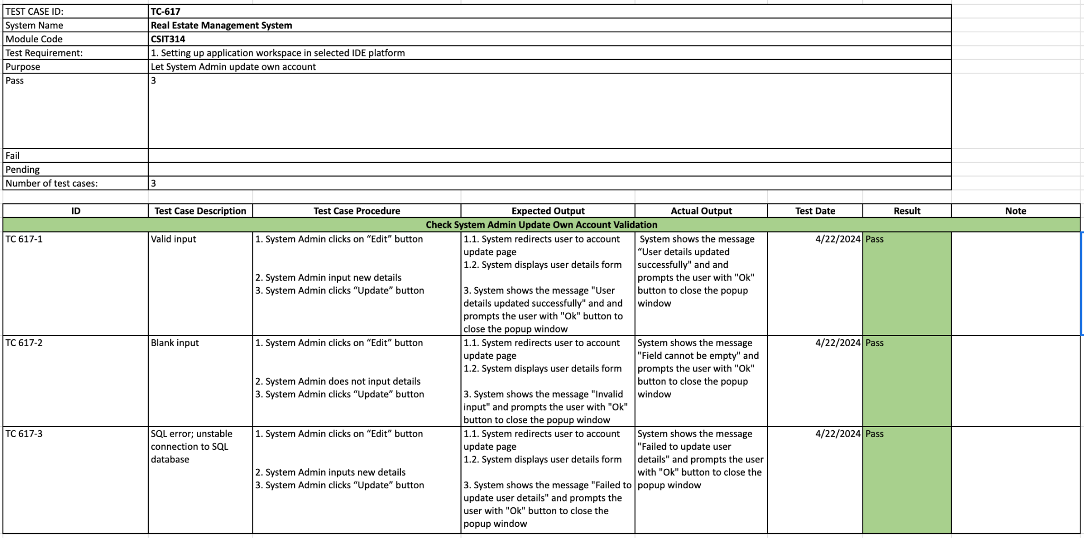

*#632 Wireframe*

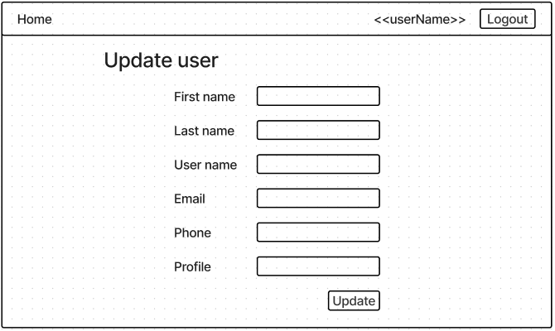

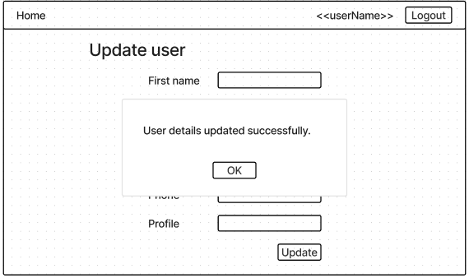

## #21 REA - Update own account details

*#397 User Story*

As a Real Estate Agent, I want to be able to Edit my user account information such as my name and contact details, so that my information remains current and accurate.

*#398 Use Case Diagram*

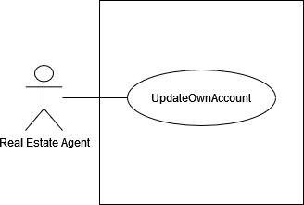

*#399 Use Case Description*

| **Name:**  REA - edit own account details | **ID:** #21 |
| --- | --- |
| **Stakeholders and goals:** Real Estate Agent - To edit the details of my account | |
| **Description:** Real Estate Agent clicks “Edit” and system displays user details form, agent inputs their new details and clicks “Update” button to save changes. | |
| **Actors:** Real Estate Agent | |
| **Trigger:** When Real Estate Agent clicks on edit button | |
| **Pre-condition:**  Real Estate Agent is logged in  Real Estate Agent is currently on view own account page | |
| **Main flow:** 1. Real Estate Agent clicks on “Edit” button 2. System redirects user to account update page 3. System displays user details form 4. Real Estate Agent input new details 5. Real Estate Agent clicks “Update” button  6. System shows the message “User details updated successfully" and redirects back to the main page.  7. End | |
| **Sub-flows:** | |
| **Alternative/Exceptional flows:** 6.1. Blank input: System displays message in popup "Invalid input"6.2. SQL Error: System displays message “Failed to update user details” | |

*#400 BCE Diagram*

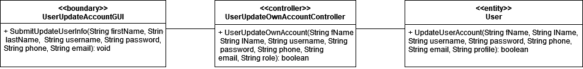

*#401 Sequence Diagram*

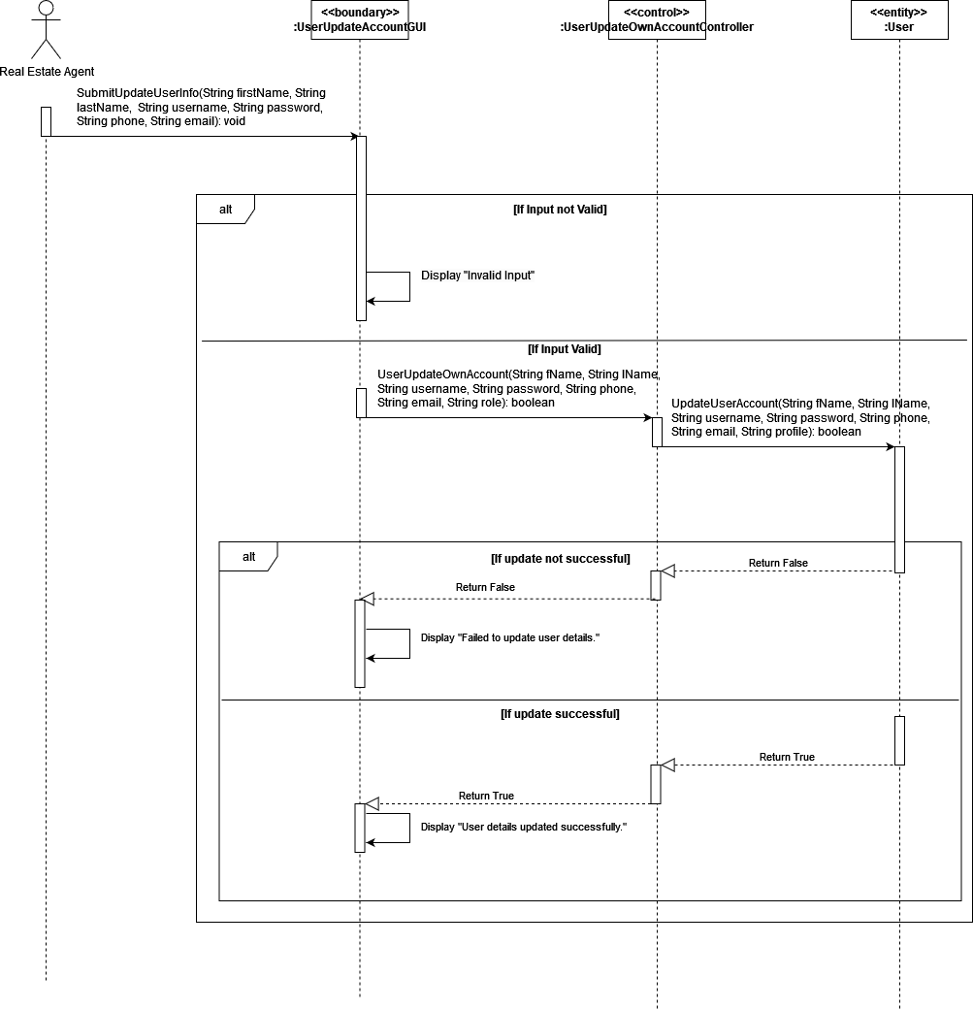

*#402 Test Case*

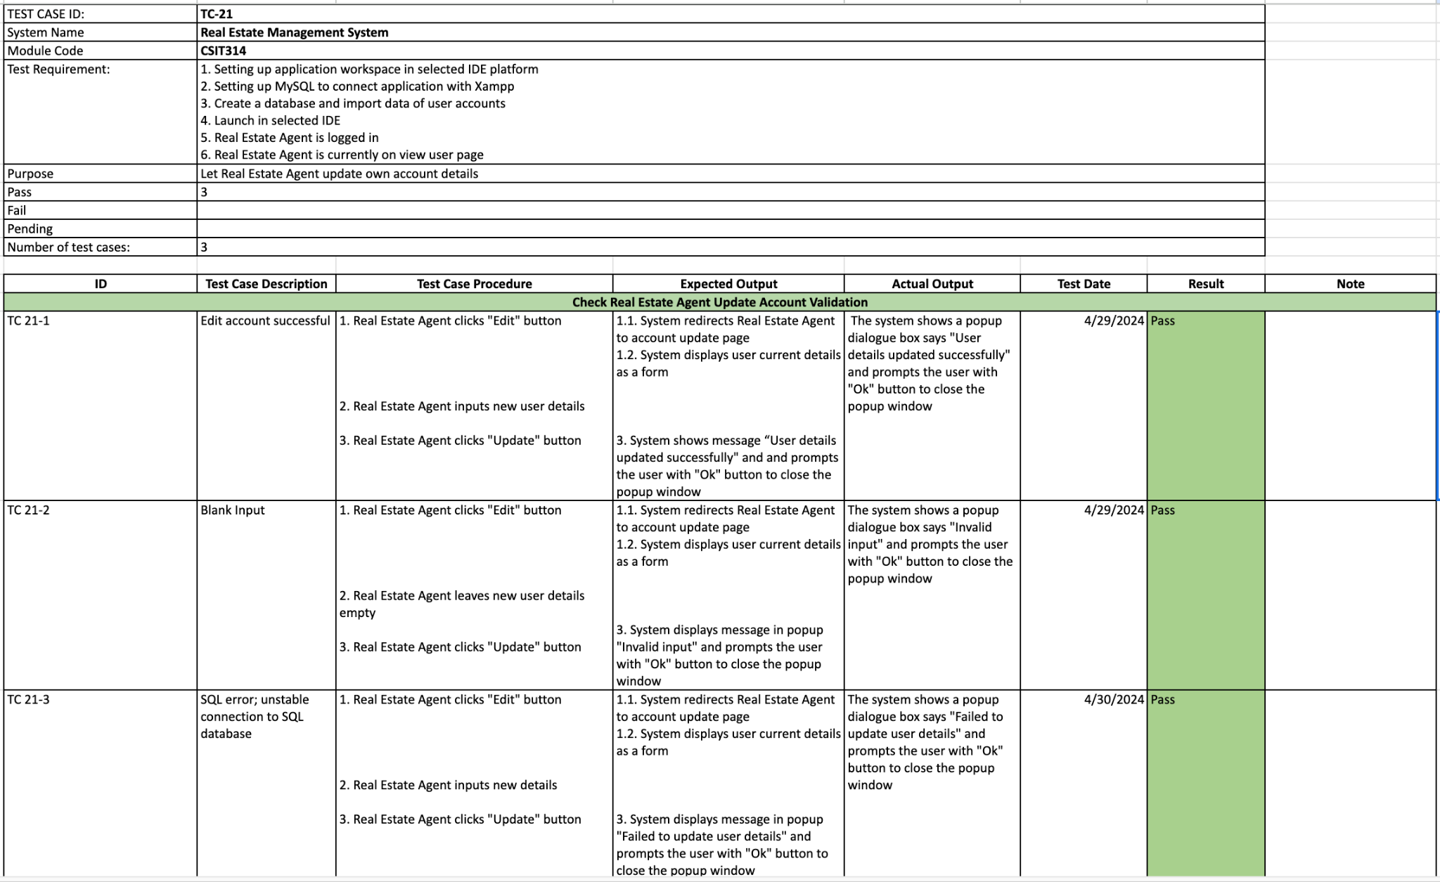

*#403 Wireframe*





## 

## #24 Seller - Update own account details

*#409 User Story*

As a Seller, I want to Edit my user account, so that I can modify my contact information or other details as needed.

*#411 Use Case Diagram*

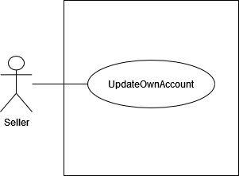

*#413 Use Case Description*

| **Name:**  Seller - edit own account details | **ID:** #24 |
| --- | --- |
| **Stakeholders and goals:** Seller - To edit the details of my user account | |
| **Description:** Seller clicks on “Edit” button and system displays user details form. Seller input their new details and click “Update” button to save changes | |
| **Actors:** Seller | |
| **Trigger:** When Seller clicks edit button | |
| **Pre-condition:**  Seller is logged in  Seller is currently on view own account page | |
| **Main flow:** 1. Seller clicks on “Edit” button 2. System redirects user to account update page 3. System displays user details form 4. Seller input new details 5. Seller clicks “Update” button  6. System shows the message “User details updated successfully" and redirects back to the main page.  7. End | |
| **Sub-flows:** | |
| **Alternative/Exceptional flows:** 6.1. Blank input: System displays message in popup "Invalid input" 6.2. SQL Error: System displays message “Failed to update user details” | |

*#414 BCE Diagram*

**

*#415 Sequence Diagram*

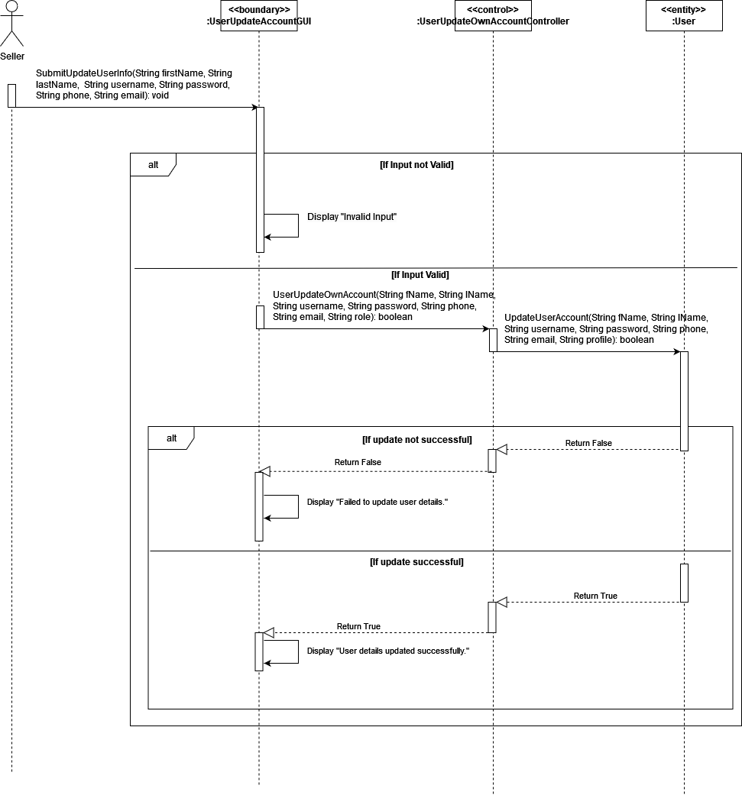

*#416 Test Case*

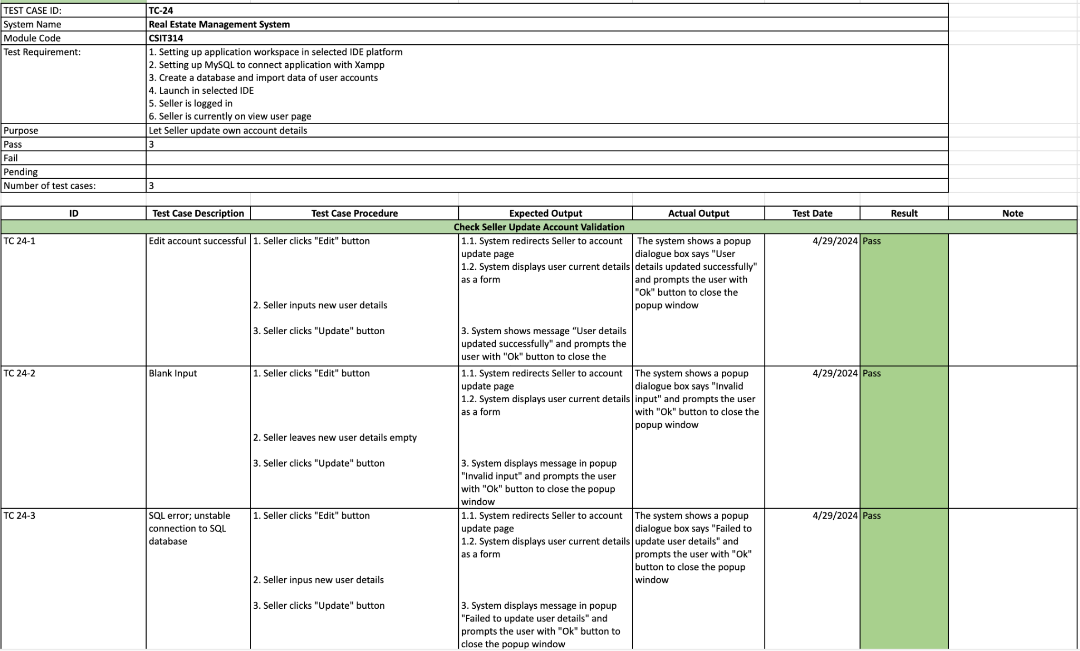

*#417 Wireframe*





## 

## #39 Buyer - Update own account details

*#427 User Story*

As a buyer, I want to be able to Edit my account information, such as contact details or profile picture, ensuring my information remains current.

*#428 Use Case Diagram*

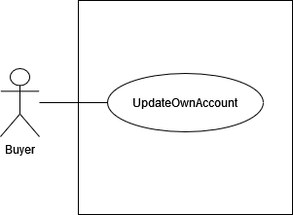

*#429 Use Case Description*

| **Name:**  Buyer - edit own account details | **ID:** #39 |
| --- | --- |
| **Stakeholders and goals:** Buyer - To edit the details of my user account | |
| **Description:** Buyer clicks “Edit” and system displays user details form, Buyer inputs their new details and clicks “Update” button to save changes | |
| **Actors:** Buyer | |
| **Trigger:** When Buyer clicks edit button | |
| **Pre-condition:**  Buyer is logged in  Buyer is currently on view own account page | |
| **Main flow:** 1. Buyer clicks on “Edit” button 2. System redirects user to account update page 3. System displays user details form 4. Buyer input new details 5. Buyer clicks “Update” button  6. System shows the message “User details updated successfully" and redirects back to the main page.  7. End | |
| **Sub-flows:** | |
| **Alternative/Exceptional flows:** 6.1. Blank input: System displays popup “Invalid input” message.  6.2. SQLError: System displays “Failed to update user details” message. | |

*#430 BCE Diagram*

**

*#431 Sequence Diagram*

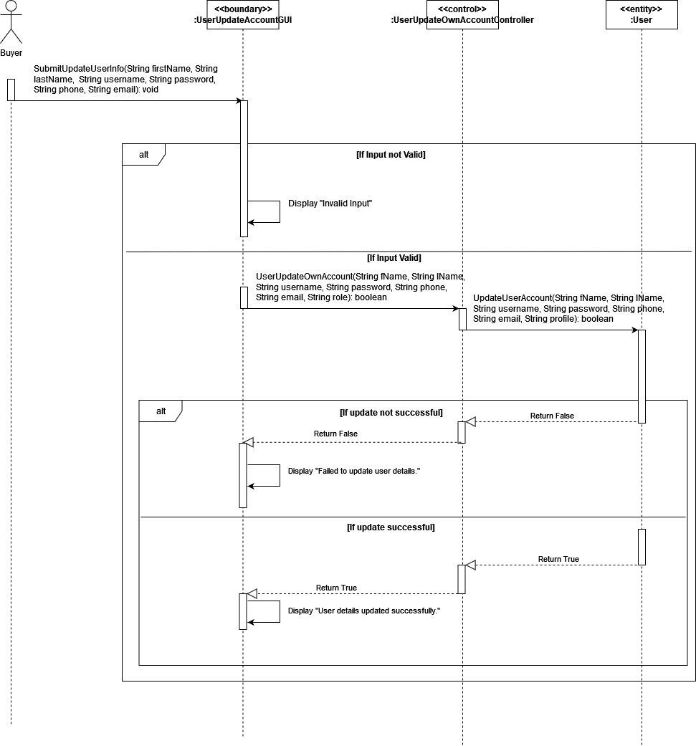

*#432 Test Case*

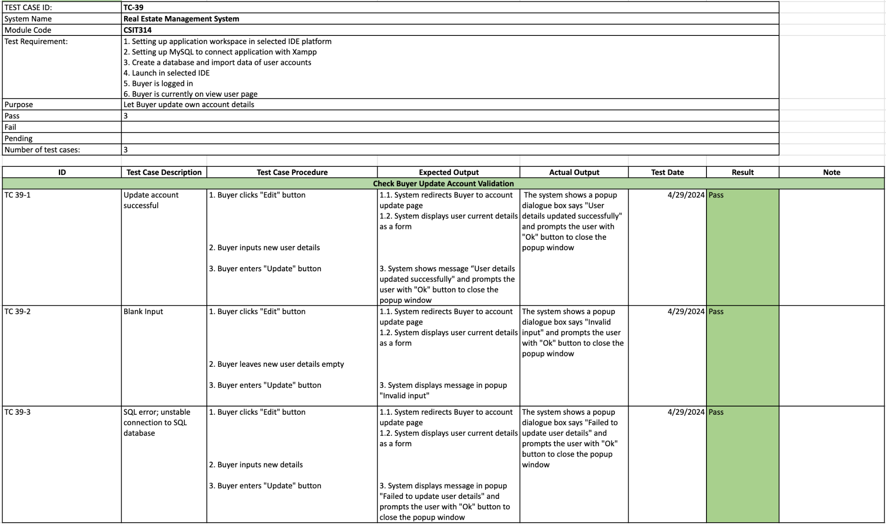

*#433 Wireframe*





# 

# Sprint Three

**Duration: 29th April - 6th May**

## Sprint Planning, Review and Retrospective

| **Meeting Date**: 29/04/2024 (Monday) | | |
| --- | --- | --- |
| **Duration:** 14:00 - 15:00 | | |
| **Sprint duration:** 29/04/2024 - 06/05/2024 | | |
| **Attendees:**  Wootaek, Vuong, Wei Hong, Roydenn, Frentsen, Jerry | | **Agenda** |
| 1. Sprint 2 review 2. Discuss about the tasks for sprint 3 |
| **Absentees:**  N/A | |
|
| **What we have done** | | **Roydenn**   * Coding & diagram * Update database to make users scalable * SA - Search user profiles * Buyer, Seller - Update account * Update Gantt Chart   **Wootaek**   * Update class diagram * Coding & diagram * SA - Create user accounts * SA - Create User profiles * SA - suspend User profiles * Amend Create account and User class   **Wei Hong**   * Create wireframe for this week’s user stories * Coding & diagram * GUI for REA, Seller, Buyer * SA - View user profiles   **Vuong**   * Coding & diagram * Fix Update function to return to main page * SA - Edit user profiles * SA, REA - Update account   **Jerry & Frentsen**   * Use case descriptions for all user stories in this sprint * Update existing diagrams * Update report * Draw BCE, Use case diagrams for all user stories in this sprint |
| **Reflection** | | **What went well:**  Database updated to be scalable with no issues.  Coding has gone very well with no issues from the coders.  **What could be improved:** |
| **What we are going to do for this sprint** | | **Roydenn**   * Draw Sequence diagrams * Coding & sequence diagram   + REA - view reviews   + REA - view ratings   + REA - delete listing   **Wootaek**   * Update class diagram * Check the existing diagrams with our product owner (sprint summaries) * Coding & sequence diagram * REA - create listing * REA - view listing * Take a look at UserViewAccount/ AdminViewUserAccount   **Wei Hong**   * Coding & sequence diagram * GUI - REA own listing * Cleaning up code * Seller view own properties (including the number of times shortlisted and ratings)   **Vuong**   * Coding & sequence diagram   + Fix Update function to return to main page   + REA - update/modify listings   **Jerry & Frentsen**   * Draw diagrams based on the sequence diagrams (sprint 1, 2 and 3) * Improve diagrams for sprint 1 or 2 based on our product owner’s feedback, if needed * Write a report for sprint 2 & 3 * Finish sprint summary for sprint 2 and 3 (3 is optional) |

## Taiga - Start

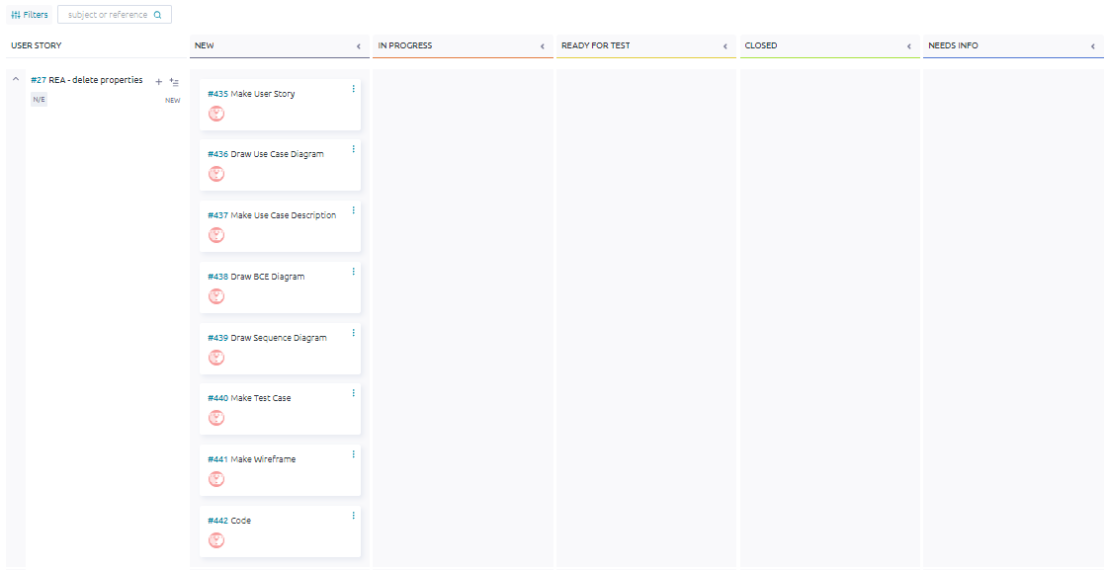

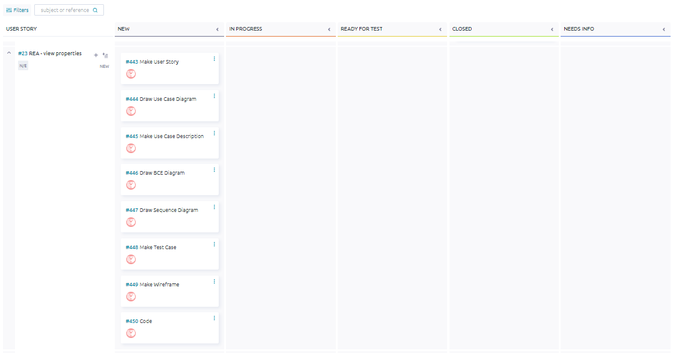

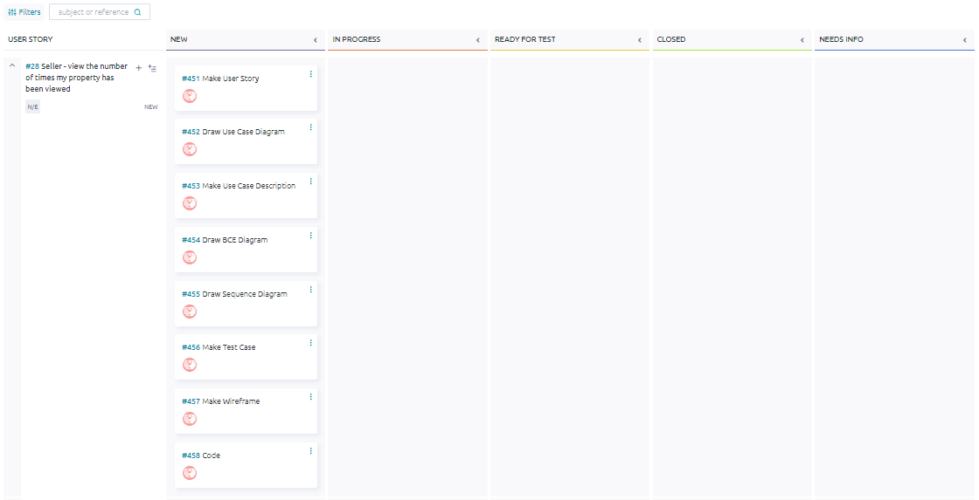

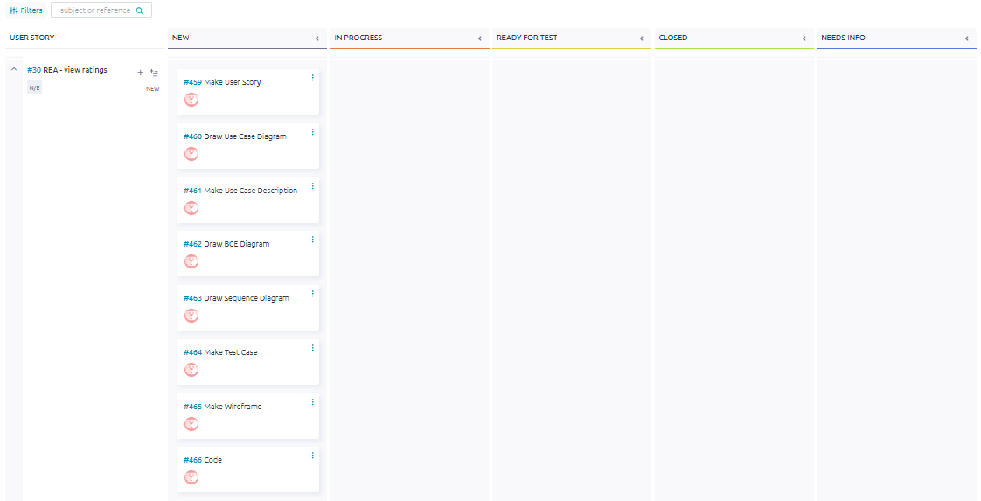

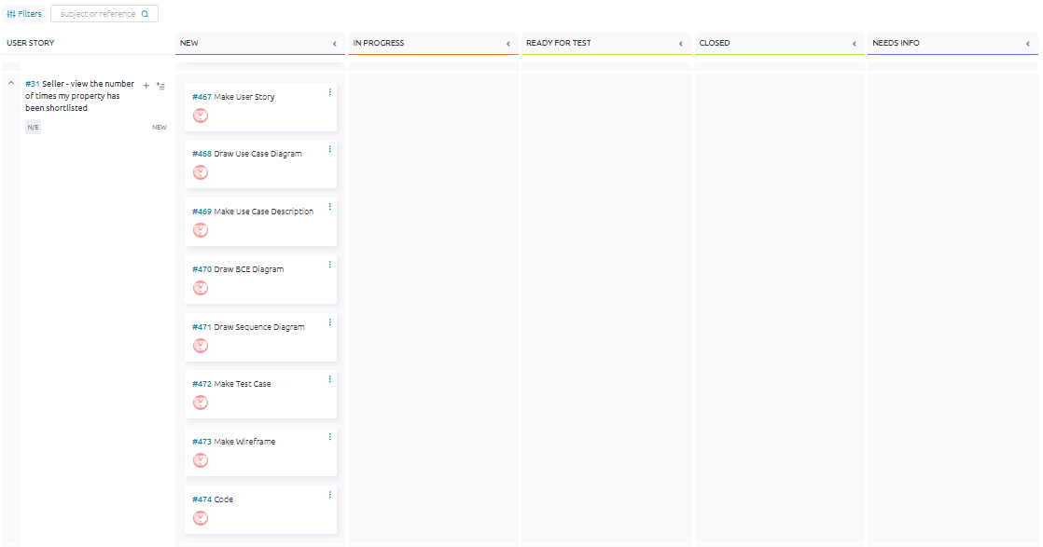

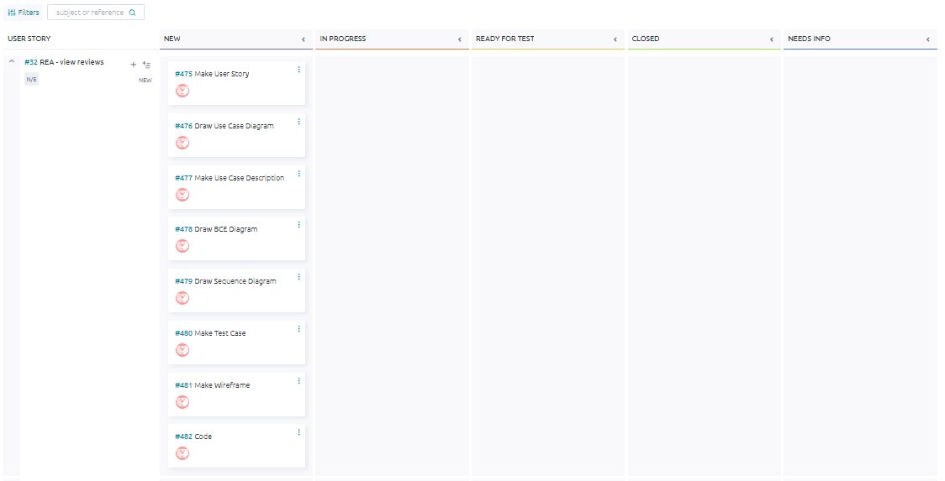

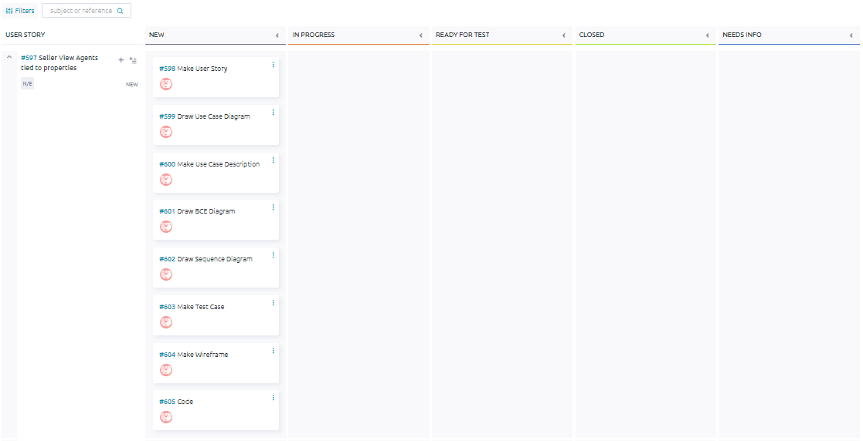

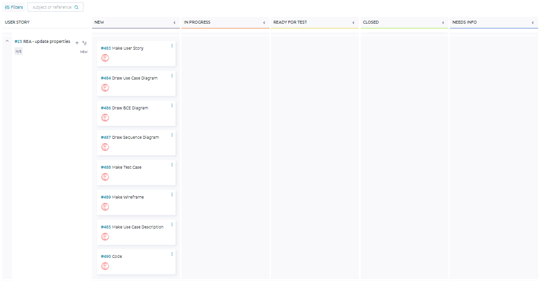

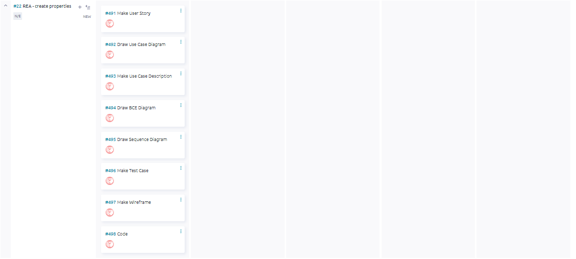

## 

## Taiga - End

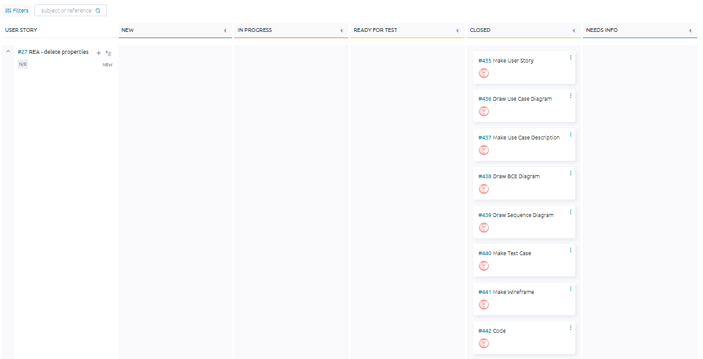

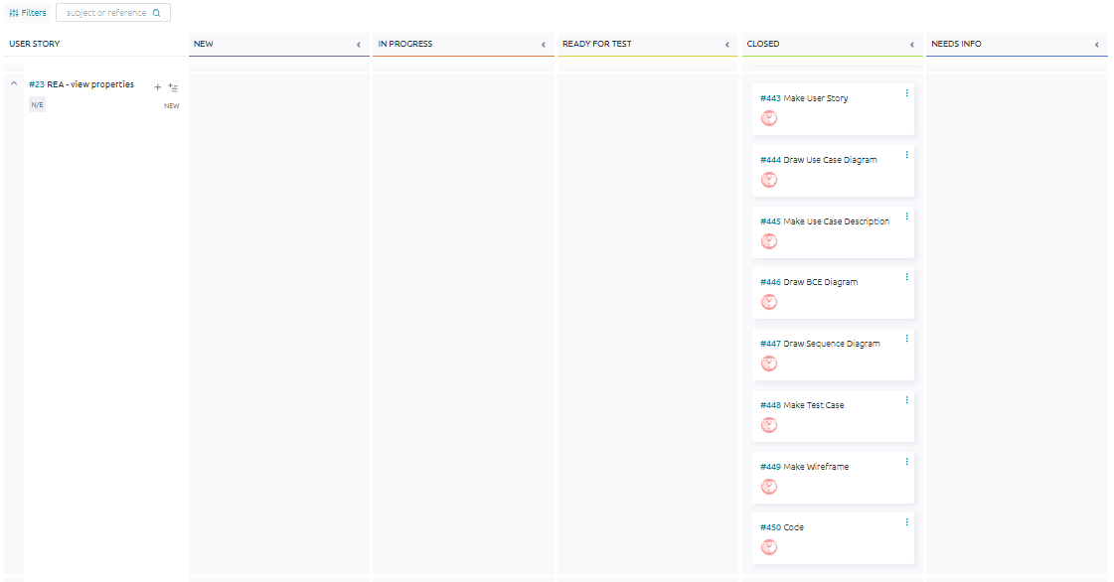

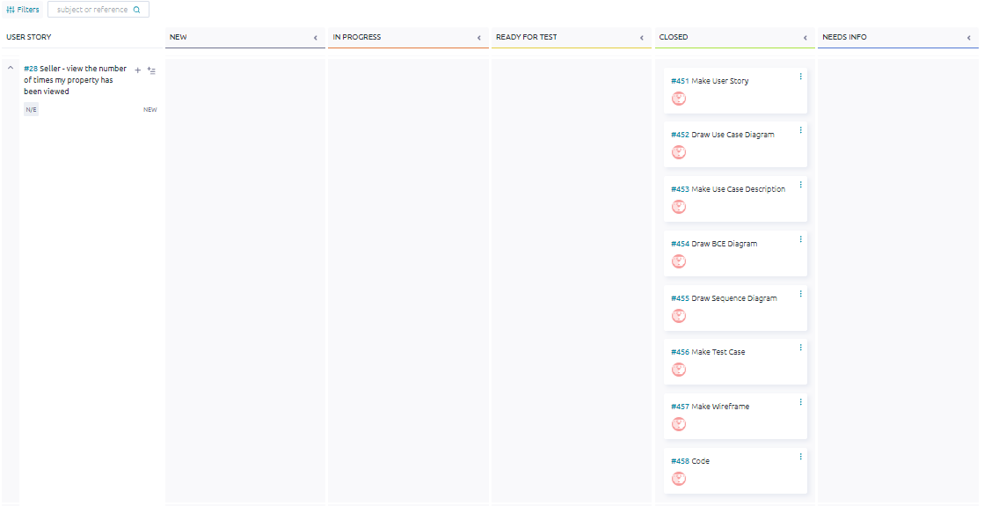

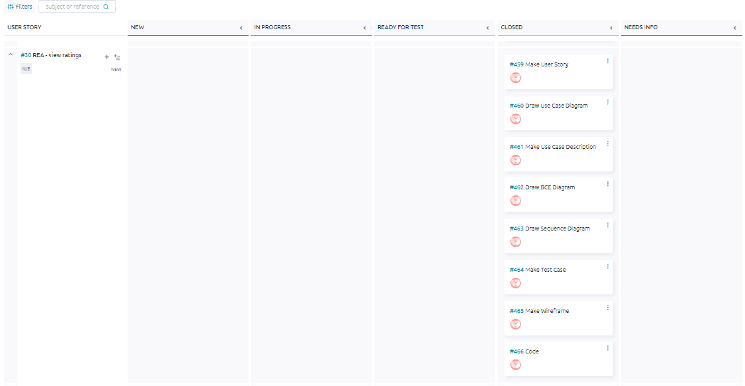

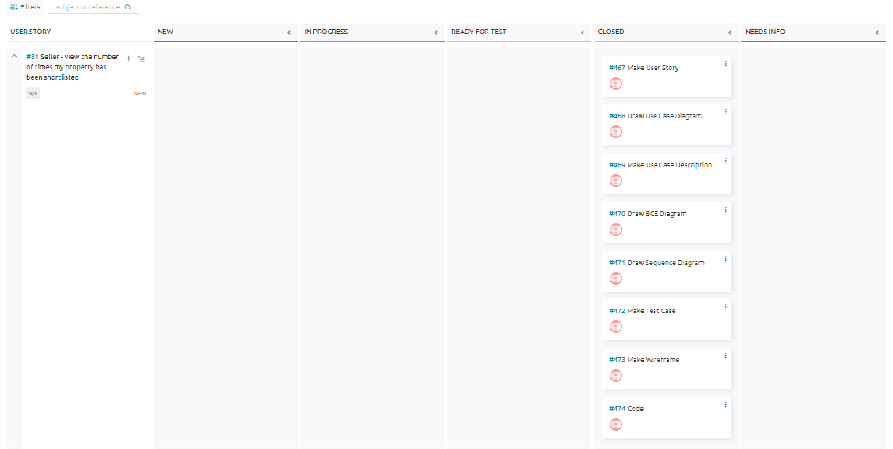

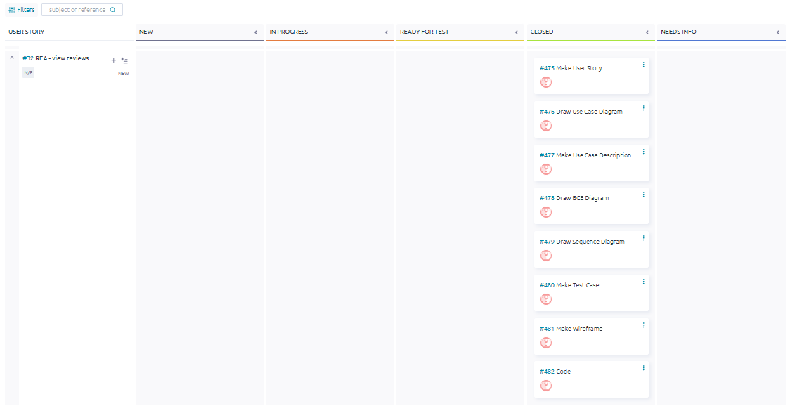

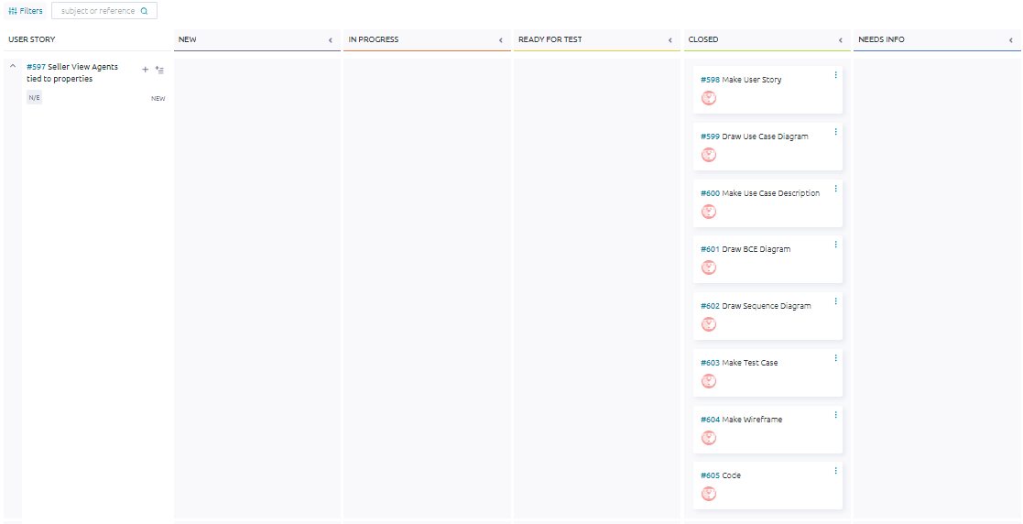

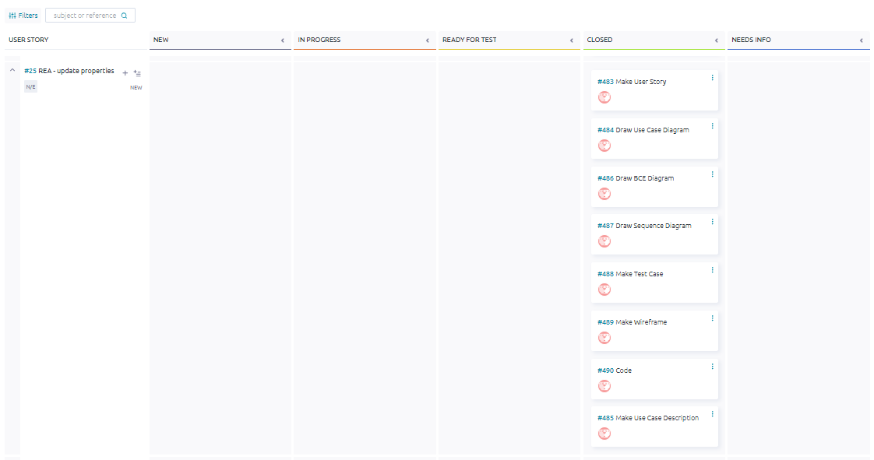

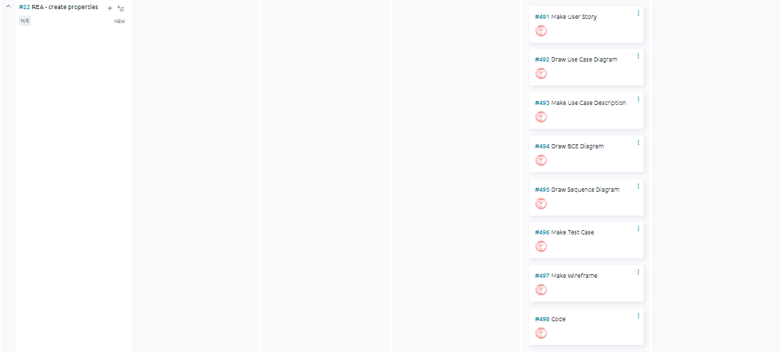

## ER Diagram

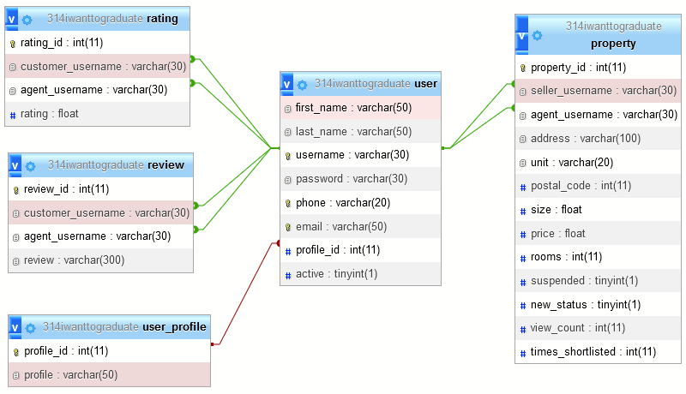

## 

## Class Diagram (Original Diagram attached)

## #22 REA - Create properties

*#491 User Story*

As a Real Estate Agent, I want to be able to Create new property listings, providing comprehensive details such as property type, location, amenities, and pricing, to attract potential buyers or renters.

*#492 Use Case Diagram*

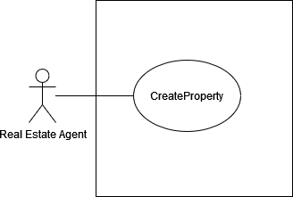

*#493 Use Case Description*

| **Name:** REA - create properties | **ID:** #22 |
| --- | --- |
| **Stakeholders and goals:** REA - To create new property listings | |
| **Description:** Real Estate Agent clicks on “create” button, inserts new property details to list into the system, system verifies the input and saves the new property into the database. | |
| **Actors:** Real Estate Agent | |
| **Trigger:** When Real Estate Agent clicks the create property listing button | |
| **Pre-condition:**  Real Estate Agent is logged in  Real Estate Agent is currently on REA’s my listing page | |
| **Main flow:**  1. Real Estate Agent clicks on “Create” button  2. System popups a window for inserting a property 3. Real Estate Agent inserts the property’s details/information  4. Real Estate Agent clicks “Create” button  5. System displays “Property created successfully”  6. Real Estate Agent clicks “Ok” to acknowledge the message  7. System redirects Real Estate Agent to his/her own properties  8. End | |
| **Sub-flows:** None. | |
| **Alternative/Exceptional flows:**  5.1a. Blank input: System displays “Invalid input” 5.1b. Real Estate Agent clicks on the “Ok” button and repeats steps 2, 3 and 4.  5.2a. Postal Code/Size/Price is not a number: System displays “Postal Code/Size/Price/rooms should be in number” 5.2b. Real Estate Agent clicks on the “Ok” button and repeats steps 2, 3 and 4.  5.3a. Invalid number of rooms (0 ~ 10) input: System displays “Please enter a valid number of rooms (0 ~ 10)” 5.3b. Real Estate Agent clicks on the “Ok” button and repeats steps 2, 3 and 4.  5.4a. Fail to create property (Seller’s name does not exist or SQL error): System displays "Failed to create property" 5.4b. Real Estate Agent clicks on the “Ok” button and repeats steps 2, 3 and 4. | |

*#434 BCE Diagram*

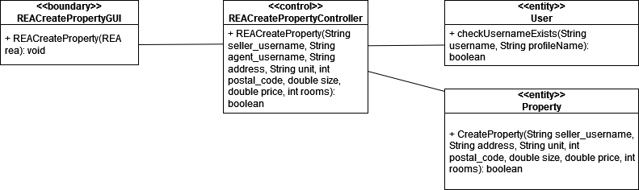

*#435 Sequence Diagram*

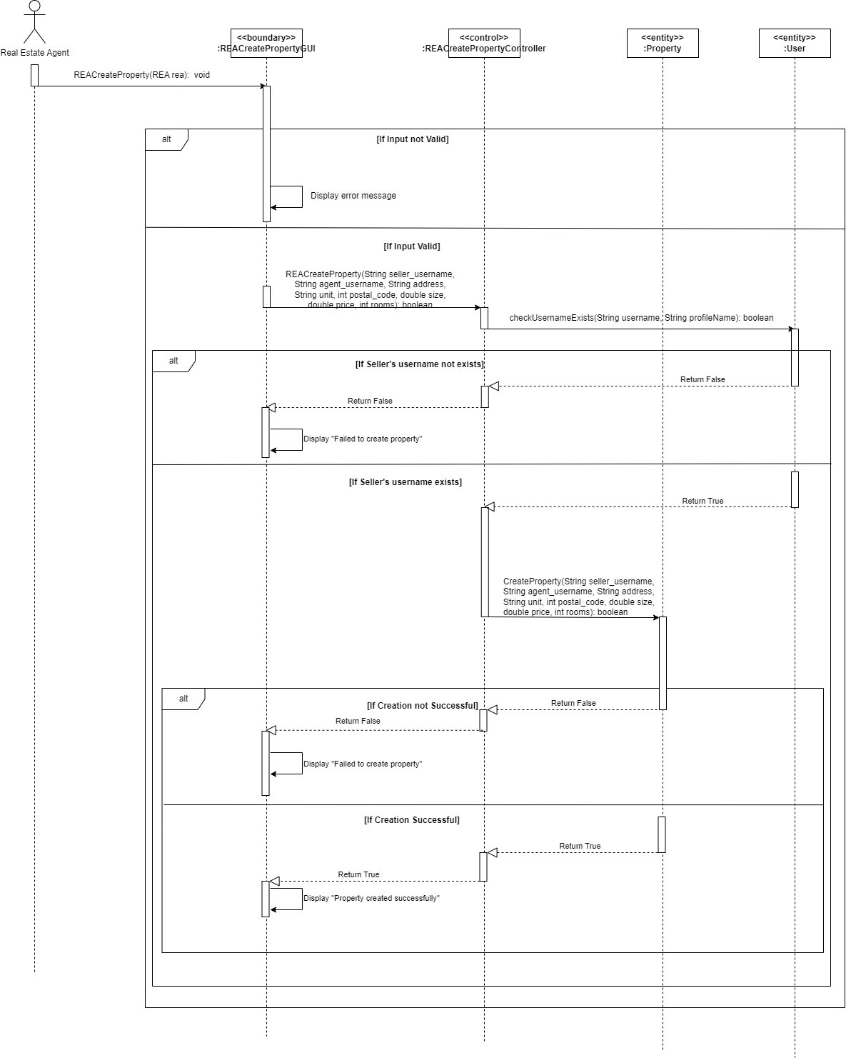

*#436 Test Case*

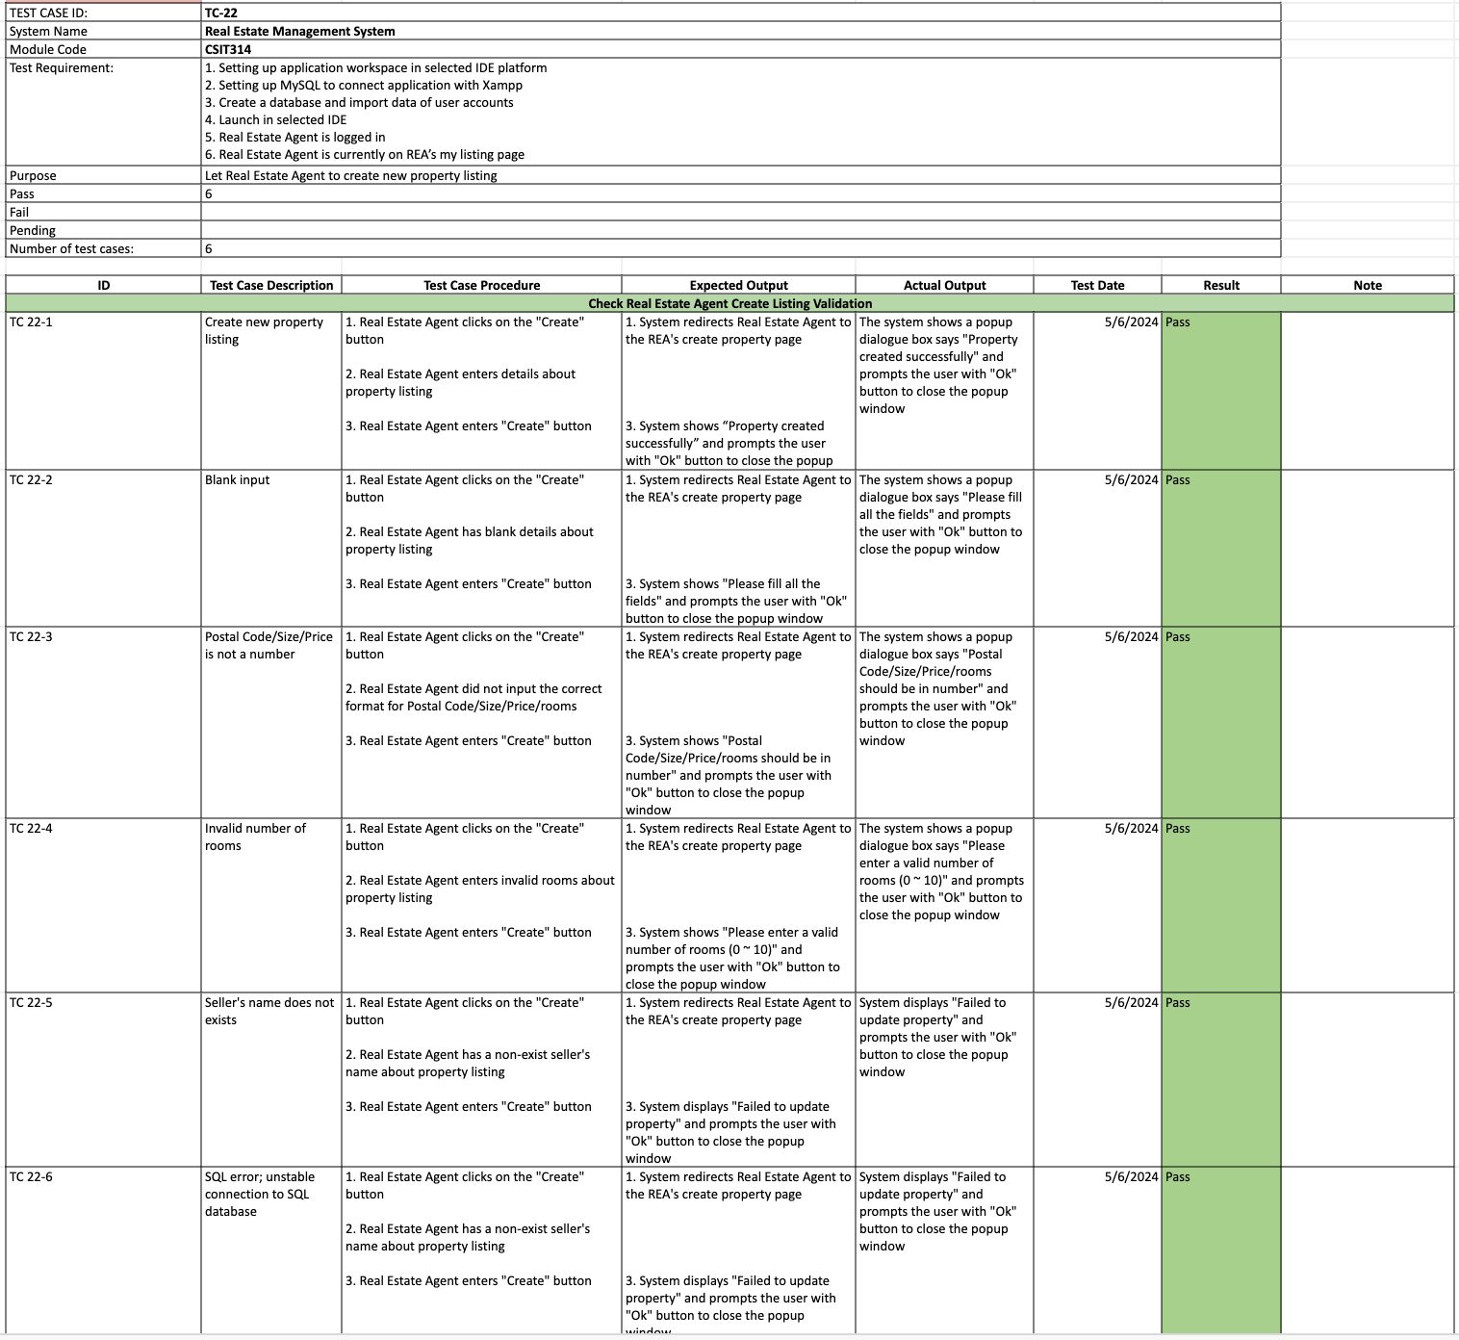

*#497 Wireframe*

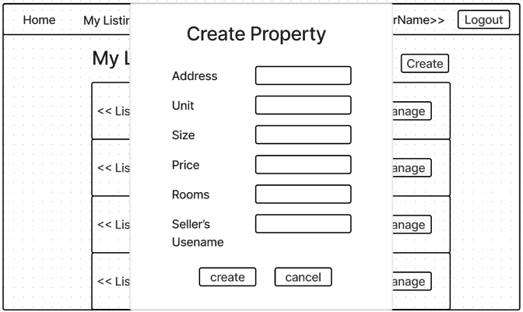

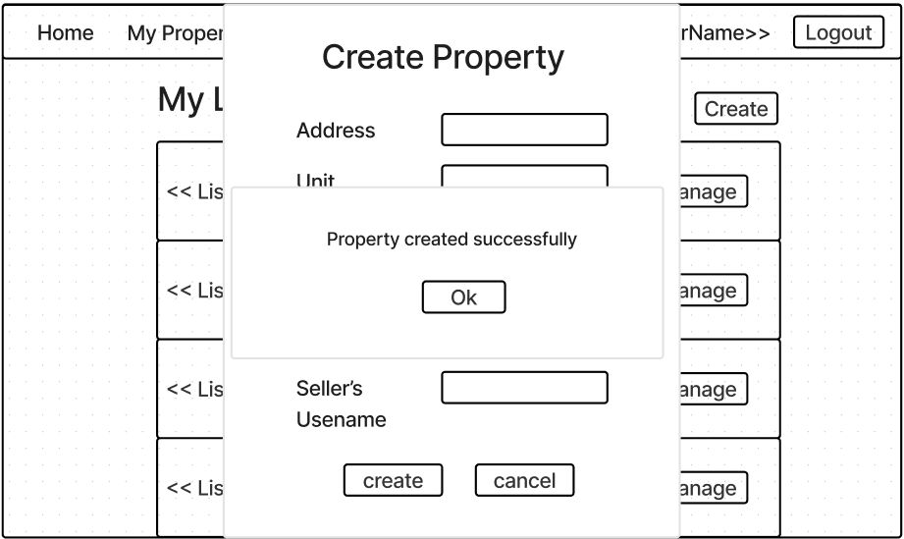

## 

## 

## #23 REA - View own properties

*#443 User Story*

As a Real Estate Agent, I want to View my property listings available on the platform, so that I can view the property in detail.

*#444 Use Case Diagram*

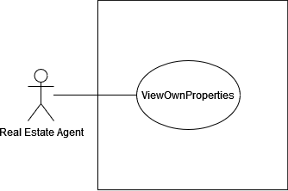

*#445 Use Case Description*

| **Name:** REA - view own properties | **ID:** #23 |
| --- | --- |
| **Stakeholders and goals:** Real Estate Agent - to view details of my properties | |
| **Description:** Real Estate Agent clicks on “Manage” button of a selected property and the system displays its details. | |
| **Actors:** Real Estate Agent | |
| **Trigger:** When Real Estate Agent clicks on “manage” button | |
| **Pre-condition:**  Real Estate Agent is logged in  Real Estate Agent is in “My Properties” page | |
| **Main flow:**   1. Real Estate Agent clicks on “Manage” button tagged to property 2. System displays all details of selected property 3. End | |
| **Sub-flows:** None. | |
| **Alternative/Exceptional flows:** | |

*#446 BCE Diagram  
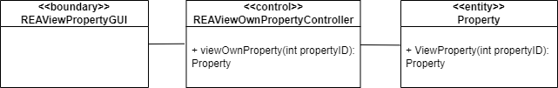*

*#447 Sequence Diagram*

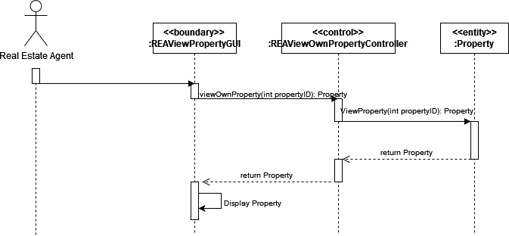

*#448 Test Case*

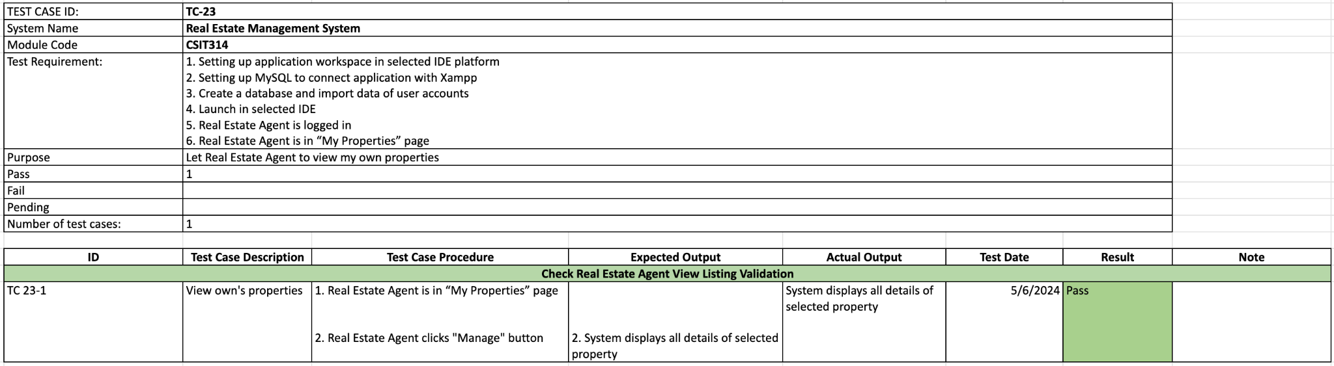

*#449 Wireframe*

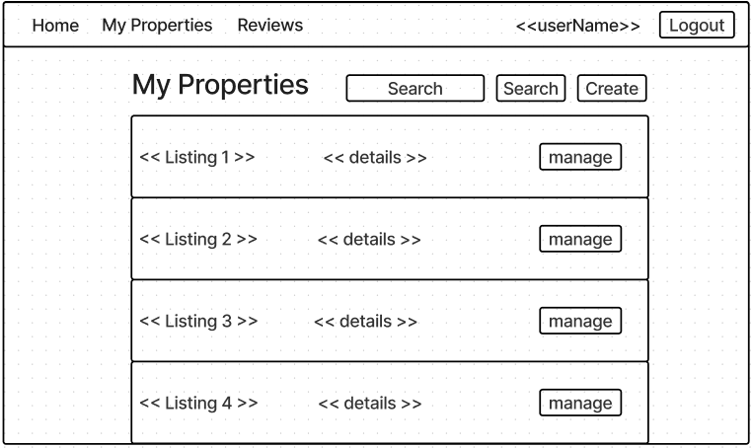

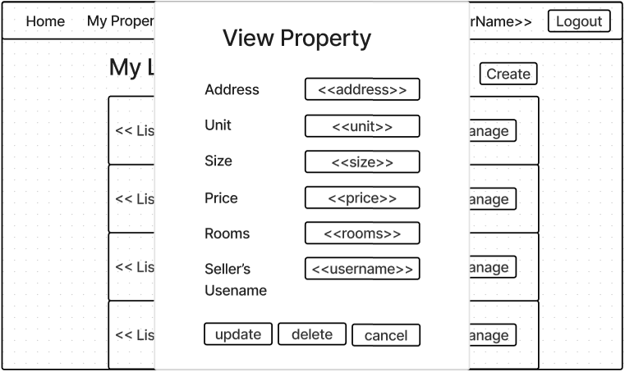

## #25 REA - Update properties

*#483 User Story*

As a Real Estate Agent, I want to be able to Edit existing property listings, such as modifying property details and adjusting pricing, to reflect any changes accurately.

*#484 Use Case Diagram*

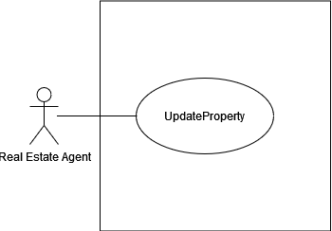

*#485 Use Case Description*

| **Name:** REA - Update properties | **ID:** #25 |
| --- | --- |
| **Stakeholders and goals:** REA - To update existing property listings | |
| **Description:** Real Estate Agent clicks on “Update” button, the system redirects to the update property page. Then the Real Estate Agent changes the details of the property and clicks “Update” and the system updates the details accordingly. | |
| **Actors:** Real Estate Agent | |
| **Trigger:** When Real Estate Agent clicks the update button | |
| **Pre-condition:**  Real Estate Agent is logged in  Real Estate Agent is currently on viewing a property listing | |
| **Main flow:**  1. Real Estate Agent clicks on the “Update” button  2. System redirects user to REA's update property page  3. Real Estate Agent insert the property’s new details/information  4. Real Estate Agent clicks “Update” button 5. System updates the account and displays “Property updated successfully”  6. Real Estate Agent clicks “Ok” to acknowledge the message  7. System redirects Real Estate Agent to his/her own properties  8. End | |
| **Sub-flows:** None. | |
| **Alternative/Exceptional flows:** 5.1.a. Blank input: System displays "Please fill in all the fields"  5.1b. Real Estate Agent clicks on the “Ok” button and repeats steps 2, 3 and 4.  5.2.a. Invalid number of rooms (0 ~ 10) input: System displays "Please enter a valid number of rooms (0 ~ 10)"  5.2.b. Real Estate Agent clicks on the “Ok” button and repeats steps 2, 3 and 4.  5.3.a. Fail to update property (Seller’s name does not exist or SQL error): System displays "Failed to update property"  5.3.b. Real Estate Agent clicks on the “Ok” button and repeats steps 2, 3 and 4. | |

*#486 BCE Diagram*

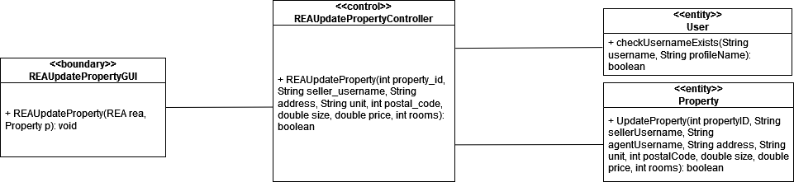

*#487 Sequence Diagram*

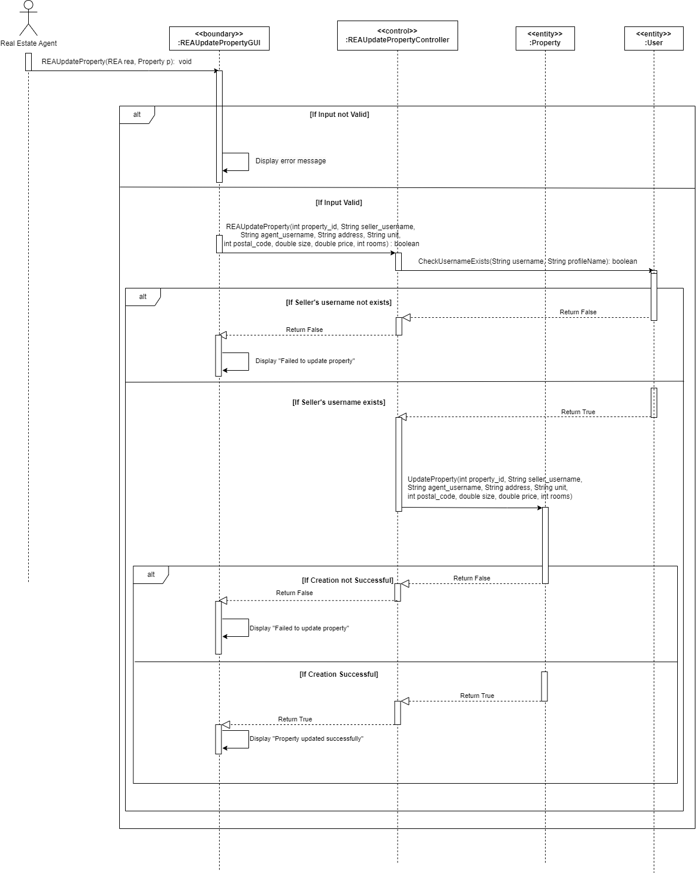

*#488 Test Case*

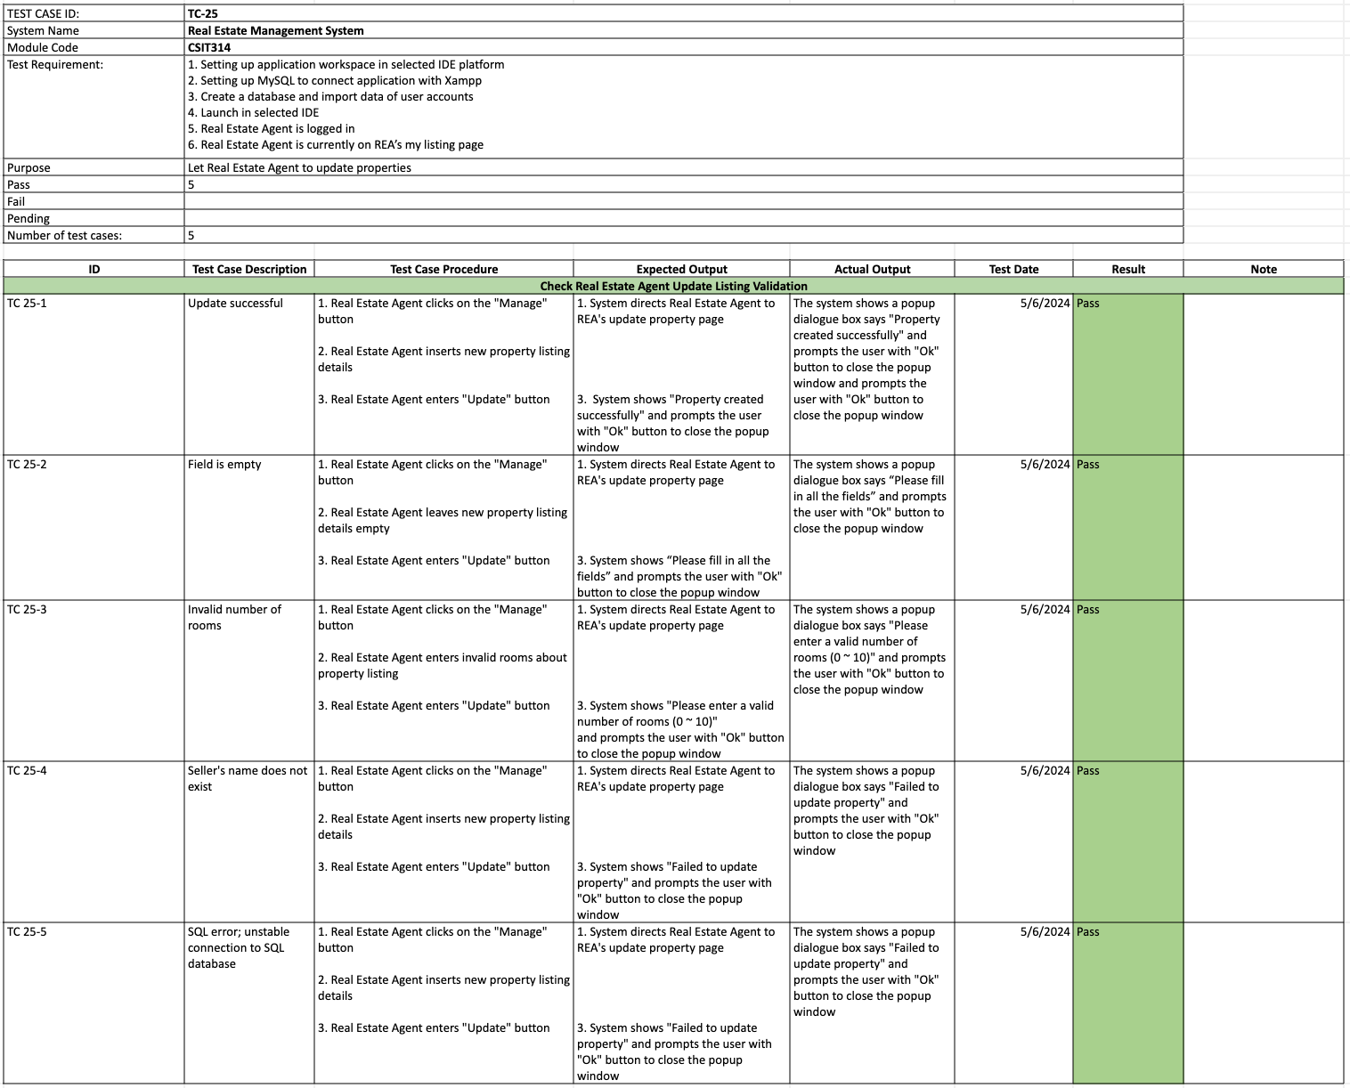

*#489 Wireframe*

**

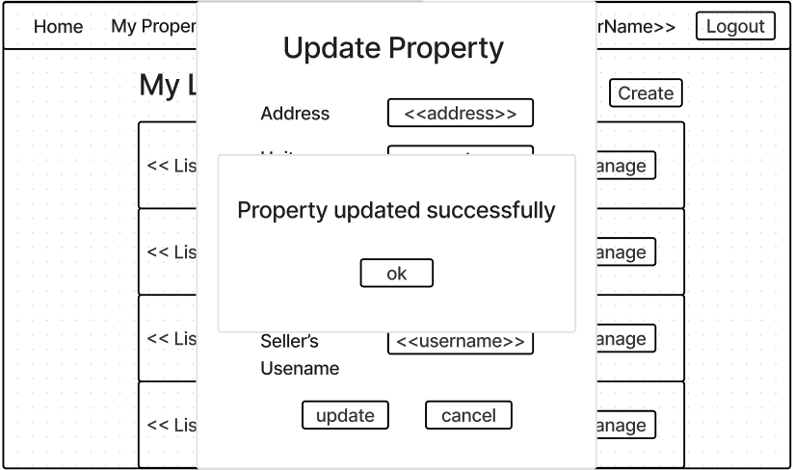

## 

## #27 REA - Delete properties

*#435 User Story*

As a Real Estate Agent, I want to be able to Delete a property listing from the platform, either because it has been sold or rented out, or because it is no longer available for other reasons.

*#436 Use Case Diagram*

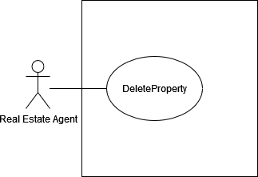

*#437 Use Case Description*

| **Name:** REA - delete properties | **ID:** #27 |
| --- | --- |
| **Stakeholders and goals:** REA - To delete a property from the listings | |
| **Description:** Real Estate Agent selects one of the properties and clicks on delete button, system verifies the action and removes it from the database. | |
| **Actors:** Real Estate Agent | |
| **Trigger:** When Real Estate Agent clicks the delete button | |
| **Pre-condition:**  Real Estate Agent is logged in  Real Estate Agent is currently on REA’s “My Properties” page | |
| **Main flow:**  1. Real Estate Agent clicks on the “Manage” button  2. System redirects user to REA's update property page  3. Real Estate Agent clicks “Delete” button 4. System displays “Are you sure you want to delete this property?”  5. Real Estate Agent clicks on “Yes” button 6. System deletes the property from the list 7. End | |
| **Sub-flows:** None. | |
| **Alternative/Exceptional flows:**  6.a. SQLError: System displays “Error deleting Property” | |

*#438 BCE Diagram*

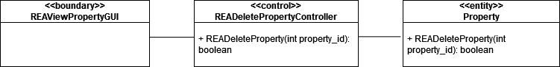

*#439 Sequence Diagram*

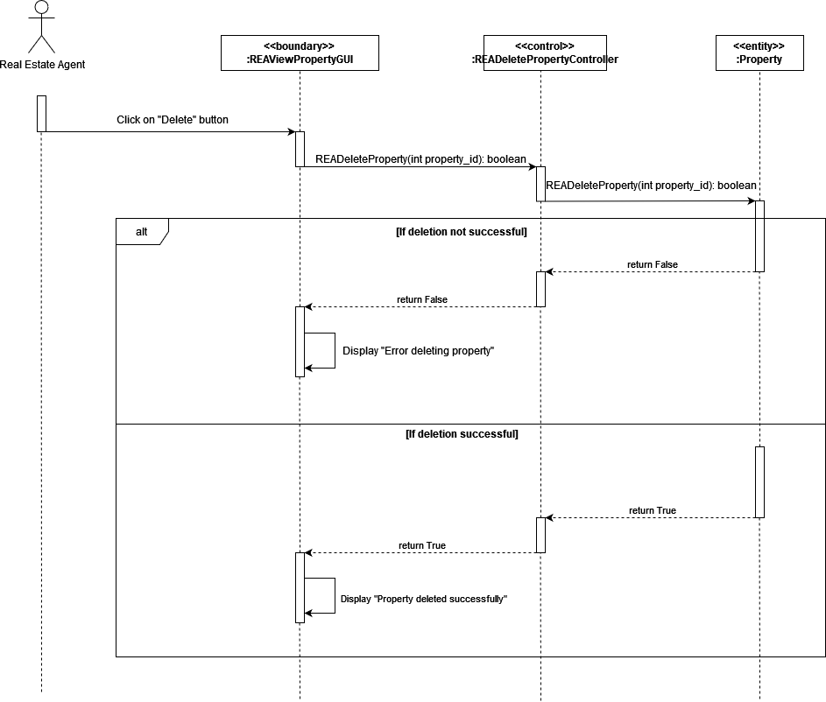

*#440 Test Case*

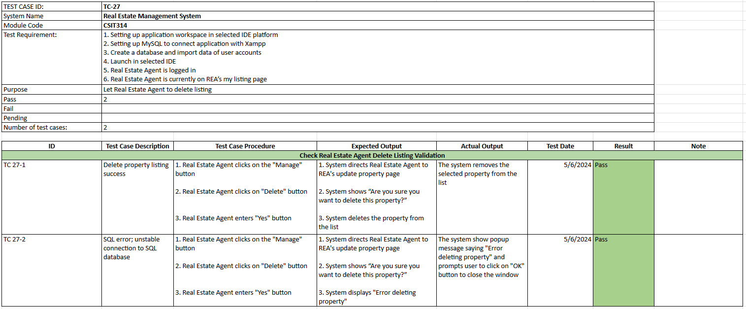

*#441 Wireframe*

**

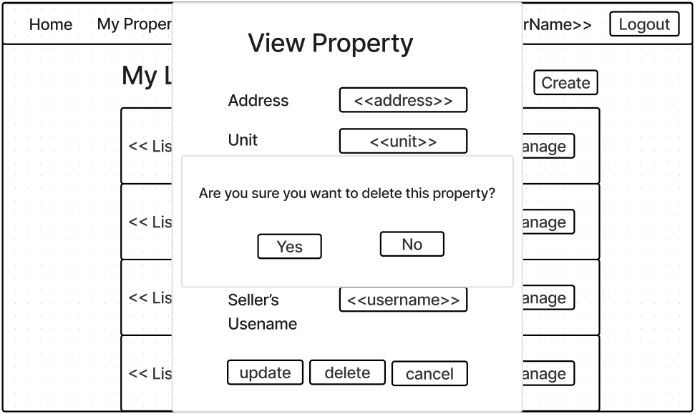

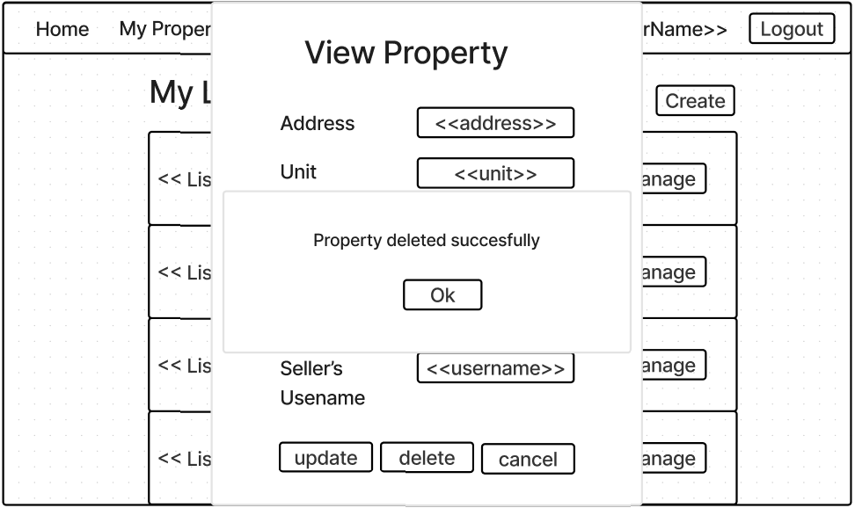

## 

## #30 REA - View ratings

*#459 User Story*

As a Real Estate Agent, I want to be able to view the average rating I have been given by buyers and sellers so that I can review my own performance based on ratings given.

*#460 Use Case Diagram*

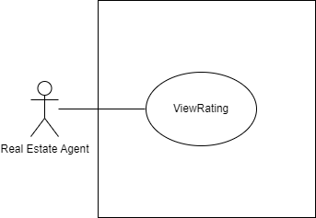

*#461 Use Case Description*

| **Name:** REA - view ratings | **ID:** #30 |
| --- | --- |
| **Stakeholders and goals:** REA - To view ratings for agent | |
| **Description:** Real Estate Agent clicks on “Reviews” and the system displays the Real Estate Agent’s average rating. | |
| **Actors:** Real Estate Agent | |
| **Trigger:** When Real Estate Agent clicks on the Review label | |
| **Pre-condition:**  Real Estate Agent is logged in | |
| **Main flow:**  1. Real Estate Agent clicks on the “Reviews”  2. System redirects Real Estate Agent to Review page  3. System displays current Real Estate Agent’s average rating  4. End | |
| **Sub-flows:** None. | |
| **Alternative/Exceptional flows:** | |

*#462 BCE Diagram*

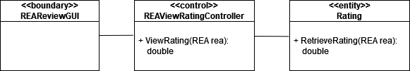

*#463 Sequence Diagram*

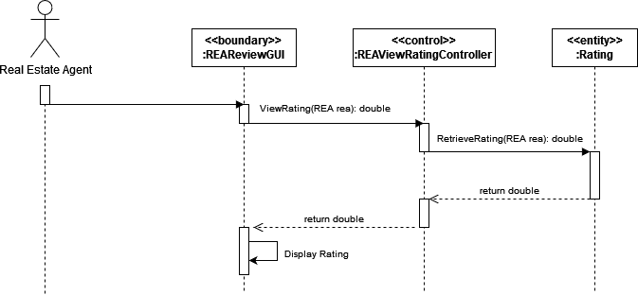

*#464 Test Case*

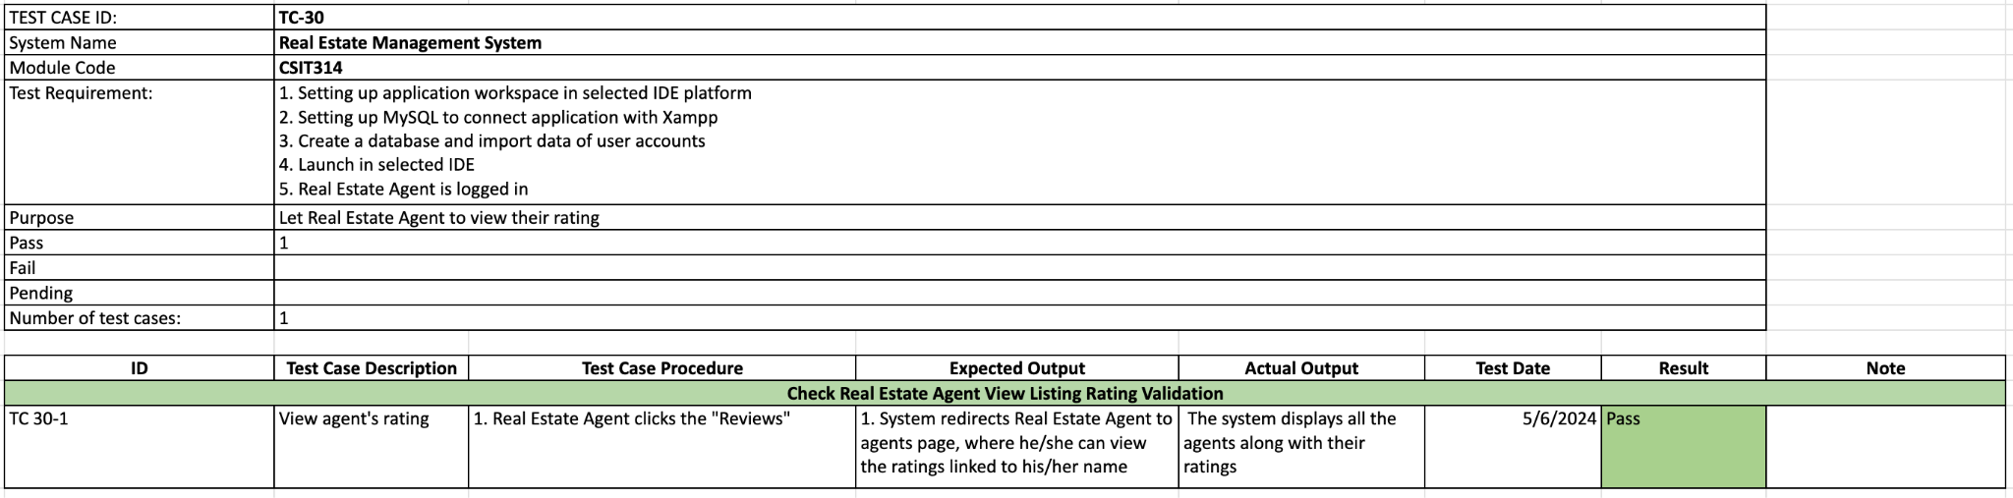

*#465 Wireframe*

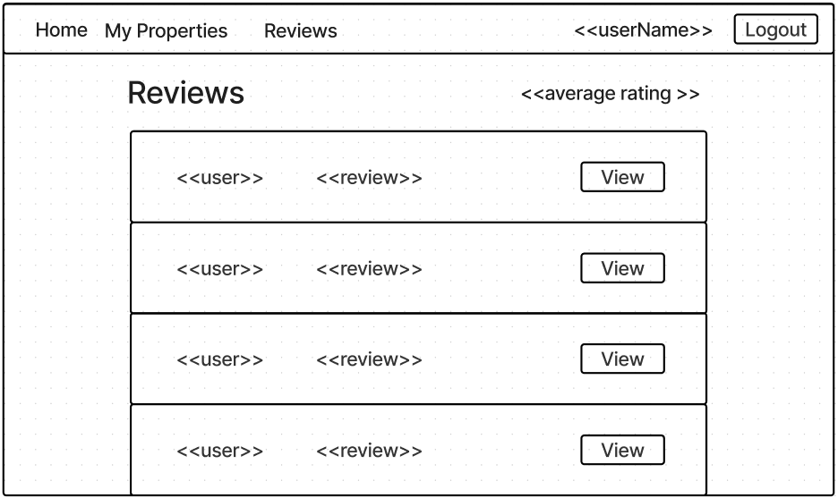

## 

## #32 REA - View reviews

*#475 User Story*

As a Real Estate Agent, I want to be able to view a review I have been given so that I can review my own performance based on the details of reviews.

*#476 Use Case Diagram*

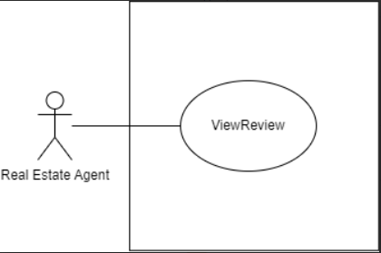

*#477 Use Case Description*

| **Name:** REA - view reviews | **ID:** #32 |
| --- | --- |
| **Stakeholders and goals:** REA - To view reviews for agent | |
| **Description:** Real Estate Agent clicks on the “view” button tagged to a specific review and the system displays the review that were given to that agent. | |
| **Actors:** Real Estate Agent | |
| **Trigger:** When Real Estate Agent clicks on the Review label | |
| **Pre-condition:**  Real Estate Agent is logged in  Real Estate Agent is on the Reviews page | |
| **Main flow:**  1. System displays all reviews under Real Estate Agent  2. Real Estate Agent clicks on “view” button tagged to a specific review  3. System redirects user to the page that displays the details of the review  4. End | |
| **Sub-flows:** None. | |
| **Alternative/Exceptional flows:** | |

*#478 BCE Diagram*

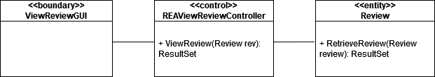

*#479 Sequence Diagram*

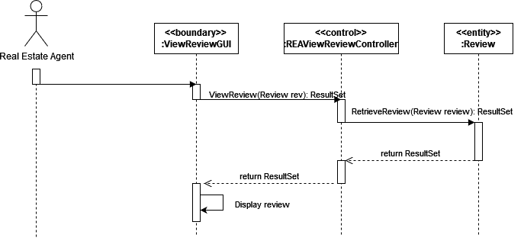

*#480 Test Case*

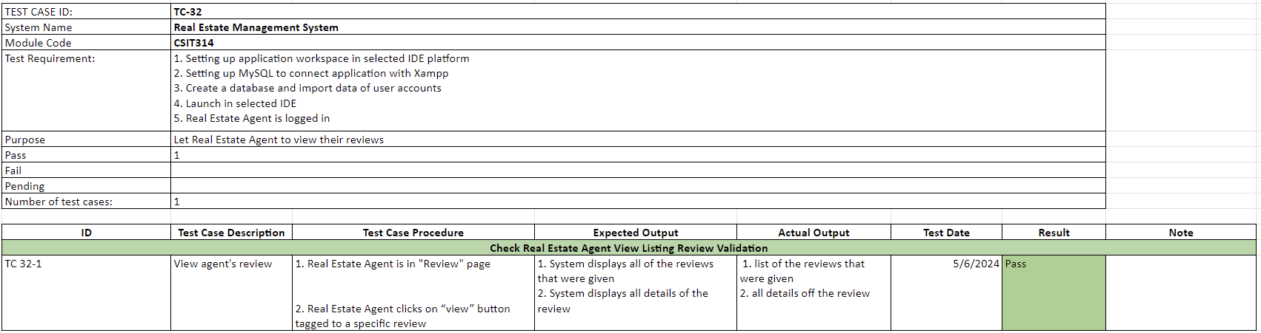

*#481 Wireframe*

**

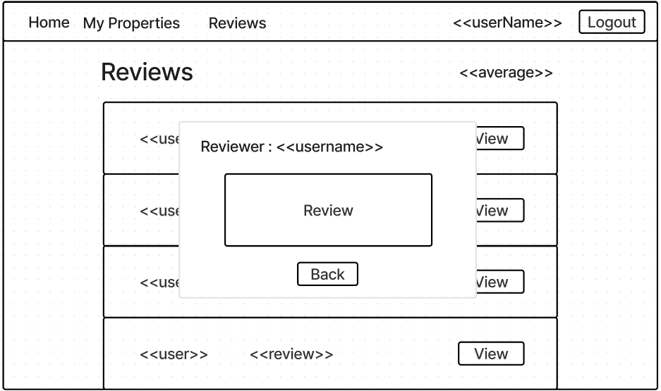

## 

## #28 Seller - View number of times my property has been viewed

*#451 User Story*

As a Seller, I want to view the number of times my property has been viewed, so that I can monitor the level of interest and engagement on my property listings.

*#452 Use Case Diagram*

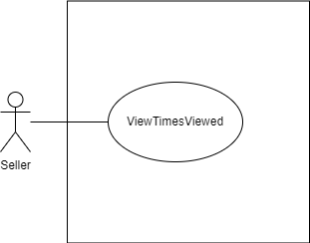

*#453 Use Case Description*

| **Name:** Seller - view property’s number of views | **ID:** #28 |
| --- | --- |
| **Stakeholders and goals:** Seller - To be able to view the number of times that my property listings have been viewed | |
| **Description:** Seller clicks on “View” button to view his or her property information and the system displays the number of times the property has been viewed. | |
| **Actors:** Seller | |
| **Trigger:** When Seller clicks on “View” button | |
| **Pre-condition:**  Seller is logged in  Seller is on main page | |
| **Main flow:** 1. Seller clicks on “View” button beside their property listing 2. System redirects Seller to view property page with times viewed displayed 3. Seller views how many times each property has been viewed  4. End | |
| **Sub-flows:** None. | |
| **Alternative/Exceptional flows:** | |

*#454 BCE Diagram*

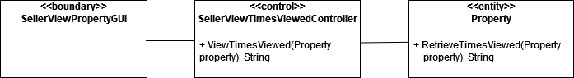

*#455 Sequence Diagram*

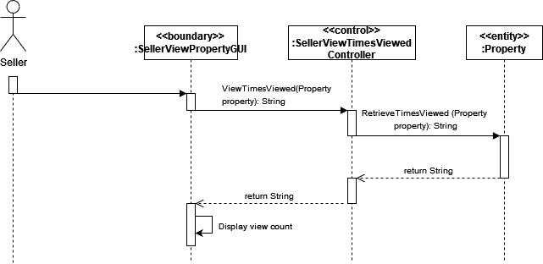

*#456 Test Case*

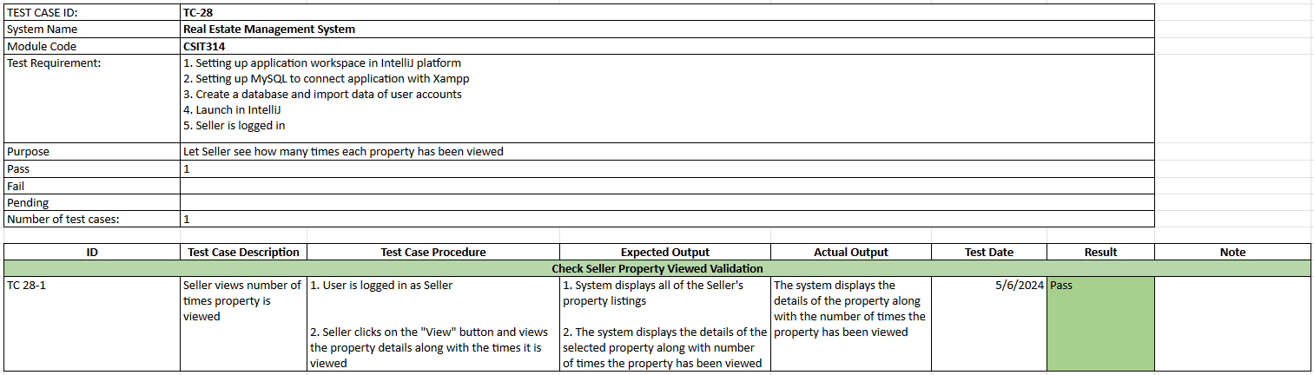

*#457 Wireframe*

## 

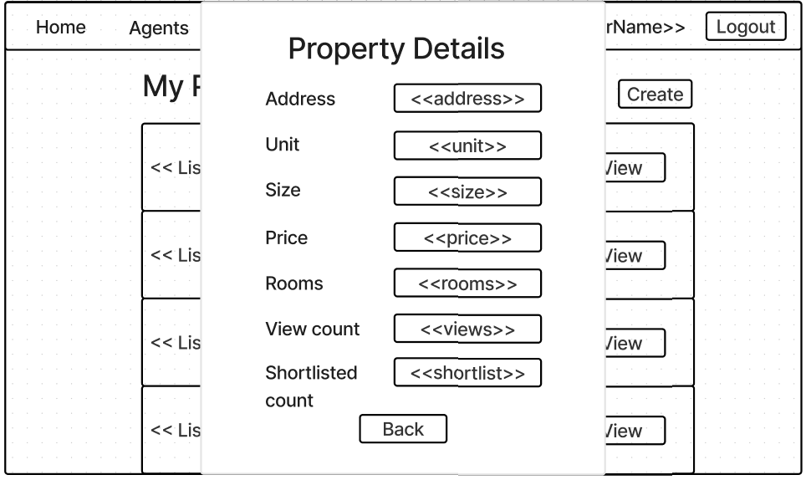

## 

## #31 Seller - View number of times my property has been shortlisted

*#467 User Story*

Seller - To be able to view the number of times that my property listings have been shortlisted.

*#468 Use Case Diagram*

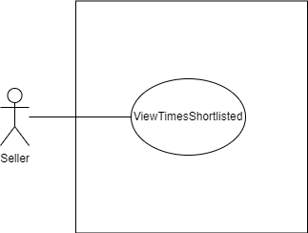

*#469 Use Case Description*

| **Name:** Seller - view shortlisted properties | **ID:** #31 |
| --- | --- |
| **Stakeholders and goals:** Seller - To be able to view the number of times that my property listings have been shortlisted | |
| **Description:** Seller clicks on “View” button to view his or her property information and the system displays the number of times the property has been shortlisted. | |
| **Actors:** Seller | |
| **Trigger:** When Seller clicks on “View” button | |
| **Pre-condition:**  Seller is logged in  Seller is on main page | |
| **Main flow:** 1. Seller clicks on “View” button beside their property listing 2. System redirects Seller to view property page with times shortlisted displayed 3. Seller views how many times each property has been shortlisted  4. End | |
| **Sub-flows:** None. | |
| **Alternative/Exceptional flows:** | |

*#470 BCE Diagram*

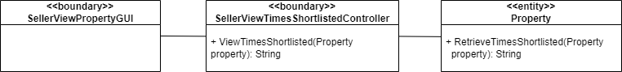

*#471 Sequence Diagram*

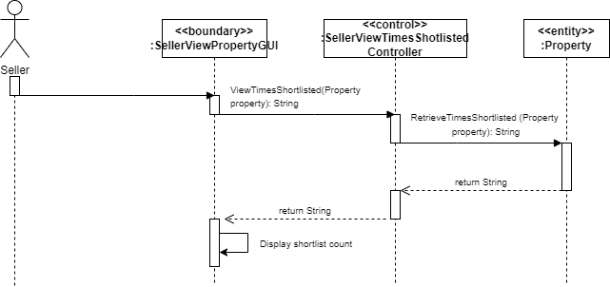

*#472 Test Case*

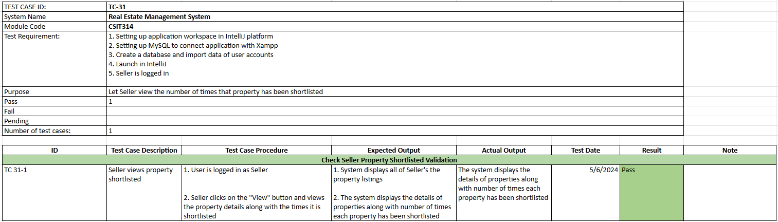

*#473 Wireframe*



## #597 Seller - View agents

*#598 User Story*

As a Seller, I want to view details of an agent who is tied to my property so that I can check their contact number or experience.

*#599 Use Case Diagram*

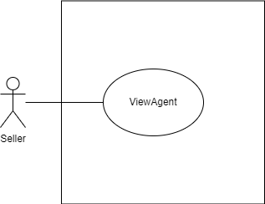

*#600 Use Case Description*

| **Name:** Seller - view agents tied to properties | **ID:** #597 |
| --- | --- |
| **Stakeholders and goals:** Seller - To be able to view Real Estate Agent tied to my properties | |
| **Description:** Seller clicks on “Agent” label and “View” button beside Real Estate Agent’s name and the system displays the details of the selected Real Estate Agent | |
| **Actors:** Seller | |
| **Trigger:** When Seller clicks on “View” button | |
| **Pre-condition:**  Seller is logged in  Seller is on the Agents Page | |
| **Main flow:** 1. System displays the list of the agent accounts  2. Seller clicks on “View” button beside selected Real Estate Agent account  3. System shows the agent’s information  4. End | |
| **Sub-flows:** None. | |
| **Alternative/Exceptional flows:** | |

*#601 BCE Diagram*

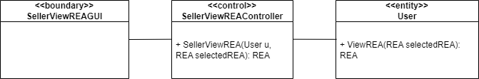

*#602 Sequence Diagram*

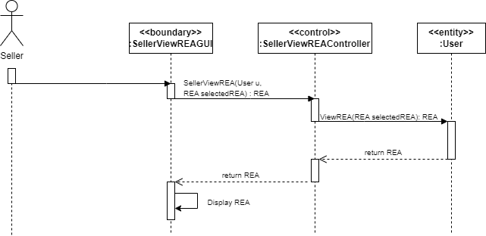

*#603 Test Case*

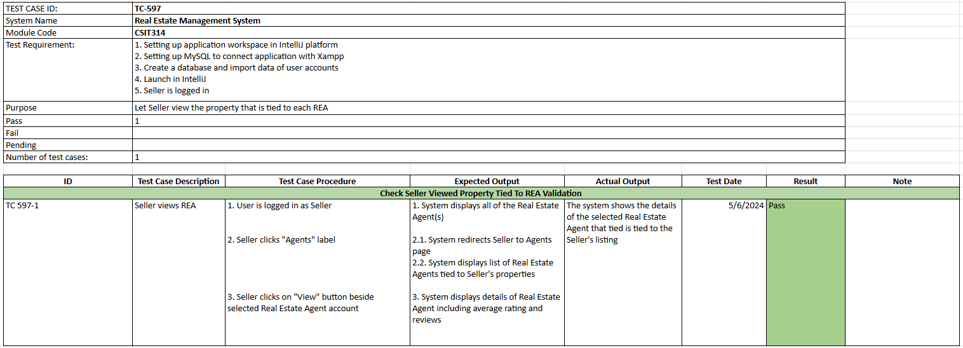

*#604 Wireframe*

# 

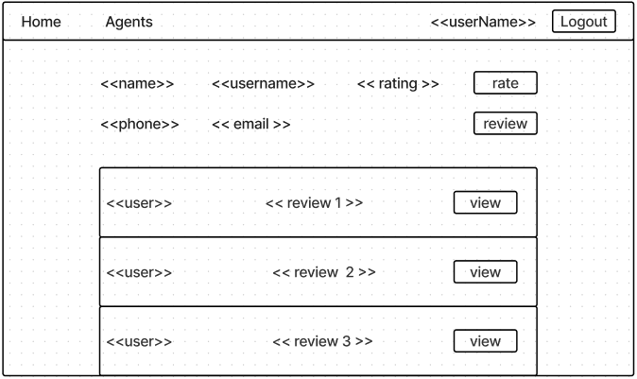

# 

# 

# Sprint Four

**Duration: 6th May - 13th May**

## Sprint Planning, Review and Retrospective

| **Meeting Date**: 06/05/2024 (Monday) | | |
| --- | --- | --- |
| **Duration:** 14:00 - 15:00 | | |
| **Sprint duration:** 06/05/2024 - 13/05/2024 | | |
| **Attendees:**  Lim Wootaek, Viktor, Wei Hong, Roydenn, Frentsen, Jerry | | **Agenda** |
| 1. Sprint 3 review 2. discuss about the tasks for sprint 4 |
| **Absentees:**  N/A | |
|
| **What we have done** | | **Roydenn**   * Draw Sequence diagrams * Coding & sequence diagram   + REA - view reviews   + REA - view ratings   + REA - delete listing   **Wootaek**   * Update class diagram * Check the existing diagrams with our product owner (sprint summaries) * Coding & sequence diagram * REA - create listing * REA - view listing * Take a look at UserViewAccount/ AdminViewUserAccount   **Wei Hong**   * Coding & sequence diagram * GUI - REA own listing * Cleaning up code * Seller view own properties (including the number of times shortlisted and ratings)   **Vuong**   * Coding & sequence diagram   + Fix Update function to return to main page   + REA - update/modify listings   **Jerry & Frentsen**   * Draw diagrams based on the sequence diagrams (sprint 1, 2 and 3) * Improve diagrams for sprint 1 or 2 based on our product owner’s feedback, if needed * Write a report for sprint 2 & 3 * Finish sprint summary for sprint 2 and 3 (3 is optional) |
| **Reflection** | | **What went well:**  Database updated to be scalable with no issues.  Coding has gone very well with no issues from the coders.  **What could be improved:** |
| **What we are going to do for this sprint** | | **Roy**   * Coding & Sequence Diagram   + Buyer - Calculate mortgage estimate   + Buyer - View OLD property listings   + Buyer - View NEW property listings   + Buyer- review real estate agents   + Seller - review real estate agents   **Wootaek**   * Coding & Sequence Diagram   + Buyer - Search for NEW property listings   + Buyer - Search for OLD property listings   + Buyer - Search Properties by address   + Update class diagram and get feedback on the class diagram for the last sprint. * CI/CD   **Wei Hong**   * Coding & Sequence Diagram   + Seller - rate real estate agents   + Buyer- rate real estate agents   + Buyer - View REA profile   + Seller - review real estate agents   + Seller - rate real estate agents   **Vuong**   * Coding & Sequence Diagram   + Buyer - Add NEW property listings to a favorites   + Buyer - Add OLD property listings to favorites   **Jerry & Frentsen**   * Draw diagrams based on the sequence diagrams for selected user stories in this sprint * Finish sprint summary for this sprint |

## Taiga - Start

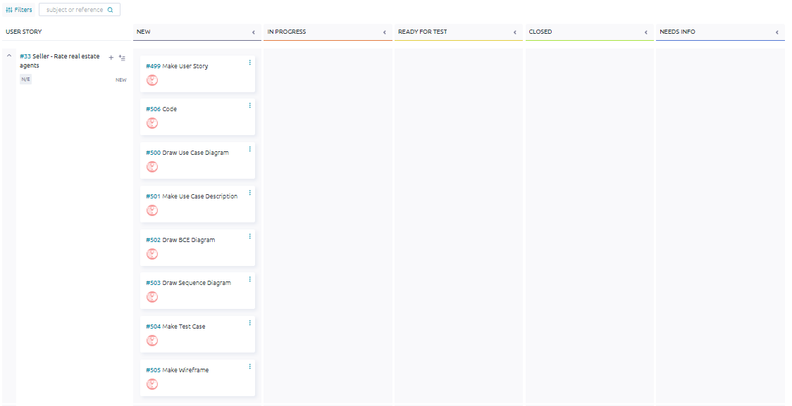

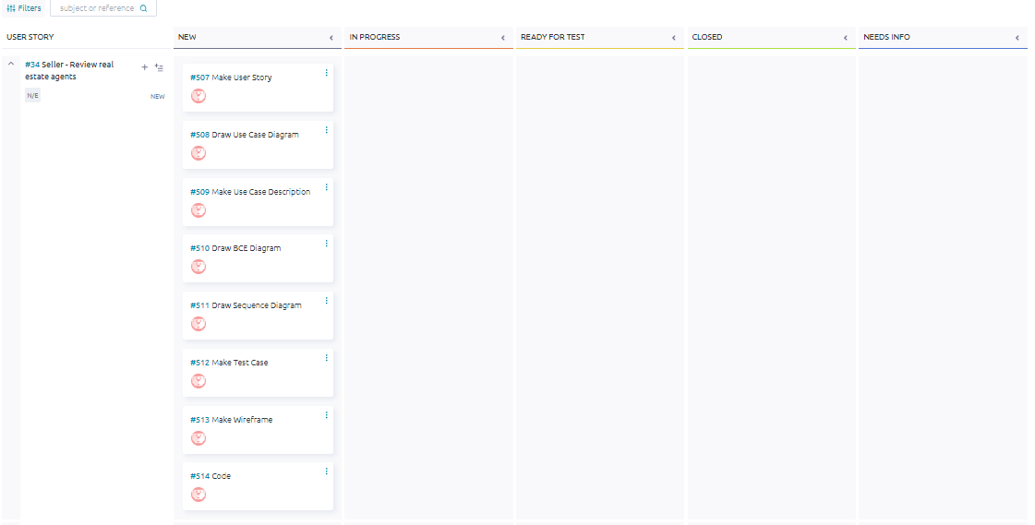

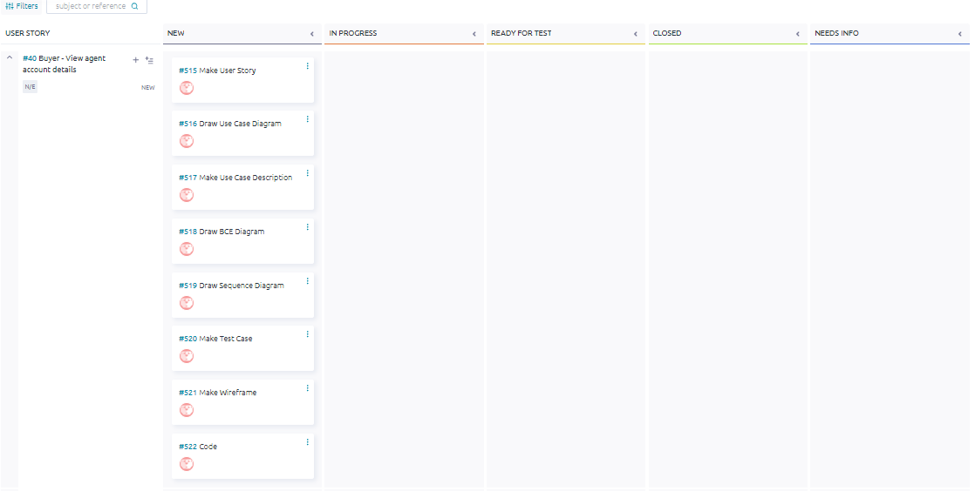

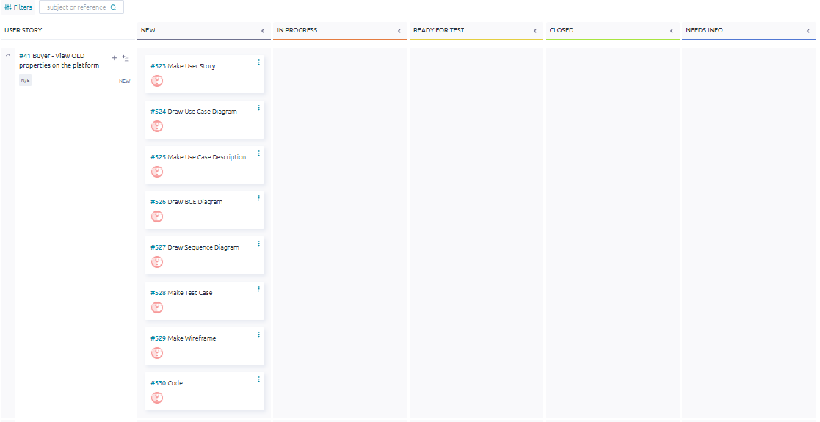

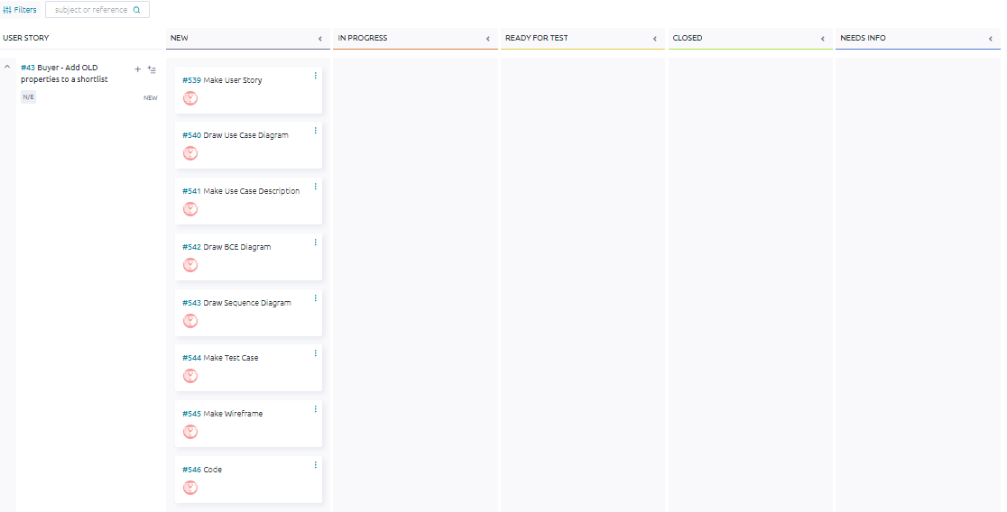

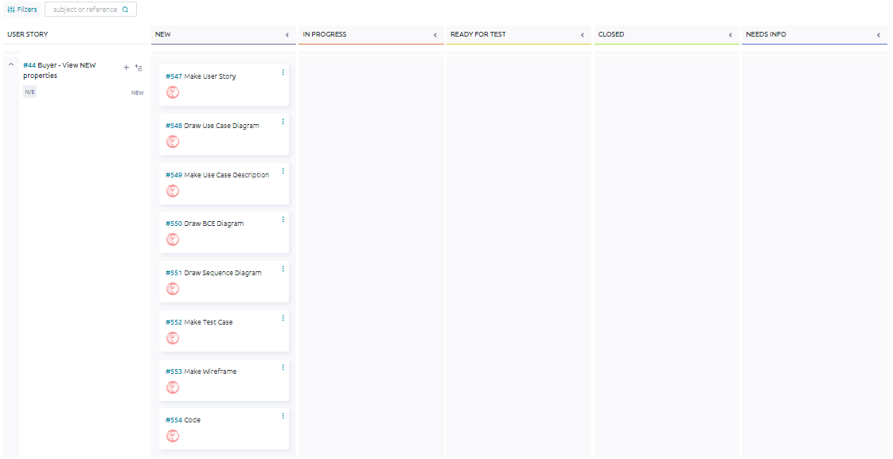

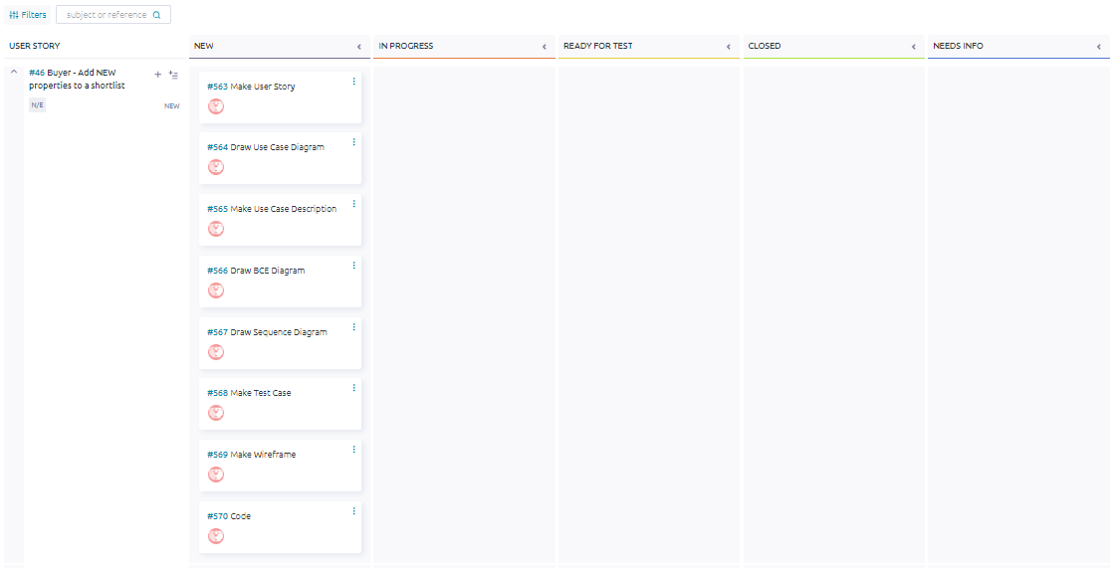

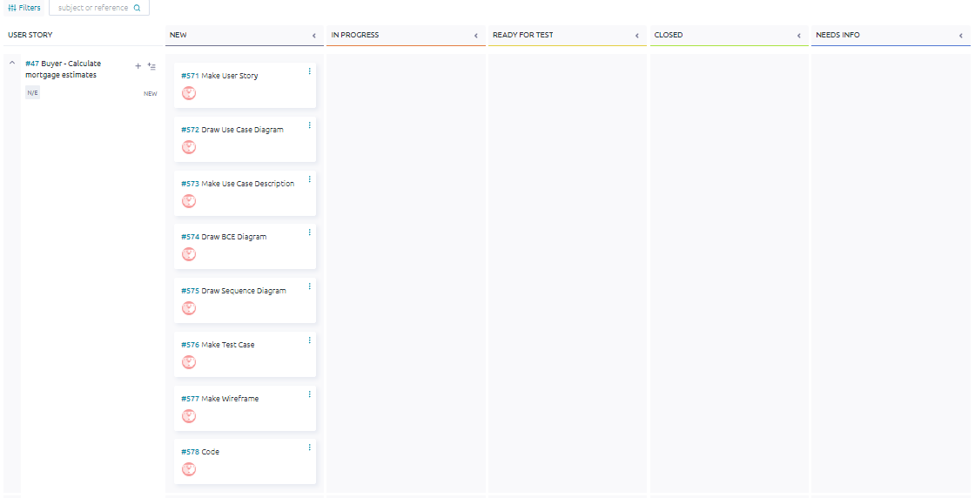

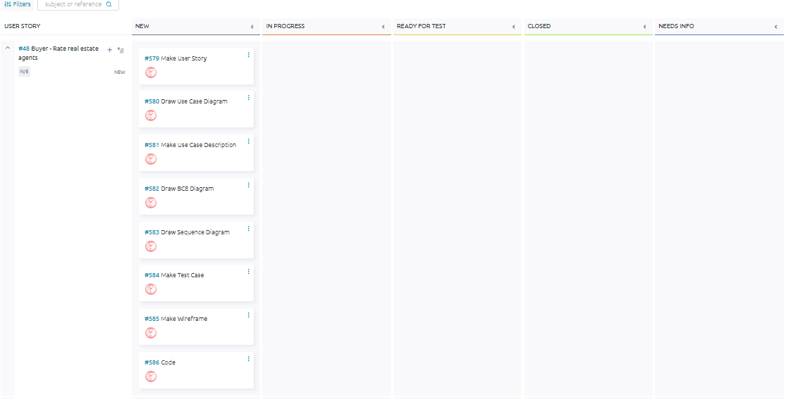

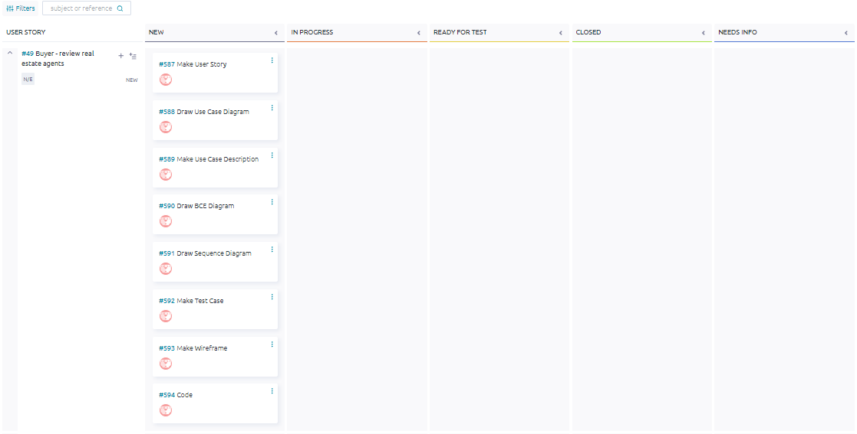

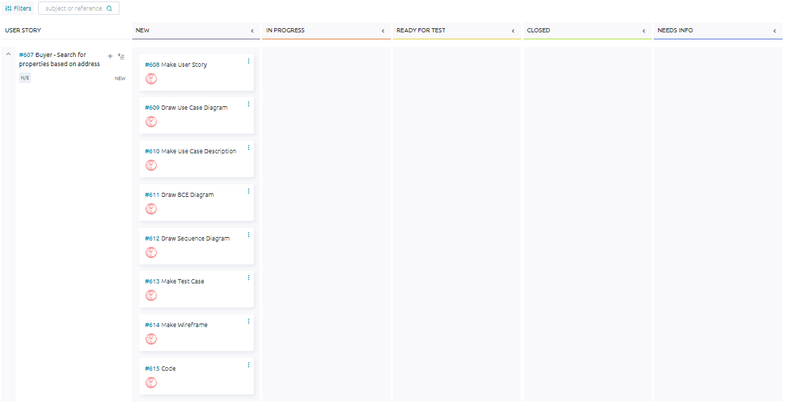

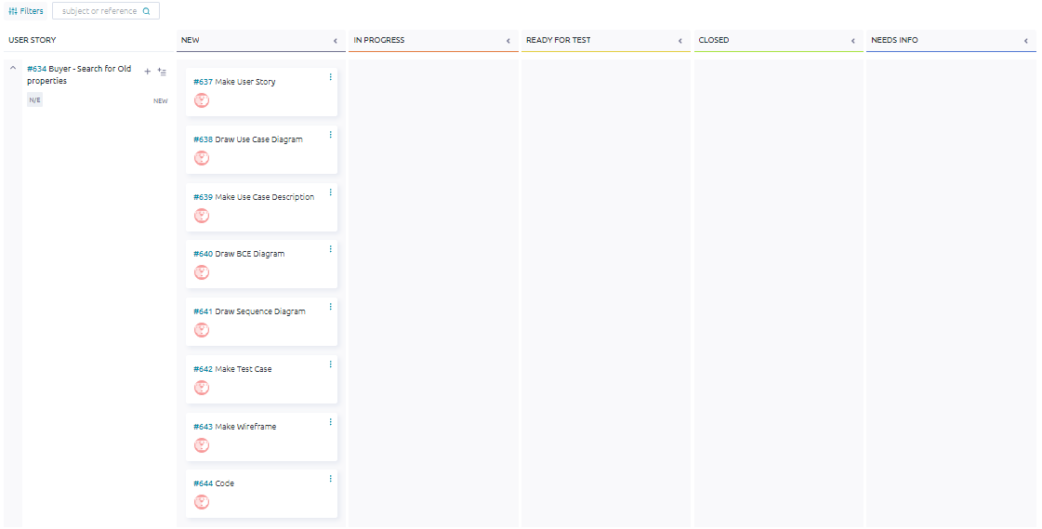

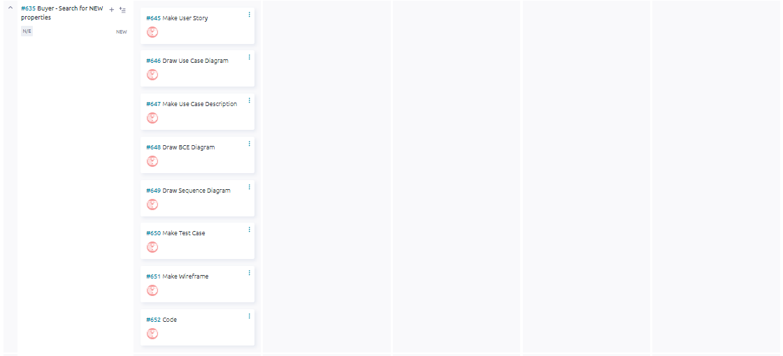

## Taiga - End

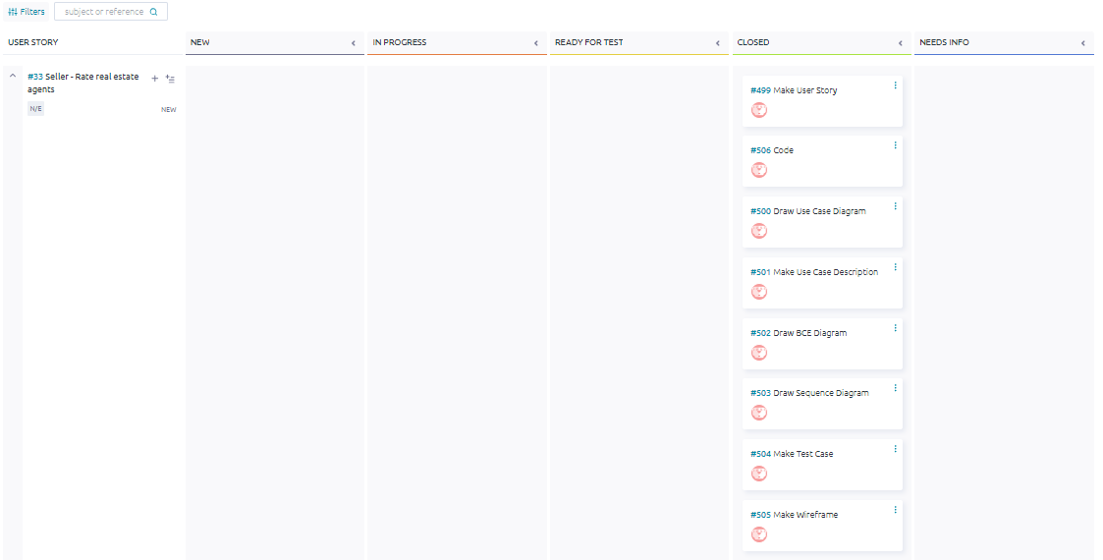

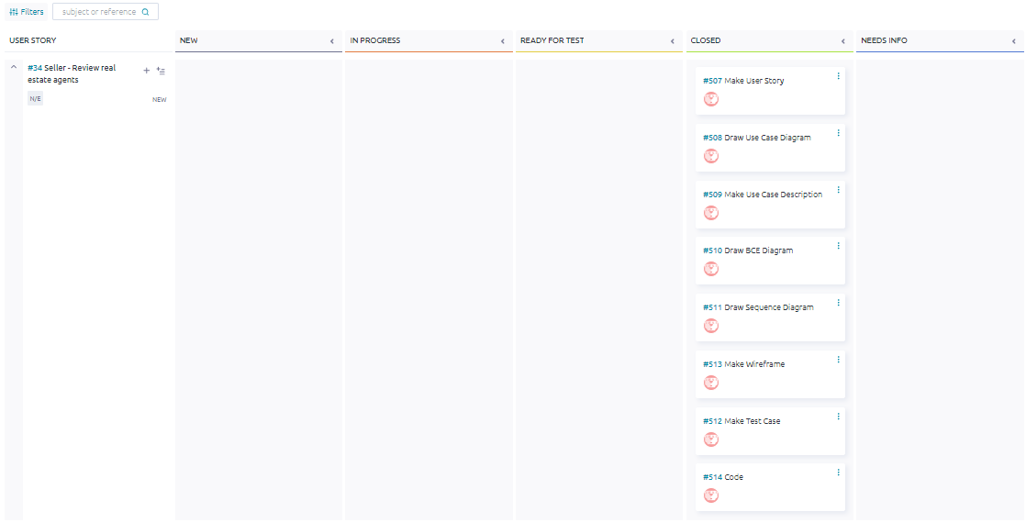

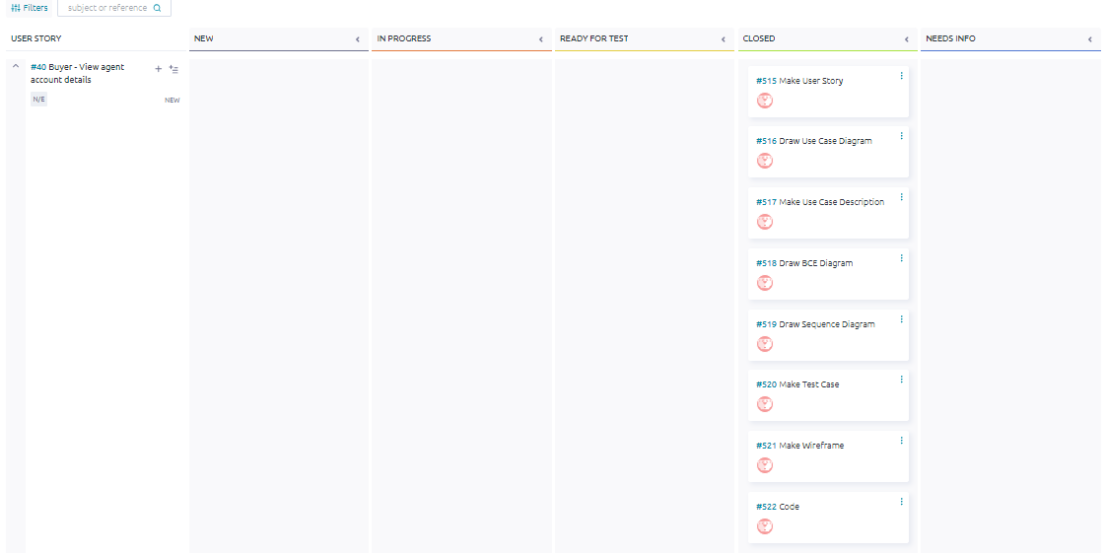

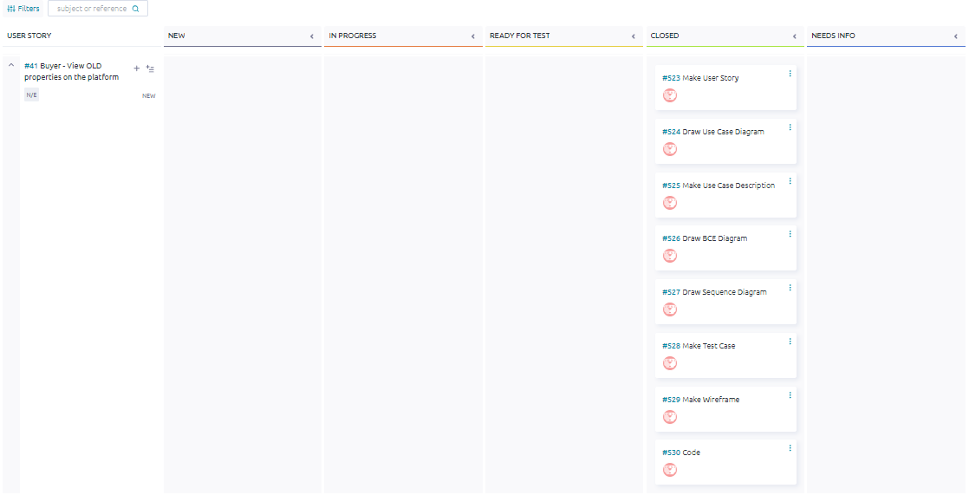

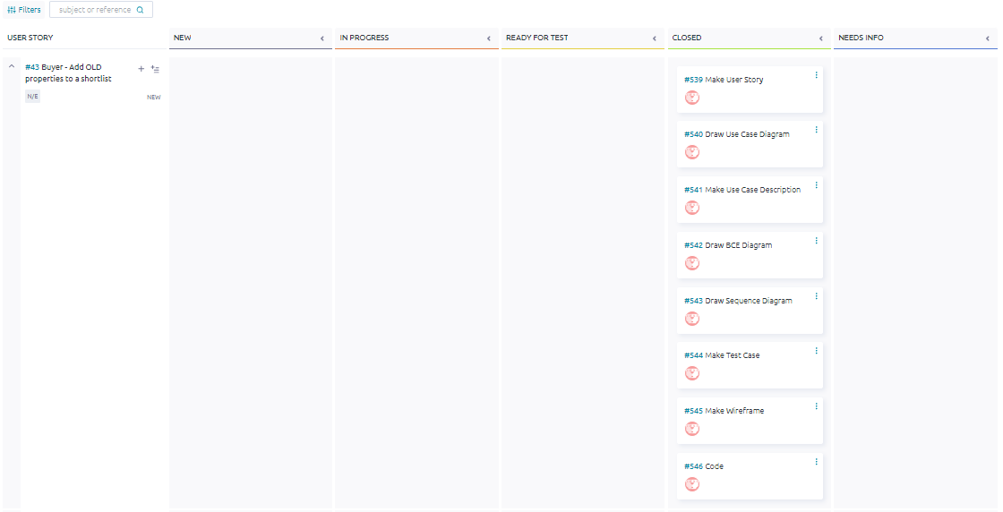

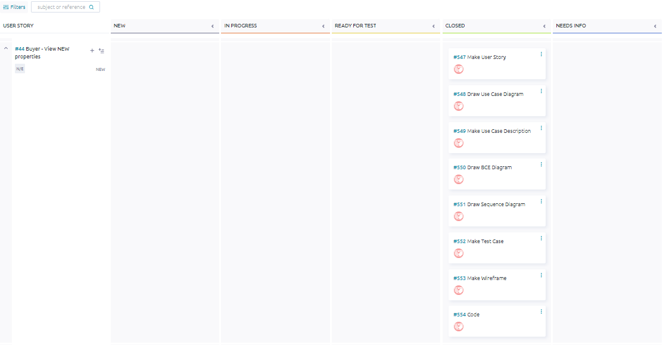

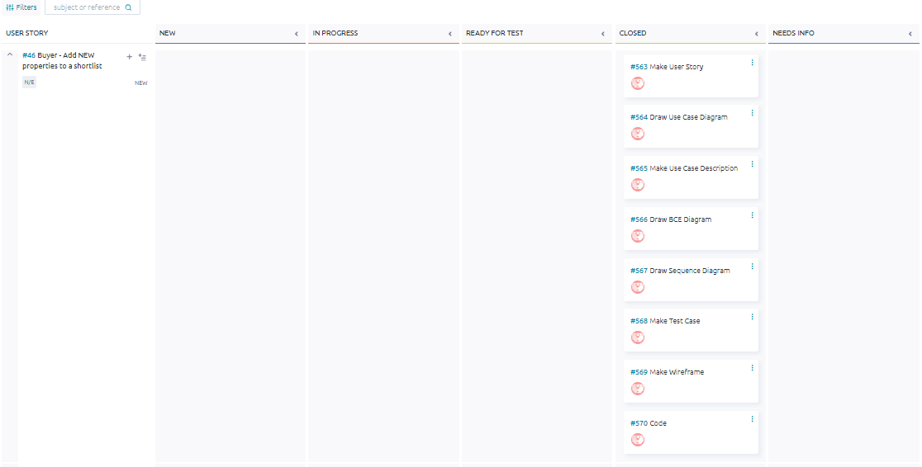

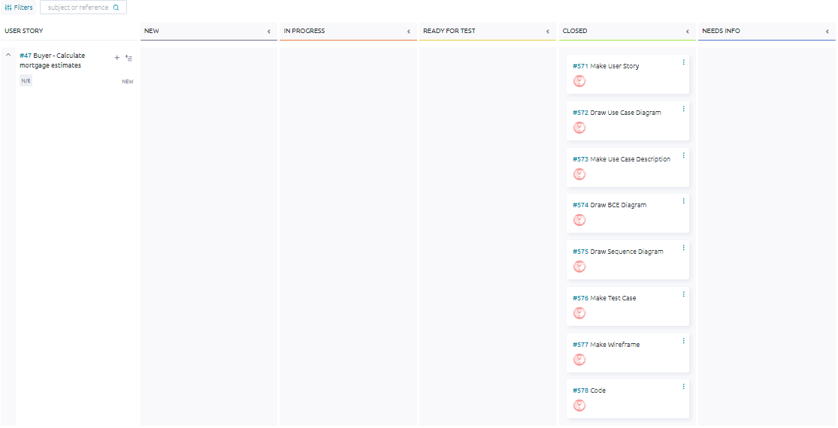

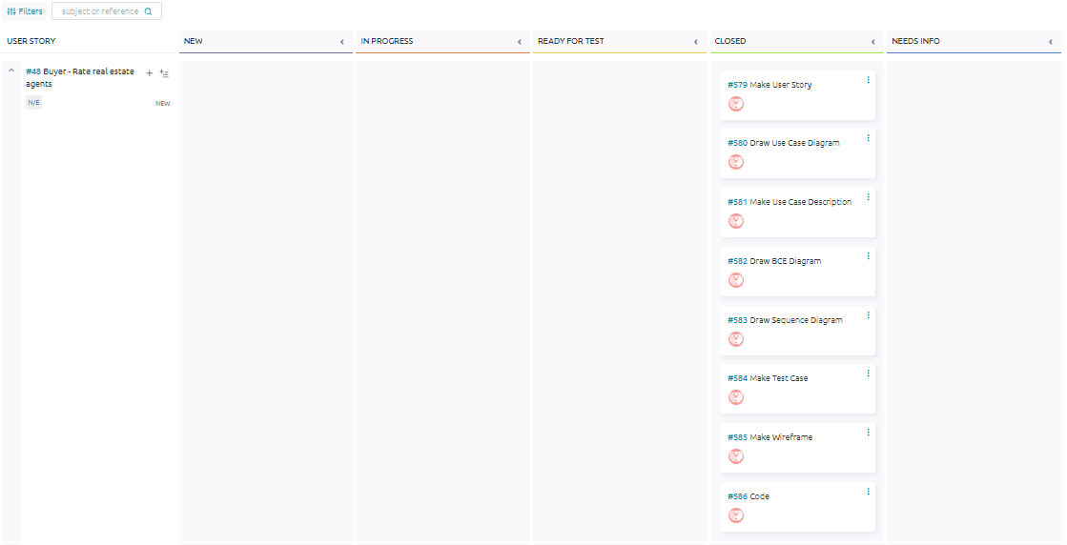

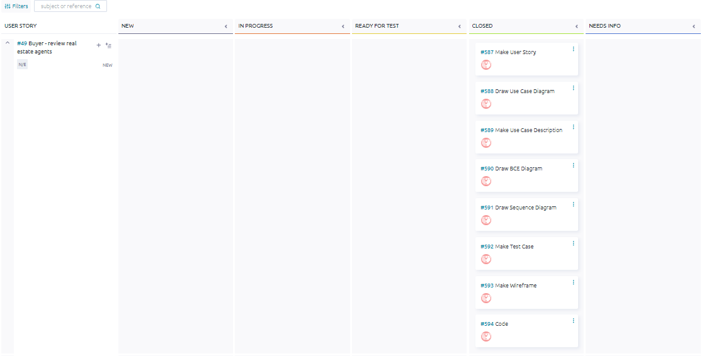

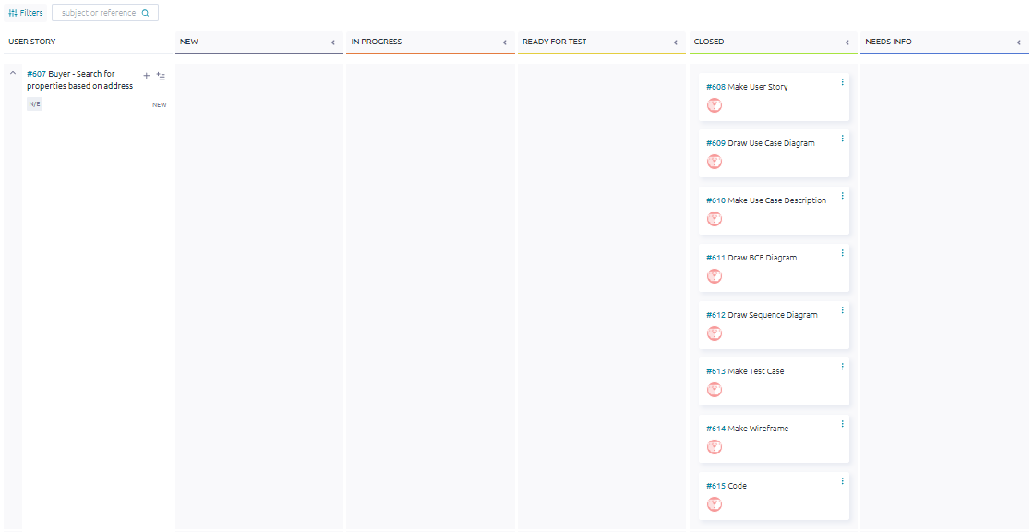

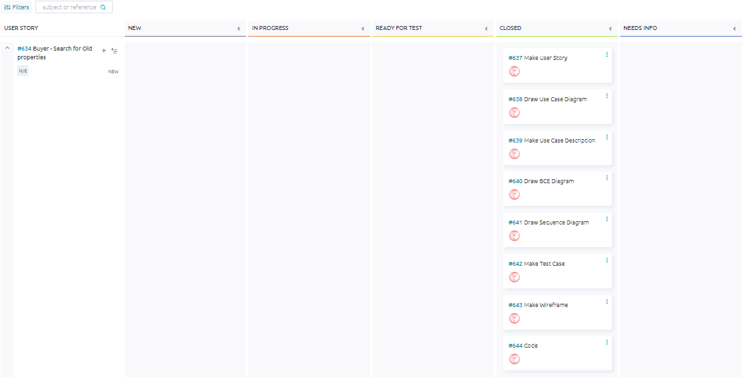

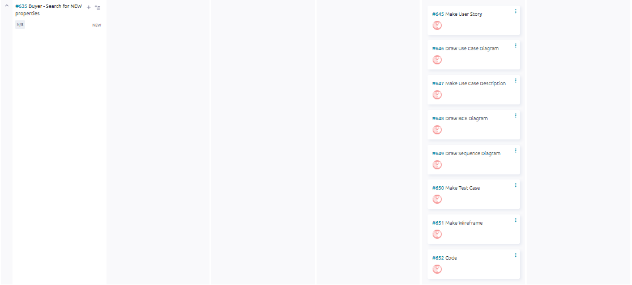

## 

## ER Diagram

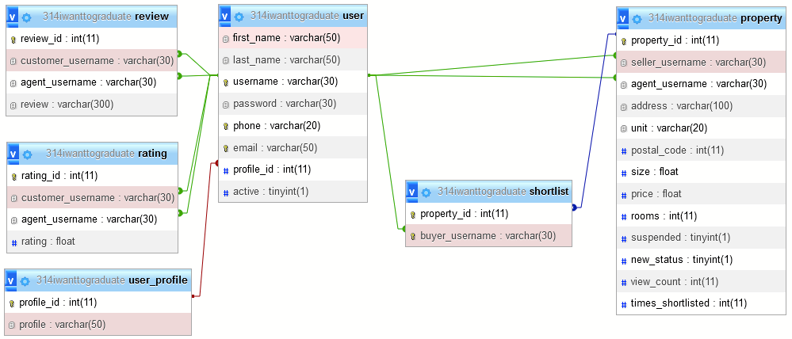

## Class Diagram

## 

## 

## #33 Seller - Rate real estate agents

*#499 User Story*

As a seller, I want to rate real estate agents based on my experience with them, providing feedback to help other users make informed decisions.

*#500 Use Case Diagram*

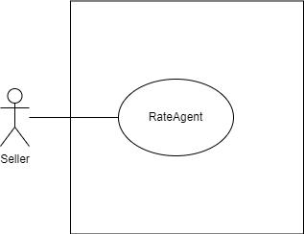

*#501 Use Case Description*

| **Name:** Seller - Rate real estate agents | **ID:** #33 |
| --- | --- |
| **Stakeholders and goals:** Seller - rate agents based on my experience | |
| **Description:** Seller selects an agent, clicks the “rate” button and gives a rating. | |
| **Actors:** Seller | |
| **Trigger:** When Seller clicks “Rate” button when viewing Real Estate Agent | |
| **Pre-condition:**  Seller is logged in  Seller is currently on view REA profile page | |
| **Main flow:**   1. Seller clicks on the “Rate” button on the specific Agent’s account page 2. Seller gives rating. 3. Seller clicks on the “Submit” button. 4. System validates the input. 5. System creates a new rating under the agent. 6. The system shows a pop-up dialogue saying “Rating submitted.”. 7. Seller clicks on the “OK” button to acknowledge the message. 8. The system redirects the user back to the Agent’s account page 9. End | |
| **Sub-flows:** None. | |
| **Alternative/Exceptional flows:**  4.a: If the rating field is empty: System displays “Please enter a rating.” 4.b: If the rating field is less than 0 or more than 5: System displays “Please enter a rating between 0 and 5.” 4.c: If the rating field is not a number: System displays “Please enter a valid rating.”  4.d: If SQL error occurs: System displays “Rating failed to submit.” | |

*#502 BCE Diagram*

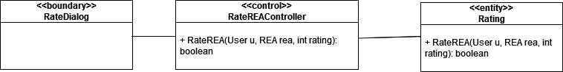

*#503 Sequence Diagram*

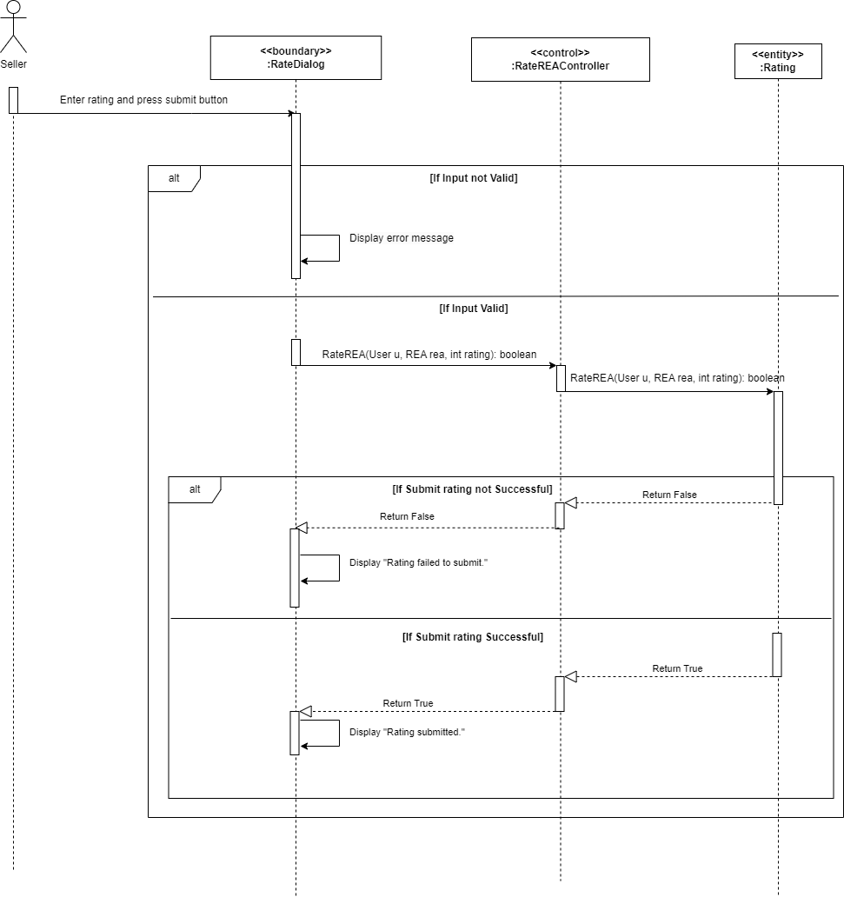

*#504 Test Case*

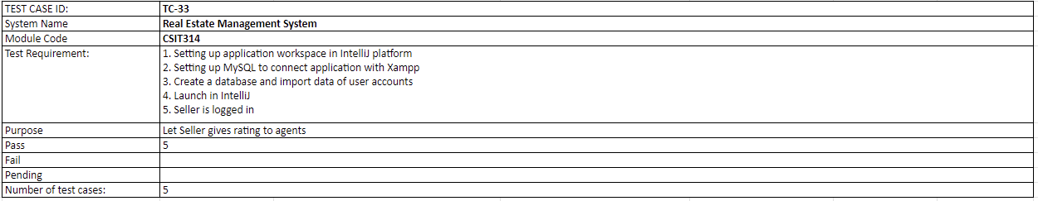

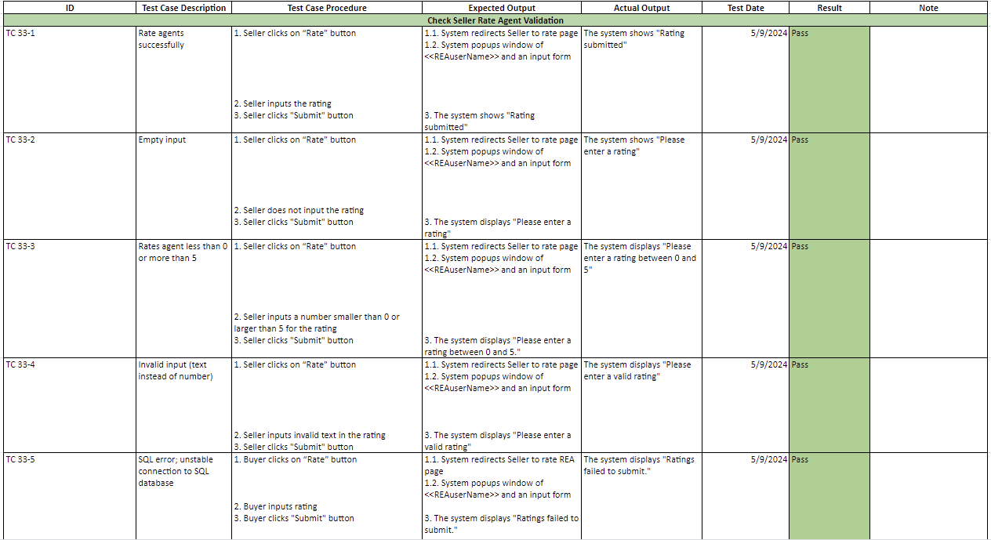

*#505 Wireframe*

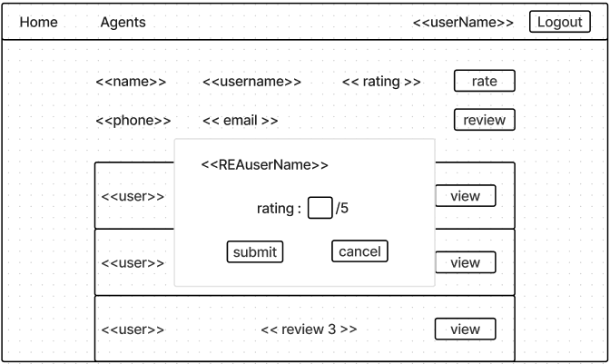

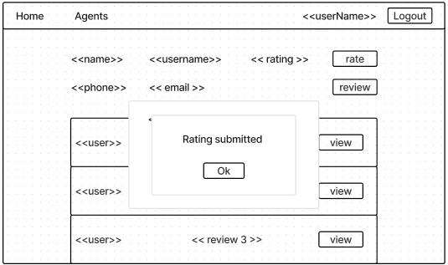

## #34 Seller - Review real estate agents

*#507 User Story*

As a Seller, I want to review real estate agents based on my experience with them, providing feedback to help other users make informed decisions.

*#508 Use Case Diagram*

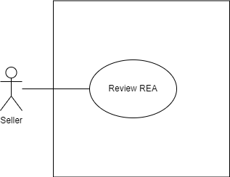

*#509 Use Case Description*

| **Name:** Seller - Review real estate agents | **ID:** #34 |
| --- | --- |
| **Stakeholders and goals:** Seller- review real estate agent | |
| **Description:** Seller leaves a review on a specific real estate agent by clicking on the “Review” button. | |
| **Actors:** Seller | |
| **Trigger:** When Seller clicks on “Review” button when viewing Real Estate Agent | |
| **Pre-condition:**  Seller is logged in  Seller is currently on view REA profile page | |
| **Main flow:**   1. Seller clicks on “Review” button 2. System popups window of agent’s username and text box column 3. Seller writes review 4. Seller clicks “Submit” button 5. System validates the input. 6. System creates a new review under the agent. 7. The system shows a pop-up dialogue saying “Review Submitted.”. 8. Seller clicks on the “OK” button to acknowledge the message. 9. The system redirects the user back to the Agent’s account page 10. End | |
| **Sub-flows:** None. | |
| **Alternative/Exceptional flows:**  5.a:If review is empty: System displays “Please enter your review”  5.b: If SQL error occurs: System displays “Review failed to submit.” | |

*#510 BCE Diagram*

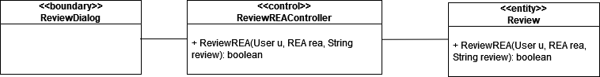

*#511 Sequence Diagram*

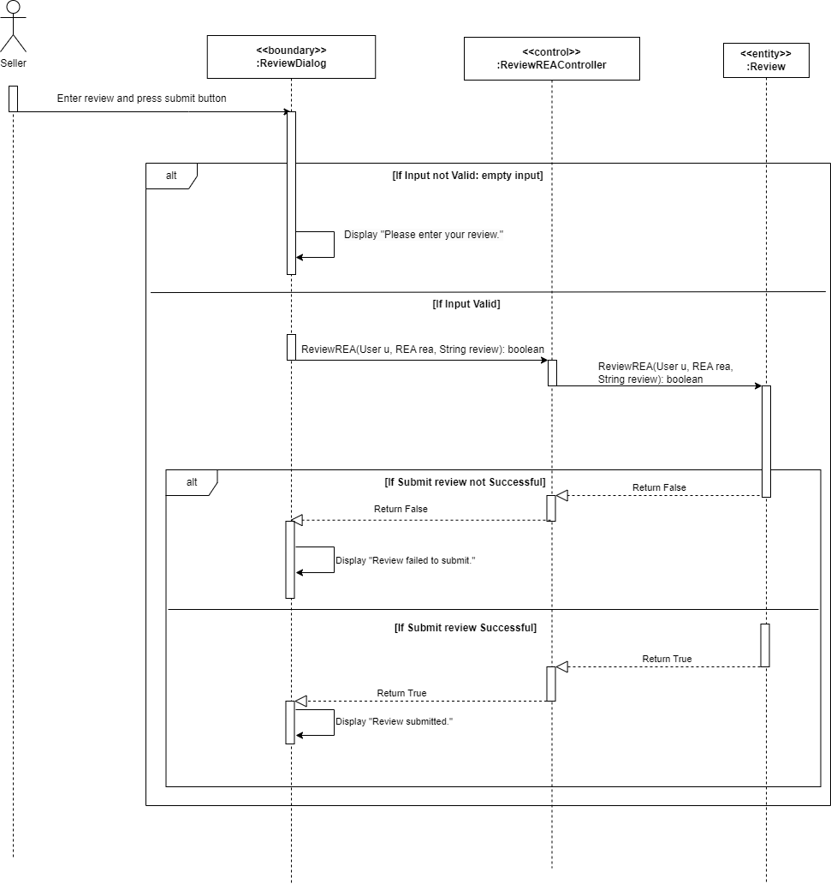

*#512 Test Case*

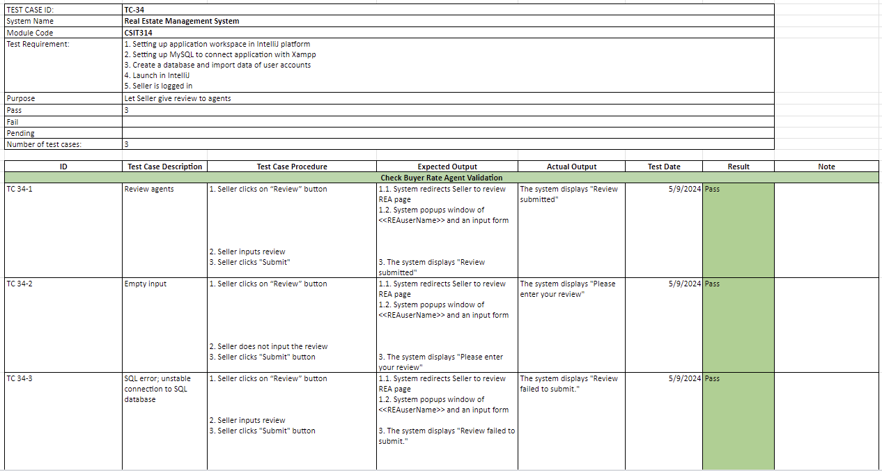

*#513 Wireframe*

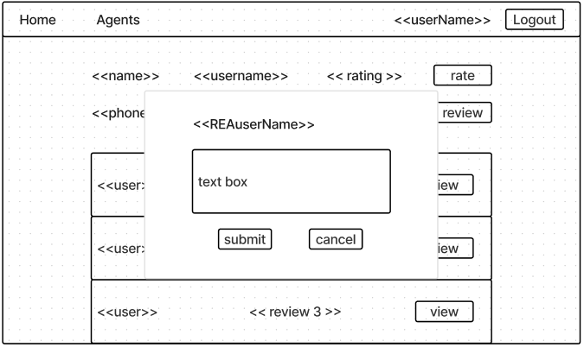

## 

## #40 Buyer - View agent account details

*#515 User Story*

As a buyer, I want to View the account details of a real estate agent, including their contact information, and reviews, to assess their suitability for my needs.

*#516 Use Case Diagram*

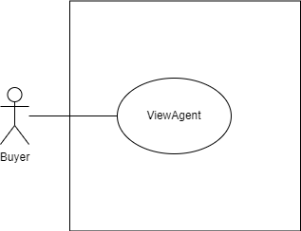

*#517 Use Case Description*

| **Name:** Buyer - view agent account details | **ID:** #40 |
| --- | --- |
| **Stakeholders and goals:** Buyer - To be able to view Real Estate Agent account details | |
| **Description:** Buyer clicks on “View” button and system displays all existing Real Estate Agents | |
| **Actors:** Buyer | |
| **Trigger:** When Buyer clicks on “View” button tagged to Real Estate Agent | |
| **Pre-condition:**  Buyer is logged in  Buyer is currently on agents page | |
| **Main flow:**  1. System displays the list of the agent accounts  2. Buyer clicks on “View” button beside selected user account  3. System shows the agent’s information  4. End | |
| **Sub-flows:** None. | |
| **Alternative/Exceptional flows:** | |

*#518 BCE Diagram*

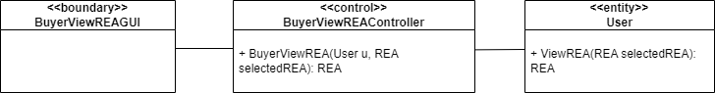

*#519 Sequence Diagram  
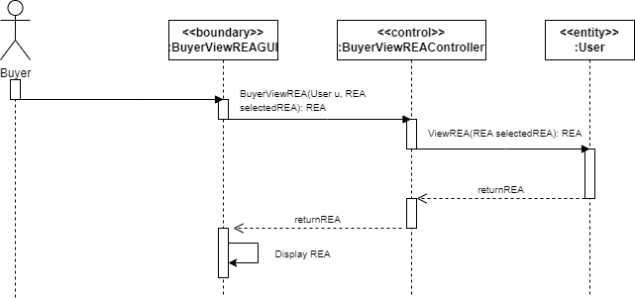*

*#520 Test Case*

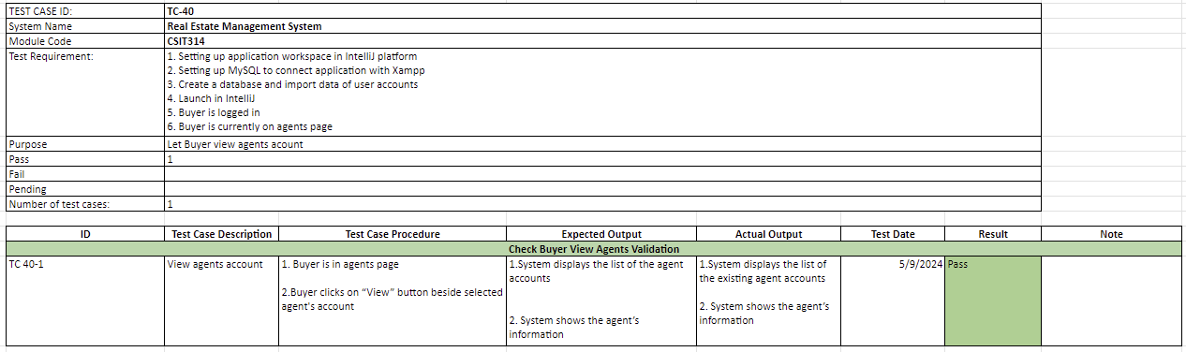

*#521 Wireframe*

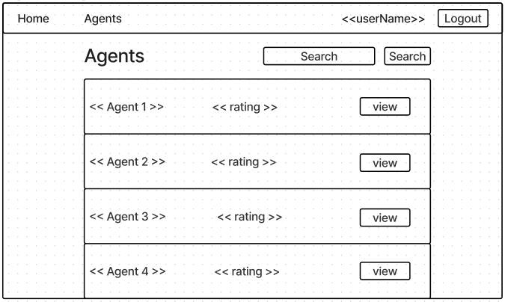



## #41 Buyer - View Old properties

*#523 User Story*

As a buyer, I want to View details about an OLD property listing on the platform, including details such as property features, and pricing so that I can compare their details.

*#524 Use Case Diagram*

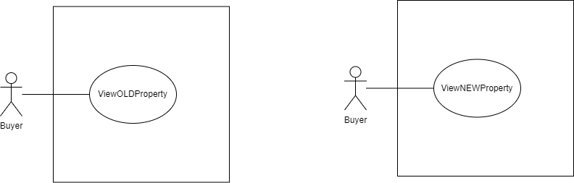

*#525 Use Case Description*

| **Name:** Buyer - View OLD properties on the platform | **ID:** #41 |
| --- | --- |
| **Stakeholders and goals:** Buyer - To view any of the OLD property listing details | |
| **Description:** Buyer click a view button to view a specific old property | |
| **Actors:** Buyer | |
| **Trigger:** When Buyer clicks on “view” button of a specific OLD property | |
| **Pre-condition:**  Buyer is logged in  Buyer is in buyer’s main page | |
| **Main flow:**   1. System displays the list of all existing properties 2. Buyer clicks on “view” button of a specific old property 3. System displays the details of the old property 4. End | |
| **Sub-flows:** None. | |
| **Alternative/Exceptional flows:** | |

*#526 BCE Diagram*

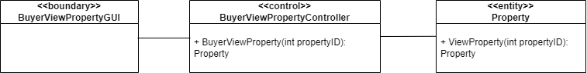

*#527 Sequence Diagram*

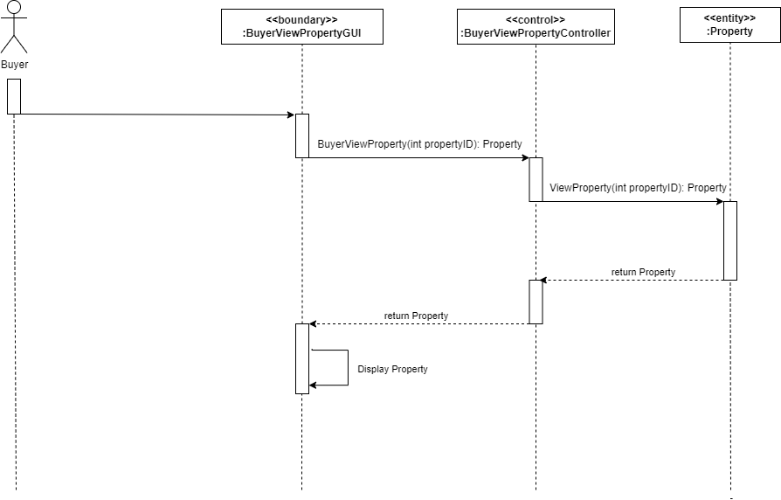

*#528 Test Case*

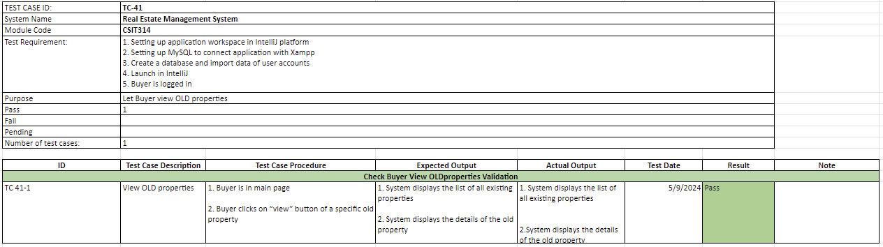

*#529 Wireframe*

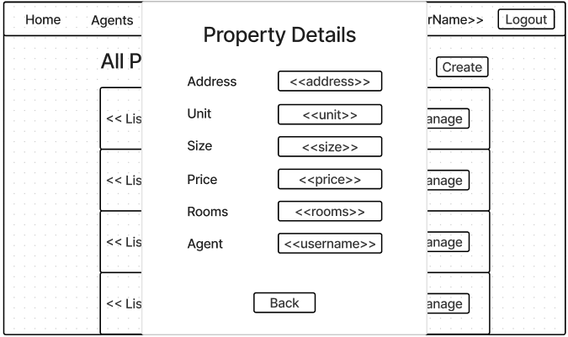

## #43 Buyer - Add old properties to a shortlist

*#539 User Story*

As a buyer, I want to be able to Add OLD property listings to a shortlist, so that I can easily access and track properties that interest me.

*#540 Use Case Diagram*

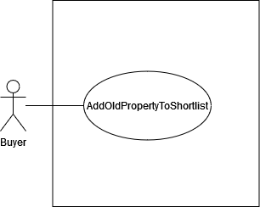

*#541 Use Case Description*

| **Name:** Buyer - Add OLD properties to a shortlist | **ID:** #43 |
| --- | --- |
| **Stakeholders and goals:** Buyer - To add OLD properties into Shortlist | |
| **Description:** Buyer add an old property into his shortlist by clicking heart icon beside a specific old property listing. | |
| **Actors:** Buyer | |
| **Trigger:** When Buyer adds OLD property to shortlist | |
| **Pre-condition:**  Buyer is logged in  There are existing properties in database | |
| **Main flow:**   1. Buyer clicks on “heart” icon tagged to a property listing 2. System adds property into shortlist 3. System displays “Successfully added to shortlist” 4. End | |
| **Sub-flows:** None. | |
| **Alternative/Exceptional flows:**  2.a.The property already exists in the buyer’s shortlist: System displays “Failed to add. Please try again.”  2b. If SQL error occurs: System displays “Failed to add. Please try again.” | |

*#542 BCE Diagram*

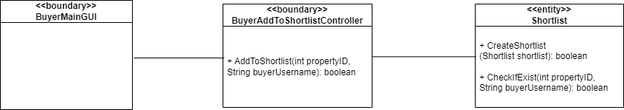

*#543 Sequence Diagram*

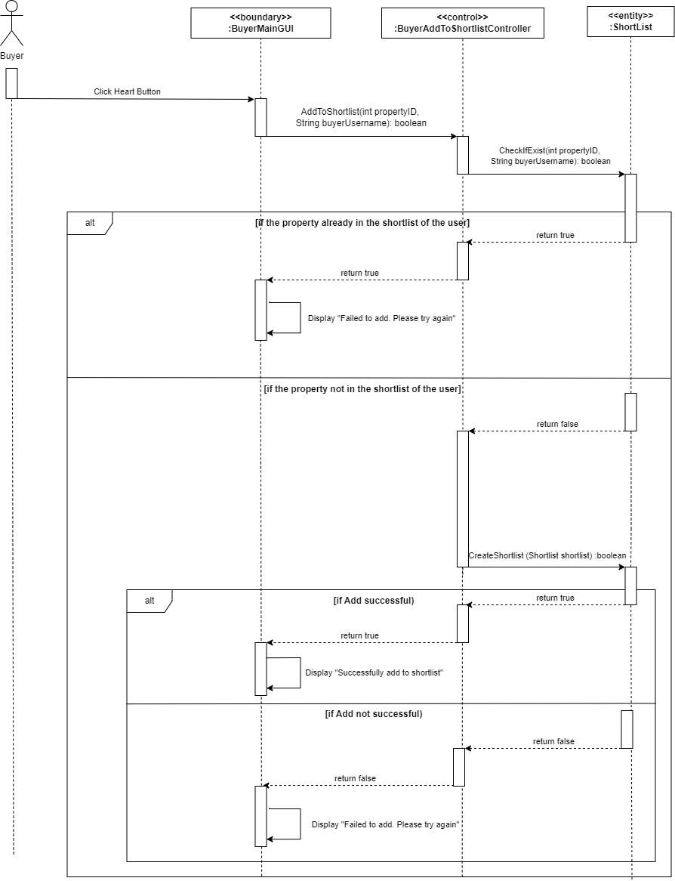

*#544 Test Case*

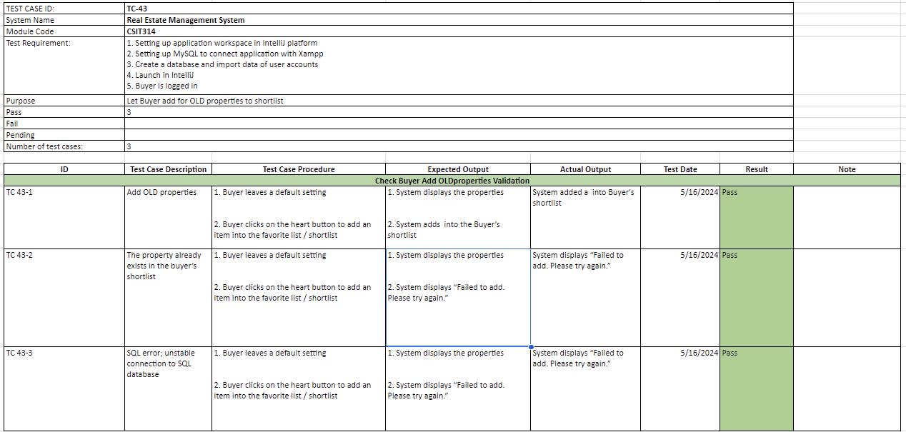

*#545 Wireframe*

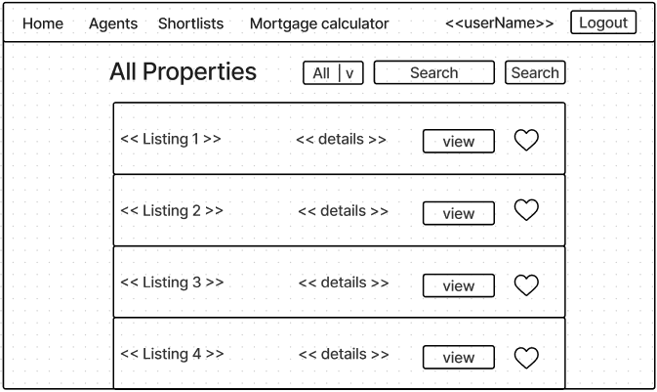

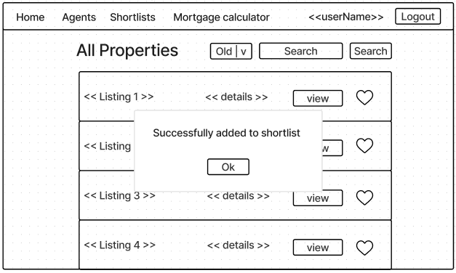

## 

## #44 Buyer - View New properties

*#547 User Story*

As a buyer, I want to View details about a NEW property listing on the platform so that I can check the details such as property features, and pricing.

*#548 Use Case Diagram*

**

*#549 Use Case Description*

| **Name:** Buyer - View NEW properties | **ID:** #44 |
| --- | --- |
| **Stakeholders and goals:** Buyer - To view NEW properties’ details | |
| **Description:** Buyer clicks on a “view” button to view a specific new property | |
| **Actors:** Buyer | |
| **Trigger:** When Buyer clicks on “NEW” in drop down box | |
| **Pre-condition:**  Buyer is logged in  Buyer is in buyer’s main page | |
| **Main flow:**   1. System displays the list of all existing properties 2. Buyer clicks on “view” button of a specific new property 3. System displays the details of the new property 4. End | |
| **Sub-flows:** None. | |
| **Alternative/Exceptional flows:** | |

*#550 BCE Diagram*

**

*#551 Sequence Diagram*

**

*#552 Test Case*

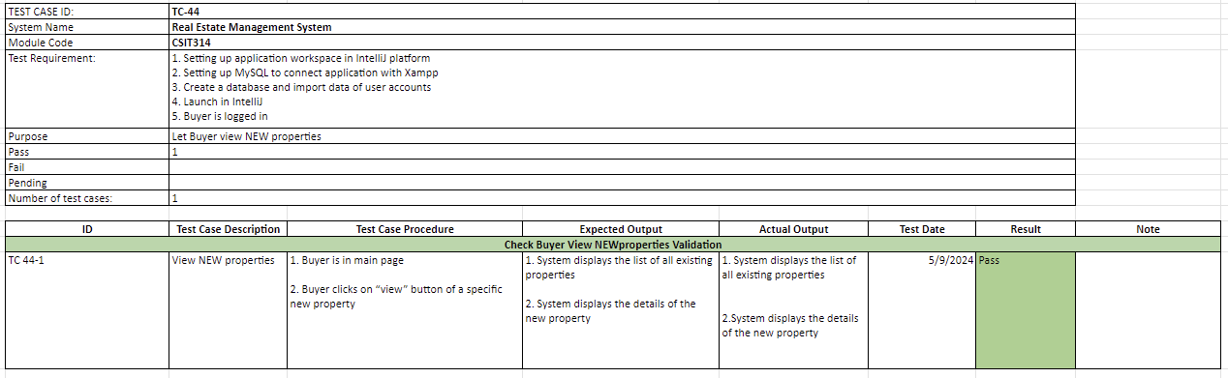

*#553 Wireframe*

**

## 

## #46 Buyer - Add New properties to a shortlist

*#563 User Story*

As a buyer, I want to Add NEW property listings to a shortlist, so that I can easily access and track properties that interest me.

*#564 Use Case Diagram*

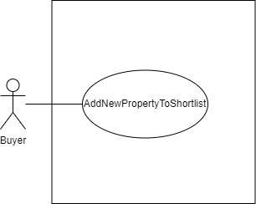

*#565 Use Case Description*

| **Name:** Buyer - Add NEW properties to a shortlist | **ID:** #46 |
| --- | --- |
| **Stakeholders and goals:** Buyer - To add NEW listings into Shortlist | |
| **Description:** Buyer add an new property into his shortlist by clicking heart icon beside a specific new property listing. | |
| **Actors:** Buyer | |
| **Trigger:** When Buyer adds NEW property to shortlist | |
| **Pre-condition:**  Buyer is logged in  There are existing properties in database | |
| **Main flow:**   1. Buyer clicks on “heart” icon tagged to listing 2. System adds property into shortlist 3. System displays “Successfully added to shortlist” 4. End | |
| **Sub-flows:** None. | |
| **Alternative/Exceptional flows:**  2.a.The property already exists in the buyer’s favorite list:System displays “Failed to add. Please try again.”  2.b. If SQL error occurs: System displays “Failed to add. Please try again.” | |

*#566 BCE Diagram*

**

*#567 Sequence Diagram*

*#568 Test Case*

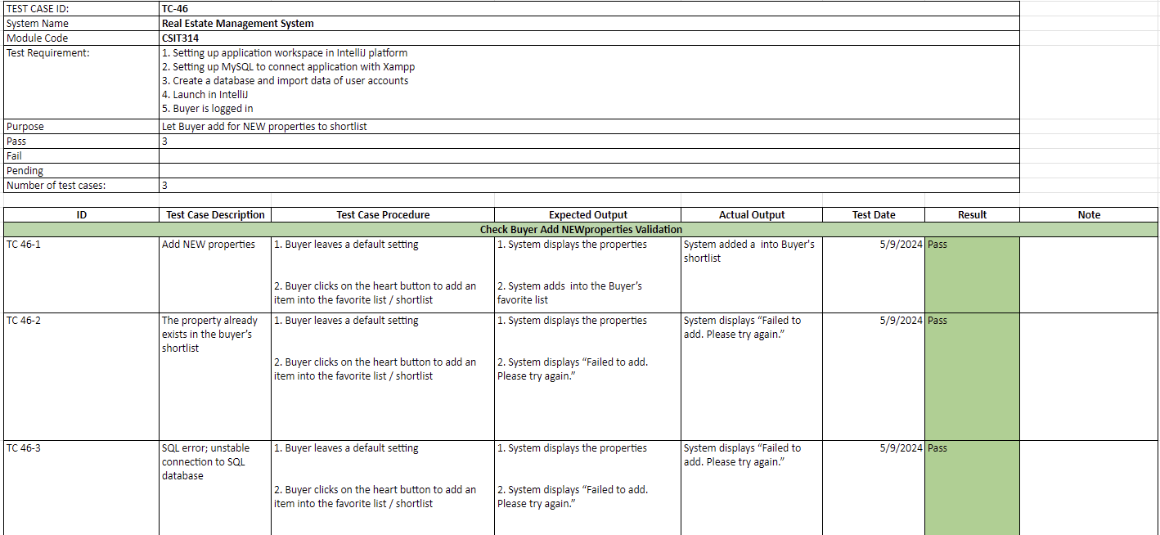

*#569 Wireframe*

**



## 

## #47 Buyer - Calculate mortgage estimates

*#571 User Story*

As a buyer, I want to Calculate mortgage estimates based on loan amount, interest rate, and loan term, to determine my budget and affordability.

*#572 Use Case Diagram*

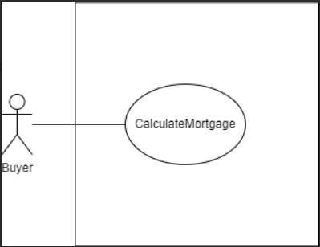

*#573 Use Case Description*

| **Name:** Buyer - Calculate mortgage estimates | **ID:** #47 |
| --- | --- |
| **Stakeholders and goals:** Buyer - To calculate the mortgage estimation | |
| **Description:** Buyer calculate the mortgage estimation by entering loan, rate and duration inn years | |
| **Actors:** Buyer | |
| **Trigger:** When Buyer calculates the mortgage estimates | |
| **Pre-condition:**  Buyer is logged in | |
| **Main flow:**   1. Buyer clicks on “Mortgage Calculator” 2. System popups mortgage calculator window to enter loan, rate, and other details 3. Buyer enters loan, rate, and duration in years 4. Buyer clicks on “Calculate button” 5. System validates the input 6. System displays Mortgage price 7. End | |
| **Sub-flows:** None. | |
| **Alternative/Exceptional flows:**  5.a If input is not a number: System displays "Invalid input”  5.b if input less than 0: System displays "Invalid input: Enter positive values" | |

*#574 BCE Diagram*

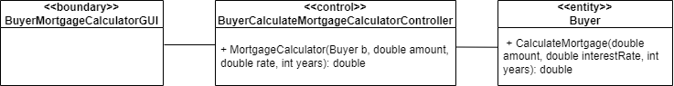

*#575 Sequence Diagram*

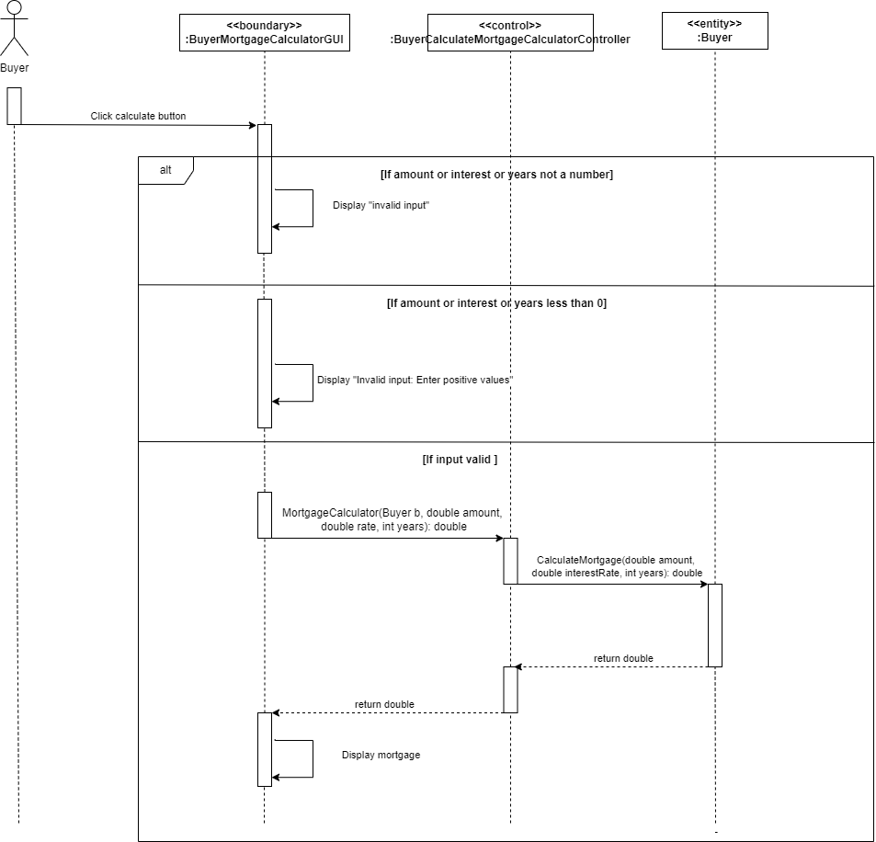

*#576 Test Case*

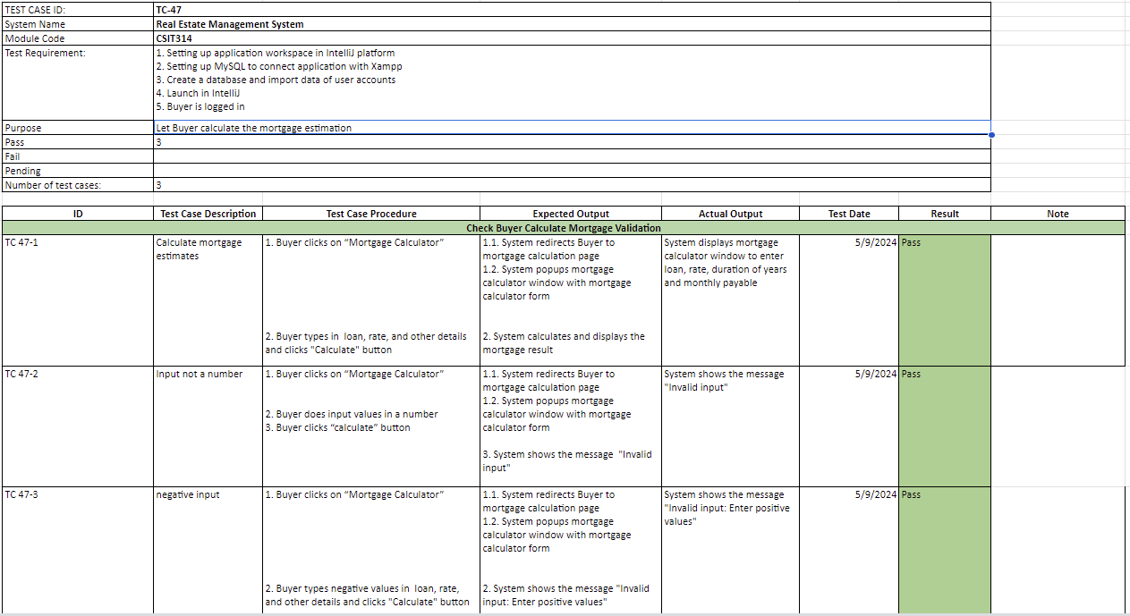

*#577 Wireframe*

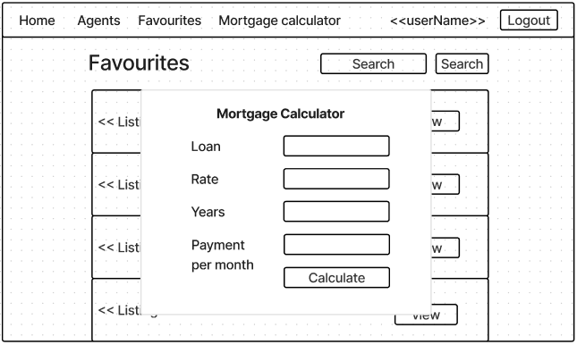

## 

## #48 Buyer - Rate real estate agents

*#579 User Story*

As a buyer, I want to rate real estate agents based on my experience with them, providing feedback to help other users make informed decisions.

*#580 Use Case Diagram*

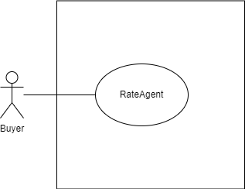

*#581 Use Case Description*

| **Name:** Buyer - Rate real estate agents | **ID:** #48 |
| --- | --- |
| **Stakeholders and goals:** Buyer - rate agents based on my experience | |
| **Description:** Buyer inputs rating and clicks on the “submit” button to rate a specific real estate agent. | |
| **Actors:** Buyer | |
| **Trigger:** When Buyer clicks “Rate” button when viewing Real Estate Agent | |
| **Pre-condition:**  Buyer is logged in  Buyer is currently on view REA profile page | |
| **Main flow:**   1. System popups window of agent’s username and number column. 2. Buyer clicks on the “Rate” button on the specific Agent’s account page 3. Buyer gives the rating. 4. Buyer clicks on the “Submit” button. 5. System validates the input. 6. System creates a new rating under the agent. 7. The system shows a pop-up dialogue saying “Rating submitted.”. 8. Buyer clicks on the “OK” button to acknowledge the message. 9. The system redirects the user back to the Agent’s account page 10. End | |
| **Sub-flows:** None. | |
| **Alternative/Exceptional flows:**  5.a: If rating is less than 0 or more than 5: System displays “Please enter a rating between 0 and 5.”  5.b: If the rating field is empty: System displays “Please enter a rating.” 5.c: If the rating field is invalid: System displays “Please enter a valid rating.”  5.d: If SQL error occurs: System displays “Rating failed to submit.” | |

*#582 BCE Diagram*

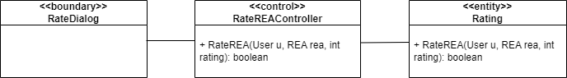

*#583 Sequence Diagram*

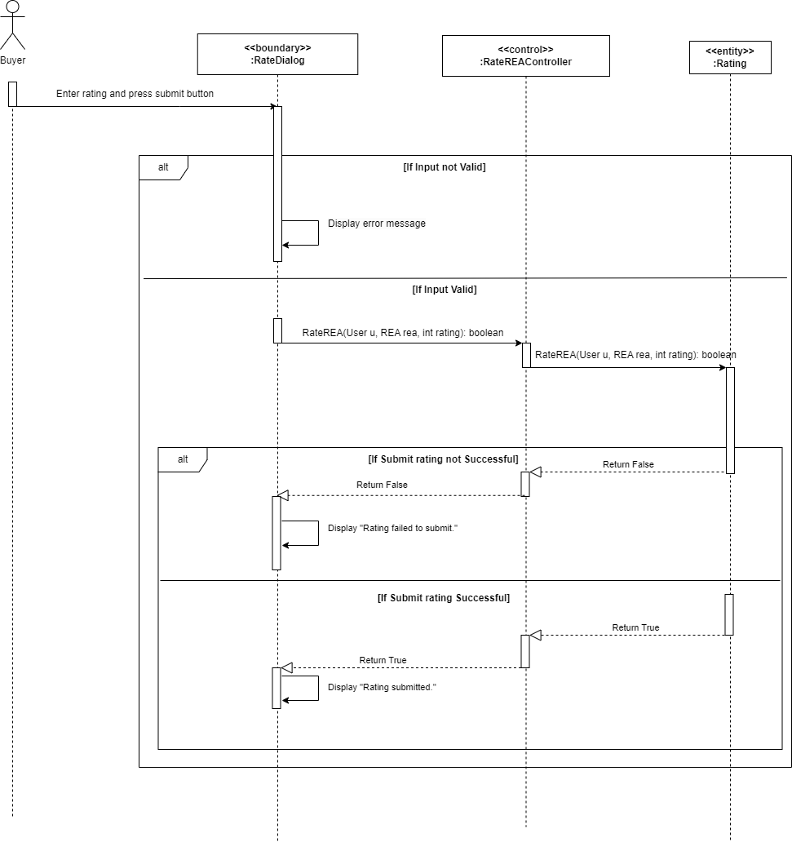

*#584 Test Case*

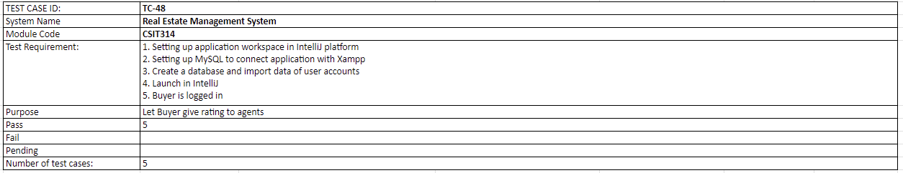

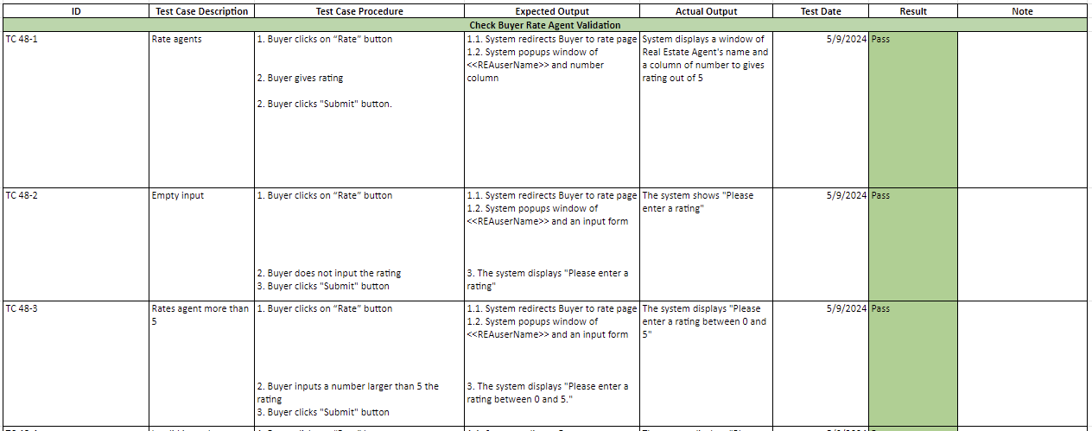

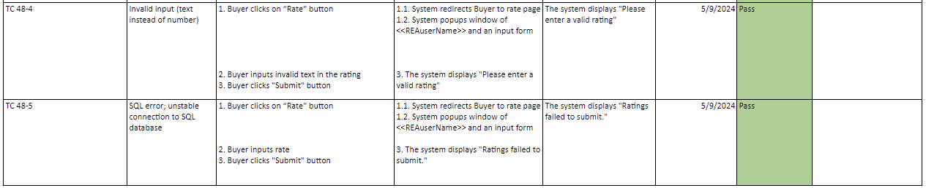

*#585 Wireframe*

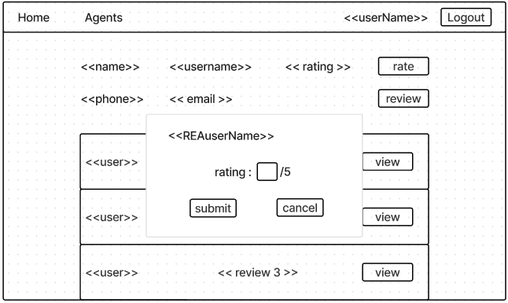

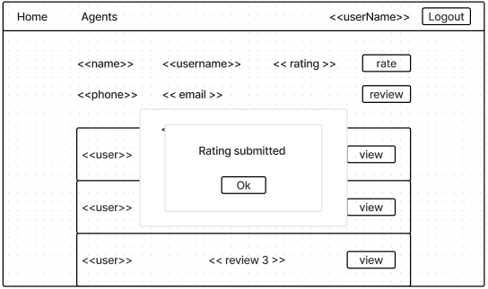

## 

## #607 Buyer - Search for properties based on address

*#608 User Story*

As a buyer, I want to Search for property listings based on their address so that I can find property in the location I want.

*#609 Use Case Diagram*

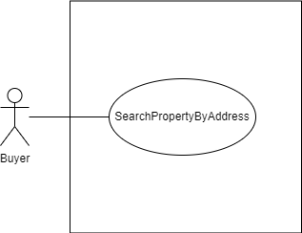

*#610 Use Case Description*

| **Name:** Buyer - Search for properties based on address | **ID:** #607 |
| --- | --- |
| **Stakeholders and goals:** Buyer - To Search for property listings based on the address | |
| **Description:** Buyer search property listings based on the address by typing the address and click on “search button” | |
| **Actors:** Buyer | |
| **Trigger:** When Buyer clicks on “Search” button | |
| **Pre-condition:**  Buyer is logged in | |
| **Main flow:**   1. Buyer clicks on the search bar 2. Buyer types in address 3. Buyer clicks on “Search” button 4. System shows all the matching address name from user input 5. End | |
| **Sub-flows:** None. | |
| **Alternative/Exceptional flows:**  4.a. If there is no matching property: System display empty scroll pane with no property listing  4.b. Buyer enters blank: All property listings displayed | |

*#611 BCE Diagram*

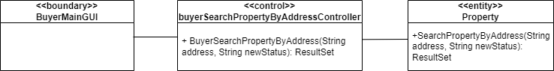

*#612 Sequence Diagram*

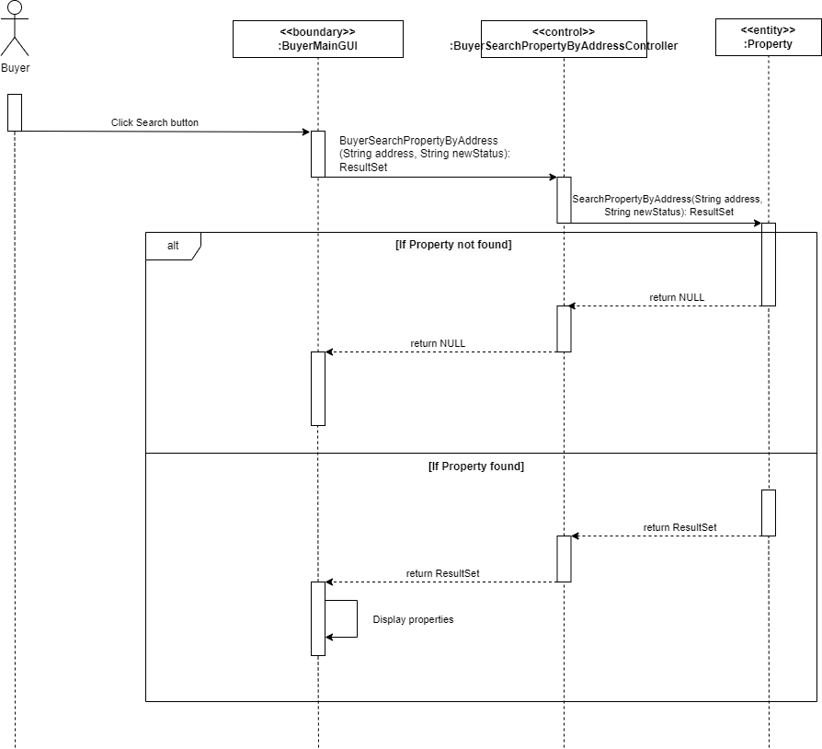

*#613 Test Case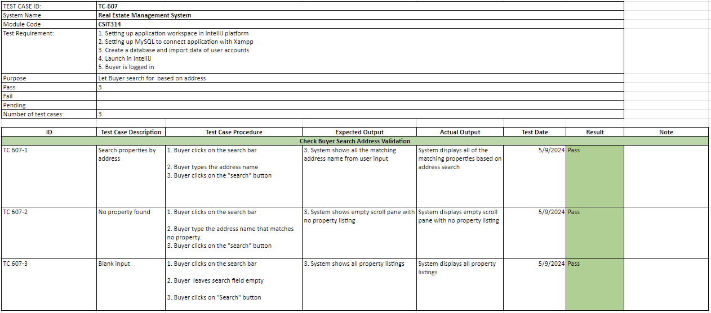*

*#614 Wireframe*

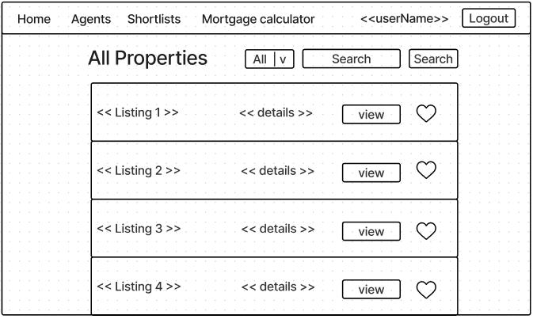

## 

## #634 Buyer - Search for Old properties

*#637 User Story*

As a buyer, I want to Search for OLD property listings so that I can view details about the OLD property.

*#638 Use Case Diagram*

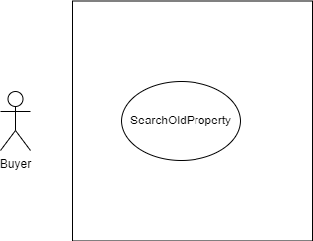

*#639 Use Case Description*

| **Name:** Buyer - Search for OLD properties | **ID:** #634 |
| --- | --- |
| **Stakeholders and goals:** Buyer - To Search for OLD property listings | |
| **Description:** Buyer clicks an option in drop down box to search OLD property listings | |
| **Actors:** Buyer | |
| **Trigger:** When Buyer clicks on “OLD” value in drop down box | |
| **Pre-condition:**  Buyer is logged in | |
| **Main flow:**   1. Buyer clicks on “OLD” value in drop down box 2. System shows all old property listings in database 3. End | |
| **Sub-flows:** None. | |
| **Alternative/Exceptional flows:**  2.a. If there is no old property: System display empty scroll pane with no property listing | |

*#640 BCE Diagram*

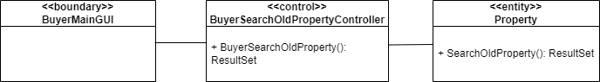

*#641 Sequence Diagram*

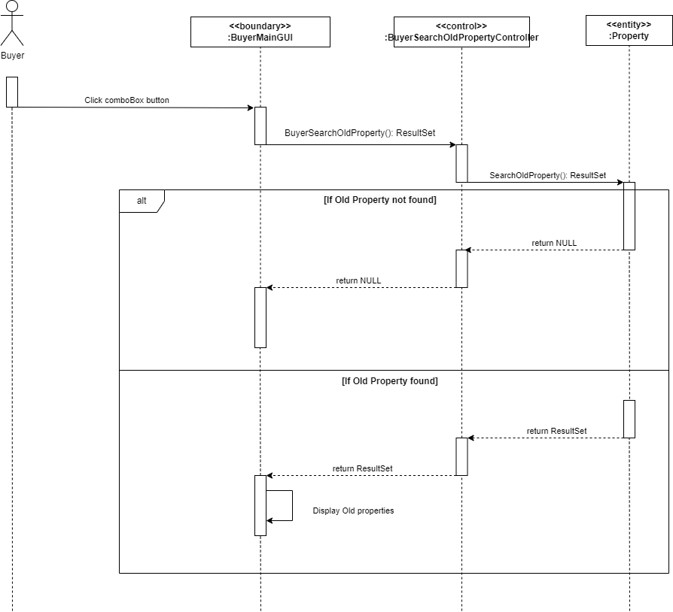

*#642 Test Case*

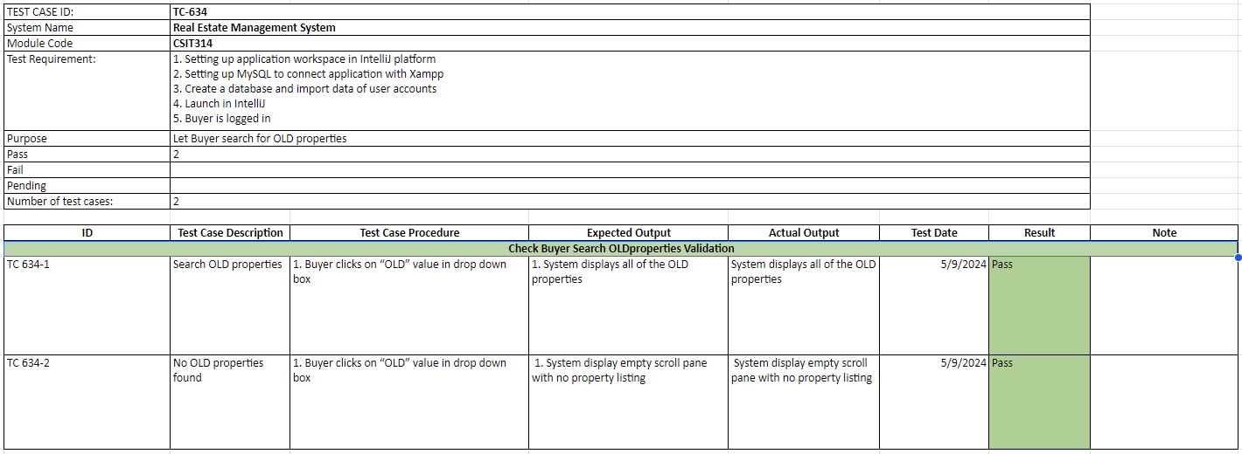

*#643 Wireframe*

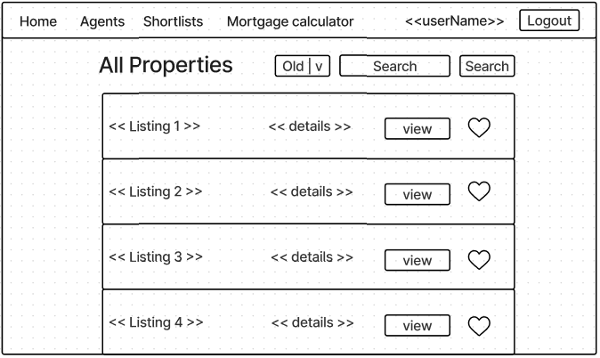

## 

## #635 Buyer - Search for New properties

*#637 User Story*

As a buyer, I want to Search for NEW property listings so that I can view details about the NEW property

*#638 Use Case Diagram*

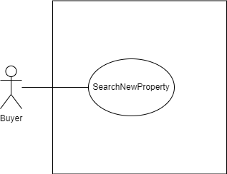

*#639 Use Case Description*

| **Name:** Buyer - Search for NEW specific properties based on criteria | **ID:** #635 |
| --- | --- |
| **Stakeholders and goals:** Buyer clicks an option in drop down box to search NEW property listings | |
| **Description:** As a buyer, I want to Search for NEW property listings so that I can view details about the NEW property | |
| **Actors:** Buyer | |
| **Trigger:** When Buyer search for NEW property listing(s) | |
| **Pre-condition:**  Buyer is logged in | |
| **Main flow:**   1. Buyer clicks on “NEW” value in drop down box 2. System shows all new property listings in database 3. End | |
| **Sub-flows:** None. | |
| **Alternative/Exceptional flows:**  2.a. If there is no new property: System display empty scroll pane with no property listing | |

*#640 BCE Diagram*

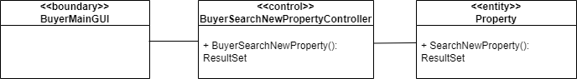

*#641 Sequence Diagram*

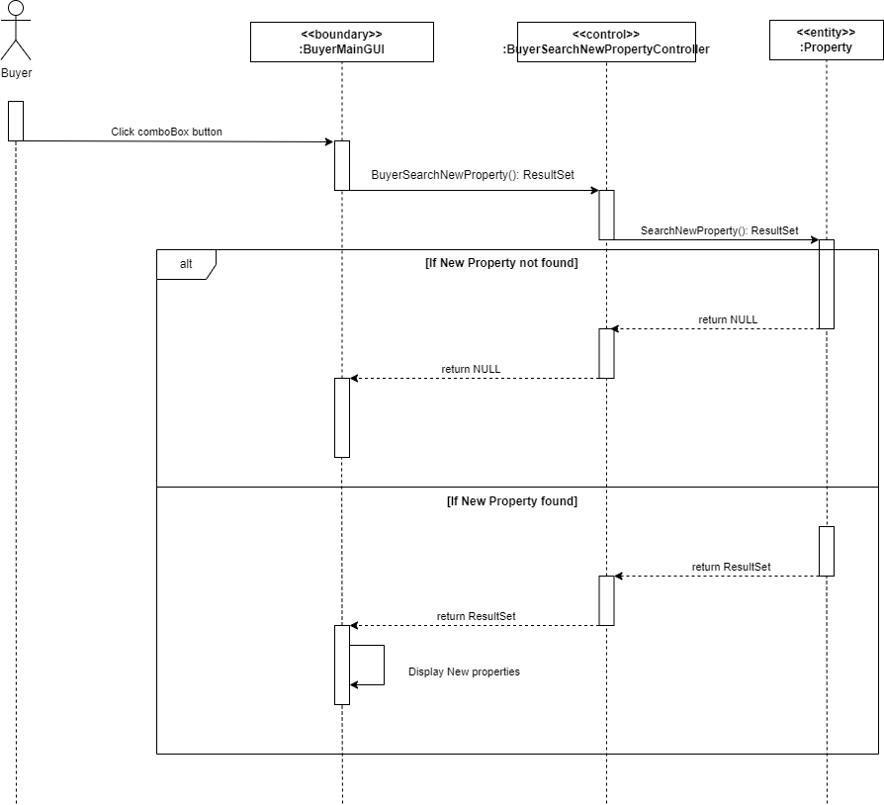

*#642 Test Case*

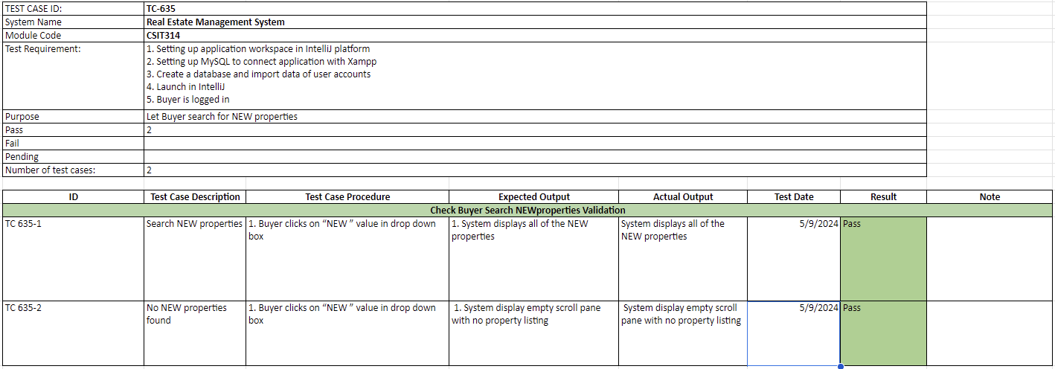

*#643 Wireframe*

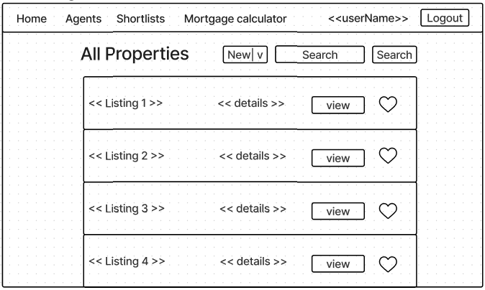

## 

## #49 Buyer - Review real estate agents

*#587 User Story*

As a buyer, I want to review real estate agents based on my experience with them, providing feedback to help other users make informed decisions.

*#588 Use Case Diagram*

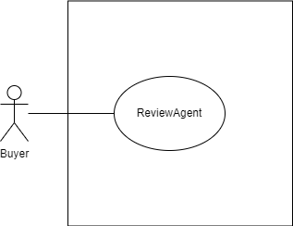

*#589 Use Case Description*

| **Name:** Buyer - Review real estate agents | **ID:** #49 |
| --- | --- |
| **Stakeholders and goals:** Buyer - review real estate agent | |
| **Description:** Buyer leaves a review on a specific real estate agent by clicking on the “Review” button. | |
| **Actors:** Buyer | |
| **Trigger:** When Buyer clicks on “Review” button when viewing Real Estate Agent | |
| **Pre-condition:**  Buyer is logged in  Buyer is currently on view REA profile page | |
| **Main flow:**   1. Buyer clicks on “Review” button 2. System popups window of agent’s username and text box column 3. Buyer writes review 4. Buyer clicks “Submit” button 5. System validates the input. 6. System creates a new review under the agent. 7. The system shows a pop-up dialogue saying “Review Submitted.”. 8. Buyer clicks on the “OK” button to acknowledge the message. 9. The system redirects the user back to the Agent’s account page 10. End | |
| **Sub-flows:** None. | |
| **Alternative/Exceptional flows:**  5.a:If review is empty: System displays “Please enter your review”  5.b: If SQL error occurs: System displays “Review failed to submit.” | |

*#590 BCE Diagram*

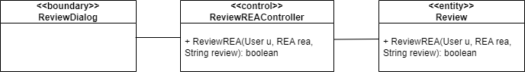

*#591 Sequence Diagram*

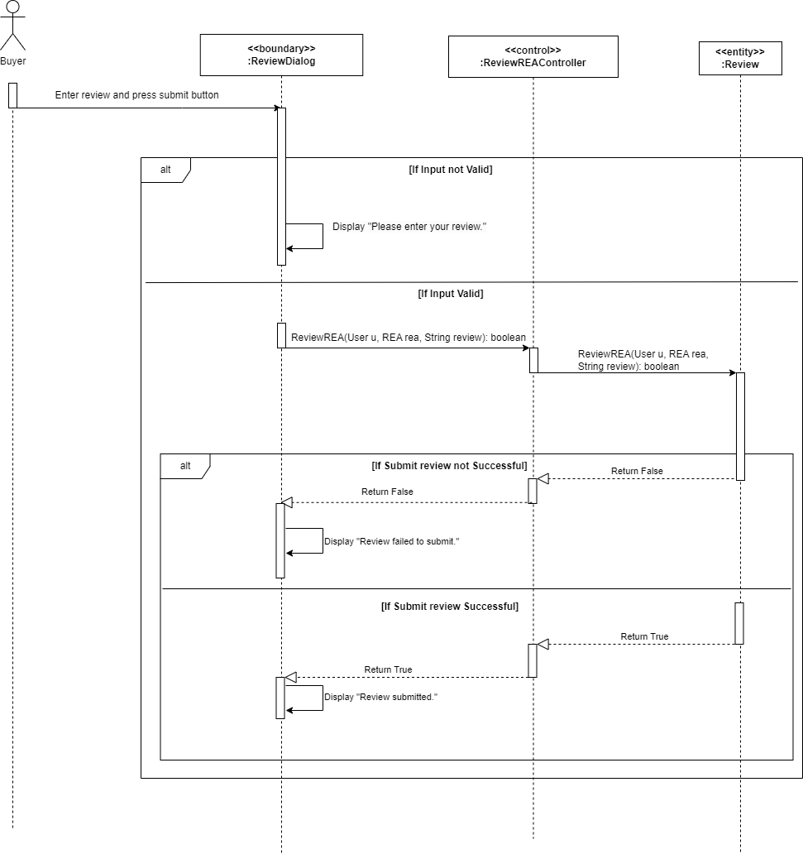

*#592 Test Case*

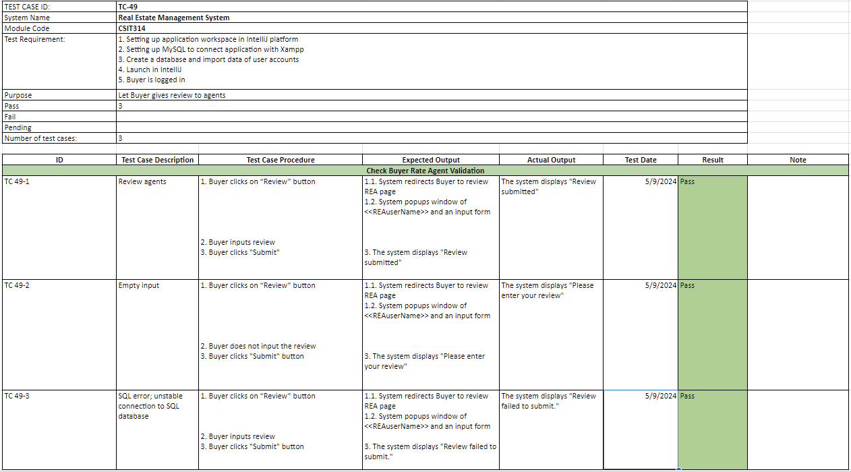

*#593 Wireframe*

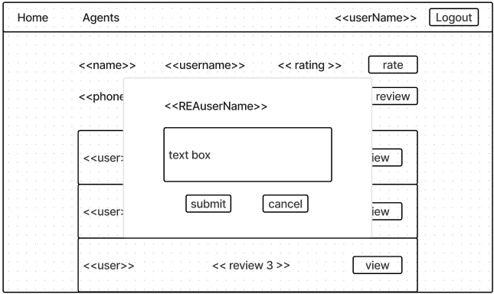

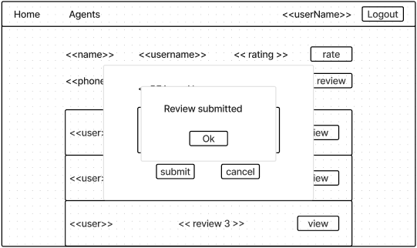

# 

# Sprint Five

**Duration: 13th May - 19th May**

## Sprint Planning, Review and Retrospective

| **Meeting Date**: 13/05/2024 (Monday) | | |
| --- | --- | --- |
| **Duration:** 12:00 - 15:00 | | |
| **Sprint duration:** 13/05/2024 - 19/05/2024 | | |
| **Attendees:**  Lim Wootaek, Viktor, Wei Hong, Roydenn, Frentsen, Jerry | | **Agenda** |
| 1. Sprint 4 review 2. Discuss about the tasks for sprint 5 |
| **Absentees:**  N/A | |
|
| **What we have done** | | **Roydenn**   * Coding & Sequence Diagram   + Buyer - Calculate mortgage estimate   + Buyer - View OLD property listings   + Buyer - View NEW property listings   + Buyer- review real estate agents   + Seller - review real estate agents   **Wootaek**   * Coding & Sequence Diagram   + Buyer - Search for NEW property listings   + Buyer - Search for OLD property listings   + Buyer - Search Properties by address   + Update class diagram and get feedback on the class diagram for the last sprint. * CI/CD   **Wei Hong**   * Coding & Sequence Diagram   + Seller - rate real estate agents   + Buyer- rate real estate agents   + Buyer - View REA profile   + Seller - review real estate agents   + Seller - rate real estate agents   **Vuong**   * Coding & Sequence Diagram * Buyer - Add NEW property listings to a favorites * Buyer - Add OLD property listings to favorites   **Jerry & Frentsen**   * Draw diagrams based on the sequence diagrams for selected user stories in this sprint * Finish sprint summary for this sprint |
| **Reflection** | | **What went well:**  Data-driven development and ethical consideration parts are approved by the product owner.  **What could be improved:**  Documentation could have been started and done earlier. |
| **What we are going to do for this sprint** | | **All**   * Clean up code * Check through code for consistency * Check through diagrams for consistency * Check through code and report to ensure it matches * Finish up report * Project video |

## **Gantt Chart**

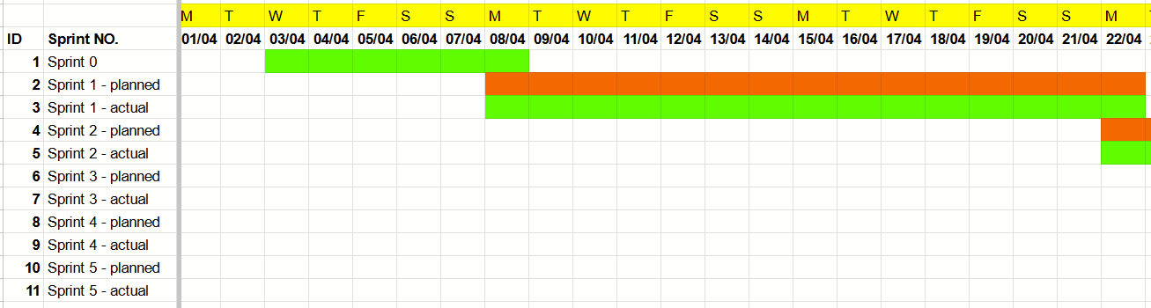

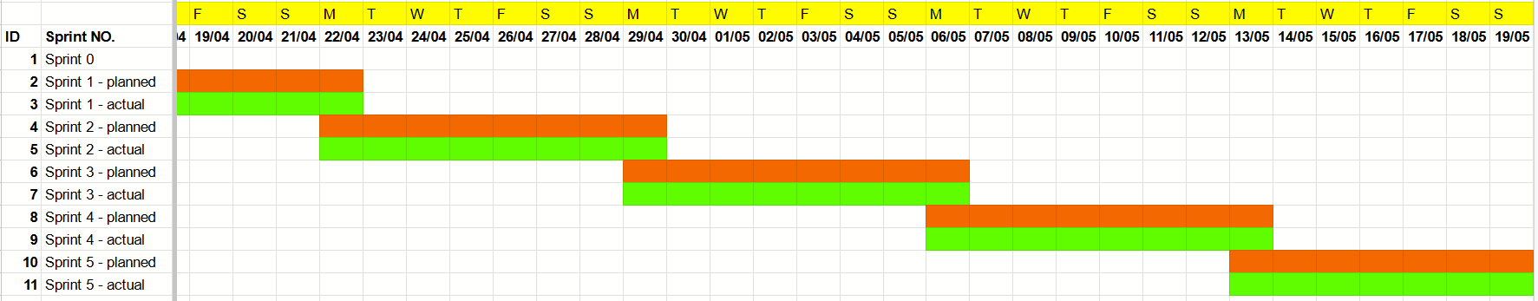

## ER Diagram - Finalized



## Class Diagram - Finalized

# CI/CD

Here the team is showing the update account pipeline

## Commits

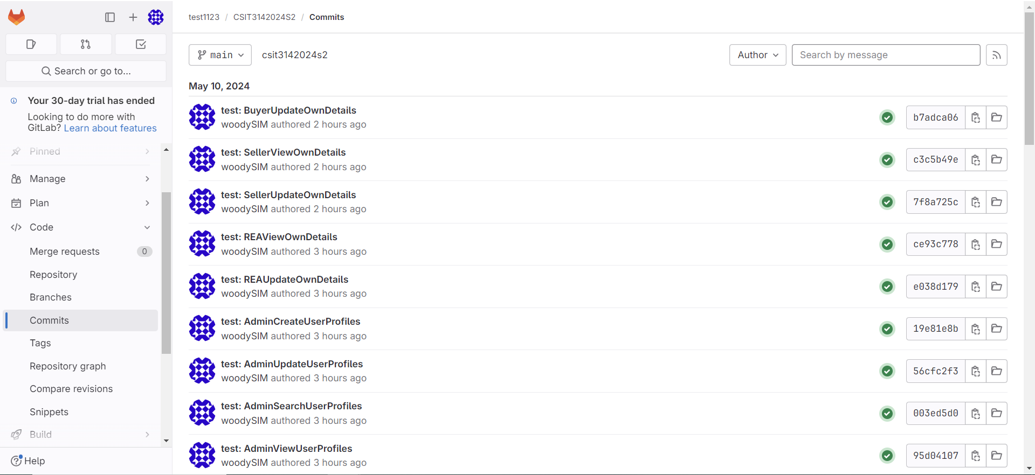

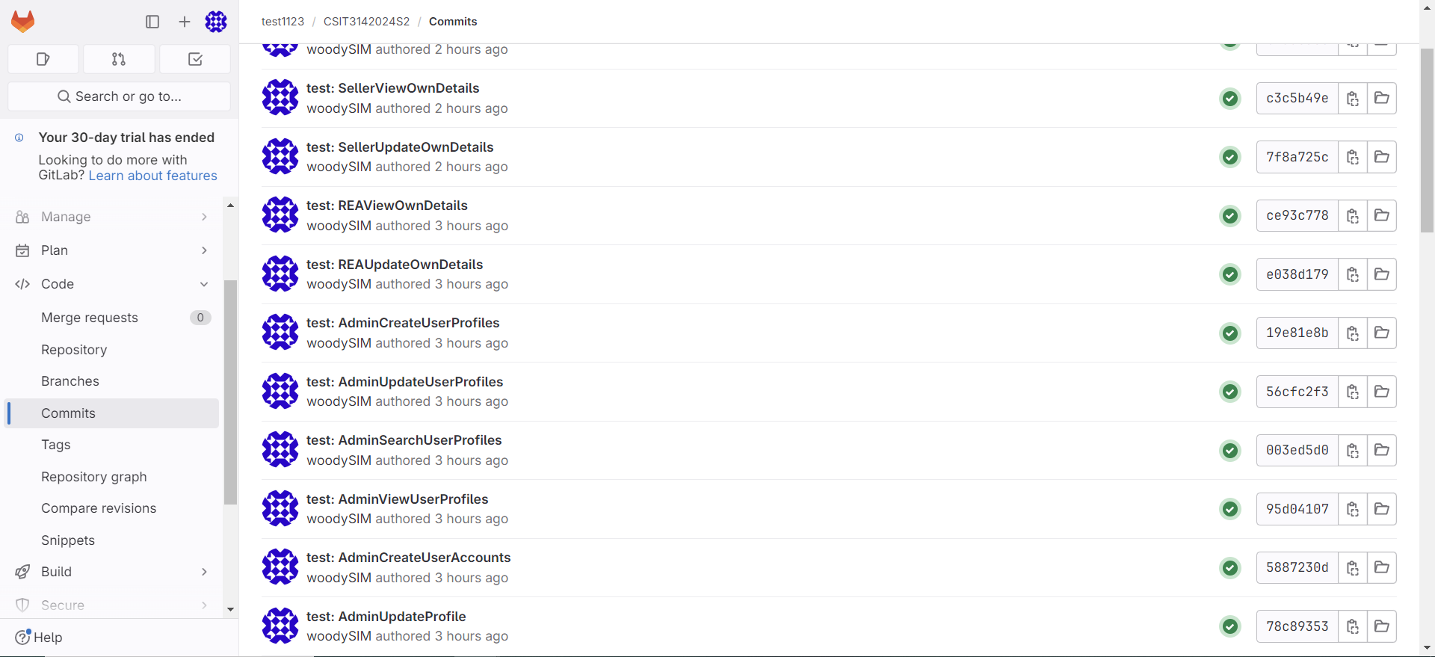

## Root directory

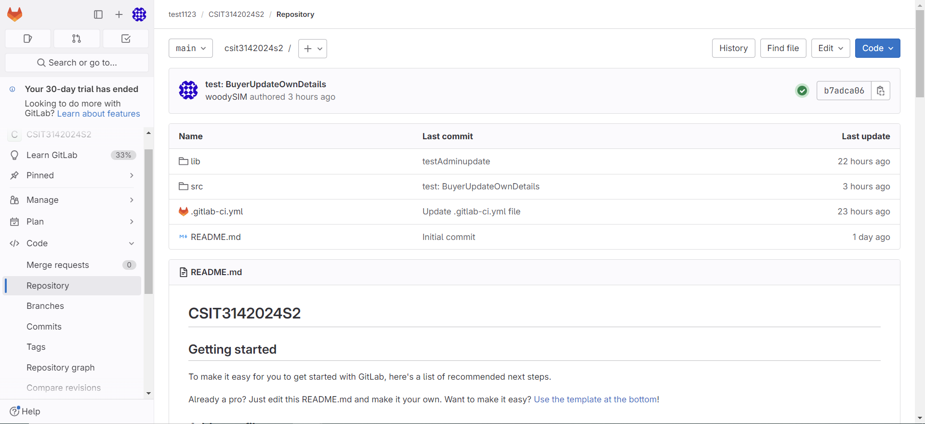

## Boundary directory

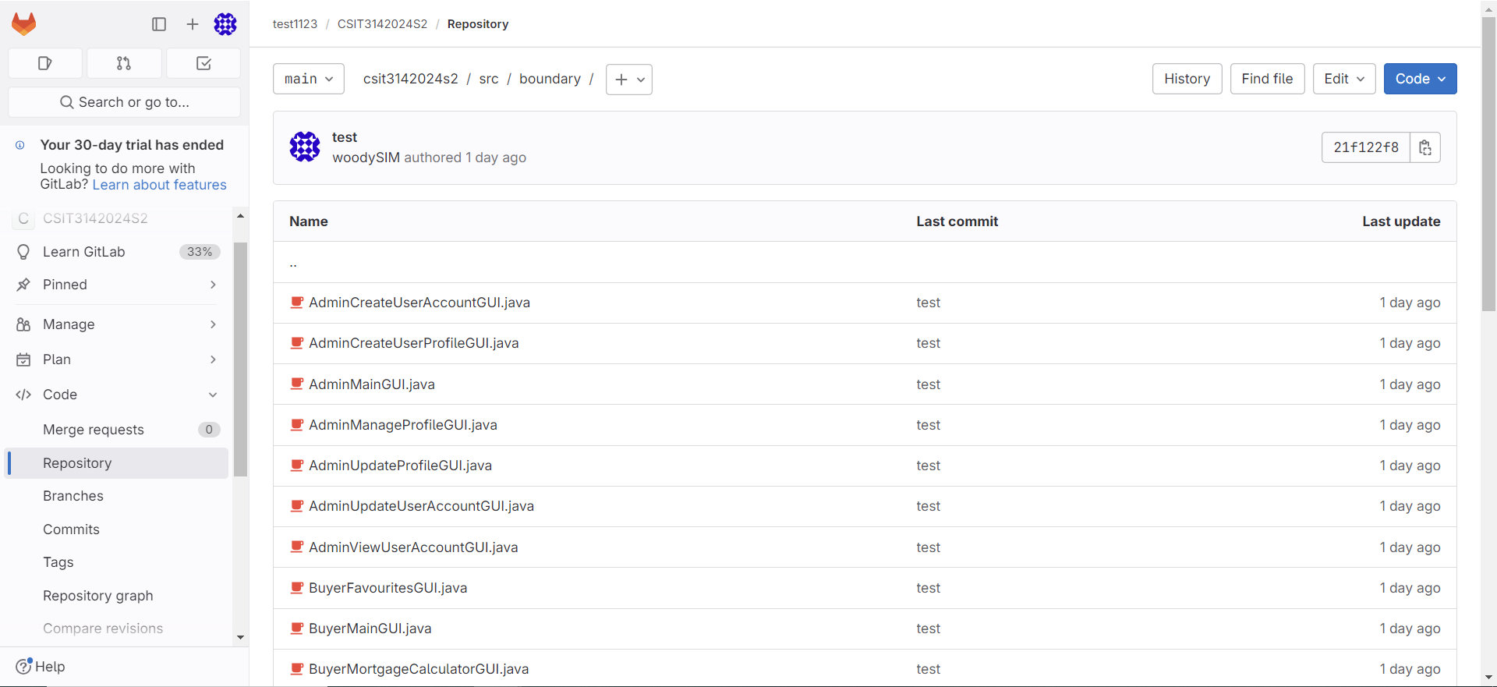

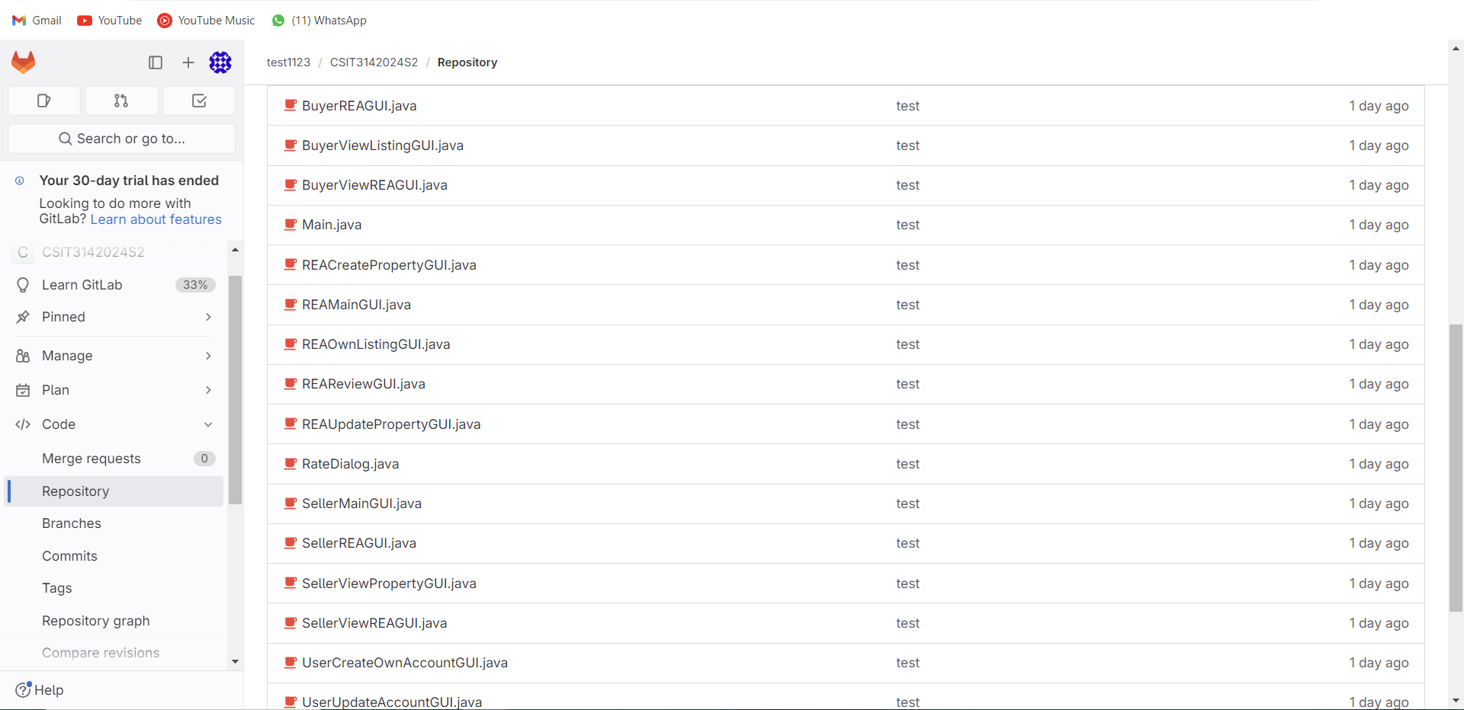

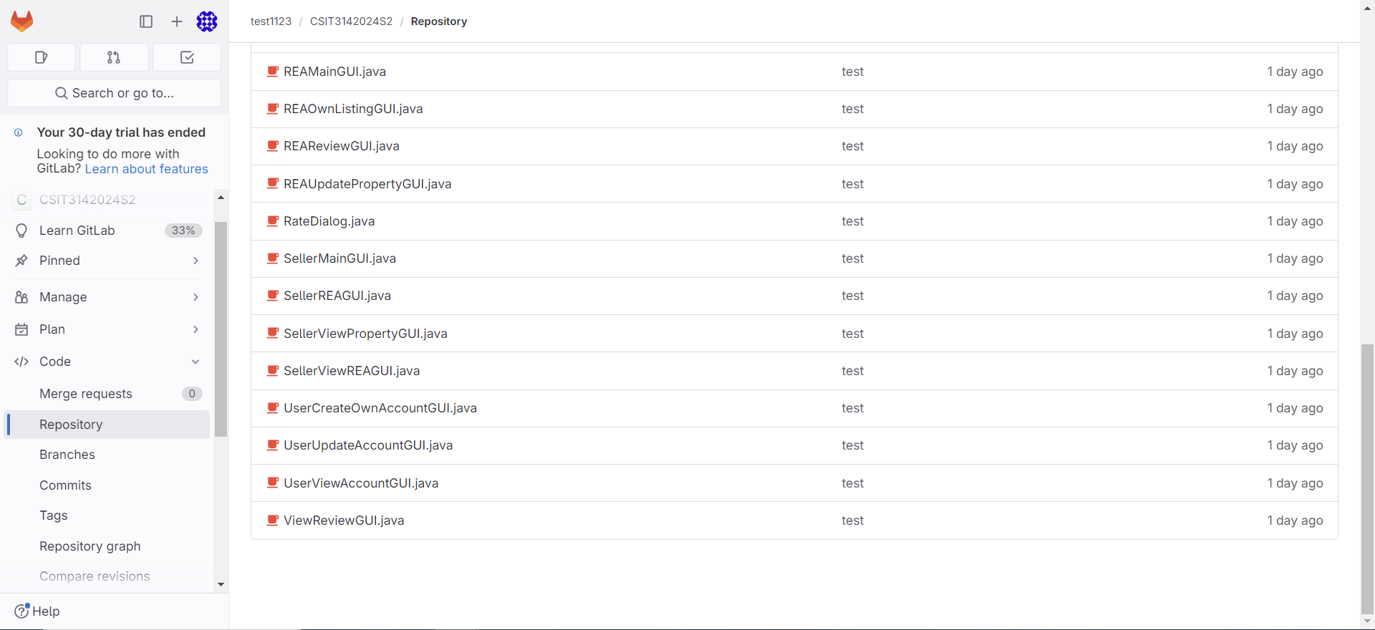

## Controller directory

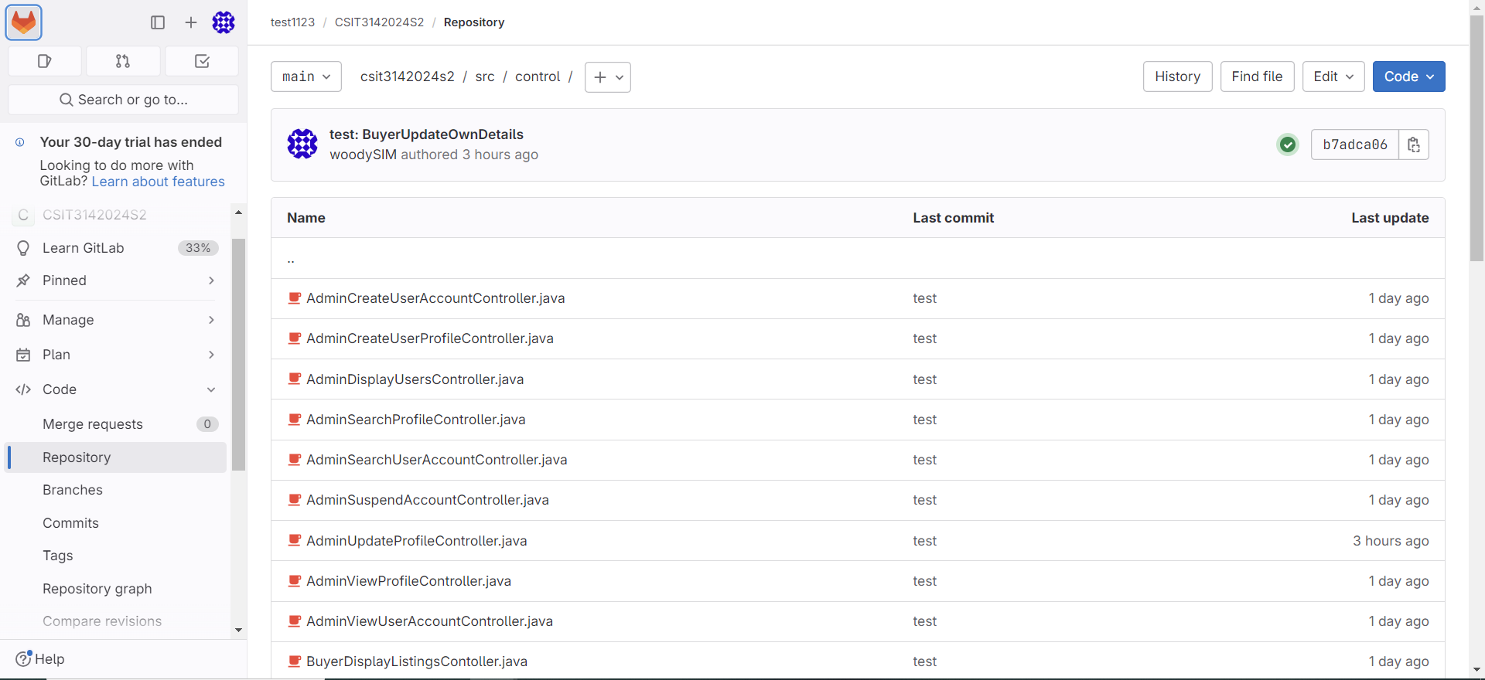

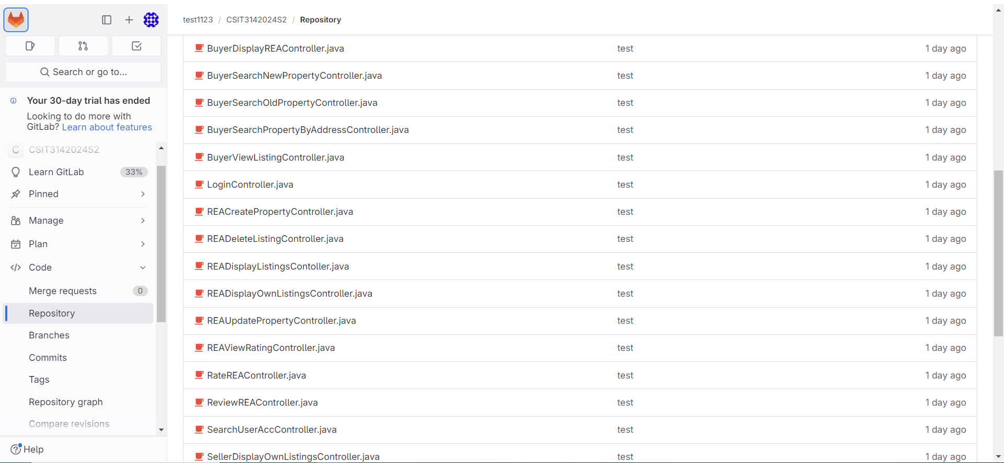

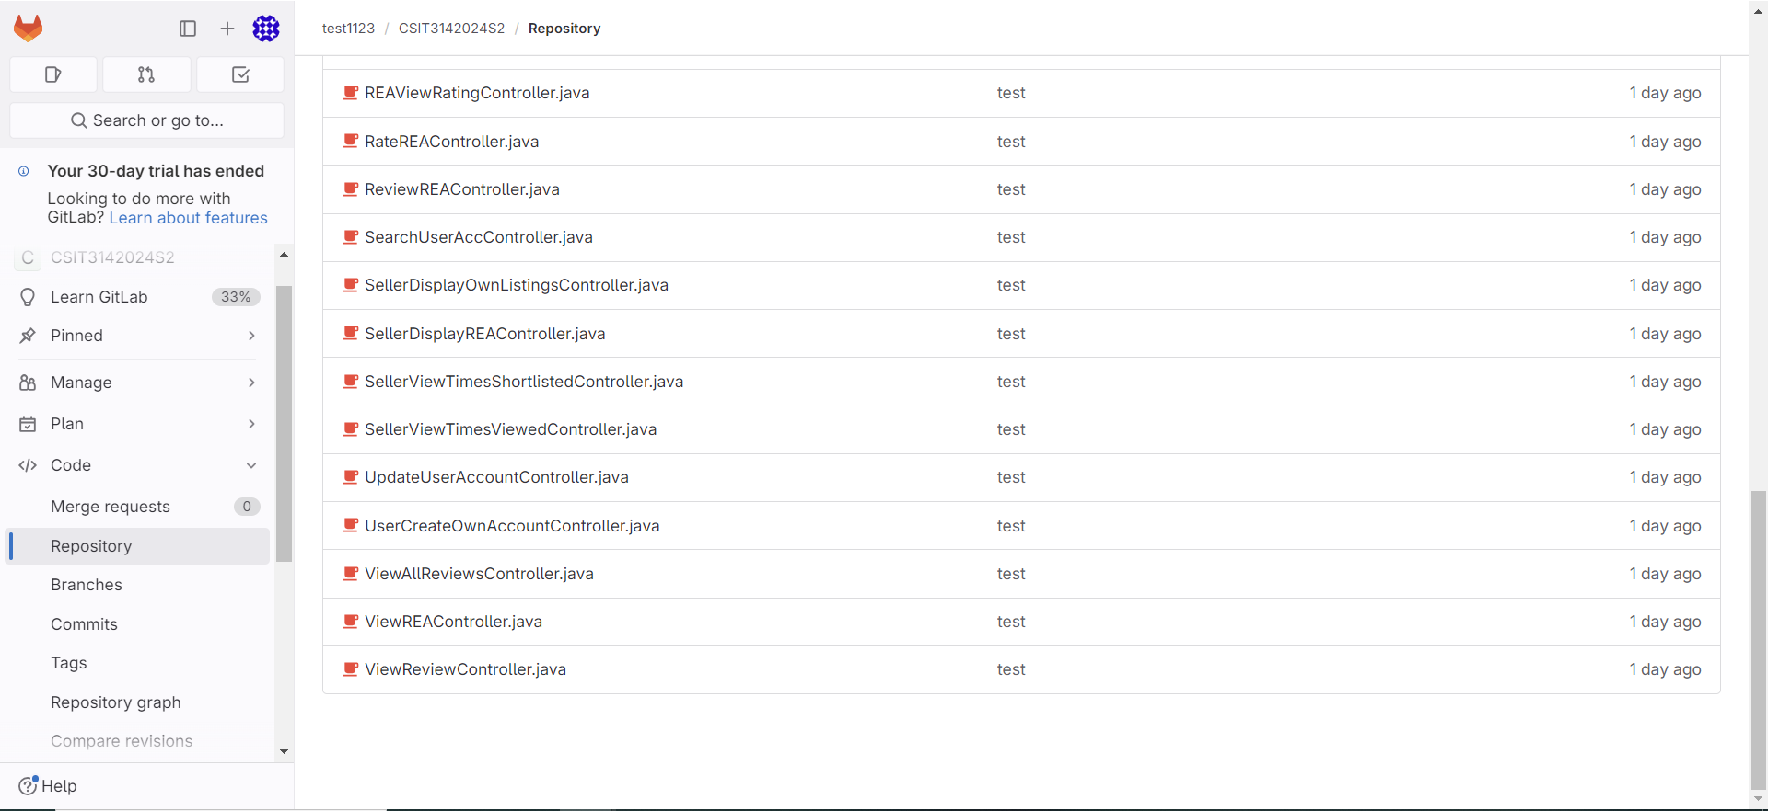

## Entity directory

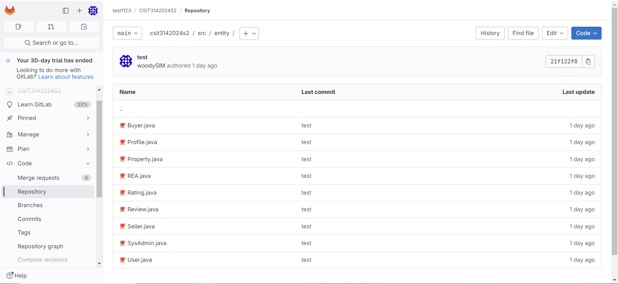

## Utility directory (for db connection)

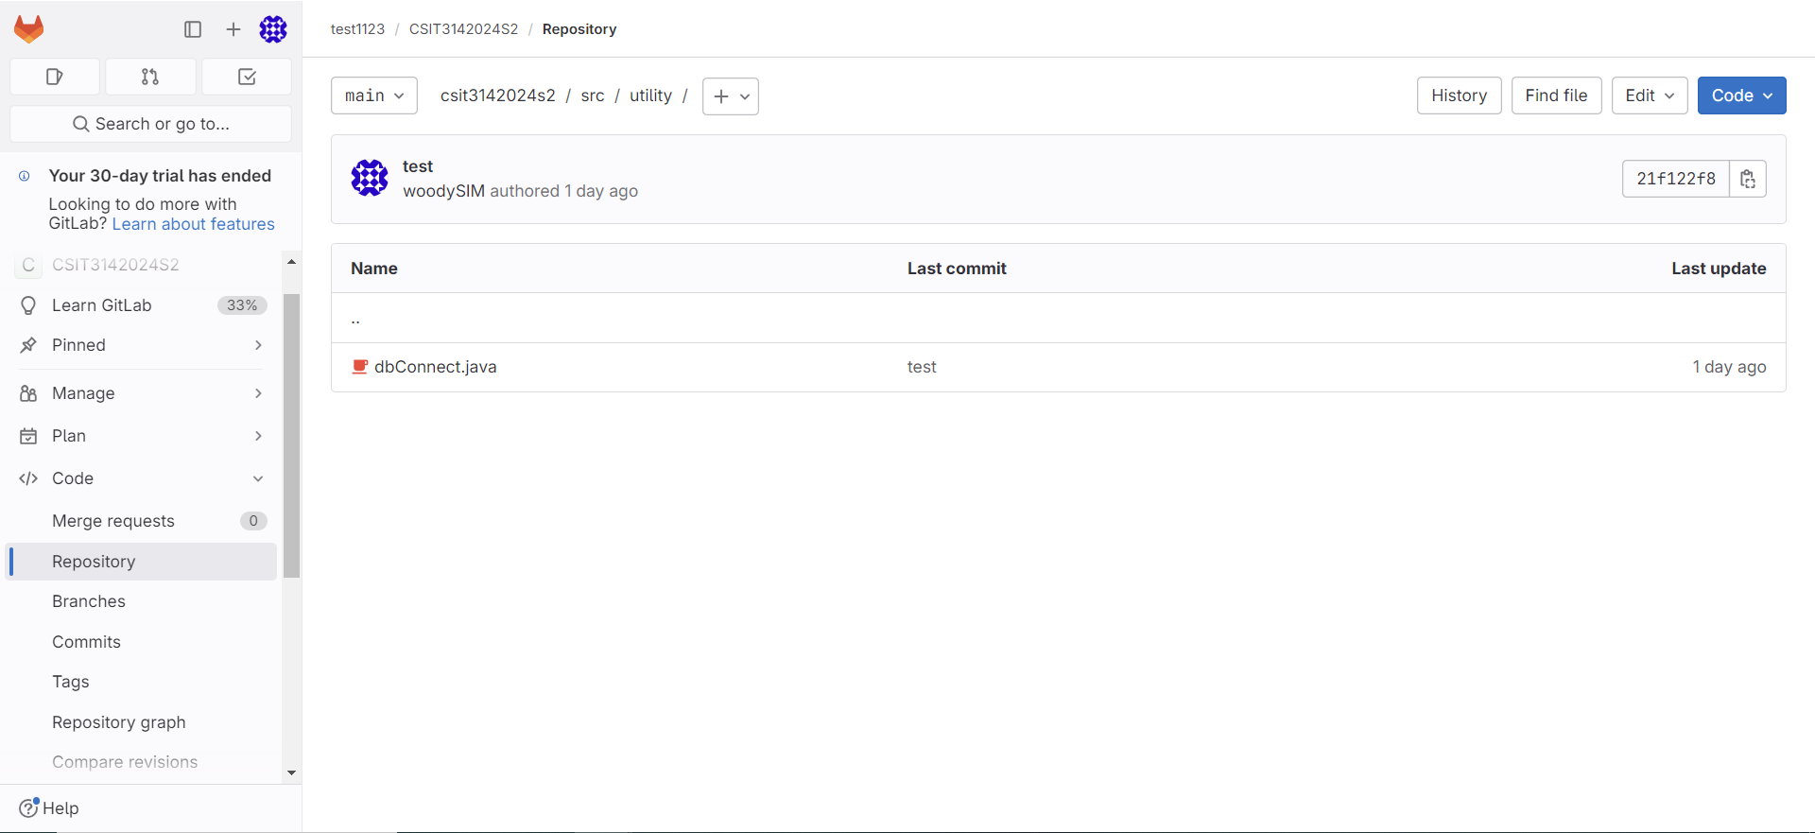

## .yml file

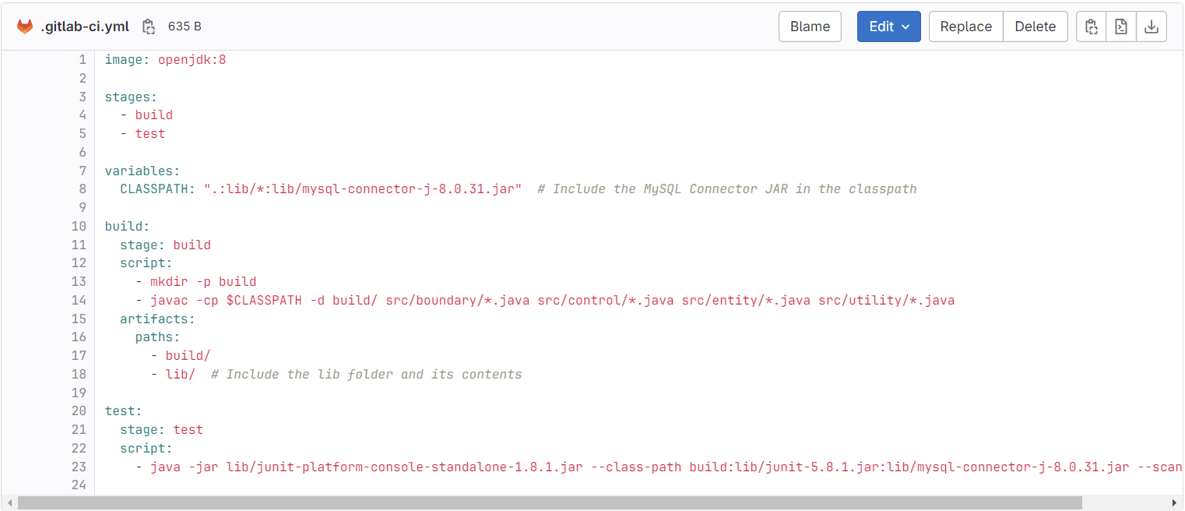

## Pipeline

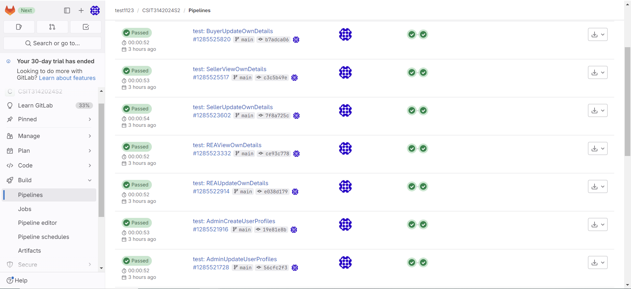

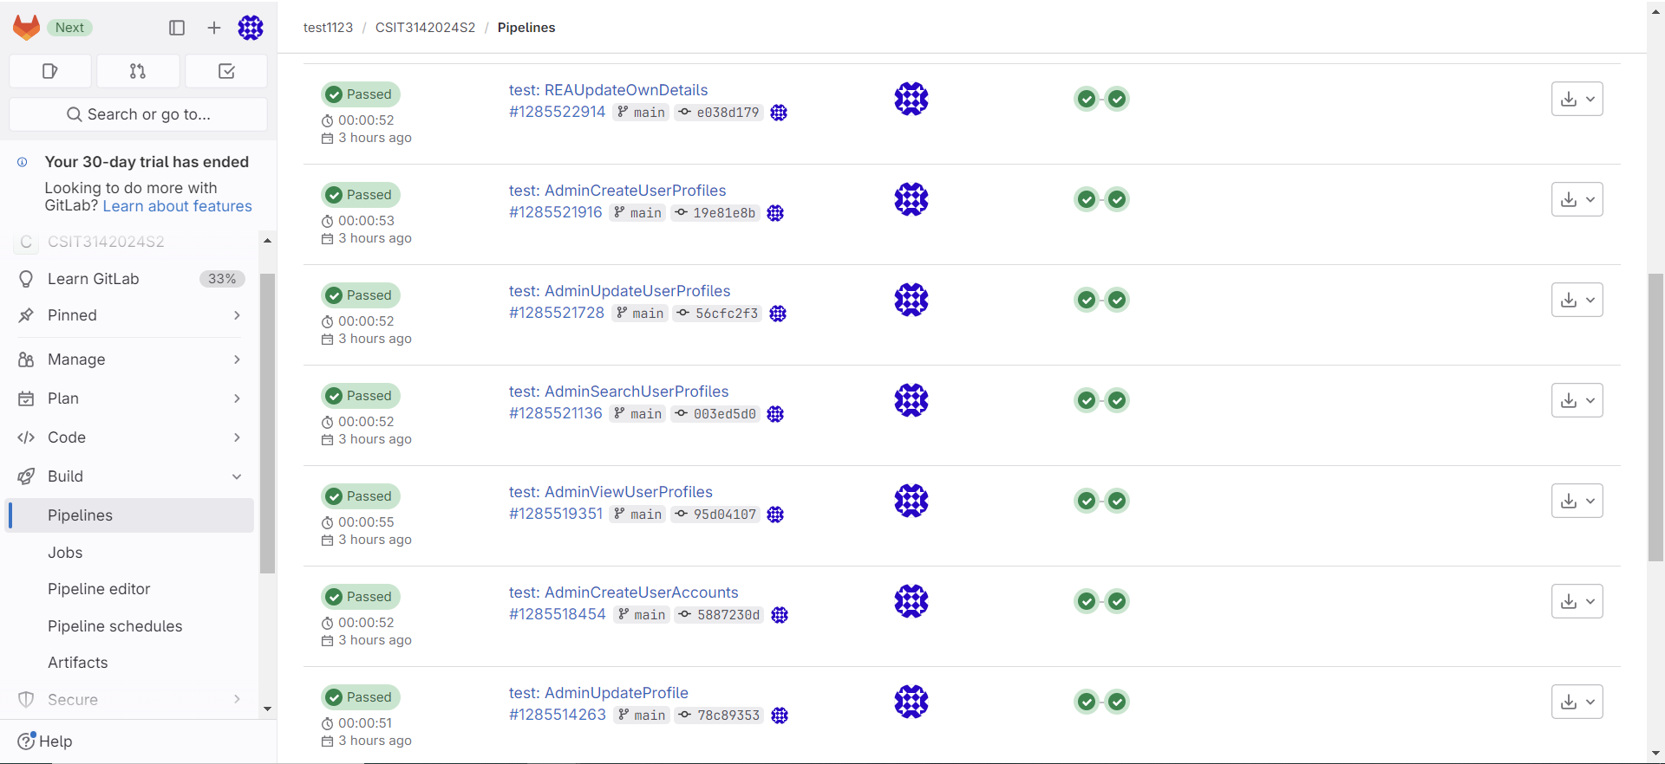

# 

# Test Driven Development

AdminUpdateProfile

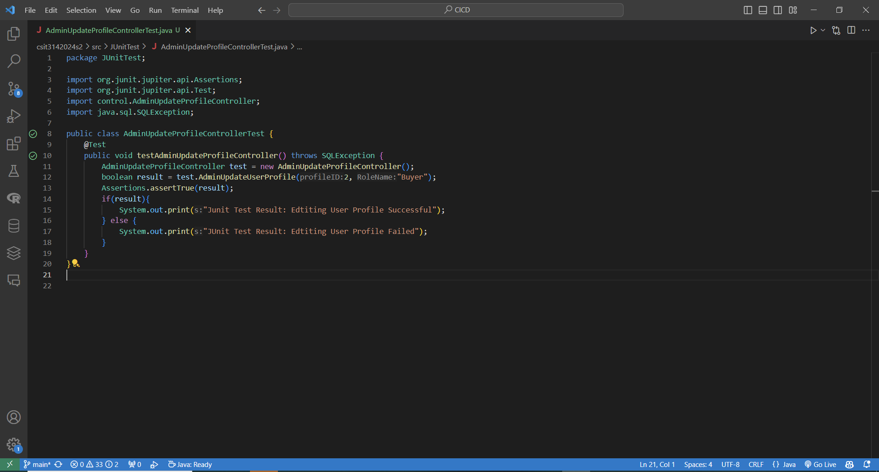

Test Result - passed:

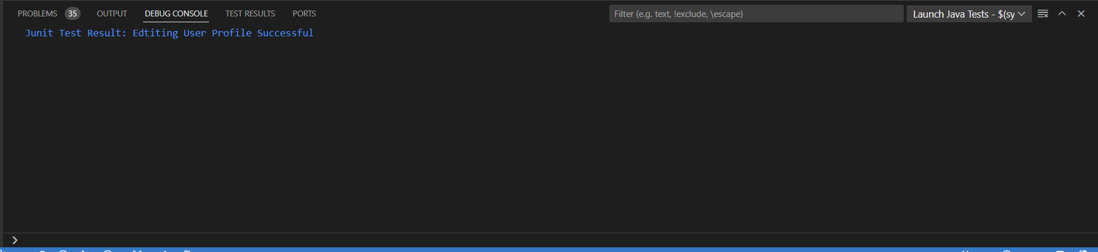

Testing code for Admin create New Account

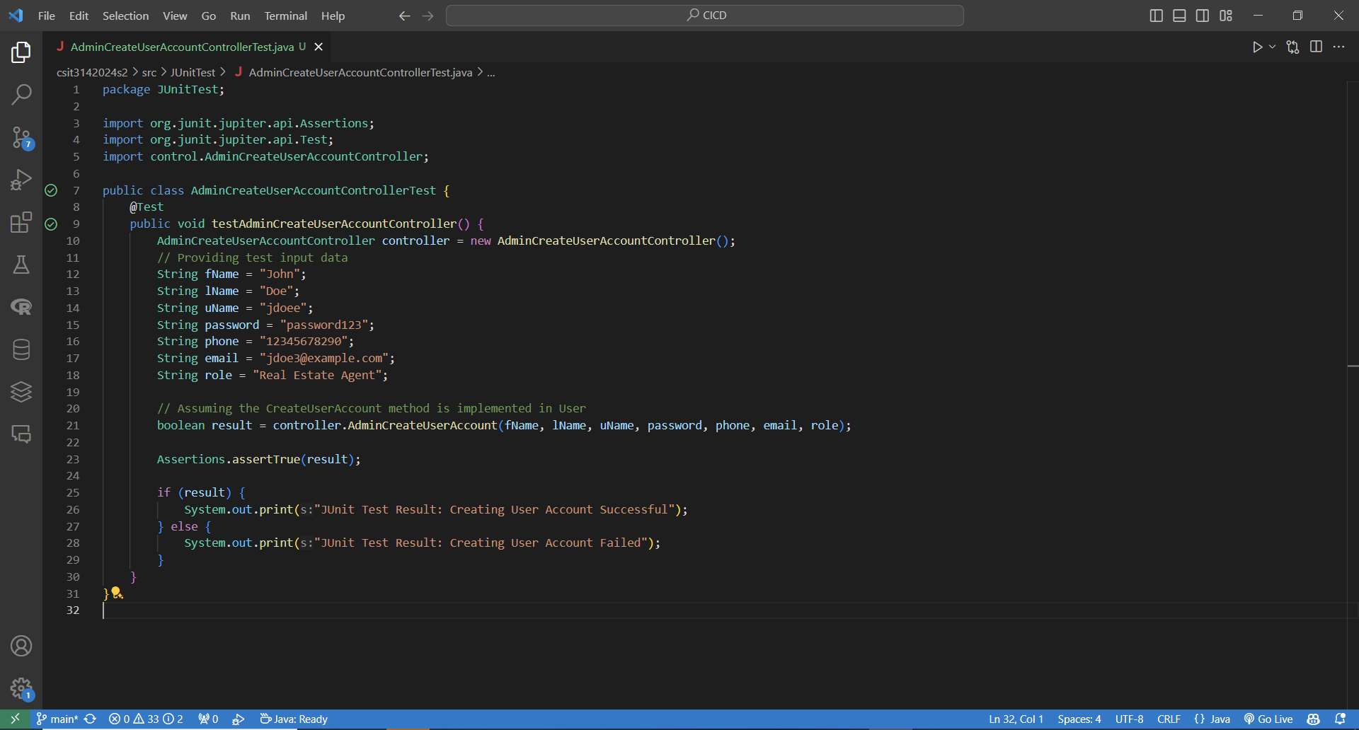

Test Result - passed:

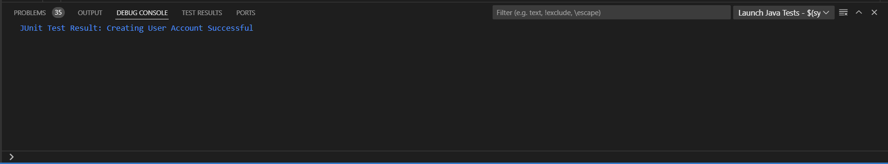

Admin view profiles

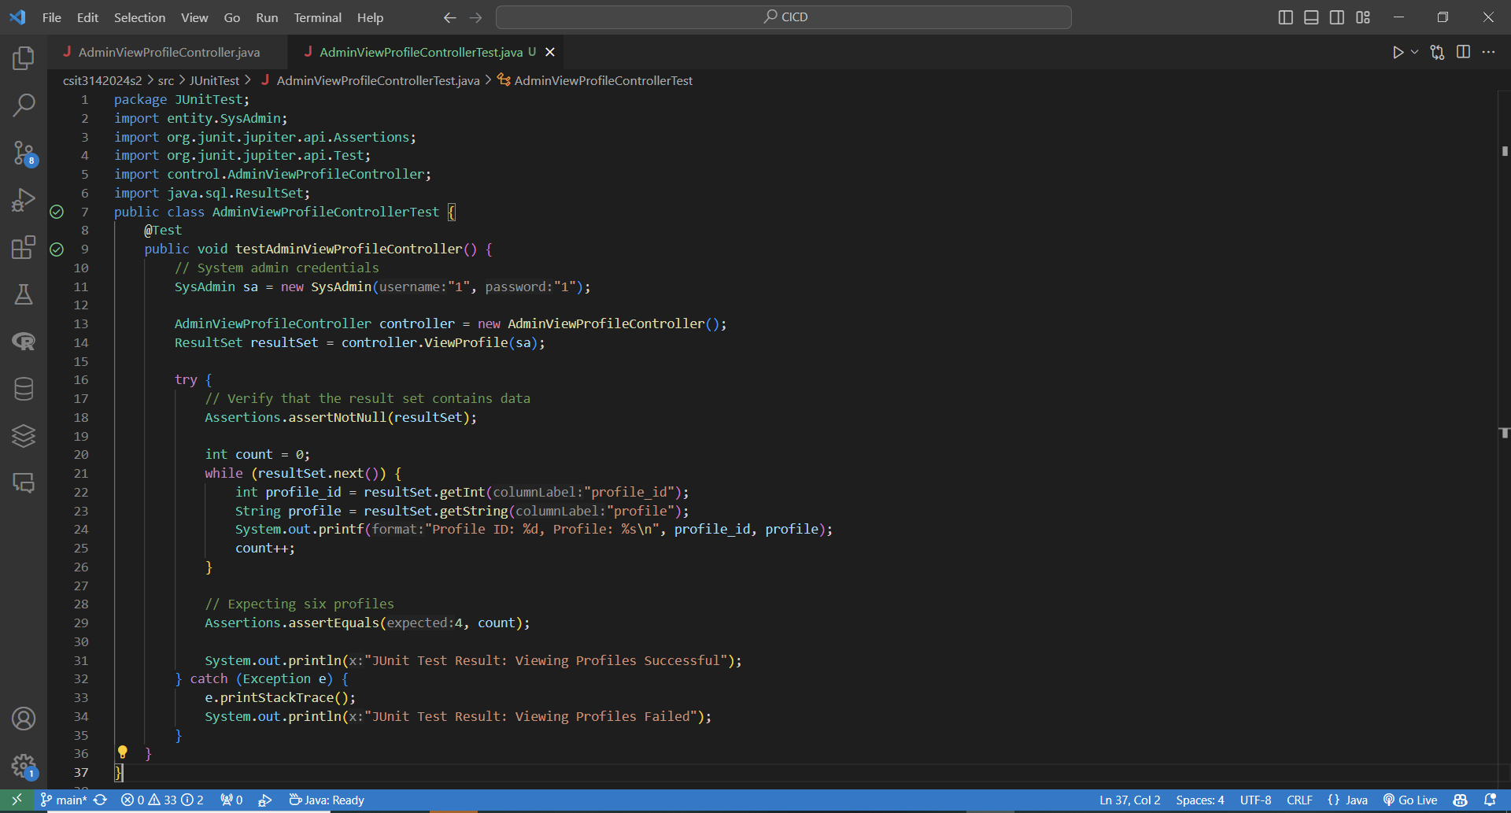

Result - passed:

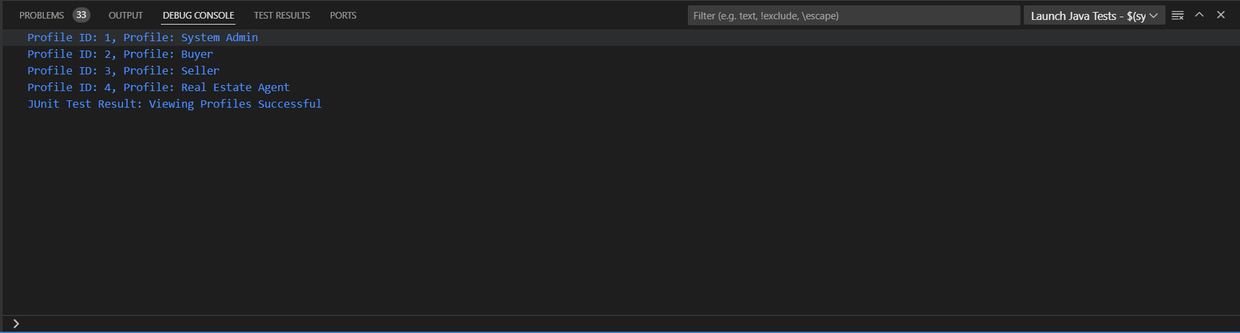

AdminSearchUserProfile

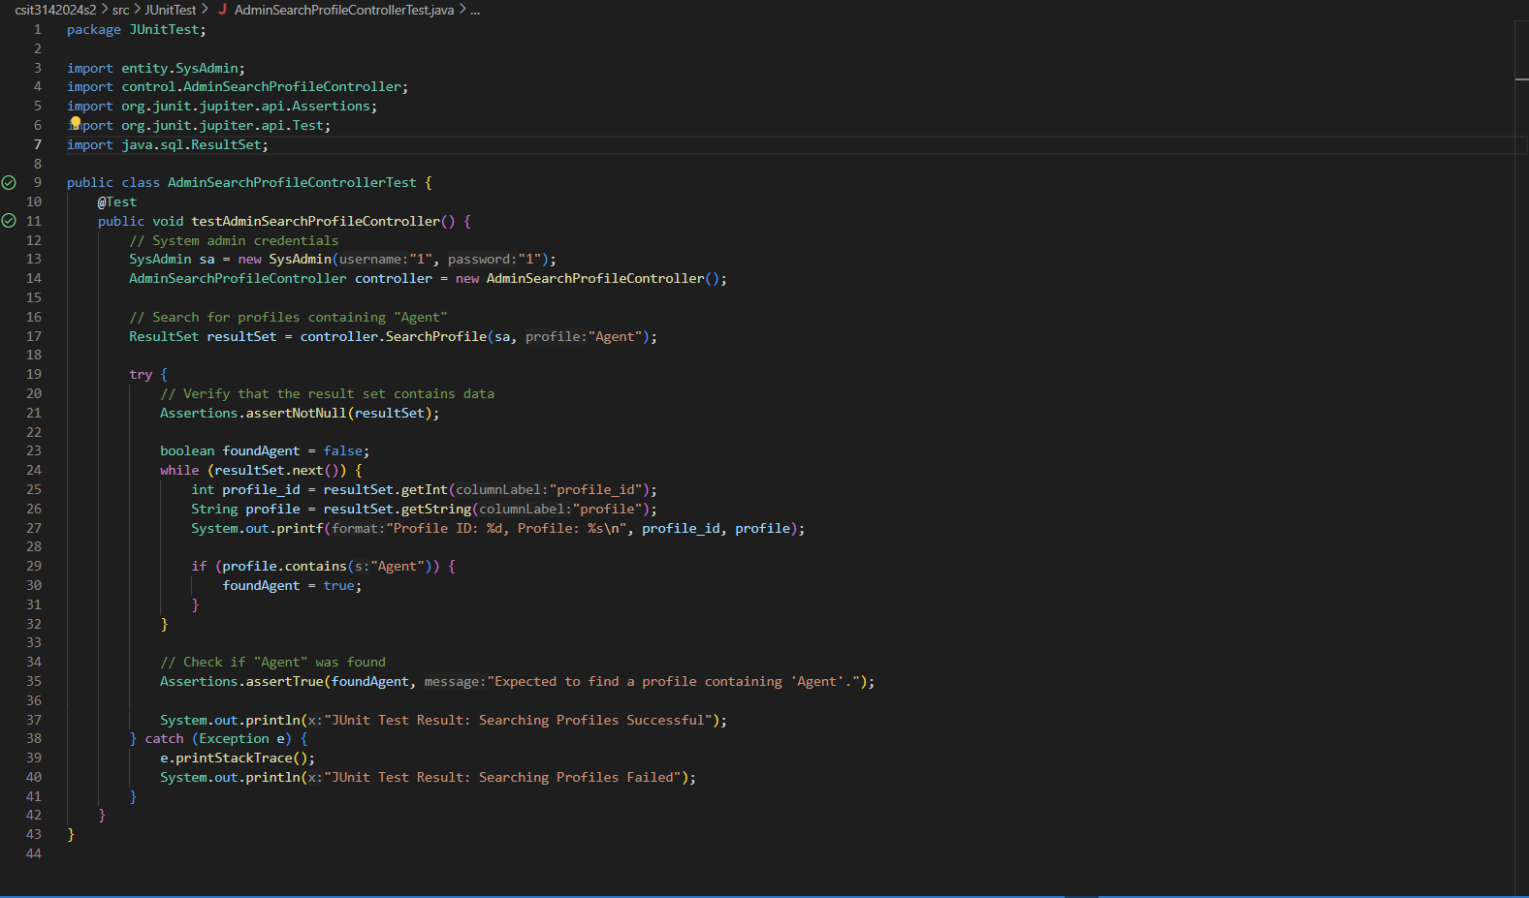

test result - passed:

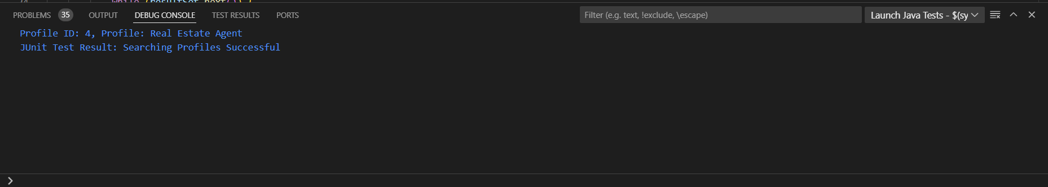

AdminCreateProfile

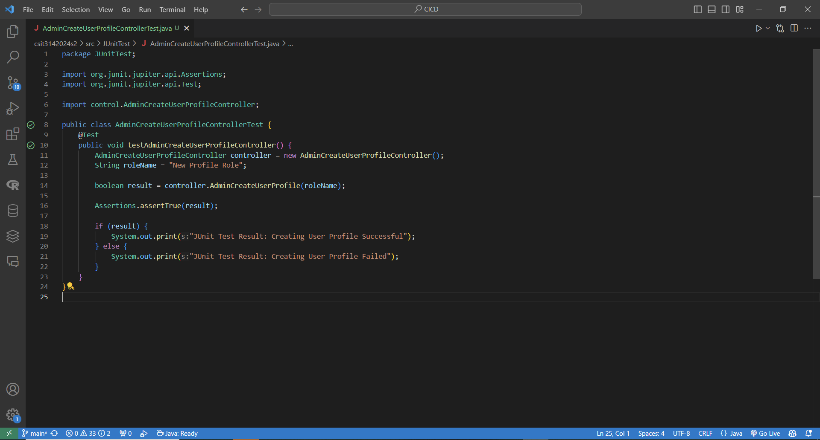

result - passed:

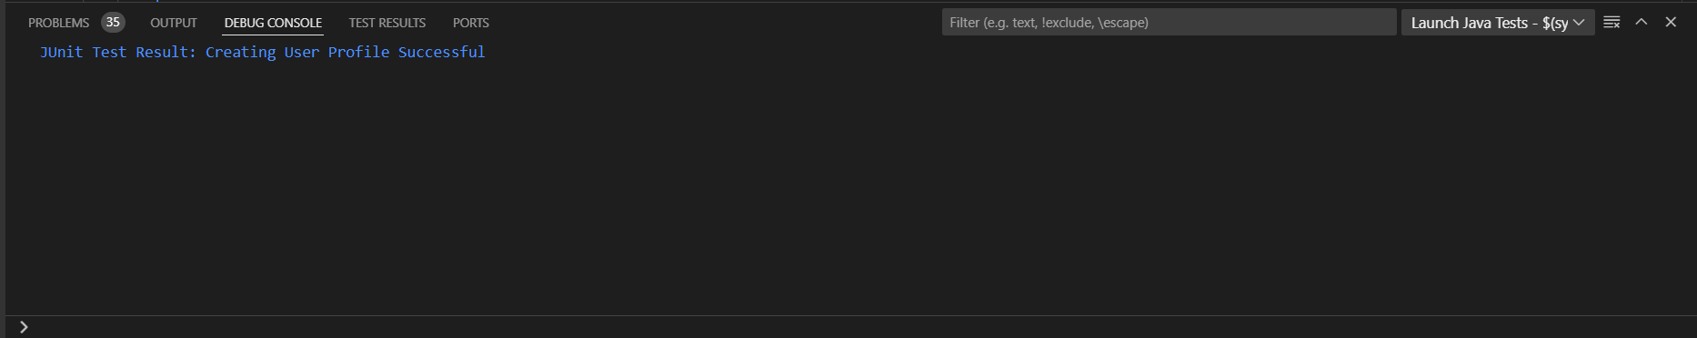

User Update Own Account

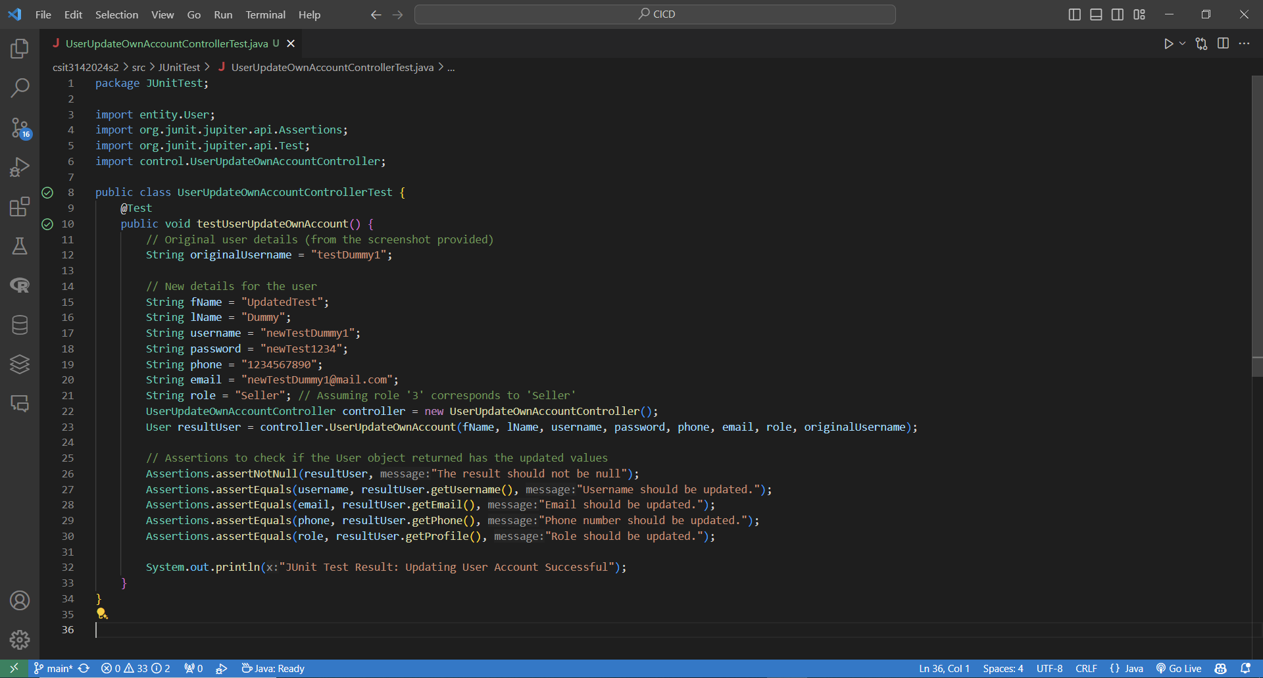

result - passed:

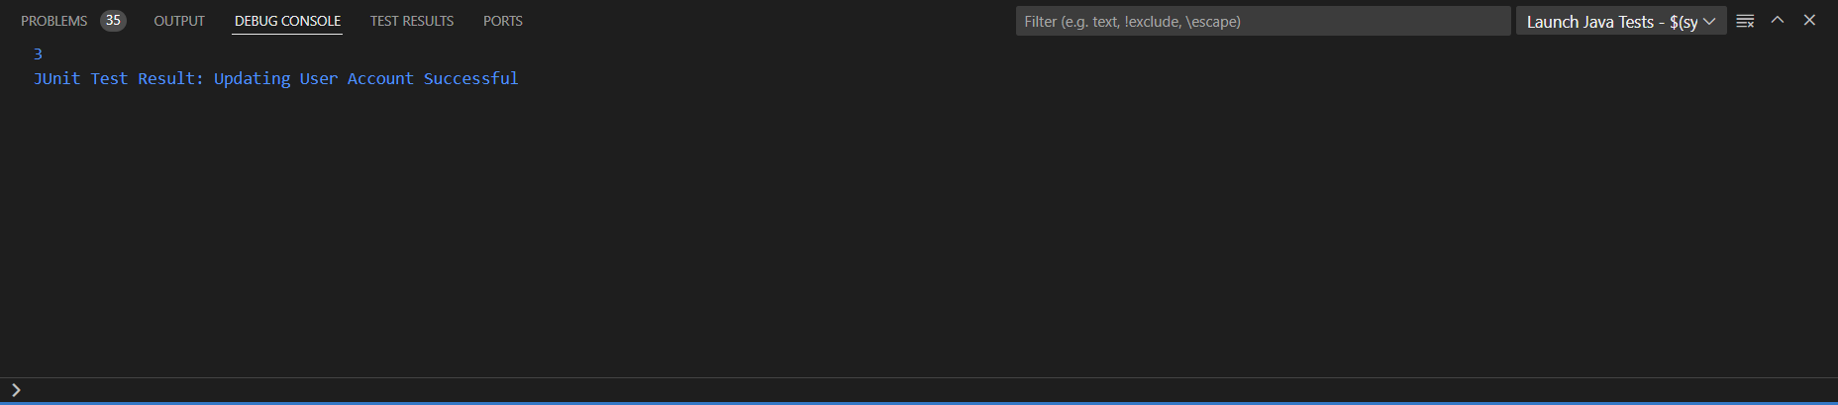

AdminSuspendProfile

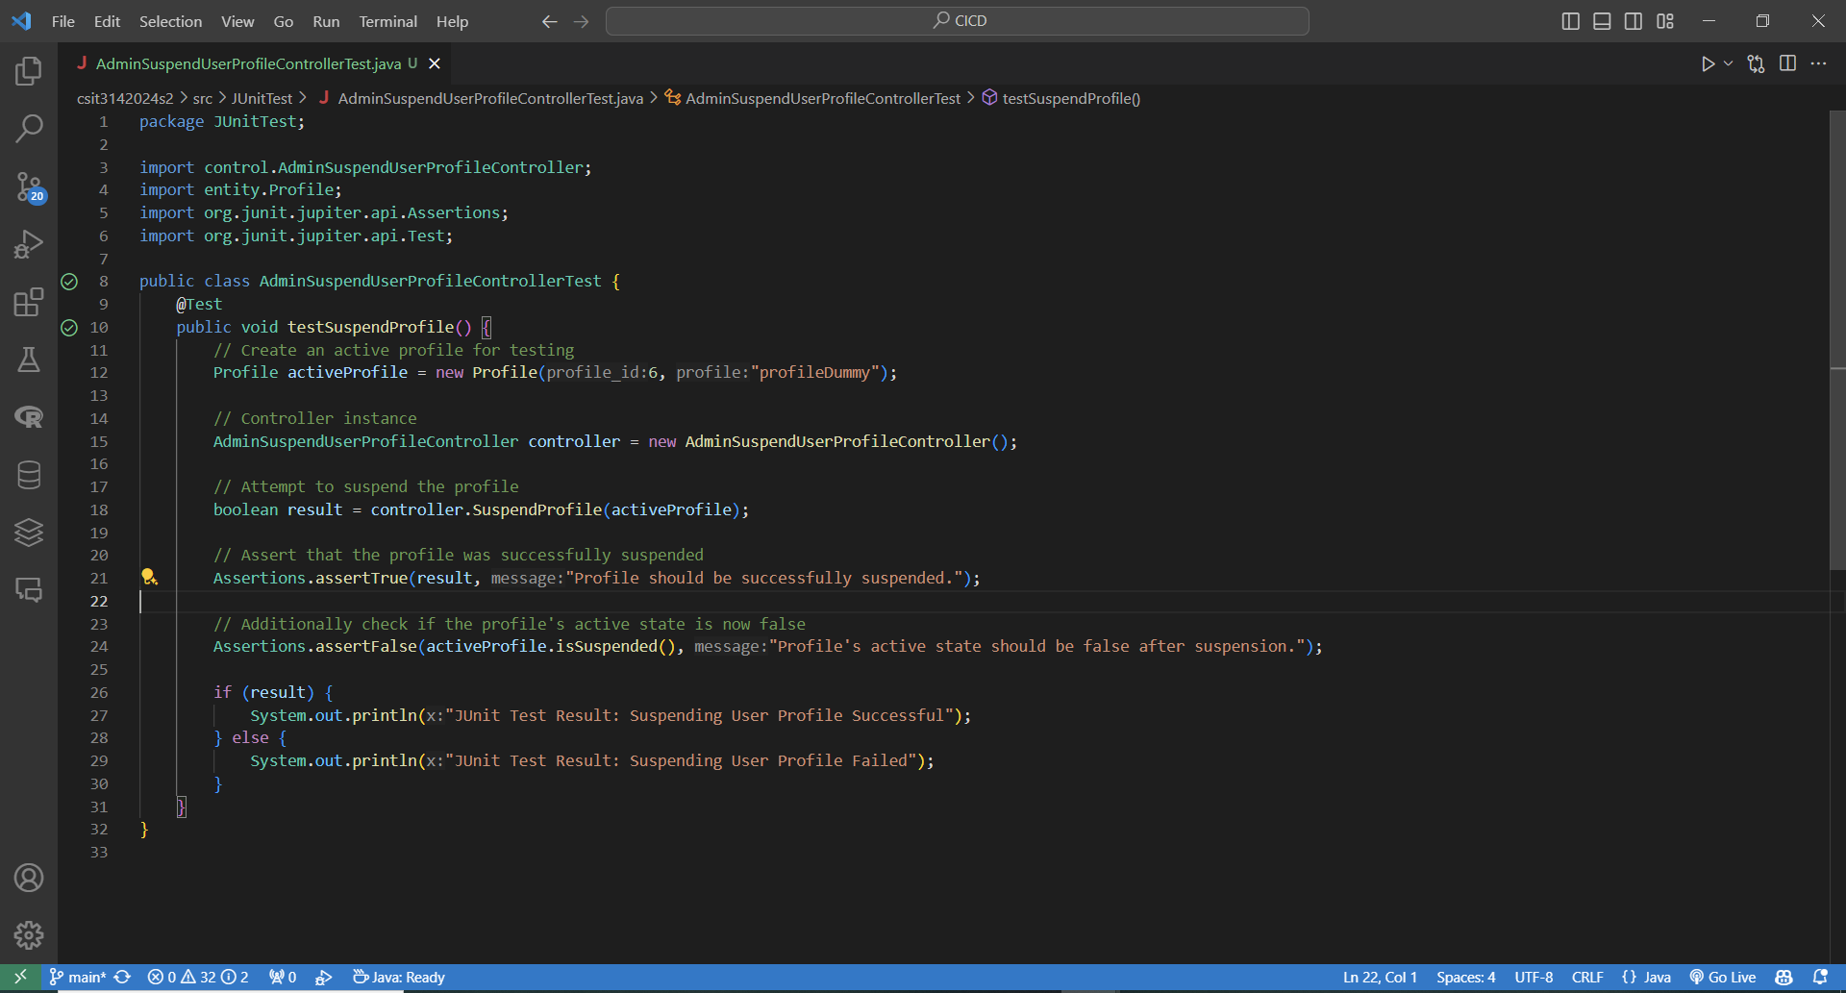

Result - passed:

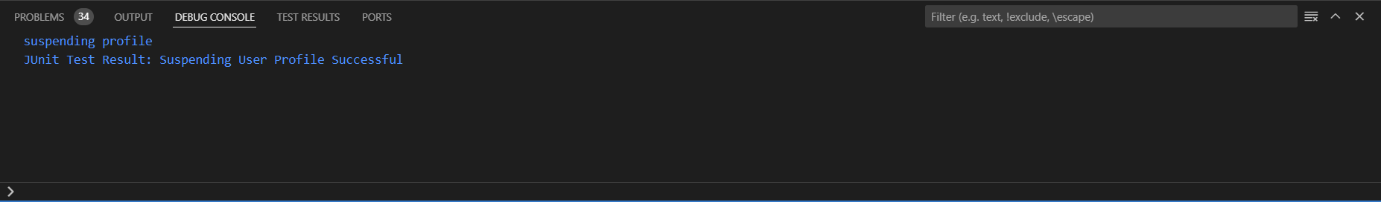

# 

# Data-Driven Development

Data-driven software development for our real estate website consists of nine stages:

**1. Model Requirements**

After a thorough analysis of the website's features, we identified opportunities to enhance the user experience with machine learning and data-driven technology. Our focus is to provide better property recommendations based on users' search behaviors and predictive analytics for market trends. The data-driven feature will include:

* **Personalized Property Recommendations:** Suggest properties tailored to users' preferences based on their interactions.
* **Market Trend Prediction:** Analyze market data to provide pricing insights and forecasts.

**2. Data Collection**

For building these models, we will collect the following datasets:

* **User Interactions:** Search queries, property views, and favorite lists of buyers and sellers.
* **Property Listings:** Active and sold property listings, including attributes like price, location, and type.
* **Market Trends**: Historical pricing trends and growth rates by region.

**3. Data Cleaning**

To ensure accurate predictions and recommendations, we will:

* **Review** datasets to remove duplicate, incomplete, or inconsistent records.
* **Handle** missing data with interpolation or deletion.
* **Normalize** numerical features (e.g., prices) and standardize categorical features (e.g., property types).

**4. Data Labeling**

* **Personalized Property Recommendations:**

Labeling is not necessary as we will use clustering techniques to group similar properties based on user preferences.

* **Market Trend Prediction:**

For supervised learning models, we will label historical property listings with actual transaction prices or market trends.

**5. Feature Engineering**

Feature selection and extraction will focus on the following attributes:

* **Property Attributes:** Location, size, type, price, and amenities.
* **Market Attributes:** Regional growth rates, comparable prices, and average market duration.
* **User Attributes:** Historical preferences, search queries, and engagement patterns.

**6. Model Training**

* **Personalized Property Recommendations:**
* Using unsupervised learning models like K-means or DBSCAN:
* Cluster properties based on attributes like location, price range, and amenities.
* Refine clusters using user interactions (e.g., views, favorites).
* **Market Trend Prediction:**
* Using supervised learning models (e.g., Linear Regression, Decision Trees):
* Train models with historical pricing and market trend data.
* Evaluate using metrics like Mean Absolute Error (MAE) and R-squared.

**7. Model Evaluation**

* **Personalized Property Recommendations:**

Evaluate clustering quality using metrics like Silhouette Score and A/B testing of personalized recommendations.

* **Market Trend Prediction:**

Measure model performance using metrics like MAE, RMSE, and R-squared. Adjust model hyperparameters if necessary.

**8. Model Deployment**

* **Personalized Property Recommendations:**

Integrate the recommendation model into the platform to deliver personalized property search results.

* **Market Trend Prediction:**

Embed the prediction model into the platform to provide pricing insights and forecast trends.

**9. Model Monitoring**

Continuous monitoring will be essential to maintain model accuracy:

* **Personalized Property Recommendations:**

Track user engagement and clustering performance to refine the recommendation algorithm.

* **Market Trend Prediction:**

Regularly compare predicted trends with actual market data to detect drift.

If discrepancies or errors arise, we will revisit model training or feature engineering to improve accuracy and reliability.

# 

# Ethical Considerations

**1. Process**

**Accountability**

An acknowledgement for activities of responsibility of actions, decision-making, and also addressing potential harm or offense stemming from the software's aspects. For the real estate application project, we will:

**Fairness**

* Ensure that tasks are assigned to team members that are best suited in their ability and skill sets.
* Ensure that tasks are assigned only within the skillsets of the team members in regard without taking race, religion etc of team members into account.
* Offer assistance to team members once our tasks are completed to reduce workload.
* Fairness refers to intellectual honesty, and revealing any significant conflicts of interest that are necessary to the project.

**Management**

* Follow Agile method and conduct weekly meetings to discuss tasks that have been completed and those that are upcoming, keeping everyone updated on progress, as well as distribute tasks among team members.
* Allow developers to fully own and flexibly implement features, while upholding quality and follow BCE structure strictly to ensure the reliability and requirements of the application.

**Inclusiveness**

* By welcoming diverse perspectives and voices to foster a comprehensive and equitable decision-making framework to better develop the Real Estate Management system.
* Soliciting feedback from all stakeholders at various stages of the process and using this feedback to address concerns and improve the software systems functionality.

**2. Product**

**Privacy and Security**

* Ensure that the software is safe for use and has undergone appropriate testing.

**Reliability and Safety**

* Align software product specifications with professional standards to ensure it is reliable, and does not easily get bugged by external hackers.
* Prioritize quality, consistency, and thorough testing and debugging for smooth functionality.

**Fairness**

* Implement transparent decision-making processes, especially in automated systems, to ensure fairness in outcomes and avoid unjust treatment.

## 